JIC — JECRC Incubation Centre
Logo-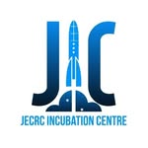
Brief summary -
JIC (JECRC Incubation Centre) was established at JECRC Foundation, Jaipur, born out of the institution's academic excellence and experience in research and innovation, with a vision to guide both campus students and entrepreneurs from across Rajasthan in turning their ideas into successful startups. It has become a one-of-its-kind startup incubation centre for young and ambitious founders who are addressing real-world challenges through their businesses, having built a collaborative entrepreneurial ecosystem and proven frameworks for early-stage startups to thrive and accelerate. With 150+ alumni-startups already supported and 50+ incubated startups under its belt, JIC's programs are designed to provide startups with the best resources and integrated support so they can evolve faster and better. Operating under the motto "Start Se Startup Tak," JIC intends to inspire individuals to innovate, offering mentoring, capital access, and structured incubation pathways to student entrepreneurs
Projects/initiative
Initiative 1 — KHOJ: The Startup Conclave
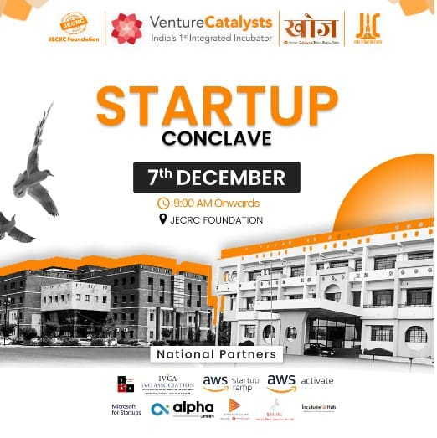
KHOJ – Bharat Startup Yatra was organized by JECRC Incubation Centre in association with Venture Catalysts, witnessing the presence of startups, investors, ecosystem enablers, and amazing founders from Jaipur's entrepreneurial ecosystem. The conclave brought together 40+ startups from 10+ colleges, featured 20+ prominent personalities, and offered cash prizes and credits worth over 2 lakh rupees and 2,700,000 USD in partner credits. National partners including IVCA, AWS Startup Ramp, AWS Activate, Alpha Microsoft for Startups, Beams Fintech Fund, and IncubateHub came under one roof, making it a landmark event for the Rajasthan startup ecosystem. The conclave featured pitching sessions, expos, quizzes, brand battles, and investor networking, providing early-stage founders with rare visibility and funding opportunities. It stands as one of JIC's most impactful events, connecting student innovators with real investors and industry leaders at scale.

Initiative 2 — Leader's Talk Series
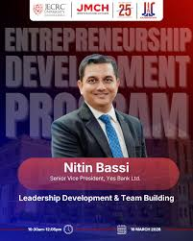
Leader's Talk is a talk series with pioneers of startups and organization leaders, designed to encourage young minds and motivate them to unleash their leadership potential. Past speakers have included Mugdha Sinha (Former IAS and present secretary at DST), Chintan Vaishnav (Director of Atal Innovation Mission), Harshit Mathur (Founder of Razorpay), Amit Jain (Founder of CarsDekho), and Chandresh Chand (Director of Engineering at Groww). The series exposes students to diverse paths in entrepreneurship and corporate leadership through first-hand accounts from some of India's most recognized names. By bridging the gap between student ambition and real-world execution, Leader's Talk serves as a consistent source of inspiration on campus. It reinforces JIC's broader mission of nurturing not just startups, but entrepreneurial mindsets from the ground up.

Initiative 3 — Accelerator & Incubation Program
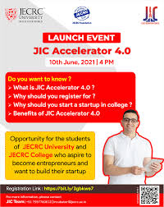
JIC's Accelerator Program is an intensive 10-week initiative for JECRC students that helps them take their ideas to market through workshops and mentoring sessions, with selected startups also receiving seed funding support. The Incubation Program complements this by connecting to the Accelerator Program, giving students foundational knowledge about startups, pitch decks, and pitching, while ensuring they progress from ideation to building an MVP. JECRC Foundation is noted as the first institute in Rajasthan to have a well-defined startup policy for students who want to pursue startups, with provisions including seed funds, access to mentor and investor networks, and special scholarships for women entrepreneurs. The program has already produced multiple incubated ventures across sectors like AgriTech, EduTech, and Mobile Apps. Together, these programs form a complete pipeline that takes a student from raw idea to a fundable, market-ready startup.

Abhivyakti Club
Logo-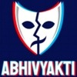

Brief Summary
Abhivyakti Club — The Drama Society of JECRC University
Abhivyakti Club is the dramatic and acting club of JECRC University, Jaipur. The club initiates to help students explore the dramatic artists within themselves during their college lives, with its main motive being to help members express themselves through emotions and enact stories with the help of them. Talking about the vision, the club is not only focused on developing dramatic artistic skills in students, but also the holistic and overall development of their personality. JECRC University's campus hosts student clubs like Maverick Club, Abhivyakti Club, and the Literature Club so that students can socialise with each other and explore interests as extracurricular activities. It serves as a creative outlet where students from all branches can come together, collaborate, and present their artistic work to the wider university community. The club actively participates in the university's annual techno-cultural fest, JU Rhythm, and various inter-college competitions, making it a key pillar of campus cultural life.
Projects / Initiatives
Initiative 1 — JU Rhythm — Annual Techno-Cultural Fest Performances
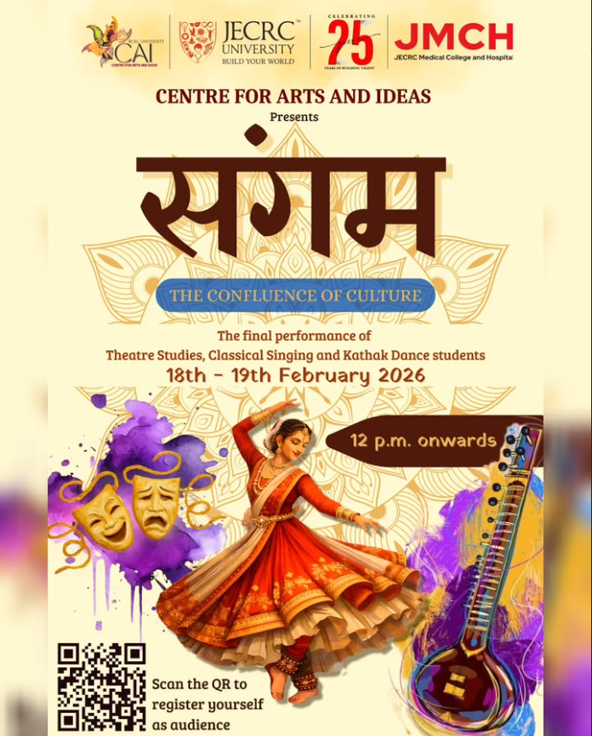
JU Rhythm is JECRC University's flagship techno-business-cultural festival, bringing together talent, creativity, and innovation on a grand stage, attracting 25,000+ attendees and offering 50+ electrifying events across technology, business, music, arts, and sports. The cultural extravaganza features a blend of dance, music, fashion shows, and theatrical performances. Abhivyakti Club is one of the key contributors to the theatrical dimension of this fest, staging dramatic productions that serve as some of the most anticipated performances of the event. JU Rhythm is envisioned as a best techno-cultural fest to bring out and explore talent in budding students, with dramatics being one of the major spotlights alongside dance and literature. The fest gives Abhivyakti members a grand platform to showcase their acting, scriptwriting, and stage craft skills to a massive audience each year.

Initiative 2 — Drama Workshops & Acting Skill Development
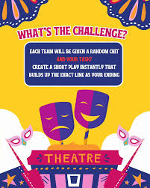

As part of its core mission, Abhivyakti Club regularly organizes acting workshops, script-reading sessions, and rehearsal-based skill-building activities for its members throughout the academic year. The club's vision goes beyond dramatic artistic skills to focus on the holistic and overall development of the personality of students. These workshops invite experienced theatre practitioners, alumni, and faculty mentors to guide students in areas like stage presence, voice modulation, improvisation, and emotional expression. The university has hosted personalities like Chandan Kumar Jangid, a theater artist and JECRC University alumnus, alongside acclaimed Hindi novelists and established poets, who shared the pearls of wisdom with students. This rich ecosystem of guidance directly benefits Abhivyakti members and helps them build confidence well beyond the stage.

Initiative 3 — Inter-College Competitions & Social Awareness Performances
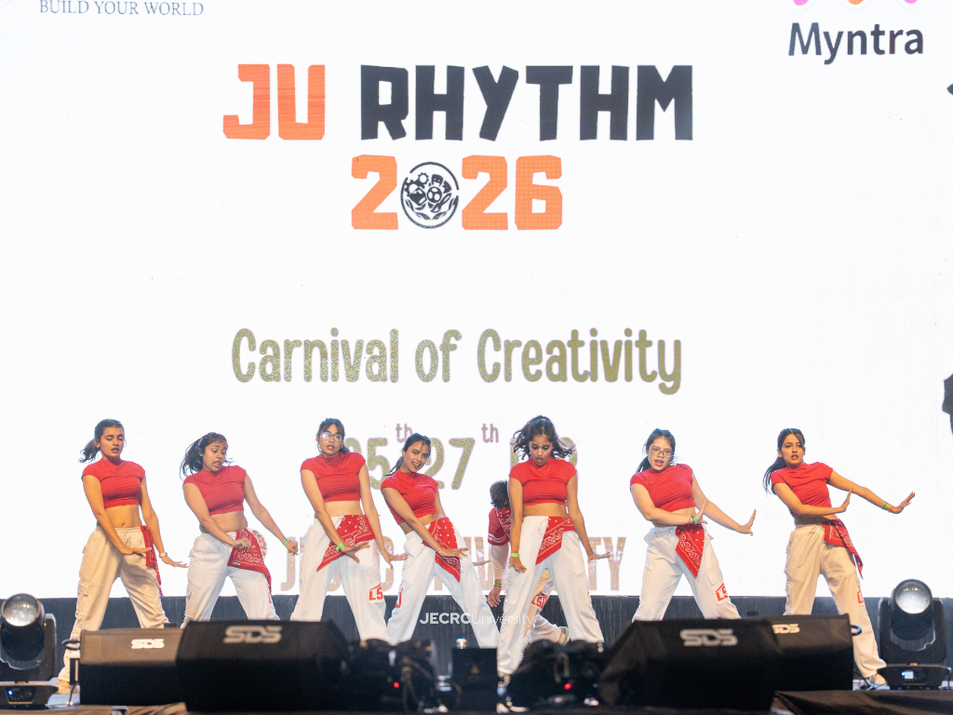
Abhivyakti Club regularly represents JECRC University at inter-college drama and street play competitions, taking the club's creative energy to wider platforms. JECRC University is known for its vibrant club culture where students explore interests as extracurricular activities and compete at inter-university levels. The club also uses the powerful medium of theatre for social messaging — performing nukkad nataks (street plays) that highlight pressing social issues such as gender equality, environmental awareness, and mental health, directly engaging audiences on campus and beyond. The club's main motive is to help students express themselves through emotions and enact stories, and this philosophy naturally lends itself to using drama as a tool for social change. Such performances add a meaningful dimension to the club's identity, positioning it as both a creative and socially conscious platform.

SWARAAG Club


BRIEF SUMMARY
JU Swaraag — The Official Music Club of JECRC University
Swaraag is the official music club of JECRC University, Jaipur. It is a club that represents all musical genres and invites any singers, musicians, and instrumentalists who are interested in learning more about the different genres of music, regardless of their ability. Known as the Swaraag Club — Indian & Western Music, it stands as one of the most prominent cultural clubs within the JECRC ecosystem. The club serves as a creative sanctuary on campus where students from all disciplines can come together and celebrate music in its many forms. Swaraag regularly performs at university events, freshers' nights, cultural fests, and community gatherings, making music an integral part of campus life. It nurtures raw talent, builds stage confidence, and fosters a deep love for music among its members throughout the academic year.
PROJECT / INITIATIVE
Initiative 1 — JU Euphoria — Music Performances at the Annual Cultural Fest
After a long time of online college life, Swaraag was able to entertain everyone with many melodious performances by its talented members at the JECRC Auditorium. JU Rhythm, the university's flagship techno-business-cultural festival, attracts 25,000+ attendees and offers 50+ electrifying events across technology, business, music, arts, and sports, with star-studded live concerts setting the stage on fire. Swaraag is a key contributor to the music segment of this mega-fest, presenting polished vocal and instrumental performances to a massive and enthusiastic audience. The club uses this grand platform to showcase the best of its members — from Indian classical renditions to western fusion covers — making it one of the most awaited acts of the festival. Performing at JU Rhythm gives Swaraag members a true stage experience, complete with professional sound systems, lighting, and a live crowd.

Initiative 2 — RAAG — Weekend Blast
RAAG — Weekend Blast was organized by the music club Swaraag in collaboration with the Student Council, with the belief that music brings peace to the soul. This initiative is a relaxed, campus-wide music event held on weekends where Swaraag members perform a mix of genres — Bollywood, classical, indie, and western — for the student community. It acts as a regular musical recharge for the campus, providing both performers and the audience a break from the grind of academics. The event also works as a discovery platform, where new and shy members of the club get their first experience performing in front of a live audience in a low-pressure, supportive environment. RAAG Weekend Blast has become a beloved recurring tradition at JECRC University, strengthening the bond between music and campus culture.

Initiative 3 — Wonder of Words (WoW) — Musical Collaborations
JECRC University organized the 11th Edition of Wonder of Words (WoW'23), one of the biggest and most illustrious literary fests of Jaipur, which saw eminent personalities from the fields of literature, art, music, films, and entertainment from across the world, including Mr. Ikram Rajasthani, a renowned Rajasthani musical artist. Swaraag actively contributes to the musical dimension of WoW by performing at its sessions and collaborating with visiting artists, blending campus talent with professional artistry. The fest ended on a poetic note with 'Jashn-e-Alfaz', wherein poets and shayars from all over the country mesmerized the youth with their talent and skills, with music from Swaraag setting the atmosphere. This collaboration exposes club members to the rich traditions of Indian classical, folk, and Sufi music, directly inspiring their own artistic growth. WoW serves as a bridge between Swaraag's student musicians and India's broader cultural and musical heritage.

3C (Catchy Cultural Club)



BRIEF SUMMARY
3C — Catchy Cultural Club, JECRC University
3C, the Catchy Cultural Club, is the official cultural club of JECRC University — a society of students who aspire to showcase their talents with a pinch of entertainment and culture. The main aim of 3C Club is to be prepared for any activity in advance and to organize events on a regular basis for JECRCians. The 3C team aims at making the college journey of students a memorable one, and gives students access to exclusive student funds, resources, and privileges that any fresher would be lucky to acquire. Their aim is to help students remain active in the area of social working and boost their leadership skills, while emphasizing the rights of others and promoting ethical standards and the dignity of all occupations. They provide a chance to young talents so that they can face the world with full confidence. 3C stands as one of JECRC University's most energetic and student-loved clubs, consistently bridging the gap between academics and a vibrant, culturally rich campus life.
PROJECT / INITIATIVE
Initiative 1 — Salam-E-Hunar
Salam-E-Hunar is one of 3C's signature events that kicks off the club's annual cultural calendar and sets the tone for the year ahead. The event is a talent showcase platform where students from across all departments and years are invited to display their hidden artistic abilities — from singing, dancing, and poetry to stand-up comedy and acting. It acts as a launchpad for shy and first-time performers to step into the spotlight in a warm, encouraging environment. Salam-E-Hunar is especially popular among freshers, giving new students one of their very first opportunities to express themselves on a university stage. The event embodies 3C's core philosophy — that every student has a talent worth celebrating, and the club's job is to give that talent a stage.

Initiative 2 — Tour De Jaipur
Tour De Jaipur is described as one of 3C's most amazing events, designed to make the college journey of students a truly memorable one. The initiative takes students out of the classroom and into the cultural and heritage landscape of Jaipur itself — exploring the Pink City's iconic forts, bazaars, monuments, and hidden gems as a community bonding experience. It combines cultural exploration with peer connection, helping students develop a deeper appreciation for Rajasthan's rich heritage while building lasting friendships outside the campus walls. The tour format also encourages teamwork, communication, and spontaneity among participants, making it as much a personal development exercise as it is a cultural outing. Tour De Jaipur reflects 3C's belief that cultural enrichment extends beyond the auditorium and into the real world around us.

Initiative 3 — Dandiya Nights
Dandiya Nights is one of 3C's most celebrated annual events that never disappoints anyone and makes the year a memorable one for all who attend. Held during the Navratri festival season, the event transforms the JECRC University campus into a vibrant celebration of Rajasthani and Gujarati folk culture, complete with traditional music, colourful costumes, and energetic dandiya and garba performances. It is one of the most widely attended events on campus, drawing students, faculty, and staff together in a joyful, inclusive celebration of Indian festive tradition. The event also encourages students to connect with their cultural roots while fostering a spirit of togetherness and community across the diverse student body. Dandiya Nights stands as a shining example of how 3C uses festivals as a tool for cultural pride, campus unity, and unforgettable memories.

Gladiators


BRIEF SUMMARY

JU Gladiators — The Official Esports Club of JECRC University
JU Gladiators is the official esports club of JECRC University, where passion meets competition — a team made up of dedicated gamers who excel in various esports titles, representing their university on national and international stages. Sports teams under the JU Eagles banner promote physical fitness and competition, with esports represented via the Gladiators club, with participation in intramural leagues and national tournaments. The club brings together gaming enthusiasts from across all departments of JECRC University, creating a structured and competitive community around titles spanning mobile, PC, and console gaming. JU Gladiators serves not just as a competitive team but as a full-fledged gaming community that fosters teamwork, strategic thinking, and digital sportsmanship on campus. It stands as one of the most forward-looking student clubs at JECRC University, recognising esports as a legitimate and celebrated form of competitive sport in modern campus culture.
PROJECT / INITIATIVE
Initiative 1 — JU VERVE — National Level Sports & Esports Fest
The University organizes a three-day inter-university national sports fest named JU VERVE, featuring disciplines including CSGO, FIFA, VALORANT, and BGMI alongside traditional sports like American football, basketball, cricket, and volleyball for both boys and girls. More than 1,500 participants from across the country participate in the event, where cash prizes worth ₹2.25 lakh and certificates are given to the winners. JU Gladiators is the primary organizing and competing force behind the esports segment of JU VERVE, setting up tournament brackets, managing online and offline rounds, and ensuring smooth competitive gameplay. The esports events at JU VERVE give student gamers from universities across India a prestigious platform to compete at a national level. For JU Gladiators members, this festival is their biggest annual stage — a chance to represent JECRC University with pride in the games they love.
Initiative 2 — Gameplay Highlights, Tournament Recaps & Live Streams
JU Gladiators actively produces content for their community, including epic gameplay highlights, tournament recaps with their latest achievements and victories, and live streams and exclusive events for their audience. Through their YouTube channel and social media presence, the club documents and broadcasts their competitive journey, making it accessible to the entire university community and beyond. This content creation arm of the club serves a dual purpose — celebrating the club's victories while also building an esports culture on campus that inspires more students to take gaming seriously. The club also organizes Game Jams — fun and creative collaborative events where members come together to build and experiment around gaming. These streams and recaps have helped JU Gladiators build a loyal following and establish a recognizable esports identity for JECRC University.
Initiative 3 — Inter-University Esports Competitions & Representation
JU Gladiators competes across various esports titles, representing JECRC University on the national and international stage as a team dedicated to bringing glory to their university. The club fields teams in popular titles such as BGMI, Valorant, CSGO, FIFA, and NFS, competing in tournaments hosted by institutions across India. The Gladiators club participates in intramural leagues and national tournaments as part of the broader JU Eagles sports vertical. These inter-university competitions provide members with high-pressure, real-tournament experience that sharpens both individual skill and team coordination. By consistently sending competitive squads to national esports events, JU Gladiators has firmly established JECRC University as a force to be reckoned with in the Indian collegiate esports landscape.

JU Eagles


BRIEF SUMMARY
JU Eagles — The Official Sports Club of JECRC University
JU Eagles is the official American Football and sports vertical of JECRC University, Jaipur. Sports teams under the JU Eagles banner promote physical fitness and competition in activities including football, basketball, volleyball, and eSports, with participation in intramural leagues and national tournaments. JECRC University offers a variety of intramural sports for its graduate students, faculty, and staff members — including Football, Basketball, Volleyball, American football (tackle & flag), Cricket, Badminton, Table tennis, Kabaddi, and Chess — all of which come under the Eagles ecosystem. The club is driven by the five S's of sports training — stamina, speed, strength, skill, and spirit — instilling not just athletic excellence but character and discipline in every member. JU Eagles has steadily grown into one of the most accomplished sports communities in Rajasthan's collegiate sports circuit, consistently bringing medals and recognition to JECRC University at state and national levels.
PROJECT / INITIATIVE
Initiative 1 — JU VERVE — National Level Sports Fest
JU VERVE is the university's three-day inter-university national sports fest, featuring disciplines such as American football, basketball, gully cricket, football, flag football, chess, table tennis, volleyball, kabaddi, CSGO, FIFA, VALORANT, BGMI, and NFS for both boys and girls. More than 1,500 participants from across the country participate in the event, where cash prizes worth ₹2.25 lakh and certificates are given to the winners. The first edition of JU VERVE in 2018 was inaugurated by Mr. Pankaj Singh, Indian Cricketer, and Mr. Vijendra Singh Yadav, Manager of the Rajasthan team, marking it as a landmark moment for sports culture at JECRC University. JU Eagles spearheads the organization and participation across all physical sports disciplines at this fest, making it the club's most prominent annual event. JU VERVE has grown edition by edition into one of Rajasthan's most anticipated collegiate sports festivals, drawing top athletes from universities nationwide.
Initiative 2 — Premier League 2.0 & Homecoming League
JU Eagles successfully organized a Premier League 2.0 for football, American football, and cricket — a one-of-its-kind sports event that attracted the best players from the university and featured an exciting auction system for player selection, adding an extra layer of competition and showcase of top talent. The sports club also successfully organized a 5-day homecoming league featuring a variety of events such as American football, basketball, cricket, badminton, table tennis, volleyball, kabaddi, and more. The auction-style player selection system, inspired by professional leagues like the IPL, brought a whole new level of excitement and strategy to campus sports, making participants feel like true professional athletes. These intra-university leagues ensure that the competitive fire burns all year round, giving even non-varsity players a chance to shine in a structured tournament setting. Both initiatives reflect JU Eagles' commitment to building a thriving, inclusive sports culture within the university, beyond just inter-college competitions.
Initiative 3 — Inter-University Competitions & National Achievements
JU Eagles has an impressive track record at inter-university competitions — at VARCHAS organized by IIT Jodhpur, JU won Gold in Chess and Silver in Basketball in 2016, and Silver in Cricket in 2023; at VIBES organized by Nirma University, Ahmedabad in 2015, JU was runners-up in Basketball and Chess; and at the AIU America Football Championship held at MDU Rohtak in 2017, the JECRC University Girl Flag Football team won a Silver Medal. Recent achievements include Bronze in Volleyball at VARCHAS'24 (IIT Jodhpur), Gold in Volleyball and Basketball at VANQUISH'24 (Global Institute of Technology, Jaipur), Silver in Powerlifting at SPARDHA'24 (Banaras Hindu University), and Gold in Table Tennis and Basketball at ATHLON'24 (JECRC Foundation College, Jaipur). Individual athletes have also excelled — Misha Sharma of B.Tech Civil won Bronze at the Taekwondo National Championship 2023, and Hemal Tenja won Gold in the 10m Air Pistol event at the 9th Samrat Prithviraj Chouhan Memorial State Shooting Championship 2023. These consistent achievements across diverse sports disciplines underscore JU Eagles' identity as a multi-sport powerhouse on the national collegiate stage.

JU-Socialz


BRIEF SUMMARY
Socialz BTS — The Social Media Marketing Cell of JECRC University
JU Socialz is a dynamic student-driven community at JECRC University where creative minds collaborate to build skills, shape the university's digital identity, and lead impactful storytelling across platforms. JU-Socialz is more than a team — it is a family of dreamers, creators, and leaders who believe that students can shape the identity of a university. Their strength lies in their diversity — engineers, designers, writers, videographers, editors, storytellers, and strategists — all coming together with one shared belief: students can lead change. This is a place where students learn to take ownership, work with responsibility, and grow through real-time experience — they don't just make content; they build a brand, and they don't just handle social media; they represent the spirit of JECRC. Because of their dedication and collective brilliance, JECRC's digital story today reaches lakhs of people across platforms. Socialz BTS functions as the behind-the-scenes engine that powers JECRC University's entire online presence, making it one of the most impactful and real-world-oriented student communities on campus.
PROJECT / INITIATIVE
Initiative 1 — Content Creation & Campus Storytelling
From reels to blog posts, Socialz students create engaging content that captures campus life, events, and achievements, learning industry-standard tools and designing visually compelling social media creatives, banners, and posters. The team is responsible for documenting every major event on campus — from JU Rhythm and JU VERVE to convocations, freshers' nights, and club activities — transforming them into polished, platform-ready content for Instagram, YouTube, and LinkedIn. Members join as first-year students and grow into confident content creators — one member shared that when they first came to JECRC for orientation, they randomly created a reel, with no idea it would lead them to representing the university's entire digital voice. Every reel, poster, and post that goes out under the JECRC University handle is crafted, edited, and published by the Socialz BTS team. This initiative gives students hands-on experience in real brand management long before they enter the professional world.

Initiative 2 — Video Production for Digital Platforms
Socialz students shoot, edit, and produce professional videos for YouTube, Instagram, and other digital platforms, functioning as a fully student-run production house for the university. The team handles everything from scripting and filming to post-production and publishing, covering events, faculty spotlights, placement success stories, and campus life vlogs. Their YouTube productions, including club features, convocation highlights, and JU Rhythm aftermovies, have helped JECRC University build a strong and visually consistent presence with over 100,000 Instagram followers. Members actively contribute as content writers, videographers, and digital creators, gaining real professional experience while still pursuing their degrees. This initiative has made Socialz BTS a genuine talent incubator for students aiming for careers in media, marketing, and digital communications.

Initiative 3 — Digital Marketing, Analytics & Campaign Management
Socialz members analyze engagement metrics, run targeted campaigns, and understand audience behavior — operating with the full toolkit of a professional digital marketing agency, just within a university setting. The team plans and executes platform-specific campaigns around key events, admissions cycles, and milestone announcements, ensuring JECRC University's messaging reaches the right audiences at the right time. JU-Socialz serves as a launching pad where students grow through real-time experience, standing as a reminder that when young people are trusted, empowered, and encouraged, they don't just perform — they transform. Students graduate from Socialz BTS with a portfolio of live campaigns, real follower growth data, and proven experience managing a brand that reaches lakhs of people — something most marketing professionals only achieve years into their careers. The cell has positioned itself as one of the most career-accelerating student communities at JECRC University.

Maverick Club
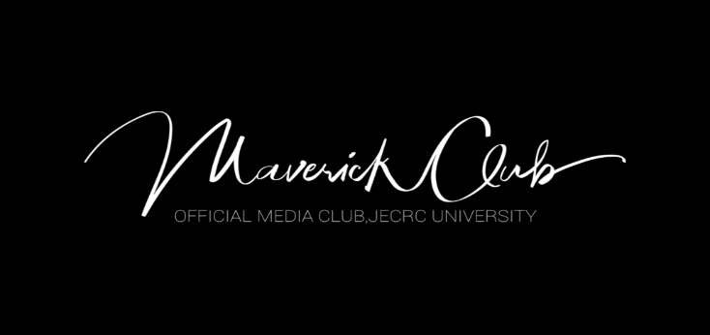

BRIEF SUMMARY
Maverick Club — The Official Media Club of JECRC University
Maverick Club is the official media club of JECRC University, made for all photography enthusiasts who wish to share their knowledge and experience with those who are inclined towards learning and enhancing their photography skills. It is recognised as the club for Photography and Creative Design, and also handles the promotion of different events through social media across the university. It is a community tailored for photography enthusiasts eager to exchange knowledge and enhance their skills, and diligently captures the vibrant moments orchestrated by the university across all its events. Beyond documenting events, Maverick Club is a proactive hub, organizing workshops, competitions, activities, and photowalks to foster skill development and creative exploration among its members. The club serves as the visual memory of JECRC University — every candid, portrait, and event frame that tells the story of campus life is the work of the Mavericks. It is the go-to platform for students passionate about visual storytelling, design, and creative media on campus.
PROJECT / INITIATIVE
Initiative 1 — Event Coverage & University Documentation
Maverick Club covers all the events that are organized by the university, including sport events and the annual techno-cultural fest JU Rhythm. The club functions as the de facto official photography and videography unit of JECRC University, deploying its members across every major campus event — from convocations and freshers' nights to inter-university sports tournaments and cultural performances. Their aftermovies and event reels have become a much-anticipated part of campus culture, with the Freshers' 2021 aftermovie being one of their most acclaimed productions, presented for the first time ever by the club. Every photograph published on JECRC University's official social media — capturing placement milestones, guest lectures, and fest highlights — is shot and edited by Maverick Club members. This initiative makes the club an indispensable part of the university's public identity and institutional memory.
Initiative 2 — Professional Photography Workshops
Maverick Club successfully hosted a professional photography workshop conducted by @vinee.studio, in which the photographer embraced the students of Maverick Club with his knowledge. These workshops bring in industry professionals, working photographers, and creative directors to mentor club members on technical aspects of photography — including lighting, composition, portrait techniques, and post-processing using tools like Lightroom and Photoshop. The JU Alumni Association also collaborated with Maverick Club for its first "Meet & Greet" program, where alumni Mr. Yash Pandiyar Sahu, a professional wedding photographer, and Mr. Vivek Surya, a wide-angle off-camera flash fashion photographer, interacted with current members and taught them basic skills of photography. These sessions bridge the gap between campus learning and professional practice, giving students direct access to working photographers who have built real careers from the craft. The workshops have made Maverick Club one of the most skill-oriented student communities at JECRC University.
Initiative 3 — Photowalks & Creative Competitions
Maverick Club organizes photowalks and competitions as part of its commitment to fostering skill development and creative exploration among its members. Photowalks take members out of the campus and into the streets, markets, and heritage spots of Jaipur — the Pink City — giving them real-world subjects to practise their craft on and develop their individual artistic voice. Photography competitions held by the club challenge members to shoot around specific themes, pushing them to think creatively under constraints and curate their best work for peer and mentor evaluation. Maverick Club has also proudly announced collaborations with prestigious organisations including ISRO, adding a unique dimension to its creative outreach and event coverage portfolio. Together, these activities make Maverick Club not just a documentation team, but a thriving creative community where students grow from beginners into confident, versatile visual storytellers.

JU VOGUE



BRIEF SUMMARY
JU Vogue is a dynamic fashion and lifestyle club that celebrates creativity, style, and self-expression among students. The club provides a platform for aspiring models, designers, photographers, and fashion enthusiasts to showcase their talent. Through workshops, fashion events, and collaborative projects, JU Vogue promotes confidence, innovation, and teamwork. It actively engages students in modern fashion trends while encouraging originality and artistic vision. The club also focuses on personality development and stage presence through various interactive activities. JU Vogue has become a vibrant community that blends fashion, creativity, and youth culture together.
PROJECT / INITIATIVE
1. Modeling Workshop Initiative
JU Vogue organized modeling and grooming workshops to help students improve their runway walk, posture, and confidence. These sessions focused on professional modeling techniques and personality enhancement. Participants were guided by experienced mentors and senior members of the club. The initiative encouraged students to step out of their comfort zones and develop stage confidence. It also provided beginners with exposure to the basics of the fashion industry. (Instagram)
2. Fashion Photography & Creative Shoots
The club conducted creative fashion photoshoots that highlighted styling, photography, and artistic direction. Students collaborated as models, photographers, makeup artists, and editors to create visually appealing content. These projects helped members gain practical experience in fashion media and teamwork. The initiative also promoted creativity and social media engagement for the club. It allowed students to express unique fashion concepts through professional-looking campaigns. (Instagram)
3. Fashion Show & Campus Events
JU Vogue actively participated in organizing fashion shows and campus fashion events to showcase student talent. These events provided a stage for models and designers to present innovative styles and themes. The club focused on building confidence, presentation skills, and event management experience among members. Students worked together in choreography, styling, and backstage coordination to make the events successful. Such initiatives helped create a strong fashion culture and creative environment within the campus community.

Literature Club


BRIEF SUMMARY
We The Lit Club is the official literature club of JECRC University that encourages students to explore creativity through writing, poetry, storytelling, and public speaking. The club provides a platform for literary enthusiasts to express their thoughts and imagination through various engaging activities. It organizes open mics, discussions, competitions, and interactive sessions to nurture communication and creative skills. The club aims to build confidence, critical thinking, and artistic expression among students. Through its events and initiatives, We The Lit Club creates a vibrant literary culture on campus. It serves as a community where students connect through their shared love for literature and creativity.
PROJECT / INITIATIVE
1. Open Mic Sessions
We The Lit Club regularly organizes open mic sessions where students perform poetry, storytelling, and spoken word pieces. These events provide a safe and creative environment for students to express their emotions and ideas. Participants gain confidence in public speaking and stage presence through these performances. The sessions also encourage interaction between writers, readers, and performers across the campus. Open mics have become one of the club’s most engaging and community-building initiatives.
2. Wonder of Words Literary Festival
The club actively contributes to “Wonder of Words (WoW),” JECRC University’s annual literary festival. The event brings together authors, poets, speakers, and students for discussions, workshops, and literary activities. Students get opportunities to interact with renowned writers and learn about literature, creativity, and communication. The initiative promotes reading culture, creative writing, and intellectual discussions within the university. It also helps students improve leadership, teamwork, and event management skills.
3. Creative Writing & Literary Activities
The club conducts various creative writing initiatives including poetry writing, short story competitions, and literary discussions. These activities encourage students to improve their writing abilities and think creatively. Members are given opportunities to showcase their talent through social media features and campus events. The initiative helps students develop imagination, vocabulary, and storytelling skills. It also creates an inspiring atmosphere for aspiring writers and literature lovers in the university.

Quintessence Crew

BRIEF SUMMARY
Quintessence Dance Crew is the official dance club of JECRC University that promotes passion, creativity, and excellence in dance. The club provides students with a platform to showcase their talent in various dance forms including hip-hop, contemporary, classical, and fusion. It regularly organizes performances, workshops, competitions, and collaborative events to encourage artistic growth. The crew is known for its energetic stage presence and strong teamwork during university events and competitions. Through dance, the club inspires confidence, discipline, and self-expression among students. Quintessence Dance Crew has become one of the most vibrant and recognized cultural communities on campus.

PROJECT / INITIATIVE
1. D-Vibe Dance Celebration
The club organized “D-Vibe,” a major dance celebration event that brought together talented performers from across the university. The event featured energetic group performances, creative choreography, and audience engagement activities. It provided dancers with an opportunity to perform on a professional stage and gain recognition for their talent. The initiative encouraged teamwork, creativity, and confidence among participants. D-Vibe also helped strengthen the dance culture and entertainment environment within the campus community.
2. Dance Workshops & Training Sessions
Quintessence Dance Crew regularly conducts workshops and practice sessions for students interested in improving their dance skills. These sessions focus on choreography, body movement, rhythm, and stage performance techniques. Senior dancers and mentors guide beginners to help them build confidence and technical abilities. The initiative creates a supportive learning environment for dancers of all skill levels. It also promotes discipline, fitness, and artistic expression among members of the club.
3. Inter-College Competitions & Performances
The crew actively participates in inter-college dance competitions and cultural festivals, representing JECRC University on larger platforms. Their performances showcase creativity, synchronization, and diverse dance styles. The club has gained appreciation for its high-energy acts and competitive spirit during such events. These initiatives provide students with exposure, teamwork experience, and opportunities to perform before wider audiences. Participation in competitions also helps members grow personally and professionally in the field of performing arts.

Student Council
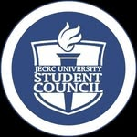
BRIEF SUMMARY
The Student Council of JECRC University is a dynamic student body that works as a bridge between students and the university administration. It promotes leadership, teamwork, and active student participation through various academic, cultural, technical, and sports initiatives. The council is dedicated to enhancing campus life by organizing events, addressing student concerns, and encouraging holistic development. With multiple specialized verticals, it ensures smooth coordination of university activities throughout the year. The council also provides students with opportunities to develop management, communication, and leadership skills. Student Council JU represents the spirit of service, innovation, and student empowerment within the university community.
PROJECT / INITIATIVE
1. Student Council Investiture Ceremony
The Student Council organized the Investiture Ceremony to officially welcome and honor newly selected council members. The event included oath-taking, badge pinning, and recognition of student leaders chosen through a rigorous selection process. It aimed to inspire responsibility, leadership, and dedication among council members. The ceremony marked the beginning of a new journey of service and representation for students. This initiative strengthened leadership culture and encouraged students to actively contribute to university development.
2. JU Verve Sports Event
The council conducted “JU Verve,” an engaging sports event designed to promote fitness, sportsmanship, and student participation. The event featured various sports competitions and fun activities that brought students together in a competitive yet enjoyable environment. It encouraged teamwork, discipline, and healthy interaction among participants. Students from different departments actively participated and showcased their athletic talent. The initiative helped create an energetic and inclusive sports culture across the campus.
3. Campus Engagement & Student Representation
The Student Council actively works throughout the year to organize cultural programs, technical events, awareness campaigns, and student engagement activities. It acts as the representative voice of students by communicating their concerns and suggestions to the administration. Through its various verticals, the council ensures smooth execution of university events and student welfare initiatives. Members gain valuable experience in event management, communication, and teamwork. This initiative plays an important role in building a connected, vibrant, and student-friendly campus environment.

ZARURAT

BRIEF SUMMARY
Zarurat is the social welfare club of JECRC University dedicated to supporting underprivileged children through education, care, and community service. The club works with the vision of creating positive social change by empowering children with knowledge and opportunities. Through teaching programs, donation drives, mentorship, and awareness campaigns, Zarurat encourages students to contribute towards society in meaningful ways. It provides a platform for volunteers to develop empathy, leadership, and social responsibility. The club has positively impacted thousands of lives through its consistent efforts and community initiatives. Zarurat represents compassion, hope, and the spirit of service within the JECRC community.
PROJECT / INITIATIVE
1. Free Education for Underprivileged Children
Zarurat regularly conducts educational classes for underprivileged children living near the university area. Student volunteers teach subjects, basic skills, and moral values to help children build a brighter future. The initiative focuses on providing quality education and creating learning opportunities for children who lack resources. Volunteers also mentor students and motivate them to continue their studies with confidence. This project reflects the club’s commitment to educational empowerment and social upliftment.
2. Vastra Samman Samaroh
The club organized “Vastra Samman Samaroh,” a clothing donation initiative aimed at helping needy families and individuals. Through this campaign, clothes were distributed respectfully among underprivileged communities and hospital areas. The initiative promoted dignity, compassion, and community support rather than simple charity. Students actively participated in collection, management, and distribution activities to maximize impact. This project successfully spread awareness about social responsibility and helping those in need.
3. Digital Mentorship & Skill Development
Zarurat launched digital mentorship and skill-development programs to guide students academically and personally. The initiative included online mentoring sessions, computer education, and career guidance for rural and underserved students. Volunteers helped children improve their communication, digital literacy, and confidence through interactive learning methods. The program aimed to prepare students for future educational and career opportunities. It also encouraged university students to use their knowledge and skills for meaningful social impact.

JECRC MUN Society (JMS)

BRIEF SUMMARY
JU MUN Society (JMS) is the official Model United Nations society of JECRC University that promotes diplomacy, leadership, and global awareness among students. The club provides a platform for students to engage in debates, negotiations, and discussions on international issues through MUN conferences and simulations. It helps members develop public speaking, critical thinking, research, and problem-solving skills. JMS encourages students to understand global politics and collaborate on real-world challenges in a professional environment. The society also organizes large-scale conferences, workshops, and training sessions for delegates across the country. JU MUN Society has become one of the leading student communities for diplomacy and leadership development at JECRC University.
PROJECT / INITIATIVE
1. JECRC Diplomacy Summit (JDS)
JU MUN Society organizes the prestigious JECRC Diplomacy Summit, one of the largest MUN conferences in Jaipur. The event brings together hundreds of delegates from schools and universities across India to participate in UN simulations and debates. Students represent different countries and discuss global issues in professionally organized committees. The summit helps participants improve diplomacy, negotiation, leadership, and communication skills. It also creates networking opportunities and encourages youth participation in international affairs.
2. MUN Training & Public Speaking Workshops
The society regularly conducts training sessions and workshops to help students understand MUN procedures, research techniques, and debate strategies. These sessions focus on improving public speaking, confidence, and analytical thinking among participants. Senior members and experienced delegates mentor beginners and guide them through committee simulations. The initiative creates a supportive environment for students interested in diplomacy and international relations. It also prepares members for inter-college and national-level MUN conferences.
3. National-Level Delegate Participation
JU MUN Society actively encourages students to participate in national-level MUN conferences and diplomacy events across the country. Members represent JECRC University in prestigious competitions where they showcase debating and negotiation skills. The initiative helps students gain exposure to diverse perspectives, international policies, and professional networking opportunities. Participation in such events enhances confidence, leadership qualities, and teamwork among students. It also strengthens the university’s presence in the national MUN and debating community.

UpScale


BRIEF SUMMARY
Upscale JU is the entrepreneurship and startup club of JECRC University that encourages innovation, creativity, and business-oriented thinking among students. The club provides a platform for aspiring entrepreneurs to develop leadership, problem-solving, and management skills through various activities and events. It organizes startup competitions, workshops, networking sessions, and business-related discussions to promote entrepreneurial culture on campus. Upscale JU helps students gain practical exposure to the world of startups and innovation. The club also motivates young minds to transform their ideas into impactful solutions and successful ventures. Through its initiatives, Upscale JU has built a strong community of ambitious and future-focused students.
PROJECT / INITIATIVE
1. Startup & Entrepreneurship Workshops
Upscale JU regularly conducts workshops and seminars focused on entrepreneurship, startup building, and innovation. Industry experts, entrepreneurs, and mentors guide students on topics like business planning, marketing, funding, and leadership. These sessions help students understand real-world startup ecosystems and entrepreneurial challenges. Participants gain practical insights and confidence to work on their own business ideas. The initiative encourages students to think creatively and develop an entrepreneurial mindset.
2. Business Pitching Competitions
The club organizes business idea and startup pitching competitions where students present innovative ideas before judges and mentors. These competitions help participants improve presentation, communication, and problem-solving skills. Students receive feedback and mentorship to refine their startup concepts and business strategies. The initiative promotes innovation and healthy competition among aspiring entrepreneurs. It also gives students exposure to professional pitching and networking opportunities.
3. Networking & Collaborative Events
Upscale JU actively hosts networking sessions and collaborative events that connect students with entrepreneurs, innovators, and industry professionals. These initiatives create opportunities for knowledge sharing, mentorship, and teamwork among participants. Students learn about emerging business trends, startup culture, and career opportunities through interactive discussions. The club also collaborates with other university communities to organize impactful events and activities. Such initiatives help students build professional connections and practical industry exposure.

JU-NCC
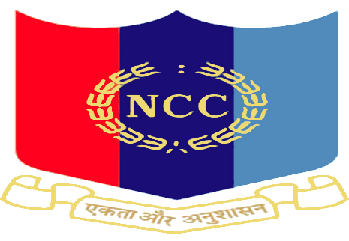
BRIEF SUMMARY
JU NCC is the National Cadet Corps unit of JECRC University that focuses on discipline, leadership, patriotism, and personality development among students. Operating under the 3 Raj Naval Unit, the club provides cadets with military-style training, physical fitness activities, and leadership opportunities. It encourages students to develop confidence, responsibility, teamwork, and national pride through various camps and events. The unit actively participates in national celebrations, social awareness campaigns, and defense-related activities. JU NCC also prepares cadets for careers in the armed forces and other leadership roles through certified training programs. The club represents the values of “Unity and Discipline” while shaping students into responsible citizens and future leaders.
PROJECT / INITIATIVE
1. Defence Counselling Session
JU NCC organized a Defence Counselling Session at JECRC University to guide students interested in careers in the armed forces. The session provided insights into defense examinations, NCC special entry schemes, and opportunities in the Army, Navy, and Air Force. Experienced officers and mentors interacted with students and motivated them towards disciplined leadership and national service. The initiative helped cadets understand the preparation strategies and career pathways in defense services. It also inspired many students to explore opportunities in military and national service sectors.
2. Run for Equality Initiative
The NCC cadets of JECRC University participated in the “Run for Equality” campaign organized to promote unity, equality, and social awareness. The event was conducted to celebrate the values of justice and inclusion while honoring Dr. B. R. Ambedkar’s vision. Cadets displayed discipline, teamwork, and enthusiasm throughout the run. The initiative encouraged fitness, social responsibility, and community participation among students. It also reflected the club’s commitment toward spreading positive social messages through active engagement.
3. Republic Day & National Representation
JU NCC actively participates in Republic Day celebrations and prestigious national camps representing JECRC University and Rajasthan. Several cadets have been selected for Republic Day Camp (RDC) and All India Nau Sainik Camp, showcasing their dedication and excellence. These activities help students build leadership, discipline, and confidence on national platforms. The initiative provides cadets with exposure to military training, cultural exchange, and teamwork experiences. Participation in such events strengthens patriotism and motivates students to contribute towards the nation with pride and responsibility.

Renegade
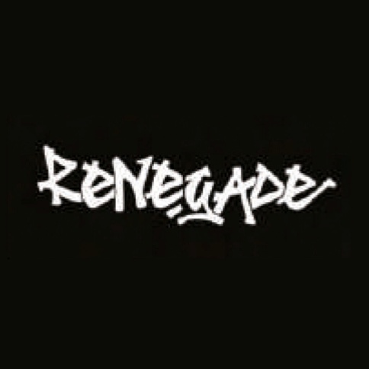
BRIEF SUMMARY
Renegade JU is the official hip-hop and rap community of JECRC University that promotes creativity, rhythm, and self-expression through urban art forms. The club brings together students passionate about rap, beatboxing, hip-hop dance, graffiti, and emceeing. It provides a platform for talented artists to showcase their skills through performances, battles, workshops, and campus events. Renegade encourages originality, confidence, and artistic freedom while building a strong community of performers and music enthusiasts. The club is known for its energetic performances and contribution to the vibrant cultural environment of JECRC University. Through its initiatives, Renegade JU continues to inspire students to explore the culture and spirit of hip-hop.
PROJECT / INITIATIVE
1. Hip-Hop Performances at JU Rhythm
Renegade JU actively performs during JU Rhythm, the annual techno-cultural fest of JECRC University. The club showcases rap performances, beatboxing acts, and high-energy hip-hop presentations before large audiences. These performances provide artists with exposure and opportunities to display their talent on a professional stage. The initiative helps students build confidence, stage presence, and teamwork through live performances. It also strengthens the hip-hop culture and entertainment atmosphere across the campus.
2. Freshers’ Hip-Hop Recruitment Drive
The club organizes recruitment and engagement activities for freshers who are interested in rap, music, and hip-hop culture. Through interactive sessions and performances, new students are introduced to the creative environment of Renegade JU. The initiative encourages students to explore their artistic abilities and become part of a supportive community. Members are trained and guided by experienced performers and seniors within the club. This activity helps discover new talent and keeps the hip-hop culture growing within the university.
3. Rap, Beatboxing & Creative Expression Workshops
Renegade JU conducts practice sessions and workshops focused on rap writing, beatboxing, rhythm, and performance skills. These sessions help students improve lyrical creativity, stage confidence, and musical coordination. The initiative provides a collaborative environment where artists can experiment with their style and learn from each other. Students also gain opportunities to participate in cyphers, freestyle sessions, and collaborative performances. Such workshops promote artistic expression, teamwork, and cultural creativity among club members.

