PREMIUM LIGHTING
MASTER CREATIVE • UX • MOTION • E-COMMERCE SPECIFICATION
Reference-driven flagship website specification for Claude implementation
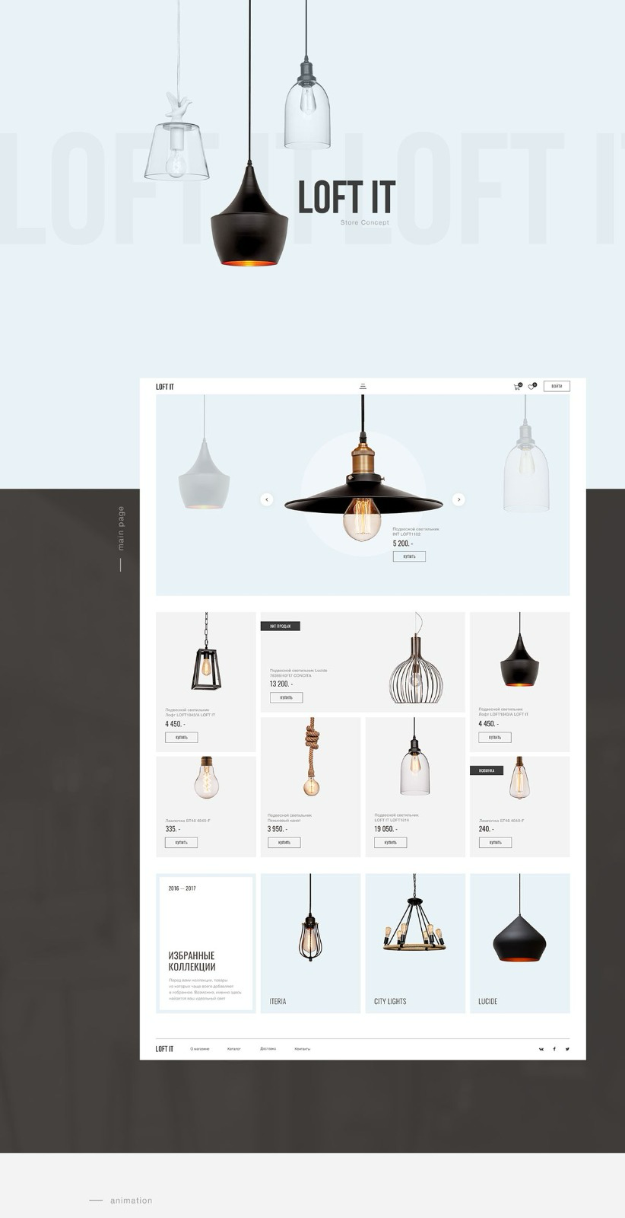
Primary visual reference — homepage / editorial lighting composition
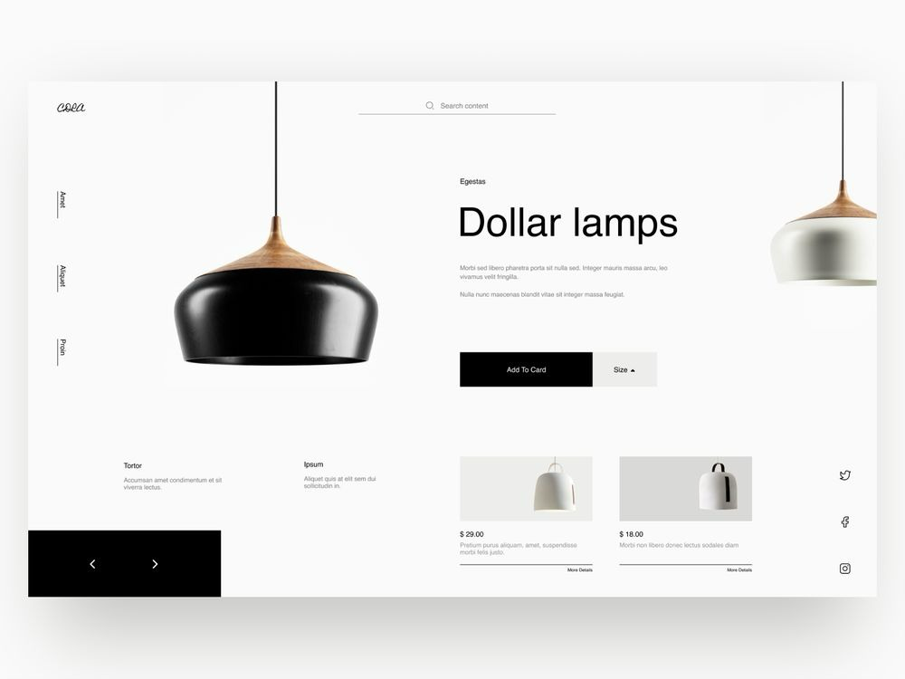
Primary visual reference — premium product-detail experience
SOURCE OF TRUTH
The two reference images define the visual DNA. The motion tables define animation behavior. This document defines the complete experience, interaction logic, responsive behavior and QA requirements.

00. HIGH PRIORITY — 4K / ULTRA-HD REWORK & REPLICATION
THIS IS A P0 / NON-NEGOTIABLE REQUIREMENT. The supplied reference images are screenshots and therefore must NOT be treated as the final image-quality target. The final website must rework and recreate the visual language shown in the references at a substantially higher production quality, with crisp, premium, 4K-ready presentation throughout.
The instruction is to REPLICATE THE DESIGN DIRECTION, COMPOSITION, PRODUCT PRESENTATION, spacing, visual hierarchy, lighting behavior and interaction ideas from the supplied references — while rebuilding them as clean, high-resolution digital assets and a fully functional website. Do not simply place the low-resolution screenshots into the website and call the design complete.
Priority | Requirement | Implementation standard
P0 | 4K visual quality | All hero/product visuals should be rendered or supplied at 4K-quality resolution where applicable; use high-resolution source assets and responsive image variants.
P0 | Reference recreation | Rebuild the reference compositions as actual HTML/CSS/React components and high-quality product assets rather than screenshot sections.
P0 | Product clarity | Lighting fixtures must remain extremely sharp and clean at large desktop sizes; never upscale a small screenshot/product image when a better source can be created.
P0 | 4K-ready motion | Animations, glow, shadows and transitions must remain crisp on high-density/Retina and 4K displays.
P0 | Asset quality | Inspect every uploaded asset. Where a source is insufficient, recreate/redraw the element or use a higher-resolution equivalent consistent with the reference.
P0 | No screenshot UI | Do not use the supplied website screenshots as a flat background or image-based website. Reconstruct the experience as real interactive UI.
P1 | Responsive resolution | Serve appropriate image sizes for desktop, tablet and mobile so quality is high without unnecessarily loading 4K assets on every device.
P1 | Visual QA | Review the implementation against the references at large desktop/4K viewport sizes and refine spacing, scale, sharpness and composition.
4K QUALITY DEFINITION: 4K should be understood as a visual production target, not merely a screen-size label. The website must look exceptionally sharp on 4K/Retina displays: product edges, typography, image details, gradients, shadows and illumination must not appear pixelated, blurry or artificially enlarged.
REBUILD, DON'T SCREENSHOT: If a visual element in the reference is a lamp, recreate it as a high-resolution asset or use the highest-quality supplied product asset. If it is typography, render it as live text. If it is a card, build it as a real component. If it is an animation, recreate the motion. If it is lighting, reproduce it using layered digital lighting effects. The reference screenshot is the visual target; it is not the implementation.
HIGH-RESOLUTION PRODUCT PRESENTATION: Product imagery should be capable of being displayed large without visible degradation. Use transparent PNG/WebP/AVIF or other appropriate high-resolution assets where available, maintain correct aspect ratios, and avoid aggressive compression. For hero products, prefer source imagery that can comfortably support a 4K desktop presentation.
VISUAL STANDARD: The final result should look materially better than the supplied screenshots while remaining recognizably faithful to their design DNA. Think: same concept and visual language, rebuilt as a polished flagship digital experience with modern 4K-quality production.

01. Creative Direction & Non-Negotiable Principles
The website is a premium lighting showroom translated into a digital e-commerce experience. The references must be treated as the primary visual DNA—not as optional inspiration. The final result should feel calm, architectural, editorial, minimal and expensive while remaining fully functional.
Priority | Requirement | Acceptance standard
P0 — Visual fidelity | Preserve the reference language | Composition, whitespace, pale environment, product scale and editorial hierarchy feel clearly derived from the supplied references.
P0 — Premium quality | Luxury lighting experience | No generic template feel; every interaction and spacing decision feels intentional.
P0 — Functionality | No dead interactions | Navigation, search, product pages, cart, quantity, checkout flow and mode switch work.
P0 — Day/Night | Signature experience | Day → dusk → night transition is gradual; lamps progressively illuminate.
P0 — Motion | Subtle, physical animation | No abrupt movement, excessive bounce or decorative motion.
P1 — Responsive | Desktop/tablet/mobile | Layouts are intentionally redesigned for smaller screens, not merely scaled.
P1 — Performance | Rich but performant | Images lazy-load; animation stays smooth; no avoidable heavy dependencies.

02. Reference Image Study
Reference A — Homepage / overall visual language
Observed reference characteristic | Implementation direction
Very pale blue/white environment | Use a soft cool-white/pale-blue base and maintain it consistently across the daytime experience.
Suspended lamps as hero objects | Treat fixtures as architectural objects with generous negative space.
Large central product scale | Hero product should dominate without crowding the typography.
Dark charcoal product against pale field | Preserve strong product/background contrast.
Editorial product grid | Use asymmetric or carefully balanced cards rather than generic equal ecommerce tiles.
Minimal navigation | Keep header visually quiet and let the products lead.

Reference B — Product detail / editorial e-commerce language
Observed reference characteristic | Implementation direction
Large product image | Product image is the dominant visual anchor.
Sparse typography | Use concise product copy and strong hierarchy.
Large whitespace | Do not fill empty space unnecessarily.
Editorial side content | Product information should sit beside/around the product rather than below a conventional store template.
Black/white CTA treatment | Use restrained, high-contrast controls with subtle hover states.
Small related products | Use supporting product cards without competing with the hero product.

03. Visual Design System
System | Direction | Rule
Color | Soft cool white / pale blue, charcoal, white, restrained warm light | No random accent colors. Product and illumination remain the visual focus.
Typography | Modern editorial sans-serif | Large elegant headings, restrained body copy, limited font weights.
Grid | Architectural/editorial grid | Use generous margins and controlled asymmetry.
Radius | Minimal | Avoid excessive rounded UI; product architecture should feel refined.
Shadow | Soft and physical | Use shadows sparingly; avoid generic card shadows.
Glow | Warm, diffused, local | Night glow must feel like emitted light—not neon.
Motion | Slow and precise | Motion supports hierarchy and physicality.
Icons | Minimal line icons | Keep stroke weight consistent and avoid decorative icon clutter.

04. Information Architecture & Page Map
Level | Page / surface | Purpose | Primary interactions
1 | Home | Brand discovery and visual entry | Hero, day/night, featured products, collections, navigation
1 | Shop | Browse complete catalogue | Search, filters, sort, product cards
1 | Category | Browse a specific lighting type | Filter, sort, product selection
1 | Collection | Editorial product story | Story, product discovery
1 | Product | Evaluate and buy a product | Gallery, specs, options, add to cart
1 | Cart | Review selected products | Quantity, remove, subtotal
1 | Checkout | Complete purchase flow | Customer, shipping, payment UI
1 | About | Brand story / philosophy | Editorial content
1 | Journal | Design inspiration / stories | Article browsing
1 | Contact | Customer contact | Contact form/details
Global | Search | Find products quickly | Search input, results, empty state
Global | Day/Night | Signature lighting experience | Gradual environmental transition

05. Core User Flow
Stage | User action | System response | Motion / feedback
Discover | Enter homepage | Hero and brand reveal | Slow entrance choreography
Explore | Scroll / hover | Products and collections reveal | Subtle scroll/hover motion
Experience | Toggle NIGHT | Environment transitions | Day → dusk → night
Evaluate | Open product | Product detail loads | Smooth page transition
Configure | Select options/quantity | UI updates | Micro-interaction
Purchase | Add to cart | Cart updates | Cart count + confirmation
Review | Open cart | Cart drawer/page | Slide/fade
Checkout | Continue | Checkout flow | Step transition
Complete | Confirm order | Confirmation state | Calm success transition

06. Header & Navigation
The header should remain minimal and architectural. It must never compete with the lamps.
Interaction | Start state | Animation | Timing | Easing / direction
Header entrance | Header visually hidden | Fade + slight upward settle | 500–700 ms | Ease-out; Y +12px → 0
Menu open | Menu closed | Overlay expands + links reveal | 650–900 ms total | Ease-out; stagger 50–70 ms
Menu item hover | Static link | Underline/weight/image response | 180–250 ms | Ease-out
Menu close | Menu visible | Reverse reveal + overlay fade | 450–650 ms | Ease-in-out
Search open | Search hidden | Input/overlay fades and expands | 350–500 ms | Ease-out
Cart open | Cart closed | Drawer slides from right + backdrop | 450–600 ms | Ease-out

07. Full-Screen Menu Content
Group | Items
SHOP | All Lighting • Pendant • Ceiling • Table • Floor • Wall • Outdoor
COLLECTIONS | New Collection • Featured • Best Sellers • Designer Collection
ABOUT | Our Story • Design Philosophy • Materials
CONTENT | Journal
CONTACT | Contact
UTILITY | Search • Cart • Day/Night

08. Homepage Hero — Signature Entrance
The hero is the first motion statement. A suspended fixture is gently released from above, settles into place, then gradually illuminates. The animation must feel physical and quiet.
Sequence | Start → End | Duration | Delay | Motion
01 | Background 0% → 100% opacity | 700 ms | 0 ms | Soft fade
02 | Brand / hero typography 0% → 100% | 650 ms | 180 ms | Fade + Y 12px → 0
03 | Cable top → final position | 1,100 ms | 280 ms | Controlled downward movement
04 | Lamp top → final position | 1,350 ms | 350 ms | Slow drop; minimal overshoot
05 | Lamp settle | 450 ms | 1,700 ms | Tiny physical settle
06 | Bulb 0% → warm illumination | 1,200 ms | 2,050 ms | Opacity + glow radius
07 | Ambient glow | 1,600 ms | 2,200 ms | Diffused radial expansion

Motion rule: the lamp should never feel like a UI element being dropped. It should feel like a real fixture being gently lowered into an architectural space.

09. DAY / NIGHT — Signature Experience
The day/night system is not a simple theme toggle. It is an environmental transition that lets the user experience how the lighting behaves as daylight disappears.
Phase | Visual state | Duration | Key animation
DAY | Pale blue/white, daylight | 0 ms | Baseline
EARLY DUSK | Brightness begins reducing | 1.2 s | Background luminance decreases
DUSK | Cool ambient light | 1.2 s | Contrast and shadows deepen
EVENING | Dark environment | 1.3 s | Products become more prominent
NIGHT | Deep charcoal environment | 1.0 s | Final night state
LAMP IGNITION | Bulbs begin glowing | 1.5–2.0 s | Warm glow ramps gradually
AMBIENT ILLUMINATION | Local light around fixtures | 1.5 s | Radial glow + soft reflections

Element | DAY | NIGHT | Transition
Background | Pale cool white/blue | Deep charcoal / near-black | 2.8–4.0 s
Main text | Charcoal | Warm white/white | 1.2–1.8 s
Product | Neutral presentation | Warmly illuminated where applicable | 1.5–2.5 s
Bulb | Neutral/off | Warm glow | 1.5–2.0 s
Ambient glow | None / minimal | Local diffused light | 1.5–2.2 s
Borders/icons | Light/dark contrast | Adjusted for night | 0.8–1.2 s

10. Product Discovery & Grid
Interaction | Behavior | Timing
Card hover | Image scale 1.00 → 1.025; metadata becomes slightly more prominent | 220–300 ms
Card image enter | Opacity 0 → 1 + Y 12px → 0 | 500–650 ms
Product click | Transition to detail page | 500–800 ms
Filter open | Panel/drawer reveals | 350–500 ms
Filter apply | Grid updates without abrupt jump | 250–450 ms
Sort | Product order changes smoothly | 300–500 ms

11. Product Detail Page
Component | Requirement | Animation
Product image | Dominant visual anchor | Fade + scale 0.985 → 1.0, 700–900 ms
Product title | Editorial hierarchy | Fade + Y 10px → 0, 450–600 ms
Price | Clear but restrained | Fade, 350–500 ms
Options | Clear selection states | 180–250 ms micro-interaction
Add to Cart | Primary action | 200 ms hover; 400–550 ms confirmation
Specifications | Readable technical information | Accordion 300–400 ms
Related products | Supporting discovery | Scroll-triggered 500–700 ms

12. Cart & Checkout
Step | Required behavior | Timing
Add to cart | Actually adds product; updates cart count | 400–600 ms
Cart drawer | Slides in with backdrop | 450–600 ms
Quantity +/− | Updates quantity and subtotal | 150–220 ms
Remove | Removes item and updates total | 250–400 ms
Checkout | Moves to customer/shipping/payment UI | 450–650 ms
Confirmation | Clear order success state | 500–800 ms

13. Global Motion System
Motion type | Recommended speed | Purpose | Rule
Micro interaction | 120–220 ms | Hover, icon, small state changes | Fast but never abrupt
UI transition | 250–450 ms | Menus, filters, accordions | Ease-in-out / ease-out
Component entrance | 450–750 ms | Cards, headings, sections | Soft ease-out
Hero object | 1,000–1,500 ms | Lamp movement / key visual | Slow physical motion
Ambient light | 1,200–2,000 ms | Glow / illumination | Very soft ramp
Page transition | 500–800 ms | Route change | Minimal crossfade/slide
Day/night | 2,800–4,500 ms | Environmental transformation | Continuous, layered transition
Scroll reveal | 500–800 ms | Content entering viewport | Trigger once; avoid repetitive motion

14. Animation Direction Rules
Element | FROM | TO | Direction
Hero typography | Opacity 0 / Y +12 | Opacity 1 / Y 0 | Bottom → final
Lamp | Above viewport / off-position | Final hanging position | Top → bottom
Product image | Scale .985 / opacity 0 | Scale 1 / opacity 1 | Depth → foreground
Menu links | Opacity 0 / Y +18 | Opacity 1 / Y 0 | Bottom → final
Cards | Opacity 0 / Y +20 | Opacity 1 / Y 0 | Bottom → final
Night glow | Opacity 0 / small radius | Opacity 1 / expanded radius | Center → environment
Cart drawer | X +100% | X 0 | Right → left

15. Scroll Choreography
Trigger | Animation | Timing | Limit
Section enters 85% viewport | Fade + translate | 500–700 ms | Once per element
Hero scroll | Very subtle parallax | Continuous | Max 10–20px movement
Product grid | Stagger cards | 60–90 ms stagger | Max 6–8 cards per sequence
Collection image | Scale 1 → 1.03 | Continuous | Very subtle
Editorial text | Reveal line/block | 500–650 ms | No aggressive word-by-word animation

16. Responsive Design Rules
Breakpoint | Behavior | Specific requirements
1440px+ | Full editorial composition | Large whitespace, full hero composition, asymmetric layouts.
1200–1439 | Desktop | Preserve hierarchy; reduce margins slightly.
1024–1199 | Compact desktop/tablet | Reduce product scale and grid density.
768–1023 | Tablet | Simplify navigation; restructure hero.
390–767 | Mobile | Intentional single-column experience; mobile menu; touch-first controls.
360–389 | Small mobile | Prevent text/button overflow; maintain comfortable tap targets.

17. Mobile-Specific Motion
Element | Desktop | Mobile
Hero lamp | Large drop choreography | Shorter, lighter drop; avoid viewport overflow
Day/night | 2.8–4.5 s | 2.2–3.5 s if needed for responsiveness
Menu | Full-screen editorial | Full-screen touch-first navigation
Product hover | Hover interaction | Replace with tap/focus states
Product grid | 2–4 columns | 1–2 columns depending on width
Cart | Drawer or page | Full-width drawer/page

18. Technical Implementation Architecture
Layer | Preferred approach | Requirement
Framework | React / Next.js | Component-driven architecture.
Language | TypeScript | Typed product/data models.
Styling | Tailwind CSS + CSS variables | Centralized design tokens.
Motion | GSAP and/or Framer Motion | Use only where it materially improves motion.
Smooth scroll | Lenis or native smooth behavior | Do not compromise accessibility.
Data | Structured product/collection data | Avoid repeating product markup.
Images | Responsive/lazy-loaded assets | Preserve quality and performance.
State | Cart + UI state | Cart must persist during navigation.

19. Suggested Component Architecture
- Header
- NavigationMenu
- SearchOverlay
- DayNightToggle
- HeroLightingScene
- ProductCard
- ProductGrid
- ProductFilters
- CollectionSection
- ProductGallery
- ProductInfo
- CartDrawer
- CartPage
- Checkout
- Footer

20. Content Direction
Area | Writing style | Rule
Brand headline | Minimal / editorial | Short, confident, memorable.
Product name | Simple | Avoid excessive descriptive wording.
Product description | Architectural | Explain form, material and light behavior concisely.
Technical specs | Precise | Dimensions, materials, bulb/light information, finish.
CTA | Direct | Shop, View Product, Add to Cart, Explore Collection.
Journal | Editorial | Design-led stories rather than generic SEO paragraphs.

21. Accessibility & Performance
Area | Requirement
Keyboard | All interactive controls reachable and visibly focused.
Semantics | Use semantic HTML and correct button/link behavior.
Contrast | Maintain readable contrast in both day and night modes.
Alt text | Meaningful product/image descriptions.
Reduced motion | Respect prefers-reduced-motion and remove non-essential choreography.
Images | Lazy load below-the-fold images; use responsive formats where available.
Animation | Prefer transform/opacity for smooth rendering.
Errors | No broken assets, missing routes or console errors.

22. QA & Definition of Done
Area | Checklist
Reference fidelity | Visual DNA, spacing, color environment and product composition reflect supplied references.
Homepage | Hero, products, collections, story, CTA and footer complete.
Navigation | Menu opens/closes; every link works; mobile menu works.
Search | Search opens, accepts input, returns products, handles empty state.
Product | Gallery, information, options, quantity, add-to-cart and related products work.
Cart | Add/remove/update quantity/subtotal works and persists.
Checkout | Customer, shipping, payment UI and confirmation flow work.
Day/Night | Transition is gradual and visually coherent; lamps illuminate progressively.
Motion | No abrupt animations, excessive bounce or unnecessary movement.
Responsive | Desktop, tablet and mobile layouts intentionally designed.
Accessibility | Keyboard, focus, semantic elements, contrast and reduced motion checked.
Performance | Images optimized; animation remains smooth; no avoidable console errors.

23. Build → Test → Polish → Stop Workflow
- Inspect the two reference images and all project assets.
- Audit existing code/data before replacing or duplicating anything.
- Build the design system and component architecture.
- Implement the homepage static composition first.
- Implement hero motion and lamp drop sequence.
- Implement day/night environmental transition.
- Build product listing, filters and search.
- Build product detail page.
- Build cart and checkout.
- Implement navigation/menu and route transitions.
- Test desktop, tablet and mobile.
- Run a complete functional QA pass.
- Run a visual fidelity pass against the two supplied references.
- Refine motion timing, spacing, typography and illumination.
- Do not stop at a static mockup; stop only when the core experience is functional and polished.
FINAL RESOLUTION DIRECTIVE: The two references are low-resolution screenshots. Rebuild their visual design at 4K-ready quality; never use screenshot resolution as the quality ceiling.

24. Final Claude / Developer Directive
Treat this document as the implementation source of truth. The supplied reference images are keyframes for visual fidelity; the motion tables define the intended choreography. Do not interpret the website as a generic e-commerce template.
Rule | Directive
Reference first | Study the supplied images before making visual decisions.
Assets first | Use the actual uploaded product assets wherever available.
Premium first | Prioritize visual quality, spacing, motion and product presentation.
Functional first | No major UI element may be decorative-only if it appears interactive.
Motion discipline | Use the documented durations as the baseline; refine only when the result becomes more natural.
Day/night | Treat lighting as the core storytelling mechanic.
Responsive | Design intentionally for mobile; do not simply scale desktop.
QA | Test every route, interaction, breakpoint and animation before completion.
Creative freedom | You may go beyond the specification when it clearly improves UX and premium quality, without violating the reference DNA.

Appendix A — Animation Timing Quick Reference
Animation | Target speed | Priority
Micro hover | 120–220 ms | P1
Button state | 150–220 ms | P1
Accordion | 300–400 ms | P1
Menu open | 650–900 ms | P0
Menu close | 450–650 ms | P0
Hero typography | 450–650 ms | P0
Lamp drop | 1,100–1,350 ms | P0
Lamp settle | 450 ms | P0
Lamp illumination | 1,200 ms | P0
Ambient glow | 1,600 ms | P0
Product entrance | 500–700 ms | P1
Cart drawer | 450–600 ms | P0
Page transition | 500–800 ms | P1
Day/night | 2,800–4,500 ms | P0

Appendix B — Reference Files
- Reference Image A: supplied homepage / lighting composition reference.
- Reference Image B: supplied product-detail / premium e-commerce reference.
- Actual product/logo/visual assets: to be uploaded into the project folder and audited by Claude before implementation.

