OBJECT-ORIENTED PROGRAMMING (C++)
PROJECT REPORT
FINANCIAL TRACKER USING C++
A Console-Based Personal Finance Management System

Subject | Object-Oriented Programming (C++)
Course / Programme | Engineering
Batch | A1
Faculty Name | Mugdha Joshi
Submission Date | 23/10/26

Project Team
Student Name | PRN
Aayush Manjrekar | 1262251824
Saksham Jain | 1262250842
Drishti Parashar | 1262250911
Miraya Ballav | 1262251072

1. Abstract
The Financial Tracker is a console-based C++ application designed to record and manage personal income and expenses. It allows users to add transactions, display saved records, calculate total income and expenses, and view the current balance. Users can also search for transactions by category and sort records by amount. The project demonstrates object-oriented programming concepts such as classes, objects, constructors, encapsulation, and member functions, along with arrays, linear search, and bubble sort.

2. Objectives
- To provide a simple console interface for recording income and expense transactions.
- To store transaction details such as ID, type, category, description, and amount.
- To display all recorded transactions in a structured format.
- To calculate total income, total expenses, and the resulting balance automatically.
- To search transaction records by category using linear search.
- To arrange transactions in ascending order of amount using bubble sort.
- To apply fundamental C++ and object-oriented programming concepts in a practical application.

3. Problem Definition
Keeping track of daily income and expenses manually can be time-consuming and may lead to calculation errors or difficulty finding a particular transaction. A person may need to repeatedly review records to understand how much money was received, how much was spent, and what balance remains. The aim of this project is to create a small, menu-driven financial tracking program that organizes transaction information and performs basic calculations, searching, and sorting automatically.

4. Implementation Details
The application is implemented in C++ using the <iostream> and <string> libraries. It follows a menu-driven approach: the program displays a menu, accepts the user's choice, executes the selected operation, and continues until the user chooses to exit.

4.1 Class: Transaction
The Transaction class represents one financial record. It contains the following data members:
- id: a unique sequential number assigned to the transaction.
- type: identifies the record as Income or Expense.
- category: stores a category such as Food, Salary, or Travel.
- description: stores a short explanation of the transaction.
- amount: stores the transaction value as a double.
The class includes a default constructor and a parameterized constructor. The parameterized constructor initializes the transaction fields when a new record is created.

4.2 Class: FinancialTracker
FinancialTracker manages the transaction records and provides the operations available from the menu. It stores up to 100 Transaction objects in an array and uses count to track how many records have been entered. The array and count are private, while the operations are exposed through public member functions.
Method | Purpose
addTransaction() | Accepts the transaction type, category, description, and amount. It assigns the next ID and stores the record, provided the 100-record limit has not been reached.
displayTransactions() | Displays all stored transactions in a tabular format. If there are no records, it displays a message.
getTotalIncome() | Loops through the records and adds the amounts of transactions marked Income or income.
getTotalExpense() | Loops through the records and adds the amounts of transactions marked Expense or expense.
showSummary() | Uses the income and expense totals to calculate and display the balance: total income minus total expenses.
searchCategory() | Accepts a category and checks each transaction sequentially, displaying all matching records. If no match is found, it reports that no transactions were found.
sortByAmount() | Uses bubble sort to arrange the stored transactions in ascending order by amount.

4.3 Program Logic and Algorithms
The main() function creates a FinancialTracker object and runs a do-while loop. A switch statement routes the user's menu choice to the appropriate member function. The loop ends when option 6 is selected.
Linear search is used for category lookup. Each stored record is compared with the requested category until all records have been checked. Its worst-case time complexity is O(n), where n is the number of transactions.
Bubble sort compares adjacent transaction amounts and swaps records when they are out of ascending order. Its worst-case time complexity is O(n²). The income and expense totals are calculated by scanning the transaction array, taking O(n) time.

4.4 Object-Oriented Programming Concepts Used
- Classes and objects: Transaction defines the structure of a record, while FinancialTracker manages a collection of records.
- Encapsulation: transaction storage and the record count are private members of FinancialTracker, accessed through its public operations.
- Constructors: constructors initialize Transaction objects and set the initial record count in FinancialTracker.
- Member functions: operations such as addTransaction(), showSummary(), searchCategory(), and sortByAmount() keep related functionality organized.
- Composition/has-a relationship: FinancialTracker contains an array of Transaction objects.

5. Output Screenshots
Insert screenshots of the program execution in the spaces below. Suggested screenshots include the main menu, adding a transaction, displaying all transactions, financial summary, category search results, sorting by amount, and exiting the program.
Screenshot 1: Main Menu
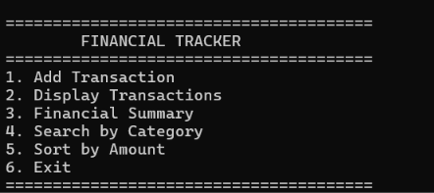
Screenshot 2: Add Transaction
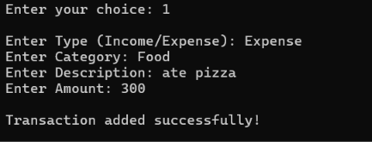
Screenshot 3: Display Transactions
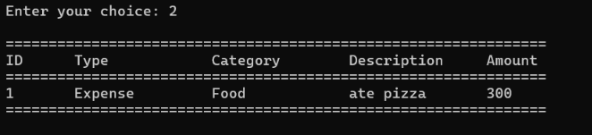
Screenshot 4: Financial Summary
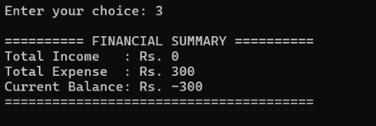

Screenshot 5: Search by Category
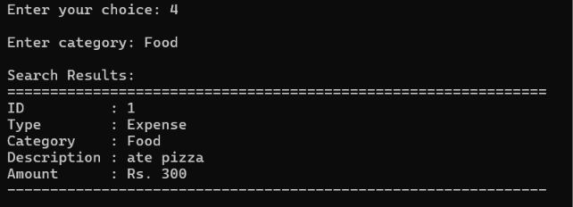
Screenshot 6: Sort by Amount / Exit
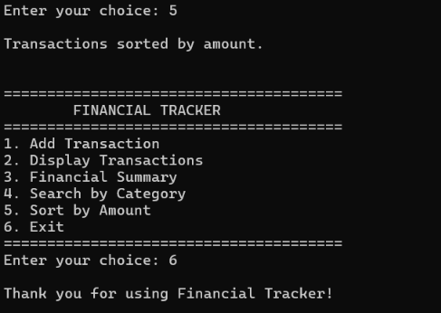

6. Conclusion and Future Scope
The Financial Tracker successfully demonstrates how a basic personal finance record system can be developed using C++. It supports transaction entry, record display, automatic income and expense totals, balance calculation, category-based search, and sorting by amount. The project also provides practical experience with classes, constructors, encapsulation, arrays, loops, and fundamental algorithms.
Possible future enhancements include:
- File handling to save transactions permanently and load them when the program starts.
- Input validation for transaction type, amount, and other fields.
- Support for categories or descriptions containing spaces during search and entry.
- Date-wise and monthly reports, category-wise spending totals, and budget alerts.
- A graphical user interface with charts to visualize income and expenses.
- More flexible storage, such as vectors or a database, instead of a fixed-size array.

7. References
- Bjarne Stroustrup, The C++ Programming Language, Addison-Wesley.
- C++ standard library documentation: https://en.cppreference.com/
- Object-Oriented Programming (C++) course notes and classroom learning materials.

