Question 1 - Write a program to print University name

Answer:

import java.lang.\*;

public class hello{

public static void main(String args[]){

System.out.println("Amity University Madhya Pradesh");

}

}

Output:



Question 2 - Write a program to take input in Java

Answer:

import java.util.\*;

public class Input {

public static void main(String[] args) {

int a,b,c;

Scanner S = new Scanner(System.in);

System.out.print("Enter two numbers : ");

a = S.nextInt();

b = S.nextInt();

c = a+b;

System.out.println("The sum is : " + c);

}

}

Output:

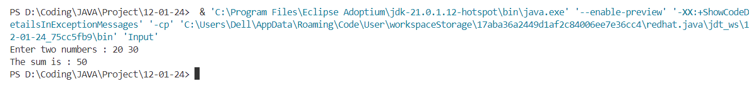

Question 3 - Write a program to calculate simple interest

Answer:

import java.util.\*;

public class Interest{

public static void main(String[] args) {

double p,t,r, i;

Scanner S = new Scanner(System.in);

System.out.print("Enter Principal Amount : ");

p = S.nextDouble();

System.out.print("Enter Rate : ");

r = S.nextDouble();

System.out.print("Enter Time : ");

t = S.nextDouble();

i = (p\*r\*t)/100;

System.out.println("Simple Interest : " + i);

}

}

Output:

Question 4 - Write a program to calculate Area of circle

Answer:

import java.util.Scanner;

public class circle {

public static void main(String[] args) {

double r, a;

Scanner S = new Scanner(System.in);

System.out.print("Enter Radius : ");

r = S.nextDouble();

a = 3.14 \* r \* r;

System.out.println("Area of circle is : " + a);

}

}

Output:

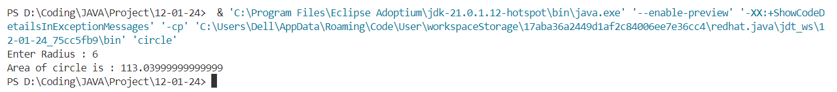

Question 5 - Write a program to calculate Area of Rectangle and Area of Circle

Answer:

import java.util.Scanner;

public class area {

public static void main(String[] args) {

double b, h, w, l, at, ar;

Scanner S = new Scanner(System.in);

System.out.print("Enter base : ");

b = S.nextDouble();

System.out.print("Enter height : ");

h = S.nextDouble()

at = (b\*h)/2;

System.out.println("Area of triangle is : " + at);

System.out.print("Enter length : ");

l = S.nextDouble();

System.out.print("Enter width : ");

w = S.nextDouble();

ar = l\*w;

System.out.println("Area of triangle is : " + ar);

}

}

Output:

Question 6 - Write a program to calculate the Area of circle using function

Answer:

import java.util.Scanner;

class circle2 {

double area(double r){

return 3.14\*r\*r;

}

public static void main(String[] args) {

double r, a;

Scanner S = new Scanner(System.in);

System.out.print("Enter Radius : ");

r = S.nextDouble();

circle2 myCircle = new circle2();

a = myCircle.area(r);

System.out.println("Area of circle is : " + a);

}

}

Output:

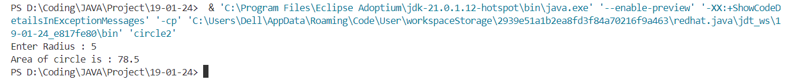

Question 7 - Write a program to calculate Area of a Rectangle using a function

Answer:

import java.util.\*;

class rectangleArea {

double area(double l, double w){

return l\*w;

}

public static void main(String[] args) {

double l,w;

Scanner S = new Scanner(System.in);

System.out.print("Enter Length - > ");

l = S.nextDouble();

System.out.print("Enter Width - > ");

w = S.nextDouble();

rectangleArea rectangle = new rectangleArea();

System.out.println("Area is - > " + rectangle.area(l, w));

}

}

Output:

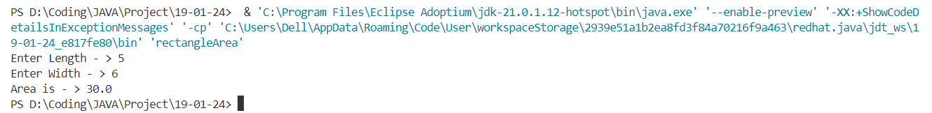

Question 8 - Write a program to calculate simple interest with function

Answer:

import java.util.\*;

class simpleInterest2 {

double calculate(double p, double r, double t){

return (p\*r\*t)/100;

}

public static void main(String[] args) {

double p,r,t;

Scanner S = new Scanner(System.in);

System.out.print("Enter Principal Amount : ");

p = S.nextDouble();

System.out.print("Enter rate (in %): ");

r = S.nextDouble();

System.out.print("Enter Time (in years) : ");

t = S.nextDouble();

simpleInterest2 calculator = new simpleInterest2();

System.out.println("Simple Interest : " + calculator.calculate(p,r,t));

}

}

Output:

Question 9 - Write a program to calculate a Area of a Triangle using a function

Answer:

import java.util.\*;

class triangleArea {

double area(double b, double h){

return (b\*h)/2;

}

public static void main(String[] args) {

double b, h;

Scanner S = new Scanner(System.in);

System.out.print("Enter Base - > ");

b = S.nextDouble();

System.out.print("Enter Height - > ");

h = S.nextDouble();

triangleArea triangle = new triangleArea();

System.out.println("Area is - > " + triangle.area(b, h));

}

}

Output:

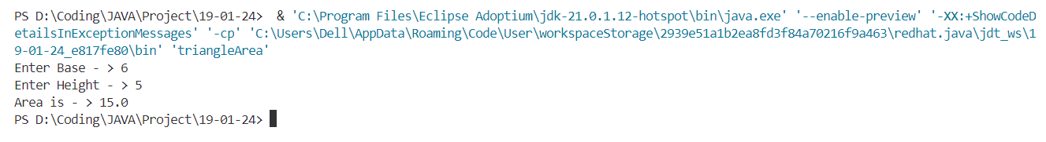

Question 10 - Write a program for this keyword with variable

Answer:

import java.util.\*;

class thisVariable{

int n;

thisVariable(int n){

this.n = n;

}

public static void main(String[] args) {

int x = 10;

thisVariable n = new thisVariable(x);

System.err.println(n.n);

}

}

Output:



Question 11 - Write a program for this keyword with method

Answer:

import java.util.\*;

class thisMethod{

int n;

thisMethod(int n){

this.n = n;

}

void print(){

System.err.println(this.n);

}

public static void main(String[] args) {

int x = 10;

thisMethod n = new thisMethod(x);

n.print();

}

}

Output:



Question 12 - Write a program for this keyword with constructor

Answer:

import java.util.\*;

class thisConstructor{

int n;

thisConstructor(int n){

this.n = n;

System.out.println(this.n);

}

public static void main(String[] args) {

int x = 10;

thisConstructor n = new thisConstructor(x);

}

}

Output:



Question 13 - Write a program for static variable

Answer:

import java.util.\*;

class thisConstructor{

int n;

thisConstructor(int n){

this.n = n;

System.out.println(this.n);

}

public static void main(String[] args) {

int x = 10;

thisConstructor n = new thisConstructor(x);

}

}

Output:

Question 14 - Write a program for static method

Answer:

import java.util.\*;

class staticMethod{

int n;

static void method(){

System.out.println("This is static method");

}

public static void main(String[] args) {

method();

}

}

Output:



Question 15 - Write a program for static block

Answer:

import java.util.\*;

class staticBlock{

    int n;

    static{

        System.out.println("This is static block");

    }

    public static void main(String[] args) {

        System.out.println("This is main block");

    }

}

Output:

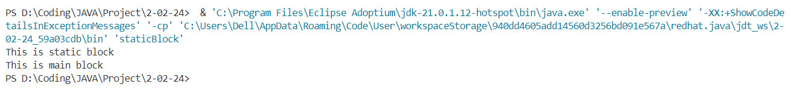

Question 16 - Write a program for instance variable

Answer:

import java.util.\*;

class instanceVariable{

    int n;

    String a;

    instanceVariable(){

        this.n = 5;

        this.a = "Hello Saksham";

    }

    public static void main(String[] args) {

        instanceVariable o = new instanceVariable();

        System.out.println(o.n);

        System.out.println(o.a);

    }

}

Output:

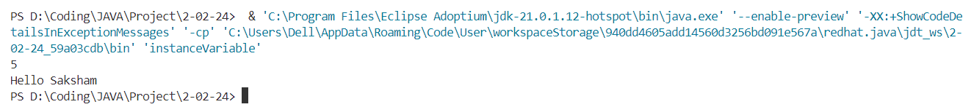

Question 17 - Write a program for local variable

Answer:

import java.util.\*;

class localVariable{

    static void localVariable(){

        String s = "This is a local variable string";

        System.out.println(s);

    }

    public static void main(String[] args) {

        localVariable();

    }

}

Output:



Question 18 - Write a program for implicit and explicit type casting

Answer:

import java.util.\*;

class casting{

public static void main(String[] args) {

// Implicit Casting

System.out.println("Implicit Casting");

int n = 100;

float num = n;

System.out.println("Befor Casting : " + n);

System.out.println("After Casting" + num);

// Explicit Casting

System.out.println("\n\nExplicit Casting");

double numd = 100;

float numf = (float)numd;

System.out.println("Befor Casting : " + numd);

System.out.println("After Casting : " + numf);

}

}

Output:

Question 19 - Write a program to use super.

Answer:

class A{

    int a;

    A(int a){

        this.a = a;

    }

    void display(){

        System.out.println("Value of a: " + a);

    }

}

class B extends A{

    B(int a){

        super(a);

    }

    void display(){

        super.display();

    }

}

class C{

    public static void main(String[] args) {

        B o1 = new B(10);

        o1.display();

    }

}

Output:



Question 20 - Write a program for if....else, if...elseif....else, Nested if....else

Answer:

import java.util.Scanner;

class main{

    public static void main(String[] args) {

        int a;

        Scanner S = new Scanner(System.in);

        System.out.println("Enter Your Age");

        a = S.nextInt();

        if(a < 18){

            System.out.println("You are child");

        }

        else if(a > 18 && a < 50){

            System.out.println("You are adult");

            if(a < 30){

                System.out.println("You are young now");

            }

            else{

                System.out.println("You are getting old");

            }

        }

        else{

            System.out.println("You are od");

        }

    }

}

Output:

Question 21 - Entry Controlled Loop

Answer:

public class p3 {

public static void main(String[] args) {

for(int i = 0; i<10; i++){

System.out.print(i + " ");

}

}

}

Output:

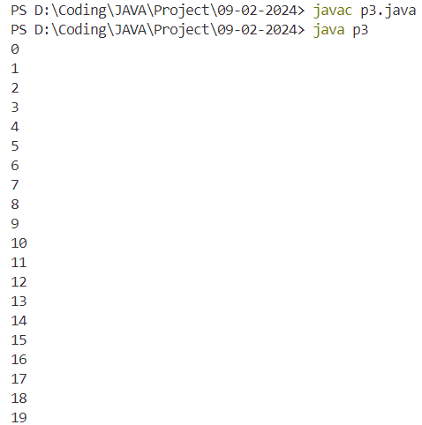

Question 22 - Exit Controlled Loop

Answer:

public class p4 {

    public static void main(String[] args) {

        int i = 10;

        do{

            System.out.print(i);

        }

        while(i<10);

    }

}

Output:

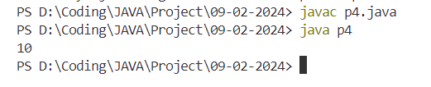

Question 23 - break and continue

Answer:

public class p5 {

    public static void main(String[] args) {

        for(int i = 0; i<10; i++){

            if(i < 3) continue;

            if(i > 8) break;

            System.out.print(i + " ");

        }

    }

}

Output:

Question 24 - Nested Loop

Answer:

public class p6 {

    public static void main(String[] args) {

        /\*

         \* 1

         \* 1 2

         \* 1 2 3

         \* 1 2 3 4

         \*/

        for (int i = 1; i <= 4; i++) {

            for (int j = 1; j <= i; j++) {

                System.out.print(j + " ");

            }

            System.out.println();

        }

        System.out.println();

        /\*

         \* 8

         \* 4 4

         \* 6 6 6

         \* 8 8 8 8

         \*/

        for (int i = 1; i <= 4; i++) {

            for (int j = 1; j <= i; j++) {

                System.out.print(i \* 2 + " ");

            }

            System.out.println();

        }

        System.out.println();

        /\*

         \* 3

         \* 5 5

         \* 7 7 7

         \* 9 9 9 9

         \*/

        for(int i = 1; i<=4; i++){

            for(int j = 1; j<=i; j++){

                System.out.print(i\*2+1 + " ");

            }

            System.out.println();

        }

        System.out.println();

        /\*

         \* 1

         \* 2 2

         \* 3 3 3

         \* 4 4 4 4

         \*/

        for(int i = 1; i<=4; i++){

            for(int j = 1; j<=i; j++){

                System.out.print(i + " ");

            }

            System.out.println();

        }

        System.out.println();

        /\*

                \*

              \* \*

            \* \* \*

          \* \* \* \*

         \*/

        for(int i = 1; i<=4; i++){

            for(int j = 1; j<=4-i; j++){

                System.out.print(" ");

            }

            for(int j = 1; j<=i; j++){

                System.out.print("\* ");

            }

            System.out.println();

        }

        System.out.println();

        /\*

          \*

          \* \*

          \* \* \*

          \* \* \* \*

         \*/

        for(int i = 1; i<=4; i++){

            for(int j = 1; j<=i; j++){

                System.out.print("\* ");

            }

            System.out.println();

        }

    }

}

Output:

Question 25 - Write a program for DataInputStream to calculate the area of circle.

Answer:

import java.io.DataInputStream;

public class p1 {

    public static void main(String[] args) {

           try{

            DataInputStream dis = new DataInputStream(System.in);

            System.out.print("Enter the radius of the circle: ");

            int radius = dis.readInt();

            double area = Math.PI \* radius \* radius;

            System.out.println("The area of the circle is: " + area);

           }catch(Exception e){

               System.out.println("Error: " + e);

           }

    }

}

Output:

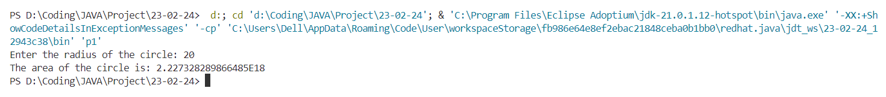

Question 26 - Write a program for class & object

Answer:

public class p2 {

int x;

public void show() {

System.out.println("Hello, World!");

}

public static void main(String[] args) {

p2 O1 = new p2();

O1.x = 10;

O1.show();

}

}

Output:



Question 27 - Write a program for creating object through another object

Box b1 = new Box();

Box b2 = b1;

Answer:

class Box{

    int length, breadth, height;

    Box(){

        length = 10;

        breadth = 20;

        height = 30;

    }

}

class p3{

    public static void main(String[] args) {

        Box b1 = new Box();

        Box b2 = b1;

        System.out.println("b1: " + b1.length + " " + b1.breadth + " " + b1.height);

        System.out.println("b2: " + b2.length + " " + b2.breadth + " " + b2.height);

    }

}

Output:

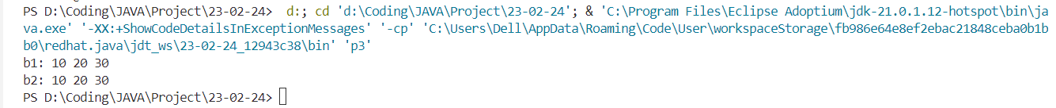

Question 28 - Write a program for default constructor that display the default values.

Answer:

public class p4 {

    int intValue = 0;

    double doubleValue = 0;

    boolean booleanValue = false;

    char charValue = 'A';

    public p4() {

        System.out.println("Default values:");

        System.out.println("int: " + intValue);

        System.out.println("double: " + doubleValue);

        System.out.println("boolean: " + booleanValue);

        System.out.println("char: " + charValue);

    }

    public static void main(String[] args) {

        p4 o1 = new p4();

    }

}

Output:

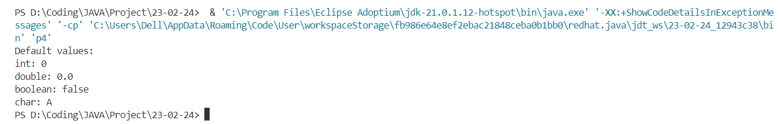

Question 29 - Write a program for parameterized constructor using scanner class.

Answer:

import java.util.Scanner;

public class p5 {

    private String name;

    private int age;

    public p5(String name, int age) {

        this.name = name;

        this.age = age;

    }

    public static void main(String[] args) {

        Scanner scanner = new Scanner(System.in);

        System.out.print("Enter your name: ");

        String name = scanner.nextLine();

        System.out.print("Enter your age: ");

        int age = scanner.nextInt();

        p5 obj = new p5(name, age);

        System.out.println("Name: " + obj.name);

        System.out.println("Age: " + obj.age);

        scanner.close();

    }

}

Output:

Question 30 - Java does not support copy constructor but there are many ways to copy the values so write a program for the same.

• By using constructor.

• By assuming the values of one object to another object.

Answer:

public class p6 {

    private int value;

    // Constructor to initialize the value

    public p6(int value) {

        this.value = value;

    }

    // Copy constructor using constructor

    public p6(p6 obj) {

        this.value = obj.value;

    }

    // Method to copy values by assuming

    public void copyValues(p6 obj) {

        this.value = obj.value;

    }

    public static void main(String[] args) {

        // Creating an object

        p6 obj1 = new p6(10);

        // Copying values using constructor

        p6 obj2 = new p6(obj1);

        // Copying values by assuming

        p6 obj3 = new p6(0);

        obj3.copyValues(obj1);

        // Printing the values

        System.out.println("obj1 value: " + obj1.value);

        System.out.println("obj2 value: " + obj2.value);

        System.out.println("obj3 value: " + obj3.value);

    }

}

Output:

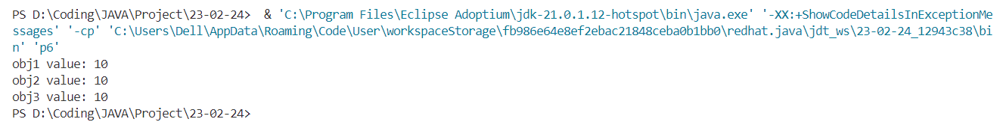

Question 31 -Switch Case.

Answer:

public class p7 {

    public static void main(String[] args) {

        int day = 3;

        String dayName;

        switch (day) {

            case 1:

                dayName = "Monday";

                break;

            case 2:

                dayName = "Tuesday";

                break;

            case 3:

                dayName = "Wednesday";

                break;

            case 4:

                dayName = "Thursday";

                break;

            case 5:

                dayName = "Friday";

                break;

            case 6:

                dayName = "Saturday";

                break;

            case 7:

                dayName = "Sunday";

                break;

            default:

                dayName = "Invalid day";

                break;

        }

        System.out.println("The day is: " + dayName);

    }

}

Output:



Question 32 -Arrays in Java.

Answer:

public class p8 {

    public static void main(String[] args) {

        int[] numbers = { 1, 2, 3, 4, 5 };

        // Accessing elements of the array

        System.out.println("First element: " + numbers[0]);

        System.out.println("Second element: " + numbers[1]);

        System.out.println("Third element: " + numbers[2]);

        // Modifying elements of the array

        numbers[3] = 10;

        System.out.println("Modified fourth element: " + numbers[3]);

        // Length of the array

        System.out.println("Length of the array: " + numbers.length);

    }

}

Output:

