Our idea aims towards finding a solution for the problems uploaded by student. As the student uploads his problem in our program, we use web scraping Technique to get the correct answer for our student.

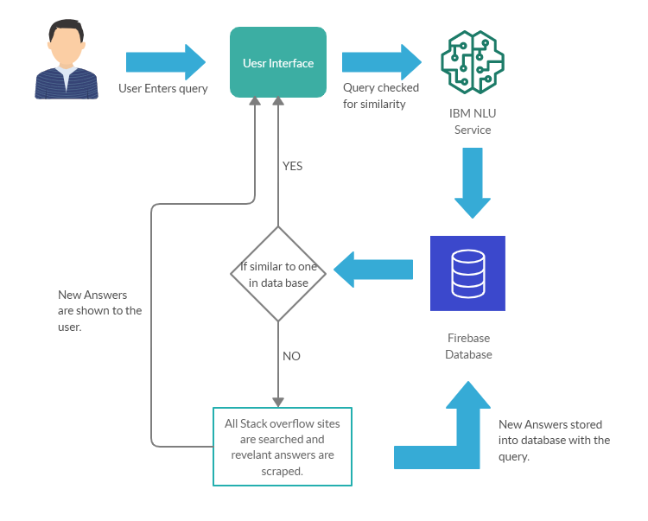

Then the correct answer along with the user is saved in a dataframe and showed to the user. As the NLP algorithm is also used by us which was specified by the IBM.

Team name- Topians