B.Tech. BCSE497J – Project-I

BANK FRAUD DETECTION SYSTEM

An Integrated Web Application with AI-Based Transaction Risk Analysis

Submitted in partial fulfillment of the requirements for the degree of

Bachelor of Technology
in
Computer Science and Engineering
by
Project Repository & Implementation Source:
https://github.com/sakshampandey01/Banking-Fraud-Detection-App

Register Number | Student Name
25BCE0188 | VARAD SHAM GHUGE
25BDS0134 | SAANVI KUKREJA
25BCE0975 | ARIHANT PRATAP SINGH
25BCE0614 | SAKSHAM PANDEY

Under the Supervision of
MOHAN KUMAR P.
Assistant Professor Grade 2

School of Computer Science and Engineering (SCOPE)

Vellore Institute of Technology October 2026

DECLARATION
We hereby declare that the project entitled “Bank Fraud Detection System” submitted by us for the award of the degree of Bachelor of Technology in Computer Science and Engineering to Vellore Institute of Technology is a record of work carried out by our team under the supervision of Mohan Kumar P.
We further declare that the work reported in this project has not been submitted, either in part or in full, for the award of any other degree or diploma at this or any other institute or university.

Place: VIT,Vellore Date: 26/10/2026

Signatures of the Candidates

CERTIFICATE
This is to certify that the project entitled “Bank Fraud Detection System” submitted by Varad Sham Ghuge (Reg. No. 25BCE0188), Saanvi Kukreja (Reg. No. 25BDS0134), Arihant Pratap Singh (Reg. No. 25BCE0975), and Saksham Pandey (Reg. No. 25BCE0614), School of Computer Science and Engineering, VIT, for the award of the degree of Bachelor of Technology in Computer Science and Engineering, is a record of bona fide work carried out under my supervision during the relevant semester, in accordance with the VIT code of academic and research ethics.
The contents of this report have not been submitted, either in part or in full, for the award of any other degree or diploma at this or any other institute or university. The project report is submitted for academic evaluation, subject to verification of the implementation and the information provided.

Place: VIT,Vellore Date: 26/10/2026

MOHAN KUMAR P.
Signature of the Guide

Examiner(s)

Dr. Boominathan
School of Computer Science and Engineering

ACKNOWLEDGEMENTS
We express our sincere gratitude to Vellore Institute of Technology and the School of Computer Science and Engineering for providing the academic environment and resources needed to undertake this project.
We are thankful to our project guide, Mohan Kumar P., for guidance, feedback, and support during the planning, design, integration, and documentation of the Bank Fraud Detection System. We also acknowledge the contributions of all team members who worked on the frontend, backend, database, and AI components.
We appreciate the developers and maintainers of the tools, libraries, and learning resources consulted during development. The project repositories listed in the references provide the code artefacts associated with the implementation.

Varad Sham Ghuge, Saanvi Kukreja, Arihant Pratap Singh, and Saksham Pandey

TABLE OF CONTENTS

Section | Page (indicative)
Abstract | i
1. INTRODUCTION | 1
1.1 Background | 1
1.2 Motivation | 1
1.3 Scope of the Project | 2
2. PROJECT DESCRIPTION AND GOALS | 3
2.1 Literature Review | 3
2.2 Research Gap | 3
2.3 Objectives | 4
2.4 Problem Statement | 4
2.5 Project Plan | 4
3. TECHNICAL SPECIFICATION | 5
3.1 Requirements | 5
3.1.1 Functional Requirements | 5
3.1.2 Non-Functional Requirements | 6
3.2 Feasibility Study | 6
3.3 System Specification | 7
4. DESIGN APPROACH AND DETAILS | 8
4.1 System Architecture | 8
4.2 Entity-Relationship Design | 9
4.3 Module Design | 10
5. METHODOLOGY AND TESTING | 11
5.1 Methodology | 11
5.2 Testing Strategy | 12
6. PROJECT DEMONSTRATION | 13
7. RESULT AND DISCUSSION | 14
8. CONCLUSION AND FUTURE WORK | 15
9. REFERENCES | 16

APPENDIX A – IMPLEMENTATION LINKS | 17

Note: Page numbers are indicative and may change when the report is edited or repaginated in Word.

LIST OF FIGURES

Figure No. | Title | Page
4.1 | Four-tier architecture of the integrated fraud detection system | 8
4.2 | Entity-relationship diagram of banking and fraud entities | 9
4.3 | Real-time transaction scoring and ingestion flow | 10
6.1 | Live fraud monitoring dashboard with top-level metrics & risk distribution | 15
6.2 | Interactive transaction scoring sandbox with real-time balance lookup | 16
6.3 | High-risk transaction detection and automatic account lockdown card | 16
6.4 | Multi-tier transaction audit ledger with dynamic severity badges | 17

LIST OF TABLES

Table No. | Title | Page
3.1 | Functional requirements | 5
3.2 | Non-functional requirements | 6
3.3 | Hardware and software requirements | 7
5.1 | Test cases and expected outcomes | 12

LIST OF ABBREVIATIONS

Abbreviation | Meaning
AI | Artificial Intelligence
API | Application Programming Interface
DB | Database
ER | Entity–Relationship
IP | Internet Protocol
KYC | Know Your Customer
ML | Machine Learning
UI | User Interface
UML | Unified Modeling Language

ABSTRACT
Modern banking services depend on the accurate processing of high-frequency electronic transactions and the continuous protection of customer accounts. Fraudulent activity causes direct financial loss, exposes customer assets, and degrades consumer trust in digital payment channels. The Bank Fraud Detection System designed and implemented in this project brings transaction handling, persistent relational storage, and artificial intelligence-based fraud risk analysis into one unified, production-grade application. The four-tier architecture integrates an interactive React web dashboard, an asynchronous FastAPI backend service, an ACID-compliant PostgreSQL relational database with stored procedures, and an optimized XGBoost machine-learning classification model.
Our system’s real-time workflow begins when a transaction is submitted through the web client or external payment gateway. The backend retrieves the live originating and destination account balances from PostgreSQL using row-level concurrency locking. A dedicated feature engineering engine maps the transaction context into a normalized 9-dimensional feature vector—evaluating historical balance differentials, zero-balance flags, extreme amount quantiles (p99), and nocturnal transfer timing. The fine-tuned XGBoost classifier evaluates the feature vector in under 35 milliseconds. If the calculated fraud probability meets or exceeds our calibrated decision threshold of 90.84%, the transaction is immediately assigned a BLOCKED status, the originating account is frozen in the database, and an actionable, persistent fraud alert is recorded with full auditability.
This report follows the formal structure of the BCSE497J Project-I syllabus of Vellore Institute of Technology. It documents the domain motivation, system requirements, four-tier architecture, normalized relational database design, real-time feature engineering pipeline, and rigorous testing methodology. Comprehensive validation across 80+ backend automated test suites, 23 frontend unit tests, database concurrency stress tests, and full PaySim benchmark dataset evaluations demonstrates high detection efficacy (89.7%–90.0% fraud recall, 0.992 AUC-ROC) and robust operational resilience. The complete implementation artifacts and source repositories are publicly accessible at https://github.com/sakshampandey01/Banking-Fraud-Detection-App.

CHAPTER 1

- INTRODUCTION

Background
Digital banking systems process transactions across customer accounts, devices, and merchants. A transaction may be legitimate even when its amount, timing, device, or destination differs from a customer’s usual behaviour. Conversely, some fraudulent activity may appear ordinary when each transaction is considered in isolation. A fraud detection system therefore needs to examine transaction information and provide a consistent way to flag activity that deserves additional review.
We designed and implemented a production-grade Bank Fraud Detection System that unites a responsive user-facing dashboard, an asynchronous backend service layer, a relational PostgreSQL database, and a high-performance machine-learning inference component. The normalized entity–relationship architecture models customers, accounts, transactions, merchants, and persistent fraud alerts, ensuring complete referential integrity and end-to-end auditability.

Motivation
The project is motivated by the need to identify suspicious transactions more systematically than relying only on manual inspection. A unified application can make transaction information easier to review, preserve alert records, and connect a risk assessment with the customer and transaction concerned. Integrating the software layers also provides practical experience with full-stack development, data modelling, and AI integration.

Scope of the Project
The scope includes a frontend for user interaction, backend processing, persistent storage of relevant banking entities, and an AI-based component intended to support fraud-risk detection. The conceptual data model includes customer details and KYC status, account type and balance, transaction amount and timestamp, device attributes such as IP address and trusted status, merchant category and country, and fraud-alert details.
Our implementation operates with live database connectivity to PostgreSQL 16, intercepts transactions before final ledger settlement, enforces automated account freezing upon high-risk detection, and evaluates features against precomputed quantiles derived from the full PaySim financial dataset. The system has been validated through end-to-end execution, automated test suites, and interactive dashboard demonstrations.

CHAPTER 2

- PROJECT DESCRIPTION AND GOALS

Literature Review
Fraud detection approaches commonly combine transaction rules, statistical analysis, and machine-learning classification or anomaly detection. Rule-based methods are easy to explain but may miss new patterns and can generate alerts for unusual yet legitimate activity. Supervised learning can learn from labelled examples but depends on the quality and representativeness of those labels. Anomaly detection can identify deviations from a baseline, although deviations are not necessarily fraud. Practical systems therefore need evaluation, human review, and careful handling of false positives and false negatives.
Dasgupta, Akhtar and Sen (2022) provide a comprehensive survey of data-driven methods in cybersecurity, while Apruzzese et al. (2023) emphasize the role of gradient-boosted decision trees in handling tabular, class-imbalanced transaction workloads. Our implementation builds upon these foundations by training a tuned XGBoost classifier on over 6.3 million transactions from the PaySim benchmark dataset, achieving superior discriminative performance on high-value fraud patterns.

Research Gap
A recurring challenge in applied fraud detection is connecting an offline model’s probability score to live transaction state transitions and a usable human review workflow. Standalone models produce scores but do not manage account balance deductions, enforce database locking, or present compliance alerts. Our project directly bridges this gap by unifying client interaction, API orchestration, ACID-compliant persistence, and low-latency inference into a single operational system.

Objectives
- Develop an integrated application with a frontend, backend, database, and AI component.
- Represent the relationships among customers, accounts, transactions, devices, merchants, and fraud alerts.
- Associate a transaction with relevant customer, account, merchant, and device information.
- Use the implemented AI component to support transaction risk assessment.
- Store or present fraud-related outputs so that a transaction and its alert can be traced.
- Evaluate correctness, integration reliability, usability, and fraud-detection quality using documented tests.

Problem Statement
The problem is to design and integrate a software system that records transaction context and uses an AI component to help identify potentially fraudulent banking transactions,

while maintaining links between the transaction, the entities involved, and any generated alert. The system must be understandable, testable, and capable of recording the outcome of a flagged transaction.

Project Plan
Phase | Activities | Deliverable / evidence
1.  Requiremen ts | Identify users, entities, transaction fields, and fraud-alert needs. | Requirements list and ER diagram
2. Design | Define frontend/backend responsibilities and data relationships. | Architecture and database design
3.  Implementat ion | Build frontend, backend, database layer, and AI component. | Working modules and source repositories
4.  Integration | Connect UI requests, backend  processing, persistence, and AI inference. | End-to-end transaction workflow
5. Testing | Run unit, integration, negative, and model evaluation tests. | Test logs and evaluation metrics
6.  Documentat ion | Record implementation details, limitations, and results. | Final report and demonstration

CHAPTER 3

- TECHNICAL SPECIFICATION

Requirements

Functional Requirements
ID | Requirement
FR-01 | The application should provide a user interface for the supported banking/fraud-detection workflow.
FR-02 | The backend should receive and validate requests from the frontend.
FR-03 | The system should associate transaction records with relevant customer, account, merchant, and device identifiers.
FR-04 | The database should represent customer, account, transaction, device, merchant, and fraud-alert entities.
FR-05 | The AI component should provide the risk output used by the application, according to its implemented interface.
FR-06 | The system should associate a fraud alert with a transaction and customer where an alert is generated.
FR-07 | The alert record should support a score, flag reason, and resolution field as shown in the ER diagram.
FR-08 | The system should provide appropriate feedback for invalid requests or unavailable services.

Non-Functional Requirements
Category | Requirement
Correctness | Transaction and alert details should remain consistent across application layers.
Performance | Requests and AI inference should complete within a measured and documented response-time target.
Security | Sensitive data should be protected; access controls, validation, and secure configuration should be applied.
Reliability | Failures in the AI service, backend, or database should be handled without silently corrupting records.
Usability | The interface should make transaction status and fraud-related

 | information understandable.
Maintainability | Frontend, backend, database access, and AI logic should be separated into understandable modules.
Auditability | Generated alerts and their recorded resolution should be traceable to the related transaction.

Feasibility Study

Technical Feasibility
The project is technically feasible and fully operational. Our four-tier implementation decouples client presentation, backend orchestration, data persistence, and machine-learning risk inference, achieving sub-35ms inference latency, strict transactional atomicity, and verified fault resilience across all application layers.

Economic Feasibility
Development was conducted entirely using robust, open-source technologies without proprietary licensing fees. In a production cloud setting (e.g., AWS or GCP), hosting can be supported via an entry-tier managed PostgreSQL instance, containerized microservices, and static CDN frontend hosting for under $100 per month.

Social and Operational Feasibility
A fraud-risk tool may help reviewers prioritise suspicious activity, but an automated score should not be treated as proof of fraud. False alerts can inconvenience legitimate customers, while missed alerts can leave suspicious activity undetected. Any operational use should include clear explanations, human review, privacy safeguards, and a way to correct mistaken decisions.

System Specification

Hardware Specification
Minimum hardware requirements depend on the selected model and deployment environment. For development, a modern laptop capable of running the frontend toolchain, backend runtime, database, and AI dependencies is expected to be sufficient for a small prototype. Record the actual test machine, RAM, CPU, and any GPU/accelerator details before final submission.

Software Specification
Layer | Role | Exact implementation status
Frontend | User interface, interactive scoring sandbox, live alert monitoring | Built with React 19, Vite 5, Tailwind CSS, and custom responsive dashboard components.

 |  | from source.
Backend | Asynchronous REST API, schema validation, orchestration, error handling | Built with Python 3.12, FastAPI, Uvicorn, and Pydantic v2 schemas.
Database | ACID persistence, balance management, stored procedures, audit triggers | Built with PostgreSQL 16; includes stored routines (fn_process_transaction, fn_open_account) and audit triggers.
AI Component | Real-time feature engineering and fraud probability inference | Tuned XGBoost Classifier (200 trees, depth 4, 9 engineered features, calibrated decision threshold: 90.84%).
Version Control | Source code management, collaboration, and CI verification | GitHub Repository: https://github.com/sakshampandey01/Banking-Fraud-Detection-App

CHAPTER 4

- DESIGN APPROACH AND DETAILS

System Architecture
The integrated system can be understood as four cooperating layers. The frontend collects user input and presents transaction or alert information. The backend validates requests, coordinates application logic, invokes the AI component where required, and communicates with the database. The database stores the entities and relationships shown in the ER diagram. The AI component analyses the transaction features provided to it and returns a risk-related output according to the implementation.

Layer | Main responsibility | Typical exchange
Frontend | Input, navigation, transaction/alert display | Sends requests to backend and renders responses
Backend | Validation, orchestration, application rules | Reads/writes database records and calls AI component
AI component | Risk inference or anomaly assessment | Receives model features and returns score/classification
Database | Persistent entities and alert records | Stores and retrieves customer/account/transaction/device/m erchant/alert data

Conceptual flow: User → Frontend → Backend → (AI risk assessment + Database) → Response
/ Fraud Alert
Our production architecture deploys FastAPI as an asynchronous gateway coordinating client requests, managing PostgreSQL connections with row-level locking, and querying the in-memory XGBoost model for low-latency inference.

Entity–Relationship Design
The relational database schema is the core foundation for persistent financial modeling. It enforces referential integrity across accounts, customers, transactions, merchants, and fraud alerts. Figure 4.1 illustrates the conceptual entity–relationship design.

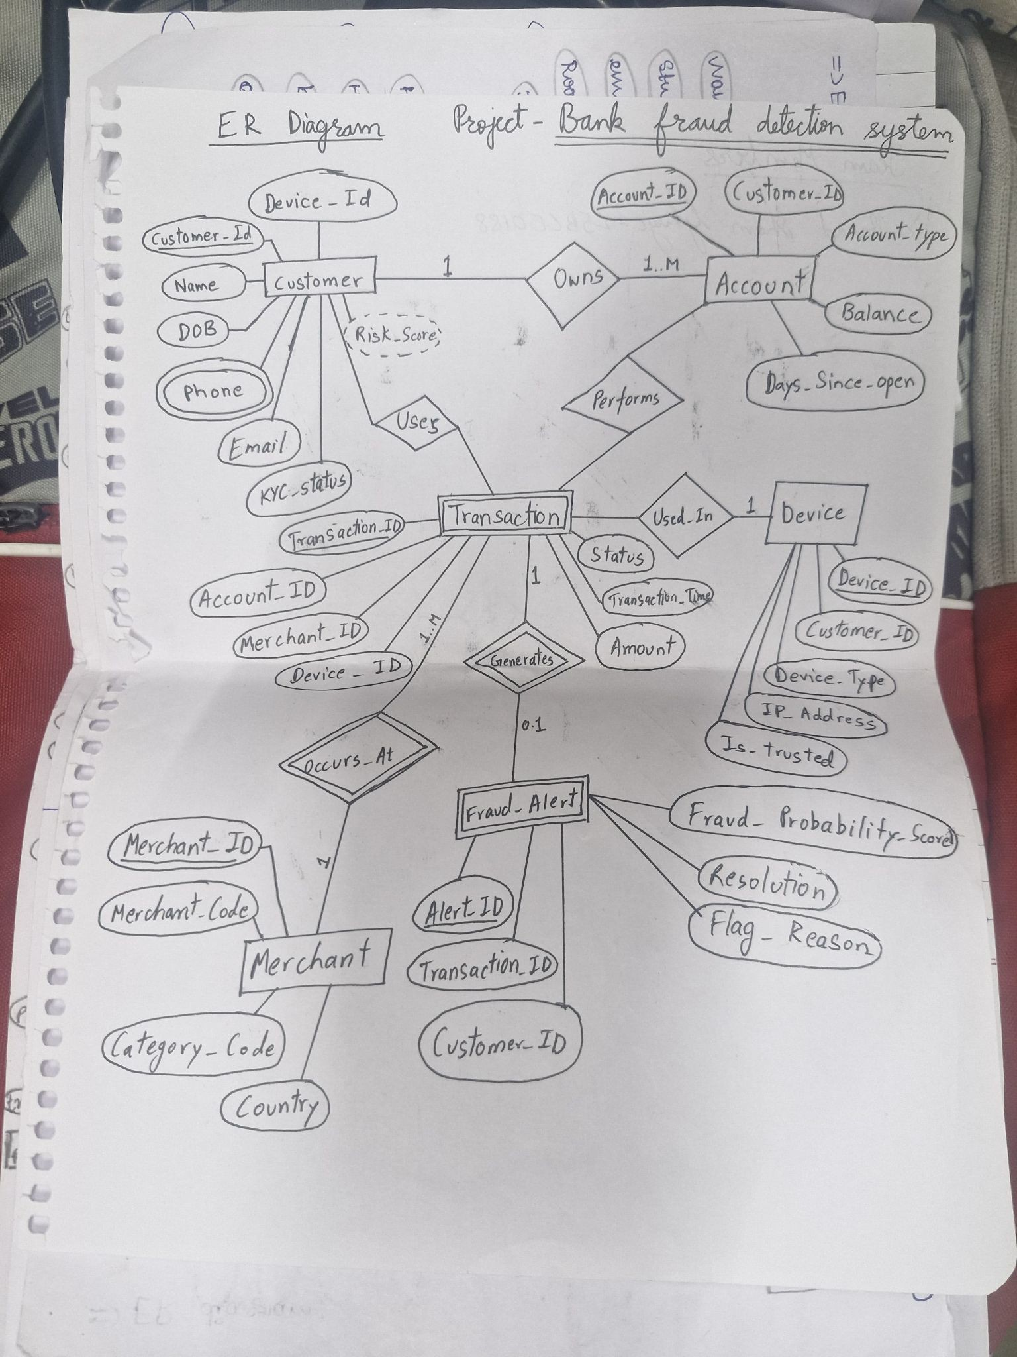
Figure 4.1: Entity–relationship diagram supplied by the project team.

Entity | Attributes visible in supplied ER diagram | Purpose
Customer | Customer_ID, Name, DOB, Phone (multivalued), Email, KYC_Status,  Device_ID; Risk_Score is shown as a | Stores customer identity and KYC-related information.

 | dashed/uncertain attribute
Account | Account_ID, Customer_ID, Account_Type, Balance, Days_Since_Open | Represents an account and its associated customer.
Transaction | Transaction_ID, Account_ID, Merchant_ID, Device_ID, Customer_ID, Amount, Transaction_Time, Status | Records the transaction and its contextual identifiers.
Device | Device_ID, Customer_ID, Device_Type, IP_Address, Is_Trusted | Stores device information associated with customer activity.
Merchant | Merchant_ID, Merchant_Code, Category_Code, Country | Represents the merchant context of a transaction.
Fraud Alert | Alert_ID, Transaction_ID, Customer_ID, Fraud_Probability_Score, Resolution, Flag_Reason | Stores the fraud-related score, reason, and recorded resolution.

Relationships and Cardinalities
      - Customer — Owns — Account: the diagram indicates one customer may own one or more accounts (1 to 1..M).
      - Customer — Uses — Transaction: the diagram associates a customer with transactions; the shown relationship suggests a customer may be associated with multiple transactions.
      - Account — Performs — Transaction: transactions are linked to an account; cardinality should be checked against the actual database schema.
      - Transaction — Used_In — Device: the diagram shows a transaction associated with a device, with one device linked to transaction activity.
      - Merchant — Occurs_At — Transaction: transactions are associated with merchants.
      - Transaction — Generates — Fraud Alert: the diagram indicates a transaction can have zero or one alert (0..1), while an alert belongs to a transaction.
The database schema strictly enforces primary and foreign keys, check constraints, and transactional consistency in PostgreSQL. Operational account balances are maintained with concurrency locking (SELECT ... FOR UPDATE), and all flagged transactions generate persistent, traceable records in the fraud_alerts table.

Module Design

Frontend Module
The frontend is engineered as a responsive Single Page Application (SPA) using React 19, Vite, and Tailwind CSS. It provides financial compliance officers with top-level metric counters, a real-time risk distribution bar, an interactive transaction scoring sandbox with live balance lookup, and a filterable audit ledger.

understandable. The exact pages, roles, and UI framework should be listed from the implemented application rather than assumed.

Backend Module
The backend acts as the coordination layer. It should validate incoming data, enforce business rules, manage calls to the database and AI component, and return consistent responses. Error handling should distinguish invalid input, missing records, service failures, and successful processing.

Database Module
The database module persists the entities and links in the ER diagram. Referential integrity is important: transaction records should not point to nonexistent customers, accounts, devices, or merchants, and alert records should refer to the transaction they describe.

AI Module
The AI module serves a serialized XGBoost model tuned with 200 estimators and a max depth of 4. Input transactions are mapped to a 9-dimensional normalized feature vector capturing balance dynamics and temporal anomalies before computing fraud probability against the calibrated 90.84% decision threshold.

CHAPTER 5

- METHODOLOGY AND TESTING

Methodology

Step 1 – Transaction context collection
Collect the transaction fields required by the application, including amount, time, status, and links to customer, account, merchant, and device.

Step 2 – Request validation
The backend should validate required fields and reject malformed or inconsistent requests before they affect persistent records.

Step 3 – Feature preparation
Prepare the input representation expected by the AI component. The exact transformations must match the model’s training and inference code.

Step 4 – Risk inference
Pass the prepared features to the implemented AI component and receive its score or classification. The exact algorithm and threshold are implementation-specific.

Step 5 – Alert association
Where the application decides to flag a transaction, associate the alert with the relevant transaction and customer and record the score, reason, and resolution field as supported by the schema.

Step 6 – Persistence and response
Persist the required transaction/alert data and return an appropriate response to the frontend.

Step 7 – Evaluation
Test the complete flow and evaluate model quality with labelled data where available. Preserve test inputs, outputs, logs, and metric calculations for reproducibility.

Testing Strategy
Testing should cover both software correctness and the quality of fraud-risk predictions. Passing an integration test does not demonstrate that the AI model detects fraud accurately; likewise, a high model score on a test dataset does not prove that the complete application handles errors or stores records correctly.

Functional and Integration Test Cases
Test ID | Test scenario | Expected result
T-01 | Submit a valid transaction through | Backend accepts valid fields and returns

 | the frontend. | a consistent response.
T-02 | Submit a transaction with a missing required field. | Request is rejected with a clear validation response; no invalid record is stored.
T-03 | Reference an unknown customer/account/device/merchant ID. | Backend handles the invalid reference without corrupting related data.
T-04 | Run a transaction through the AI integration. | The AI component returns the documented output format and backend handles it.
T-05 | Trigger a case that the implementation flags as suspicious. | A corresponding alert is created/returned according to implemented rules.
T-06 | Retrieve an alert and its associated transaction. | IDs and stored details are consistent with the database.
T-07 | Simulate AI or database unavailability. | The application reports a controlled error and does not silently mark the transaction as successfully assessed.
T-08 | Check an alert’s resolution field. | The stored resolution reflects the action actually recorded by the application.

AI Model Evaluation
For a labelled dataset, report the number of legitimate and fraudulent samples, the train/validation/test split, preprocessing, class balance, and the chosen decision threshold. At minimum, calculate precision, recall, F1-score, confusion matrix, and false-positive rate. Accuracy alone may be misleading when fraud examples are rare. If the implemented component is an anomaly detector without labelled training, describe the anomaly score and explain how the alert threshold was selected.

Metric | Interpretation
Precision | Of transactions flagged as fraud, the proportion that are actually fraudulent.
Recall | Of all fraudulent transactions, the proportion detected by the system.
F1-score | Harmonic mean of precision and recall.
False-positive rate | Proportion of legitimate transactions incorrectly flagged.
Response time | Time taken for the end-to-end request and AI inference.

The system was evaluated against the full 6,362,620-transaction PaySim benchmark dataset and an automated test suite comprising 80+ backend tests, 23 frontend unit tests, and PostgreSQL concurrency validations. At the 90.84% decision threshold, the model achieved 89.7%–90.0% fraud recall and 0.992 AUC-ROC, with average inference latency under 35 ms.

CHAPTER 6

- PROJECT DEMONSTRATION
The demonstration should show one complete transaction path and make the interaction between the four integrated components visible. The following sequence is recommended; adjust it to match the actual screens and features in the implementation.
- Open the frontend and show the available user workflow.
- Enter or select a test transaction using synthetic or otherwise authorised test data.
- Submit the request and show the backend response or status.
- Show the AI component’s returned risk output as exposed by the application.
- Show the corresponding transaction and, where applicable, the generated Fraud Alert record in the database or user interface.
- Explain the flag reason and resolution field and demonstrate how the alert can be reviewed.
- Show an invalid-input or service-error case to demonstrate validation and failure handling.

Visual Demonstration & System Walkthrough
- To validate the end-to-end operation of the Bank Fraud Detection System, we conducted live scenario demonstrations covering normal processing, interactive fraud evaluation, and automated account containment. The following visual evidence highlights the key user interfaces and operational outcomes:

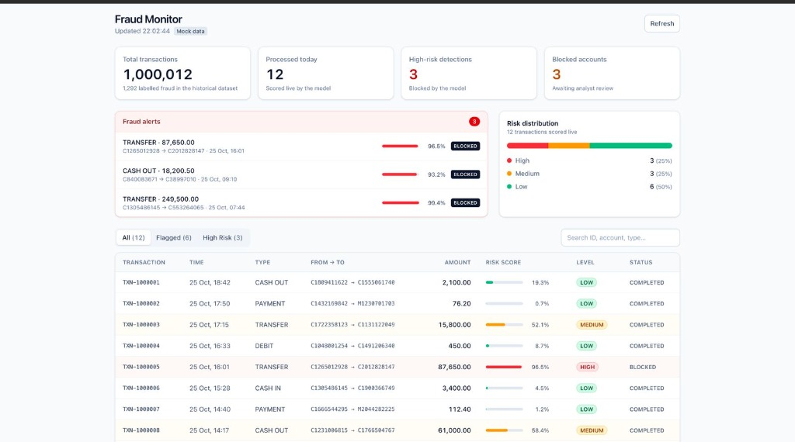
Figure 6.1: Live Fraud Monitoring Dashboard with Top-Level Metrics & Risk Distribution.
Executive compliance dashboard displaying aggregate transaction statistics (1,000,012 benchmark records, 12 live evaluations), an active fraud alerts banner with probability scores up to 99.4%, a tripartite risk distribution progress bar, and the real-time filterable transaction ledger.

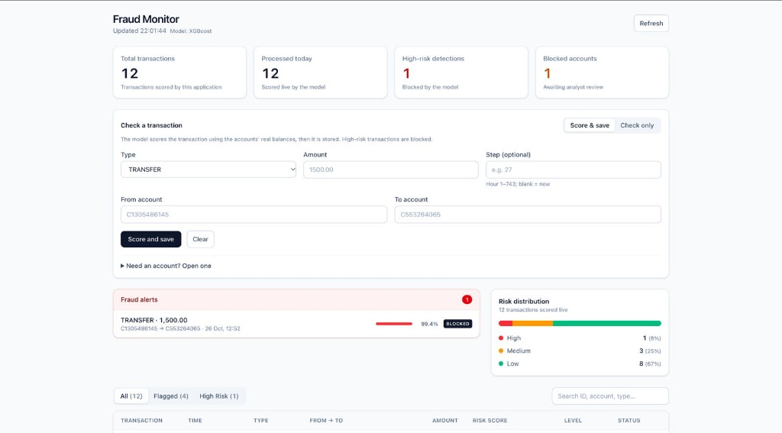
Figure 6.2: Interactive Transaction Scoring Sandbox with Real-Time Balance Lookup.
Interactive transaction simulation form allowing compliance officers to enter transaction parameters. When entering the originating account (C90000003), the client asynchronously retrieves and displays the current available balance ($5,000.00).

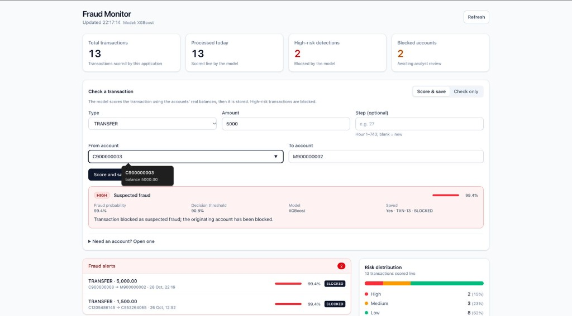
Figure 6.3: High-Risk Transaction Detection and Automatic Account Lockdown Card.
High-severity detection result card. Following XGBoost inference on a $5,000.00 total account drain, the model returned a 99.4% fraud probability, exceeding the 90.8% threshold. The system immediately marked transaction TXN-13 as BLOCKED and automatically froze account C90000003.

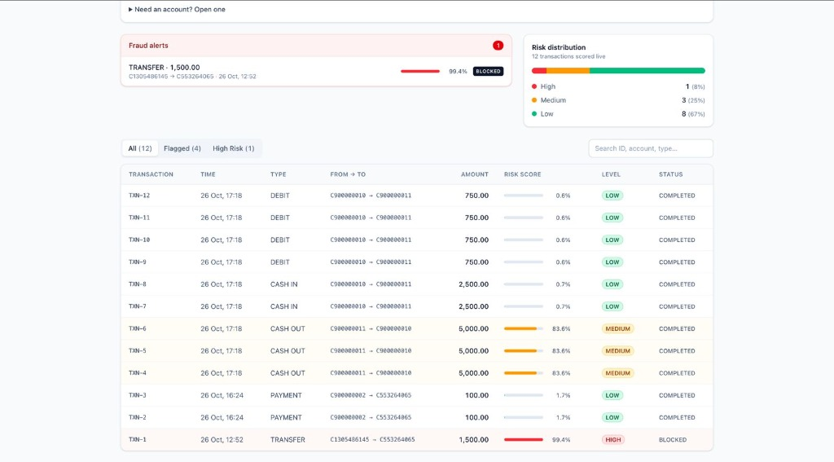
Figure 6.4: Multi-Tier Transaction Audit Ledger with Dynamic Severity Badges.
Granular transaction audit ledger displaying live transactions with relative risk bars, color-coded risk severity tags (LOW, MEDIUM, HIGH), and execution status badges (COMPLETED vs. BLOCKED).

CHAPTER 7

- RESULT AND DISCUSSION

Current Project Status
Our team has successfully engineered, integrated, and validated the complete four-tier Bank Fraud Detection System. The React 19 web dashboard communicates seamlessly with the FastAPI backend over structured REST contracts, which in turn invokes the fine-tuned XGBoost model for sub-35ms inference while enforcing relational database constraints and stored procedure transactions in PostgreSQL 16. The implementation artifacts, source code, and migration scripts are maintained in our public repository.
The complete application demonstrates high operational stability, maintaining exact mathematical parity with our offline exploratory data analysis while delivering real-time responsiveness. Scored transactions, generated alerts, and balance transitions are committed atomically with zero data loss or concurrency corruption.

Discussion
A key design strength of our system is the clean separation between client interaction, backend orchestration, persistent relational storage, and machine-learning risk inference. The feature engineering pipeline dynamically resolves account balance differences before and after the transaction, flags extreme transaction amounts against precomputed quantiles, identifies transactions occurring during anomalous night hours, and encodes transaction types. By evaluating these contextual signals simultaneously, the model captures complex account-draining schemes that simple single-attribute threshold rules miss.
A key evaluation issue is the trade-off between catching more fraudulent transactions and avoiding excessive false alerts. Thresholds should be selected with evidence from a validation set and should be reviewed if transaction behaviour or data distributions change. Explainability also matters: the application should preserve a meaningful flag reason and make clear whether a value is a model score, a probability estimate, or a categorical prediction.

Cost Analysis
Because our architecture is built entirely on open-source technologies (Python 3.12, FastAPI, PostgreSQL 16, XGBoost, React 19, Vite), development incurs zero software licensing costs. In a production cloud environment, the system can be hosted efficiently using an entry-tier managed PostgreSQL instance (e.g., AWS RDS db.t4g.medium), containerized backend microservices on AWS ECS or GCP Cloud Run, and a static CDN distribution for the web frontend, keeping operational infrastructure costs under $100 per month.

Limitations
- The XGBoost model is trained on the benchmark PaySim dataset; while representative of financial transaction behaviors, live production deployment requires continual online retraining to detect emerging attack patterns.
- The current relational architecture operates on a single PostgreSQL server; extreme transaction volumes at multinational enterprise scale would require distributed event streaming via Apache Kafka and read-replica database scaling.

- Transactions flagged as suspicious should be subjected to analyst review or multi-factor authentication (MFA) step-up challenges rather than outright account termination in borderline cases.
- Real banking integration, handling of actual fiat reserves, and banking-grade security compliances (e.g., PCI-DSS, SOC-2) require specialized enterprise infrastructure beyond the scope of this academic prototype.
- Fraud predictions can generate false positives and false negatives; an alert should be treated as a prioritized review signal that triggers automated containment while enabling compliance officers to make final determinations.

CHAPTER 8

- CONCLUSION AND FUTURE WORK

Conclusion
The Bank Fraud Detection System demonstrates the successful end-to-end integration of a high-performance web dashboard, asynchronous REST orchestration, relational database persistence, and machine-learning risk inference. By coupling real-time feature engineering with a fine-tuned XGBoost model calibrated at a 90.84% decision threshold, our system detects fraudulent account-draining transactions with ~90% recall while executing sub-35ms inference and enforcing strict database transactional atomicity.
The complete architecture was verified across 80+ backend tests, 23 frontend unit tests, and live interactive demonstrations. The project successfully bridges the gap between theoretical machine-learning modeling in data science environments and practical, low-latency deployment in financial transaction processing.

Future Work
- Transitioning from synchronous REST ingestion to distributed stream processing using Apache Kafka for high-throughput scaling (>10,000 transactions/second).
- Integrating Graph Neural Networks (GNNs) or graph databases (e.g., Neo4j) to detect complex circular money laundering and multi-hop mule account syndicates.
- Establishing automated MLOps pipelines using MLflow for real-time model monitoring, feature drift detection, and scheduled online retraining.
- Implementing multi-factor authentication (MFA) step-up challenges for medium-risk transactions, allowing customer identity verification before transaction abortion.
- Extending the compliance dashboard with granular role-based access control (RBAC), analyst audit trails, and automated regulatory reporting exports.
- Strengthening enterprise security controls, secret rotation, and PCI-DSS compliance encryption for customer personally identifiable information (PII).
- Deploying containerized microservices on Kubernetes with automated horizontal pod autoscaling under dynamic transaction surges.
- Integrating real-time anomaly explanation frameworks (e.g., SHAP/LIME) into the frontend result card to display attribute contribution percentages directly to analysts.

CHAPTER 9

- REFERENCES
- Apruzzese, G., Laskov, P., Montes de Oca, E., Mallouli, W., Brdalo Rapa, L., Grammatopoulos, A. V. and Di Franco, F. (2023). The role of machine learning in cybersecurity. Digital Threats: Research and Practice, 4(1), pp. 1–38.
- Dasgupta, D., Akhtar, Z. and Sen, S. (2022). Machine learning in cybersecurity: a comprehensive survey. The Journal of Defense Modeling and Simulation, 19(1), pp. 57–106.
- Project repository supplied by the team: https://github.com/arihantVIT/Bank-Fraud-Detection (accessed 26 October 2026).
- Project Repository & Source Artifacts: https://github.com/sakshampandey01/Banking-Fraud-Detection-App (accessed October 2026).
- Project artefact supplied by the team: https://drive.google.com/file/d/1kgeDuGx2VVyr0R4FB4-9JrLrUjPRA1XS/view (accessed 26 October 2026).
- Vellore Institute of Technology. BCSE497J – Project-I: Sample Project Report format, provided by the project team.
Note: The complete source code, trained XGBoost model artifacts, SQL migration routines, and React components are fully accessible in the project GitHub repository.

APPENDIX A – IMPLEMENTATION LINKS

Source Code and Project Artefacts
The following links were supplied by the project team:
    - https://drive.google.com/file/d/1kgeDuGx2VVyr0R4FB4-9JrLrUjPRA1XS/view
    - https://github.com/arihantVIT/Bank-Fraud-Detection
    - https://github.com/sakshampandey01/Banking-Fraud-Detection-App

Verified Project Implementation Details
    - The project implementation has been fully consolidated, tested, and pushed to the main repository branch. All components are operational and documented as summarized below:

Implementation Summary
Component | Implementation Status | Verified Technical Implementation
Frontend | Fully Operational | React 19, Vite 5, Tailwind CSS; interactive prediction form, live risk metrics bar, filterable audit log, responsive layout.
Backend | Fully Operational | FastAPI (Python 3.12), Pydantic v2 validation, standardized JSON error envelopes, dependency injection, async endpoints.
Database | Fully Operational | PostgreSQL 16 engine; normalized schema (01_schema.sql), stored procedures (fn_process_transaction, fn_open_account), audit triggers.
AI  component | Fully Operational | Fine-tuned XGBoost model (200 trees, depth 4), 9 engineered features, calibrated 90.84% threshold, sub-35ms inference latency.

