ELL715 Assignment 4

Saksham Jain

2017MT10747

Shivam Singla

2016MT10619

**Part 2**

1. Implement the Seam carving method of image compression by removing the areas with low energy. Read the link in detail for better understanding.

https://perso.crans.org/frenoy/matlab2012/seamcarving.pdf

Find the best compressed image without losing much information in image. Also find the compression ratio and challenges for the method. [40]

**Seam Carving:**

Seam carving (or liquid rescaling) is an algorithm for content-aware [image resizing](https://en.wikipedia.org/wiki/Image_scaling), developed by [Shai Avidan](https://en.wikipedia.org/w/index.php?title=Shai_Avidan&action=edit&redlink=1), of [Mitsubishi Electric Research Laboratories](https://en.wikipedia.org/wiki/Mitsubishi_Electric_Research_Laboratories) (MERL), and [Ariel Shamir](https://en.wikipedia.org/w/index.php?title=Ariel_Shamir&action=edit&redlink=1), of the [Interdisciplinary Center](https://en.wikipedia.org/wiki/Interdisciplinary_Center) and MERL. It functions by establishing a number of *seams* (paths of least importance) in an image and automatically removes seams to reduce image size or inserts seams to extend it. Seam carving also allows manually defining areas in which pixels may not be modified, and features the ability to remove whole objects from photographs. *(wikipedia*)

The seam was selected according to the rule:

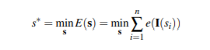

The following Dynamic Programming formulation was used, to avoid re-computations of already computed results.

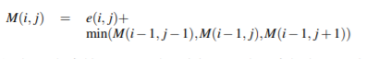

Input Image:



Size = 256 X 256

I successively applied seam carving, and calculated the resulting energy of the carved image.

The plot showing number of dimensions retained vs energy of image is as follows:

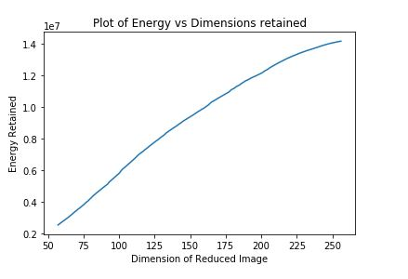

The curve is almost linear. So, I could not find an optimal dimension for carving.

The result of carving 25 times is as follows:

Compression Ratio = 1.228

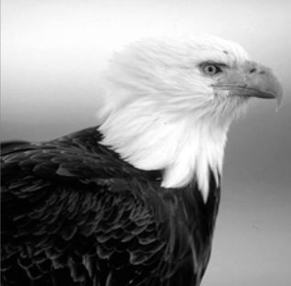

The result of carving 50 times is as follows:

Compression Ratio 1.54

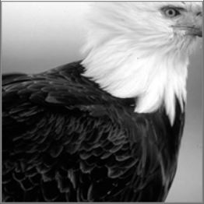

The result of carving 100 times is as follows:

Compression Ratio = 2.7

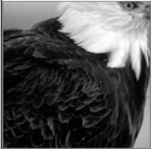

**Challenges:**

It is computationally expensive, when the image size is large, because every time the energy has to be computed, the optimal seam (and the corresponding axis- x or y ) have to be computed, and the whole image is shifted in every iteration (because of removal of pixels from each row/column). Hence, will take long time to run when image size is large and the needed compression is significant.

**Part 3:**

1. Image compressing using 2-D Wavelet decomposition to an image as

[LL, LH, HL, HH] = wavelet_Decomp(I)

1. Reconstruct the original image using decomposed components. [10]
2. Further perform wavelet decomposition on LL component, to obtain 4 components.

Show the reconstructed image using this 2nd level image and compare the loss in two cases. [10]

**Input Image:**



Size = 256 X 256

Energy = 3474615

**Various Components of the DWT:**

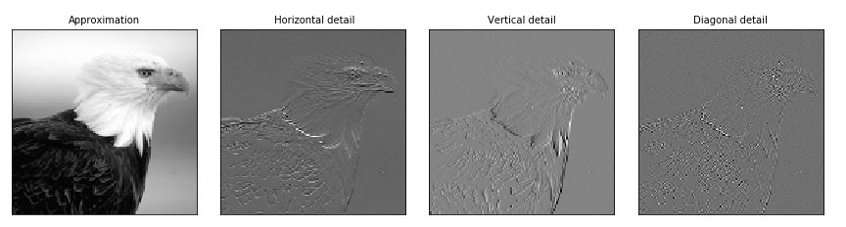

Level 1 Reconstructed Image:

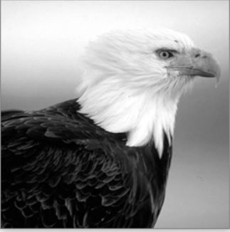

Energy = 3482057

Loss (Difference in Energy) = 5642

Level 2 Reconstruction Image :

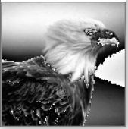

Energy = 1528228

Loss (Difference in energy ) = 1946387

**Conclusion:**

With subsequent levels of reconstruction, we are able to achieve higher compression raitos, but information lost increases significantly.