#### Steps to run:

* pip install -r requirements.txt
* run csv_to_json.py

### Problem statement: Create and design a Players data, flask application which would expose the following data through API’s:

#### Todo 1: Returns % of players above a particular year. Input could be any year for example, 1989. All players born on or after 1989 should be considered and the percentage should be calculated.

Endpoint: [127.0.0.1:5000/year/1989](http://127.0.0.1:5000/und-player)

Output:

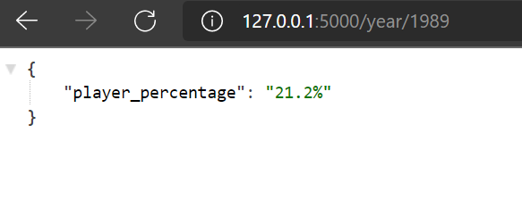

#### Todo 2: Average age of players in the different teams.

Endpoint: [127.0.0.1:5000/avg-age](http://127.0.0.1:5000/und-player)

Output:

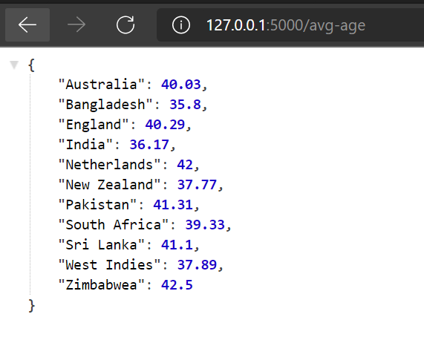

#### Todo 3: Which country has the maximum number of left-hand batsmen.

Endpoint: [127.0.0.1:5000/left-hand](http://127.0.0.1:5000/und-player)

Output:

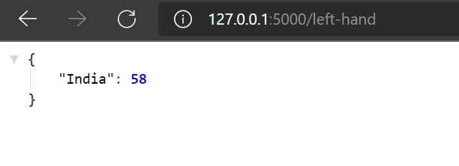

#### Todo 4: List all the players whose Country is not identified in the dataset.

Endpoint: [127.0.0.1:5000/und-player](http://127.0.0.1:5000/und-player)

Output:

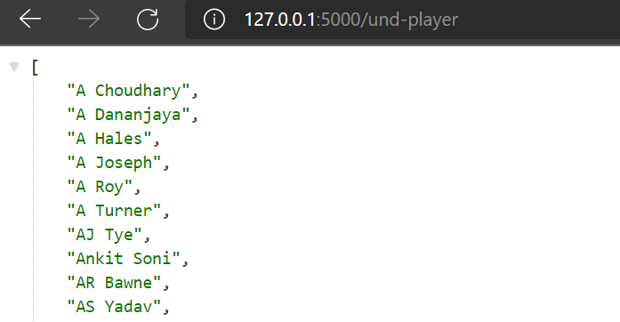

#### Todo 5: List of all players in an input Country. For example, if input is given as India, the API should list down names of all the players representing India.

Endpoint: [127.0.0.1:5000/country/England](http://127.0.0.1:5000/und-player)

Output:

