**Unit I**

**Chapter 1.4**

**(Third Normal Form 3NF)**

**Third Normal Form**

For a relation to be in Third Normal Form, it must be in Second Normal form and the following must satisfy −

* No non-prime attribute is transitively dependent on prime key attribute.
* For any non-trivial functional dependency, X → A, then either −
* X is a superkey or,
* A is prime attribute.

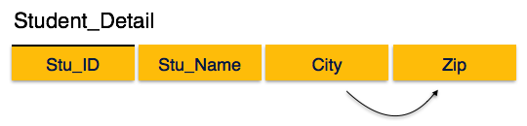We find that in the above Student_detail relation, Stu_ID is the key and only prime key attribute. We find that City can be identified by Stu_ID as well as Zip itself. Neither Zip is a superkey nor is City a prime attribute. Additionally, Stu_ID → Zip → City, so there exists transitive dependency.

To bring this relation into third normal form, we break the relation into two relations as follows −

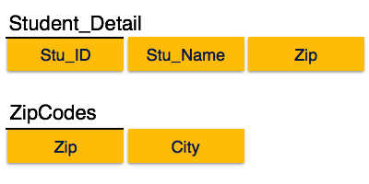

The third normal form is the nest **database normalization** form. Any relation is said to be in the third normal is it satisfies the below conditions:

* The relation should comply with the second normal form (2NF).
* Any non-prime attribute should not have a transitive functional dependency on the super key.

You can also define the third normal form of **database normalization** as the table should be in the 2NF and the functional dependency **X -> Y** should follow any one of the following conditions:

* **X should be the superkey of the relation.**
* **Y should be the prime-attribute of the relation.**

We shall see how the table complies with the third normal form. Consider an **Employee relation having Emp_ID, Emp_Name, Emp_Zip, Emp_State, Emp_City, and Emp_District**. This relation is represented as follows:

**Employee**



The super keys of the Employee relation are {Emp_ID}, {Emp_ID, Emp_Name}, {Emp_ID, Emp_Name, Emp_Zip}, and many others. The candidate key is {Emp_ID}. Hence, the EMP_ID is the prime attribute and all other are non-prime attributes.

You can see that the three attributes, Emp_State, Emp_City, and Emp_District, are functionally dependent on the Emp_Zip attribute. We can find the zip number using the Emp_ID attribute. Hence, Emp_Zip is dependent on Emp_ID.

The three attributes, Emp_State, Emp_City, and Emp_District, are non-prime attributes. They are indirectly dependent on the Emp_ID attribute, which breaks 3NF rules. To make the Employee relation comply with the third normal form (3NF), we need to break the table into smaller tables as below:

**Employee_ID**



**Employee_Zip**



The above two tables are in the third normal form.

**Other References**

[Introduction to Database Normalization (softwaretesttips.com)](https://www.softwaretesttips.com/database-normalization/)

[DBMS - Normalization - Tutorialspoint](https://www.tutorialspoint.com/dbms/database_normalization.htm)

[Normalization in DBMS: 1NF, 2NF, 3NF and BCNF with Examples (hackr.io)](https://hackr.io/blog/dbms-normalization)

**Suggested Book References**

1. J. Date, “An Introduction to Database Systems”,Addison Wesley.
2. Navathe,“Fundamentals of Database System”, The Benjamin / Cummings Publishing Co.