**ER Diagram Practice Problems**

1. A university registrar’s office maintains data about the following entities:

**Courses**: number, title, credits, syllabus, and prerequisites.

**course offerings**: course_number, year, semester, section_number, instructor(s), timings, and classroom

**students**: student-id, sname, and program

**instructors**: empid, ename, department, and title.

Further, the enrollment of students in courses and grades awarded to students in each course they are enrolled for must be appropriately modeled. Construct an E-R diagram for the registrar’s office. Document all assumptions that you make about the mapping constraints.

1. Suppose you are Data Base Administrator (DBA) working in sports Department and you are designing a Database for the National Hockey League with following requirement and the constraints

* NHL- may have n number of teams and each team is having attribute a name, a city, a coach, a captain, and a set of players,
* Each player has a name, a position (such as left wing or goalie), a skill level, and a set of injury records,
* a game is played between two teams (referred to as host_team and guest_team) and has a date (such as May 11th, 2020) and a score (such as 4 to 2) of winning team is to be recorded.
  + 1. Construct a clean and concise ER diagram for the NHL database.
    2. Generate tables from ER Model.
    3. Apply the knowledge of relational algebra to answer the followings.
    4. Find the names of teams who belong to Chandigarh.
    5. Search the name of Players who are captains and not with excellent skill level.
    6. Teams who won the first league match.

1. Design an ERD for an e-commerce website. The website has multiple products, each identified by a unique product ID, and has attributes like name, price, and quantity in stock. Customers have unique customer IDs and attributes such as name, email, and shipping address. Customers can place multiple orders, and each order can include multiple products. Each product can belong to multiple orders.
2. Draw ER diagram and map it to Relational Schema and Map it to Relational Schema

In an educational institute, there are several departments and each student belongs to one of them. Each department has a unique department number, a name, a location, phone number and is headed by a professor. Professors have a unique employee Id, name and a phone number. A professor works for exactly one department.

We like to keep track of the following details regarding students: name, unique roll number, sex, phone number, date of birth, age and one or more email addresses. Students have a local address consisting of the hostel name and the room number. They also have home address consisting of house number, street, city and PIN. It is assumed that all students reside in the hostels.

A course taught in a semester of the year is called a section. There can be several sections of the same course in a semester; these are identified by the section number. Each section is taught by a professor and has its own timings and a room to meet. Students enroll for several sections in a semester.

Each course has a name, number of credits and the department that offers it. A course may have other courses as pre-requisites i.e, courses to be completed before it can be enrolled in.

Professors also undertake research projects. These are sponsored by funding agencies and have a specific start date, end date and amount of money given. More than one professor can be involved in a project. Also, a professor may be simultaneously working on several projects. A project has a unique projectId

1. Consider the ER diagram mentioned below. Identify the entity sets, attributes & convert the following ER diagram to set of relational schemas.

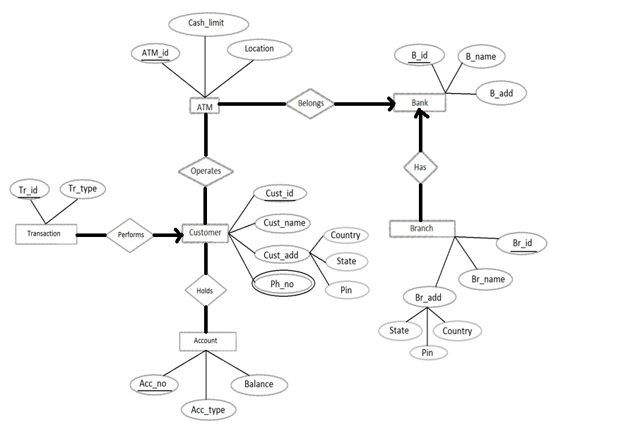

1. Design an E-R diagram for keeping track of the exploits of your favorite sports team. You should store the matches played, the scores in each match, the players in each match and individual player statistics for each match. Summary statistics should be modeled as derived attributes.
2. A database is being constructed to keep track of the teams and games of a sports league. A team has a number of players, not all of whom participate in each game. It is desired to keep track of the players participating in each game for each team, the positions they played in that game, and the result of the game. Design an ER schema diagram for this application, stating any assumptions you make. Choose your favourite sport (e.g., soccer, baseball, football).
3. Draw ER Diagram for the scenario below and map it to Relational Schema: -

We store each employee’s name (first, last, MI), Social Security number (SSN), street address, salary, sex (gender), and birth date. An employee is assigned to one department, but may work on several projects, which are not necessarily controlled by the same department. We keep track of the current number of hours per week that an employee works on each project. We also keep track of the direct supervisor of each employee (who is another employee).

Each department has a particular employee who manages the department.

We want to keep track of the dependents of each employee for insurance purposes. We keep each dependent’s first name, sex, birth date, and relationship to the employee

A department controls a number of projects which has a unique number and a single location.

1. Consider the ER diagram mentioned below. Identify the entity sets, attributes & Convert the ER model into a relational Schema

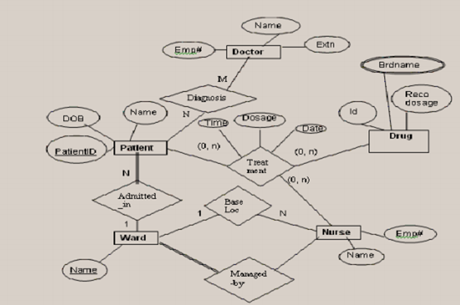

1. Analyze the given ERD & reduce the following ER diagram to relational database schema. Identify Candidate keys & determine total numbers of Tables required.

