**ANDROID DEVELOPMENT**

**Assignment - 3**

**Aim : To create a login form with two activity.**

**Algorithm:**

1. Create a new project of loginForm with an empty activity.
2. Add textview for login text, username text and password text.
3. Add E-mail EditText and Password EditText to the layout. Set text hint attribute to “enter email” and “enter password” respectively.
4. Add button to the layout and change its text to “Submit”.
5. Set the different attributes for the added items to the layout to make it look good. For example, margin, padding, constraints, layout width, layout height in their xml file.
6. Create an onclick listener for submit button which when clicked take us to the new activity page.
7. In MainActivity.java get the response from the username and password form field and check if they are not empty. If empty then toast an empty message to the screen else create an instance of new activity and start the activity.
8. Create an empty activity called MainActivity2 which will be opened when submit button is clicked.
9. Add plain text on the main_activity2.xml using the design tab.
10. Now, our app is created, test it on the emulator or android device.

**activity_main.xml :-**

*<?*xml version="1.0" encoding="utf-8"*?>*<androidx.constraintlayout.widget.ConstraintLayout xmlns:android="http://schemas.android.com/apk/res/android" xmlns:app="http://schemas.android.com/apk/res-auto" xmlns:tools="http://schemas.android.com/tools" android:layout_width="match_parent" android:layout_height="match_parent" tools:context=".MainActivity">  
  
 <TextView  
 android:id="@+id/textView"  
 android:layout_width="wrap_content"  
 android:layout_height="wrap_content"  
 android:text="@string/login"  
 android:layout_marginTop="20dp"  
 android:textSize="35sp"  
 app:layout_constraintEnd_toEndOf="parent"  
 app:layout_constraintStart_toStartOf="parent"  
 app:layout_constraintTop_toTopOf="parent" />  
 <TextView  
 android:id="@+id/textView2"  
 android:layout_width="wrap_content"  
 android:layout_height="wrap_content"  
 android:layout_marginTop="55dp"  
 android:layout_marginLeft="25dp"  
 android:text="@string/username"  
 android:textSize="28sp"  
 app:layout_constraintStart_toStartOf="parent"  
 app:layout_constraintTop_toBottomOf="@+id/textView" />  
 <EditText  
 android:id="@+id/inuser"  
 android:layout_width="wrap_content"  
 android:layout_height="wrap_content"  
 android:layout_marginTop="12dp"  
 android:layout_marginLeft="25dp"  
 android:ems="10"  
 android:hint="enter email"  
 android:inputType="textEmailAddress"  
 android:padding="10dp"  
 app:layout_constraintStart_toStartOf="parent"  
 app:layout_constraintTop_toBottomOf="@+id/textView2" />  
 <TextView  
 android:id="@+id/textView3"  
 android:layout_width="wrap_content"  
 android:layout_height="wrap_content"  
 android:layout_marginTop="20dp"  
 android:layout_marginLeft="25dp"  
 android:text="@string/pass"  
 android:textSize="28sp"  
 app:layout_constraintStart_toStartOf="parent"  
 app:layout_constraintTop_toBottomOf="@+id/inuser" />  
 <EditText  
 android:id="@+id/inpass"  
 android:layout_width="wrap_content"  
 android:layout_height="wrap_content"  
 android:layout_marginTop="10dp"  
 android:layout_marginLeft="25dp"  
 android:ems="10"  
 android:hint="enter password"  
 android:inputType="textPassword"  
 android:padding="10dp"  
 app:layout_constraintStart_toStartOf="parent"  
 app:layout_constraintTop_toBottomOf="@+id/textView3" />  
  
  
 <LinearLayout  
 android:layout_width="match_parent"  
 android:layout_height="wrap_content"  
 android:orientation="horizontal"  
 android:layout_centerHorizontal="true"  
 android:gravity="center_horizontal"  
 android:layout_marginTop="30dp"  
 app:layout_constraintStart_toStartOf="parent"  
 app:layout_constraintTop_toBottomOf="@+id/inpass">  
 <Button  
 android:id="@+id/submit"  
 android:layout_width="wrap_content"  
 android:layout_height="wrap_content"  
 android:onClick="changeactivity"  
 android:text="@string/submit"  
 android:textAllCaps="false" />  
 </LinearLayout>  
</androidx.constraintlayout.widget.ConstraintLayout>

**activity_main2.xml :-**

*<?*xml version="1.0" encoding="utf-8"*?>*<androidx.constraintlayout.widget.ConstraintLayout xmlns:android="http://schemas.android.com/apk/res/android" xmlns:app="http://schemas.android.com/apk/res-auto" xmlns:tools="http://schemas.android.com/tools" android:layout_width="match_parent" android:layout_height="match_parent" tools:context=".MainActivity2">  
  
 <EditText  
 android:id="@+id/editTextTextPersonName"  
 android:layout_width="wrap_content"  
 android:layout_height="wrap_content"  
 android:ems="10"  
 android:inputType="textPersonName"  
 android:text="@string/act2"  
 android:textSize="30sp"  
 android:gravity="center"  
 app:layout_constraintBottom_toBottomOf="parent"  
 app:layout_constraintEnd_toEndOf="parent"  
 app:layout_constraintStart_toStartOf="parent"  
 app:layout_constraintTop_toTopOf="parent"  
 />  
</androidx.constraintlayout.widget.ConstraintLayout>

**MainActivity.java :-**

*<?*xml version="1.0" encoding="utf-8"*?>*<androidx.constraintlayout.widget.ConstraintLayout xmlns:android="http://schemas.android.com/apk/res/android" xmlns:app="http://schemas.android.com/apk/res-auto" xmlns:tools="http://schemas.android.com/tools" android:layout_width="match_parent" android:layout_height="match_parent" tools:context=".MainActivity2">  
  
 <EditText  
 android:id="@+id/editTextTextPersonName"  
 android:layout_width="wrap_content"  
 android:layout_height="wrap_content"  
 android:ems="10"  
 android:inputType="textPersonName"  
 android:text="@string/act2"  
 android:textSize="30sp"  
 android:gravity="center"  
 app:layout_constraintBottom_toBottomOf="parent"  
 app:layout_constraintEnd_toEndOf="parent"  
 app:layout_constraintStart_toStartOf="parent"  
 app:layout_constraintTop_toTopOf="parent"  
 />  
</androidx.constraintlayout.widget.ConstraintLayout>

**MainActivity2.java :-**

package com.example.loginform;  
  
import androidx.appcompat.app.AppCompatActivity;  
  
import android.os.Bundle;  
  
public class MainActivity2 extends AppCompatActivity {  
  
 @Override  
 protected void onCreate(Bundle savedInstanceState) {   
 super.onCreate(savedInstanceState);   
 setContentView(R.layout.*activity_main2*);  
 }  
}

**OUTPUT :-**

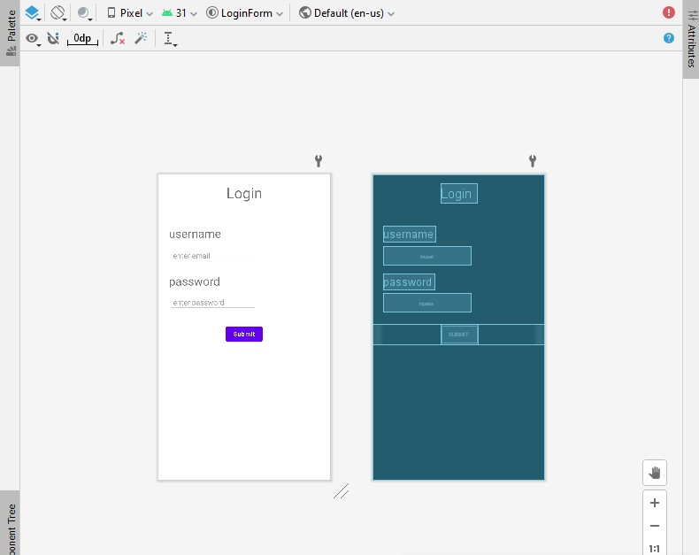

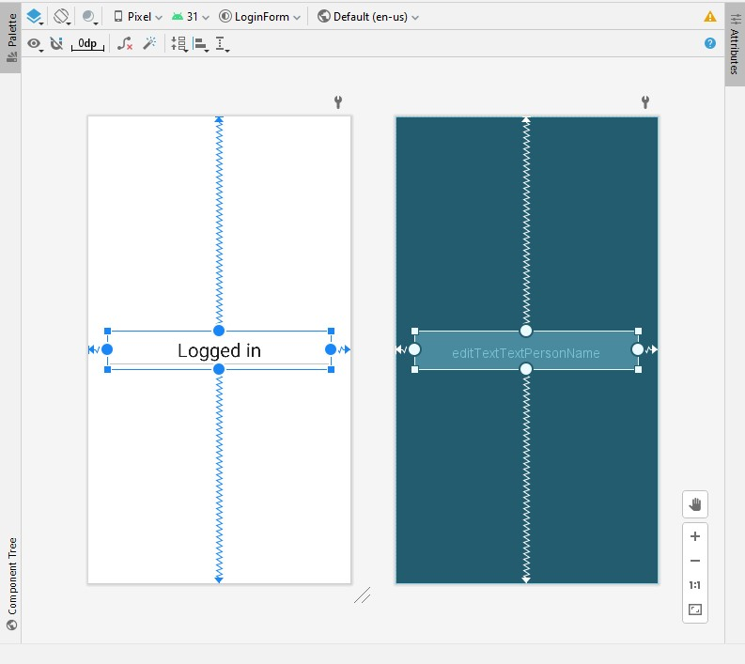

**EMULATOR:-   
 when input details are wrong.**



