**NAME : SAKSHAM SINGHAL**

**REG NO : 2018105184**

**ANDROID LAB ASSIGNMENT - 6**

**Aim : Create an Image Viewer in Android Studio.**

**Algorithm :**

1. Create the new project image viewer and select empty activity.

2. Create a text view in main activity xml and write text for opening window of app, like, this is an image viewer.

3. Create the new empty activity in the java folder of the project name this activity as ImageViewerActivity.

4. In the xml code of the ImageViewerActivity create an image view setting it’s width height and scaleType= “center”, centerInParent = “True”.

5. Go to ImageViewerActivity.java file and write the java code for viewing an image in our activity.

6. Our app is created and now we can run it.

**XML CODE :**

**activity_main.xml :**

*<?*xml version="1.0" encoding="utf-8"*?>*<androidx.constraintlayout.widget.ConstraintLayout  
 xmlns:android="http://schemas.android.com/apk/res/android"  
 xmlns:app="http://schemas.android.com/apk/res-auto"  
 xmlns:tools="http://schemas.android.com/tools"  
 android:layout_width="match_parent"  
 android:layout_height="match_parent"  
 tools:context=".MainActivity">  
 <TextView  
 android:layout_width="wrap_content"  
 android:layout_height="wrap_content"  
 android:gravity="center"  
 android:text="This is an Image Viewer"  
 android:textSize="30sp"  
 app:layout_constraintBottom_toBottomOf="parent"  
 app:layout_constraintLeft_toLeftOf="parent"  
 app:layout_constraintRight_toRightOf="parent"  
 app:layout_constraintTop_toTopOf="parent"  
 />  
</androidx.constraintlayout.widget.ConstraintLayout>

**activity_image_viewer :**

*<?*xml version="1.0" encoding="utf-8"*?>*<androidx.constraintlayout.widget.ConstraintLayout  
 xmlns:android="http://schemas.android.com/apk/res/android" xmlns:app="http://schemas.android.com/apk/res-auto"  
 xmlns:tools="http://schemas.android.com/tools"  
 android:layout_width="match_parent"  
 android:layout_height="match_parent"  
 tools:context=".MainActivity">  
 <ImageView   
 android:layout_width="match_parent"  
 android:layout_height="match_parent"   
 android:layout_centerInParent="true"   
 android:scaleType="centerInside"   
 android:id="@+id/imageView"   
 />   
</androidx.constraintlayout.widget.ConstraintLayout>

**AndroidManifest.xml :**

*<?*xml version="1.0" encoding="utf-8"*?>*<manifest xmlns:android="http://schemas.android.com/apk/res/android" package="com.example.imgviewer">   
 <application   
 android:allowBackup="true"   
 android:icon="@mipmap/ic_launcher"   
 android:label="@string/app_name"  
 android:roundIcon="@mipmap/ic_launcher_round"   
 android:supportsRtl="true"   
 android:theme="@style/Theme.ImgViewer">   
 <activity   
 android:name=".ImageViewerActivity"   
 android:exported="true" >   
 <intent-filter >   
 <action android:name="android.intent.action.VIEW" />  
 <category android:name="android.intent.category.DEFAULT" />   
 <data android:mimeType="image/*"/>   
 </intent-filter>   
 </activity>  
 <activity   
 android:name=".MainActivity"   
 android:exported="true">   
 <intent-filter>   
 <action android:name="android.intent.action.MAIN" />   
 <category android:name="android.intent.category.LAUNCHER" />   
 </intent-filter>  
 </activity>   
 </application>  
</manifest>

**JAVA CODE :**

**MainActivity.java :**

package com.example.imageviewer;  
  
import androidx.appcompat.app.AppCompatActivity;  
  
import android.os.Bundle;  
  
public class MainActivity extends AppCompatActivity {  
  
 @Override  
 protected void onCreate(Bundle savedInstanceState) {  
 super.onCreate(savedInstanceState);  
 setContentView(R.layout.activity_main);  
 }  
}

**ImageViewerActivity.java :**

package com.example.imageviewer;  
import androidx.appcompat.app.AppCompatActivity;  
import android.content.Intent;  
import android.net.Uri;  
import android.os.Bundle;  
import android.widget.ImageView;  
public class ImageViewerActivity extends AppCompatActivity {  
 @Override  
 protected void onCreate(Bundle savedInstanceState) {  
 super.onCreate(savedInstanceState);  
 setContentView(R.layout.activity_image_viewer);  
 Intent intent = getIntent();  
 Uri data = intent.getData();  
 ImageView imageView = findViewById(R.id.imageView);  
 imageView.setImageURI(data);  
 }  
}

**OUTPUT :**

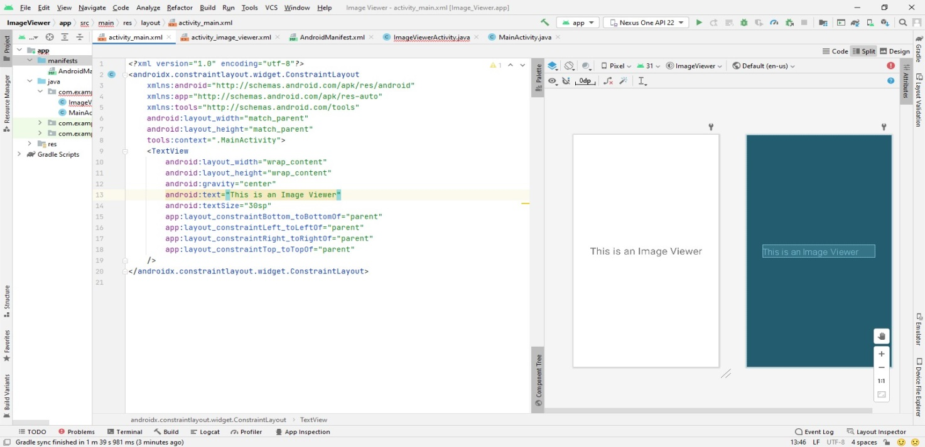

**Emulator :**

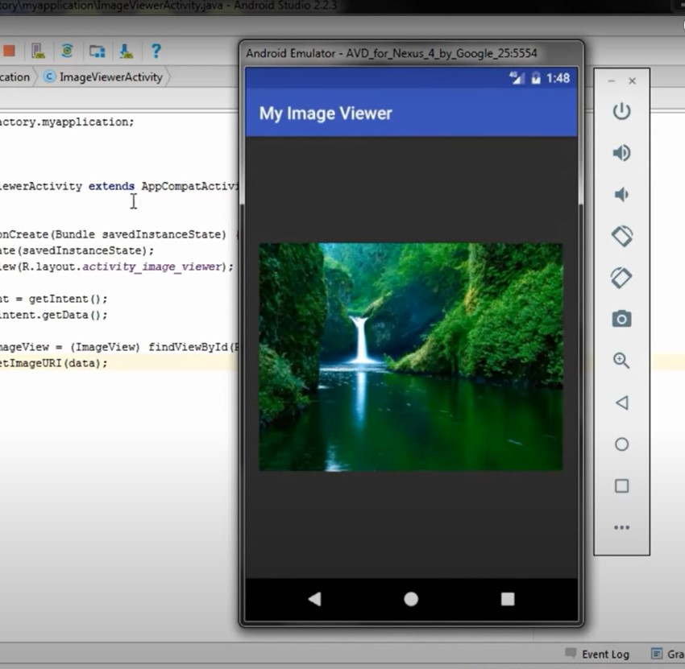

-----------------------end------------------------