**NAME : SAKSHAM SINGHAL**

**REG NO : 2018105184**

**ANDROID LAB ASSIGNMENT - 4**

**Aim : Create an alarm clock manager .**

**Algorithm :**

1. Create a project named as Alarm Clock with empty activity.

2. Design the app main activity xml file.

3. Create button for select time, set alarm, cancel alarm with text view for time.

4. Create the on click listener for the button for setting time picker, setting alarm and cancelling alarm write the java code in main activity java file.

5. Create the alarm receiver java file for broadcasting alarm sound and notification on selected time.

6. In the alarm receiver class, create the notification for the selected time with media player object used to create ringtone sound at the selected time for alarming.

7. Set receiver in android manifest file.

8. Create the new destination activity which can be opened when you click on the notification.

9. Now, App is created, run it on the emulator or in mobile device.

**XML Code :**

**activity_main.xml :**

*<?*xml version="1.0" encoding="utf-8"*?>*<LinearLayout  
 xmlns:android="http://schemas.android.com/apk/res/android"  
 xmlns:tools="http://schemas.android.com/tools"  
 xmlns:app="http://schemas.android.com/apk/res-auto"  
 android:layout_width="match_parent"  
 android:layout_height="match_parent"  
 android:orientation="vertical"  
 tools:context=".MainActivity">  
 <TextView  
 android:id="@+id/selectedTime"  
 android:layout_width="match_parent"  
 android:layout_height="wrap_content"  
 android:layout_marginTop="200dp"  
 android:text="05 : 30 PM"  
 android:textAlignment="center"  
 android:textColor="@color/black"  
 android:textSize="46dp" />  
 <Button  
 android:id="@+id/selectTime"  
 android:layout_width="match_parent"  
 android:layout_height="70dp"  
 android:layout_marginTop="30dp"  
 android:layout_marginHorizontal="26dp"  
 android:text="Select Time"  
 android:textSize="24dp"/>  
 <Button  
 android:id="@+id/setAlarm"  
 android:layout_width="match_parent"  
 android:layout_height="70dp"  
 android:layout_marginTop="8dp"  
 android:layout_marginHorizontal="26dp"  
 android:text="Set Alarm"  
 android:textSize="24dp"/>  
 <Button  
 android:id="@+id/cancelAlarm"  
 android:layout_width="match_parent"  
 android:layout_height="70dp"  
 android:layout_marginTop="8dp"  
 android:layout_marginHorizontal="26dp"  
 android:text="Cancel Alarm"  
 android:textSize="24dp"/>  
</LinearLayout>

**Activity_destination.xml :**

*<?*xml version="1.0" encoding="utf-8"*?>*<androidx.constraintlayout.widget.ConstraintLayout  
 xmlns:android="http://schemas.android.com/apk/res/android"  
 xmlns:app="http://schemas.android.com/apk/res-auto"  
 xmlns:tools="http://schemas.android.com/tools"  
 android:layout_width="match_parent"  
 android:layout_height="match_parent"  
 tools:context=".DesstinationActivity">  
 <EditText  
 android:id="@+id/editTextTextPersonName"  
 android:layout_width="wrap_content"  
 android:layout_height="wrap_content"  
 android:ems="10"  
 android:inputType="textPersonName"  
 android:text="Notification Activity"  
 app:layout_constraintBottom_toBottomOf="parent"  
 app:layout_constraintEnd_toEndOf="parent"  
 app:layout_constraintStart_toStartOf="parent"  
 app:layout_constraintTop_toTopOf="parent" />  
</androidx.constraintlayout.widget.ConstraintLayout>

**AndroidManifest.xml :** add this line after closing activity tag.

<receiver android:name=".AlarmReceiver"/>

**JAVA CODE :**

**MainActivity.java :**

package com.example.alarmclock;  
import androidx.appcompat.app.AppCompatActivity;  
import androidx.core.app.NotificationManagerCompat;  
import android.app.AlarmManager;  
import android.app.NotificationChannel;  
import android.app.NotificationManager;  
import android.app.PendingIntent;  
import android.content.Context;  
import android.content.Intent;  
import android.os.Build;  
import android.os.Bundle;  
import android.view.View;  
import android.widget.Toast;  
import com.example.alarmclock.databinding.ActivityMainBinding;  
import com.google.android.material.timepicker.MaterialTimePicker;  
import com.google.android.material.timepicker.TimeFormat;  
import java.util.Calendar;  
public class MainActivity extends AppCompatActivity {  
 private ActivityMainBinding binding;  
 private MaterialTimePicker picker;  
 private Calendar calendar;  
 private AlarmManager alarmManager;  
 private PendingIntent pendingIntent;  
 @Override  
 protected void onCreate(Bundle savedInstanceState) {  
 super.onCreate(savedInstanceState);  
 binding = ActivityMainBinding.*inflate*(getLayoutInflater());  
 setContentView(binding.getRoot());  
 createNotificationChannel();  
 binding.selectTime.setOnClickListener(new View.OnClickListener() {  
 @Override  
 public void onClick(View v) {  
 showTimePicker();  
 }  
 });  
 binding.setAlarm.setOnClickListener(new View.OnClickListener() {  
 @Override  
 public void onClick(View v) {  
 setAlarm();  
 }  
 });  
 binding.cancelAlarm.setOnClickListener(new View.OnClickListener() {  
 @Override  
 public void onClick(View v) {  
 cancelAlarm();  
 }  
 });  
 }  
 private void cancelAlarm() {  
 Intent intent = new Intent(this, AlarmReceiver.class);  
 pendingIntent = PendingIntent.*getBroadcast*(this, 0, intent, 0);  
 if(alarmManager==null){  
 alarmManager = (AlarmManager)  
 getSystemService(Context.*ALARM_SERVICE*);  
 }  
 alarmManager.cancel(pendingIntent);  
 Toast.*makeText*(this, "Alarm cancelled...", Toast.*LENGTH_SHORT*).show();  
 }  
 private void setAlarm() {  
 alarmManager = (AlarmManager) getSystemService(Context.*ALARM_SERVICE*);  
 Intent intent = new Intent(this, AlarmReceiver.class);  
 pendingIntent = PendingIntent.*getBroadcast*(this, 0, intent, 0);  
 alarmManager.setInexactRepeating(AlarmManager.*RTC_WAKEUP*, calendar.getTimeInMillis(), AlarmManager.*INTERVAL_DAY*, pendingIntent);  
 Toast.*makeText*(this, "Alarm set successfully...", Toast.*LENGTH_SHORT*).show();  
 }  
 private void showTimePicker() {  
 picker = new MaterialTimePicker.Builder()  
 .setTimeFormat(TimeFormat.*CLOCK_12H*)  
 .setHour(12)  
 .setMinute(0)  
 .setTitleText("Select Alarm Time")  
 .build();  
 picker.show(getSupportFragmentManager(), "Experiment");  
 picker.addOnPositiveButtonClickListener(new View.OnClickListener() {  
 @Override  
 public void onClick(View view) {  
 if (picker.getHour() > 12) {  
 binding.selectedTime.setText(String.*format*("%02d", (picker.getHour() - 12)) + " : " + String.*format*("%02d", picker.getMinute()) + "PM");  
 } else {  
 binding.selectedTime.setText(picker.getHour() + " : " + picker.getMinute() + " : " + "AM");  
 }  
 calendar = Calendar.*getInstance*();  
 calendar.set(Calendar.*HOUR_OF_DAY*, picker.getHour());  
 calendar.set(Calendar.*MINUTE*, picker.getMinute());  
 calendar.set(Calendar.*SECOND*, 0);  
 calendar.set(Calendar.*MILLISECOND*, 0);  
 }  
 });  
 }  
 private void createNotificationChannel() {  
 if (Build.VERSION.*SDK_INT* >= Build.VERSION_CODES.*O*){  
 CharSequence name = "Experiment";  
 String description = "Alarm Manager";  
 int importance = NotificationManager.*IMPORTANCE_HIGH*;  
 NotificationChannel channel = new NotificationChannel("Experiment", name, importance);  
 channel.setDescription(description);  
 NotificationManager notificationManager = getSystemService(NotificationManager.class);  
 notificationManager.createNotificationChannel(channel);  
 }  
 }  
}

**AlarmReceiver.java :**

package com.example.alarmclock;  
import android.app.Notification;  
import android.app.NotificationManager;  
import android.app.PendingIntent;  
import android.content.BroadcastReceiver;  
import android.content.Context;  
import android.content.Intent;  
import android.media.MediaPlayer;  
import android.provider.MediaStore;  
import android.provider.Settings;  
import androidx.core.app.NotificationCompat;  
import androidx.core.app.NotificationCompat.Builder;  
import androidx.core.app.NotificationManagerCompat;  
public class AlarmReceiver extends BroadcastReceiver{  
 @Override  
 public void onReceive(Context context, Intent intent) {  
 Intent i=new Intent(context, DesstinationActivity.class);  
 intent.setFlags(Intent.*FLAG_ACTIVITY_NEW_TASK* | Intent.*FLAG_ACTIVITY_CLEAR_TASK*);  
 PendingIntent pendingIntent = PendingIntent.*getActivity*(context, 0,i, 0);  
 MediaPlayer mediaPlayer = MediaPlayer.*create*(context, Settings.System.*DEFAULT_RINGTONE_URI*);  
 mediaPlayer.start();  
 NotificationCompat.Builder builder = new NotificationCompat.Builder(context, "Experiment")  
 .setSmallIcon(R.drawable.*ic_launcher_background*)  
 .setContentTitle("wakeUP Alarm Manager")  
 .setAutoCancel(true)  
 .setDefaults(NotificationCompat.*DEFAULT_ALL*)  
 .setPriority(NotificationCompat.*PRIORITY_HIGH*)  
 .setContentIntent(pendingIntent);  
 NotificationManagerCompat notificationManagerCompat = NotificationManagerCompat.*from*(context);  
 notificationManagerCompat.notify(123, builder.build());  
 }  
}

**DestinationActivity.java :**

package com.example.alarmclock;  
import androidx.appcompat.app.AppCompatActivity;  
import android.os.Bundle;  
public class DesstinationActivity extends AppCompatActivity {  
 @Override  
 protected void onCreate(Bundle savedInstanceState) {  
 super.onCreate(savedInstanceState);  
 setContentView(R.layout.*activity_destination*); } }

**OUTPUT** :

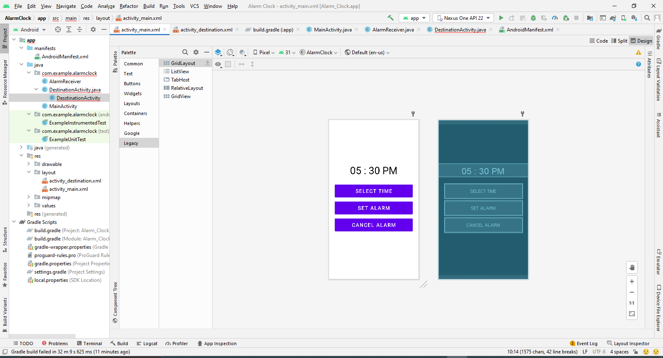

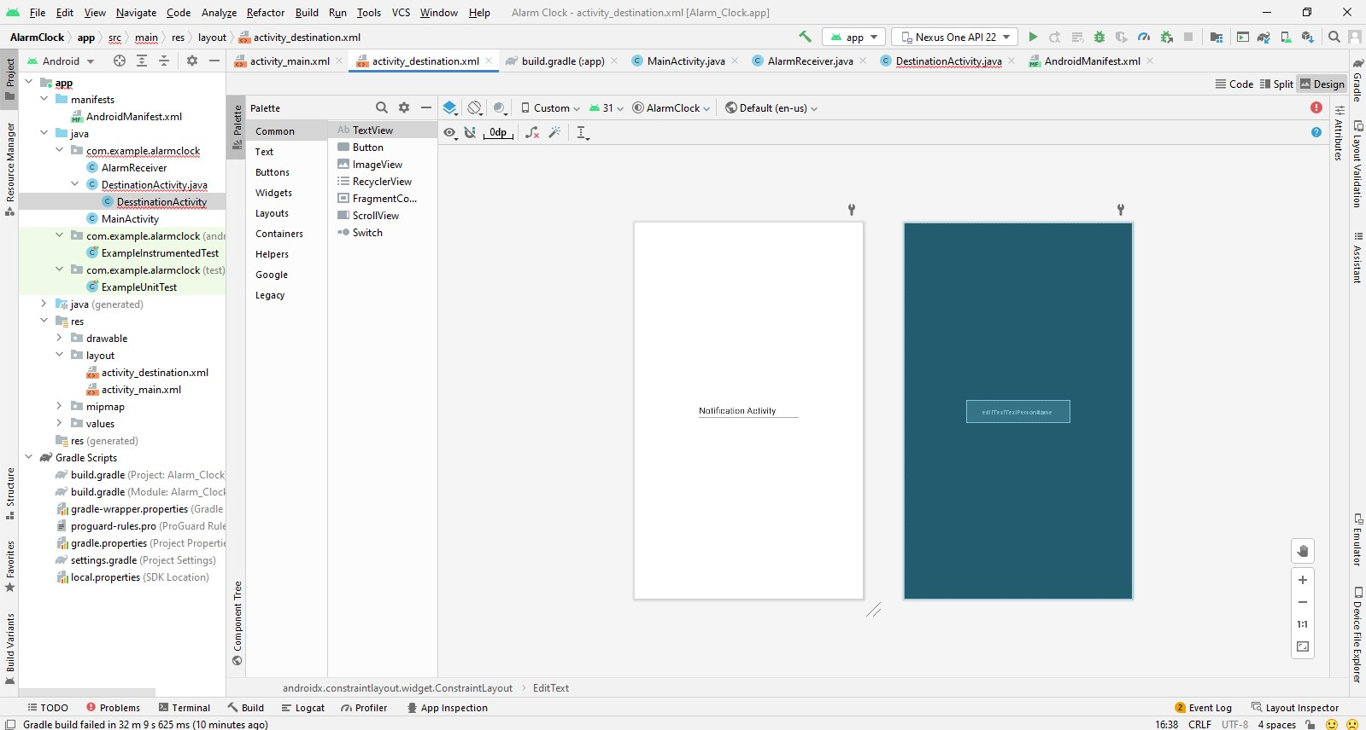

ON EMULATOR :

