NAME : SAKSHAM SINGHAL
REG NO : 2018105184
ANDROID LAB ASSIGNMENT - 5
Aim : Create a Stopwatch in Android Studio.
Algorithm :
1. Create a project stopwatch with empty activity.
2. Go to xml code and make the layout, with setting width and height.
3. Make a chronometer, with two image button one start and another stop.
4. Go to drawable create background for the chronometer.
5. Set the width height and size of the layout, buttons, chronometer.
6. Create play, pause and stop button using vector assist from New->Vector Assist menu.
7. Go to java file and create on click listener for button like start, pause.
8. Once started, you can pause the clock and clicking on stop will reset the timer.
9. Write the code and run the app.

XML Code :
Activity_main.xml :
<?xml version="1.0" encoding="utf-8"?>
<LinearLayout xmlns:android="http://schemas.android.com/apk/res/android"
xmlns:app="http://schemas.android.com/apk/res-auto"
xmlns:tools="http://schemas.android.com/tools"
android:layout_width="300dp"
android:layout_height="300dp"
android:layout_gravity="center"
android:background="@drawable/bg_round"
android:gravity="center"
tools:context=".MainActivity">
<Chronometer
android:id="@+id/chronometer"
android:layout_width="wrap_content"
android:layout_height="wrap_content"
android:format="00:00:00"
android:textColor="@color/white"
android:textSize="40sp"
android:textStyle="bold" />
<LinearLayout
android:layout_width="wrap_content"
android:layout_height="wrap_content"
android:layout_marginTop="10dp">
<ImageButton
android:id="@+id/bt_start"
android:layout_width="wrap_content"
android:layout_height="wrap_content"
android:background="@android:color/transparent"
android:src="@drawable/ic_play" />
<ImageButton
android:id="@+id/bt_stop"
android:layout_width="wrap_content"
android:layout_height="wrap_content"
android:layout_marginLeft="20dp"
android:background="@android:color/transparent"
android:src="@drawable/ic_stop" />
</LinearLayout>
</LinearLayout>

bg_round.xml :
<?xml version="1.0" encoding="utf-8"?>
<shape
xmlns:android="http://schemas.android.com/apk/res/android">
android:shape="rectangle"
<solid
android:color="@color/purple_500"
/>
<corners
android:radius="200dp"
/>
</shape>

ic_play.xml :
<vector xmlns:android="http://schemas.android.com/apk/res/android"
android:width="40dp"
android:height="40dp"
android:viewportWidth="24"
android:viewportHeight="24"
android:tint="?attr/colorControlNormal">
<path
android:fillColor="@android:color/white"
android:pathData="M8,5v14l11,-7z"/>
</vector>
Ic_pause.xml :
<vector xmlns:android="http://schemas.android.com/apk/res/android"
android:width="40dp"
android:height="40dp"
android:viewportWidth="24"
android:viewportHeight="24"
android:tint="?attr/colorControlNormal">
<path
android:fillColor="@android:color/white"
android:pathData="M6,19h4L10,5L6,5v14zM14,5v14h4L18,5h-4z"/>
</vector>
ic_stop.xml :
<vector xmlns:android="http://schemas.android.com/apk/res/android"
android:width="40dp"
android:height="40dp"
android:viewportWidth="24"
android:viewportHeight="24"
android:tint="?attr/colorControlNormal">
<path
android:fillColor="@android:color/white"
android:pathData="M6,6h12v12H6z"/>
</vector>

OUTPUT :
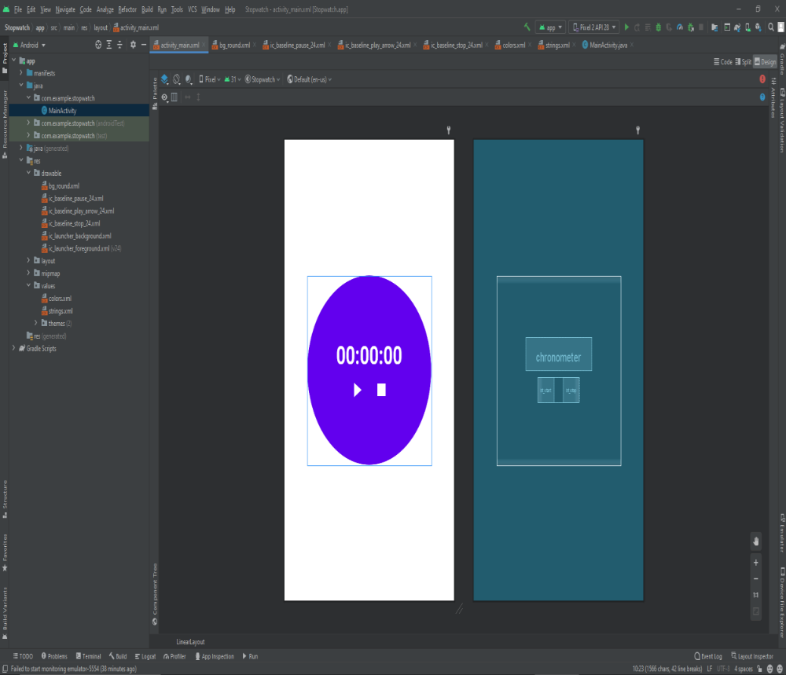
ON EMULATOR :
Play :
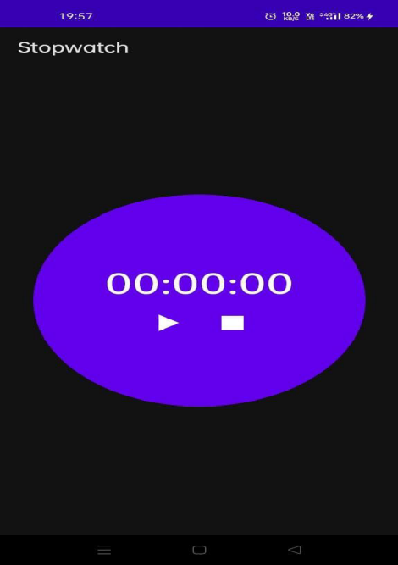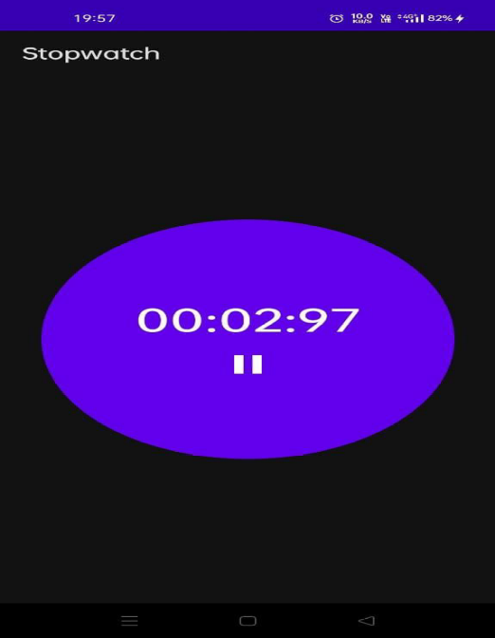
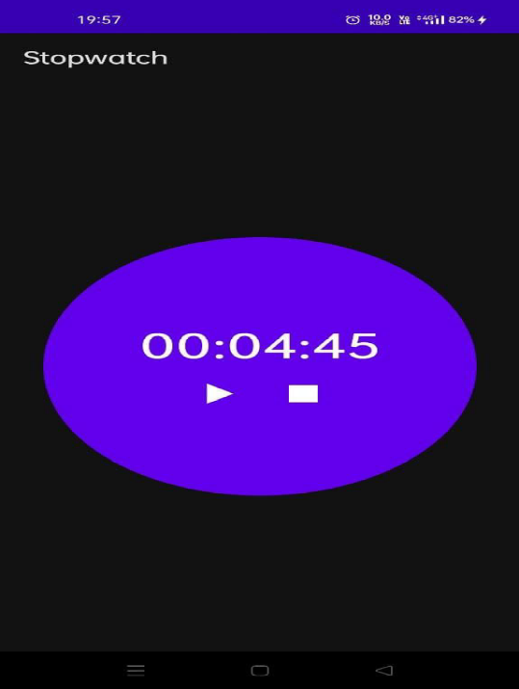
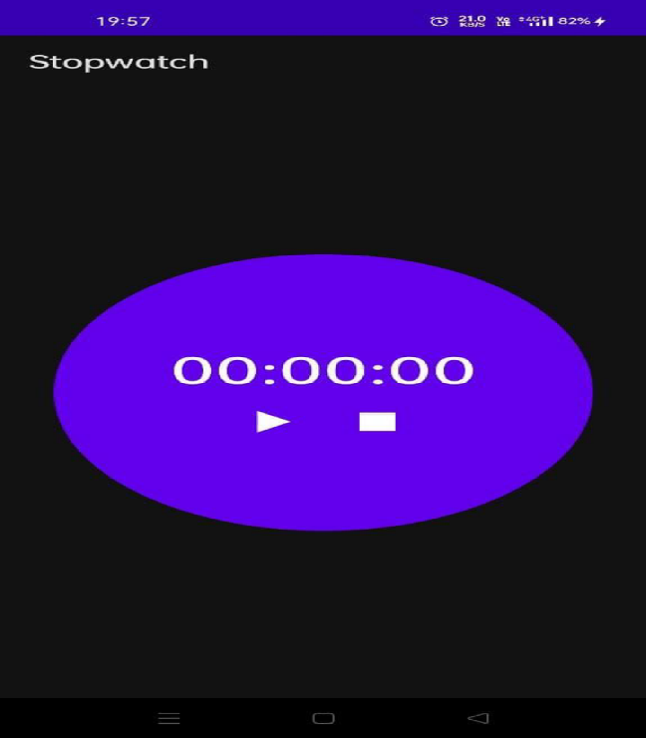
Pause : Stop :

