Circuit Diagram

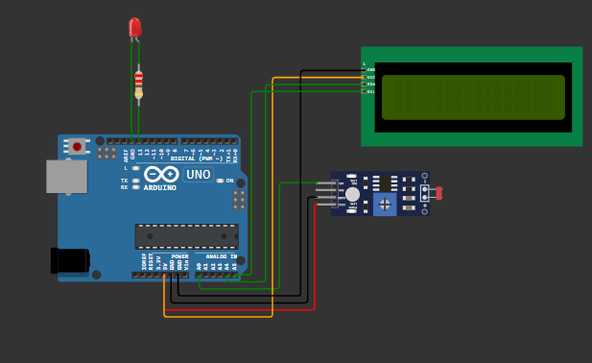

Source Code
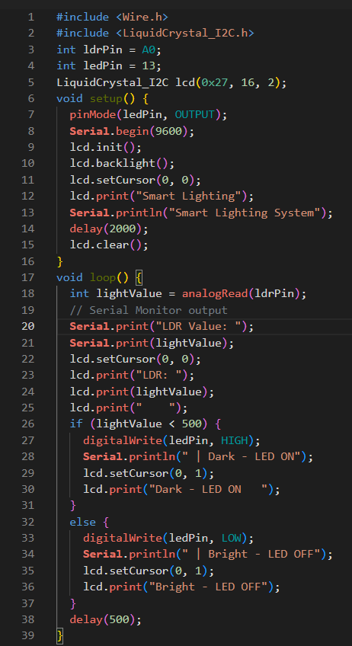
Working Explanation
The Smart Lighting System is an automated lighting system based on an LDR (Light Dependent Resistor) sensor and an Arduino Uno. The LDR sensor detects the surrounding light intensity and sends the analog value to the Arduino through the AO pin.
The Arduino reads the LDR value and uses IF/ELSE automation logic to control the LED. If the LDR value is less than 500, the system considers the environment dark and automatically turns the LED ON. If the value is 500 or higher, the environment is considered bright and the LED turns OFF. This demonstrates the automation logic required in Task-3.
The 16×2 LCD displays the LDR value and the current status of the LED. The same information is also displayed on the Serial Monitor, providing real-time monitoring of the system. Monitoring through an LCD or Serial Monitor is one of the Task-3 requirements.
Why this system is useful?
This system can be used for automatic lighting in homes, offices, classrooms, and other areas. It helps reduce unnecessary use of lights by automatically switching the LED according to the surrounding light conditions. The project demonstrates how an embedded system can sense, make a decision, and automatically control an output.

Serial Monitoring Output
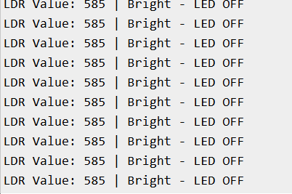
LCD Output
