Circuit Diagram
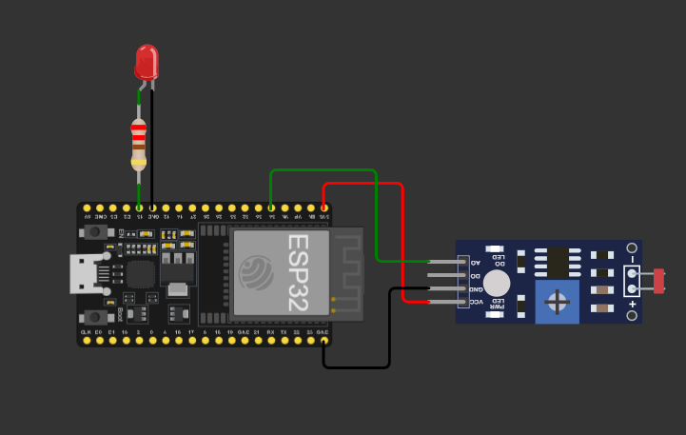
Dashboard
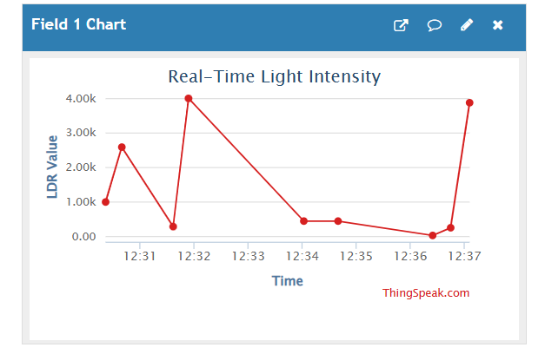
Source Code
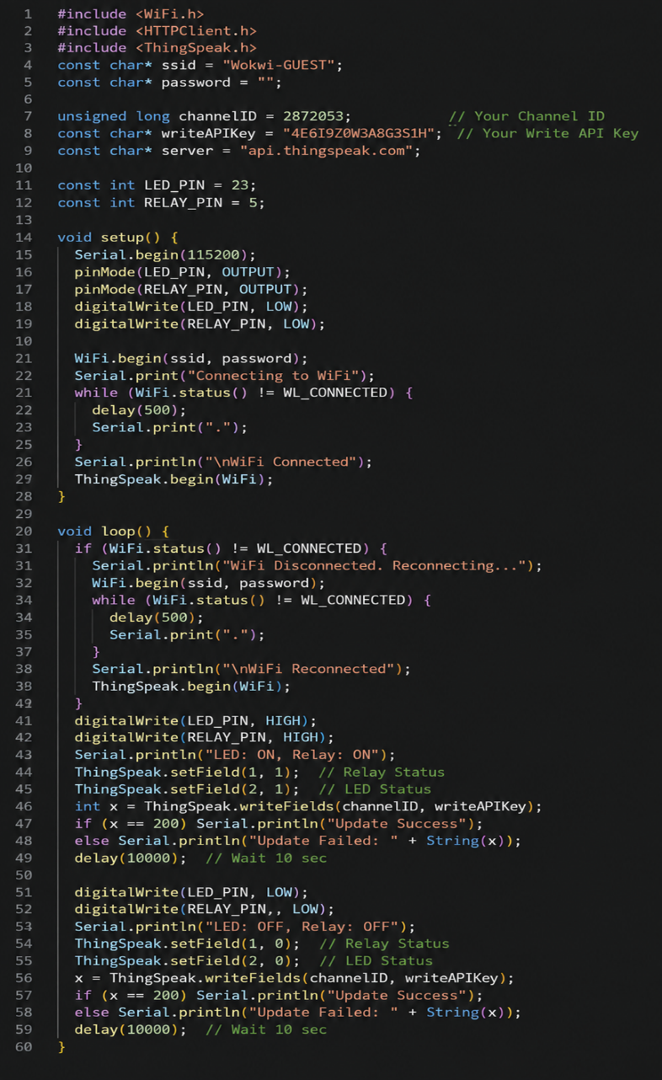
Working System

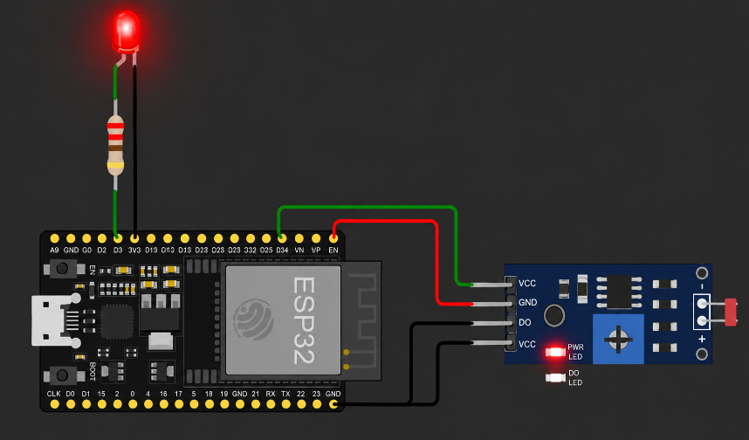

Explanation
The control signal reaches the physical device through a complete communication path that connects the user, IoT cloud, Internet, Wi-Fi network, ESP32 microcontroller, and output device. The process begins when the user sends a command through an IoT application or cloud-based platform. For example, the user may send a command to turn an LED or electrical appliance ON or OFF. This command is first transferred to the IoT cloud, where it is processed and made available to the connected ESP32 device. The command then travels through the Internet and reaches the Wi-Fi network to which the ESP32 is connected. The ESP32 continuously communicates with the cloud and checks for new commands or control information.
Once the ESP32 receives the command, its programmed software processes the received data and identifies the required operation. Based on the command, the ESP32 generates an appropriate digital signal through one of its GPIO (General Purpose Input/Output) pins. This GPIO pin is connected to an output component such as an LED, relay module, or another electronic device. When the GPIO pin produces a HIGH signal, the connected output may be activated, while a LOW signal may deactivate it, depending on the circuit design and logic used.
In the case of a relay, the GPIO signal controls the relay module rather than directly powering a high-voltage appliance. The relay operates as an electronic switch and allows the ESP32 to control an external electrical load safely through the appropriate interface circuit. For an LED, the GPIO signal can directly control its ON/OFF state when the circuit is designed with suitable current-limiting components.
The complete communication process can therefore be represented as User → IoT Application/Cloud → Internet → Wi-Fi → ESP32 → GPIO → Relay/LED → Physical Device. This communication path allows the user to control a device remotely without being physically present near it. The ESP32 acts as the central bridge between the digital cloud environment and the physical hardware. This demonstrates the basic concept of IoT cloud-to-device communication, where commands generated remotely are transmitted to an embedded device and converted into physical actions. It also demonstrates how Wi-Fi connectivity, cloud services, microcontroller programming, GPIO control, and electronic switching work together to create a remote automation system.

