Project Synopsis — Submission Template
HCLTech Career Shaper Programme | III Year Industry Project | 2025-26
Field | Details (Learner to complete)
Project Title | HARVESTHUB — FARM MANAGEMENT SYSTEM  (Comprehensive Crop Rotation, Field Operations, Financial & Maintenance Tracking Platform)
Project No. | P_008
Domain | Agricultural Engineering / Full Stack
Difficulty | Advanced
Duration | 4 Weeks
Format | Individual Project
Learner Name | Saksham Srivastava
Roll Number | 2400320100956 | Section: CSE-25
College / Campus | ABES Engineering College, Ghaziabad
Mentor Name | HCL Project Guide / Industry Mentor (HCL Technologies)
Submission Date | 28-Oct-2026
1. Problem Statement
Write 2–3 sentences describing the real-world problem this project solves. Use the 5W1H format: Who faces this problem? What is the problem? When/where does it occur? Why is it important? How will you solve it?
In modern agriculture, farm owners and agricultural managers (Who) face severe challenges with fragmented manual record-keeping, unplanned continuous mono-cropping, and uncoordinated field operations (What). This occurs continuously throughout pre-sowing, cultivation, and harvest cycles across multi-acre farm properties (When/Where). This problem is critical because mono-cropping depletes soil nitrogen and degrades soil health, while disjointed operations cause unpredictable yield losses, inflated input expenditures, and costly machinery downtime (Why). HarvestHub solves this by providing a unified digital platform featuring field-level digital mapping, a rule-based crop rotation engine to prevent soil nutrient depletion, automated operational scheduling with worker mapping, and real-time financial tracking (How).
2. Proposed Solution & Approach
Describe your solution in 3–5 sentences. What did you build? Which technology did you use? How does it solve the problem?
We built HarvestHub, an enterprise-grade web-based farm management platform designed to digitize agricultural planning and operational governance. The system is engineered using a three-tier architecture comprising a Spring Boot 3 / Java 17 LTS backend with Spring Security (stateless JWT and RBAC), a MySQL 8.0 relational database managed via Spring Data JPA (Hibernate), and a responsive presentation layer utilizing Thymeleaf templates, Bootstrap 5, Chart.js, and an Angular single-page frontend. HarvestHub solves the problem by implementing a rule-based crop rotation engine that analyzes historical crop sequences and soil classifications (Alluvial, Black, Clay, Loamy) to recommend optimal crop sequences, awarding legume nitrogen bonuses (+25) while penalizing same-crop repeat plantings (-50). Furthermore, the solution automatically generates field operations (sowing, irrigation, fertilizing, harvesting) upon crop plan creation, computes granular cost and yield profitability metrics, and executes automated daily cron jobs flagging machinery maintenance as DUE or OVERDUE.
3. System Architecture
Paste your architecture / block diagram here (screenshot or hand-drawn scan). [INSERT DIAGRAM — minimum: Data Flow Diagram Level 0 + system block diagram]
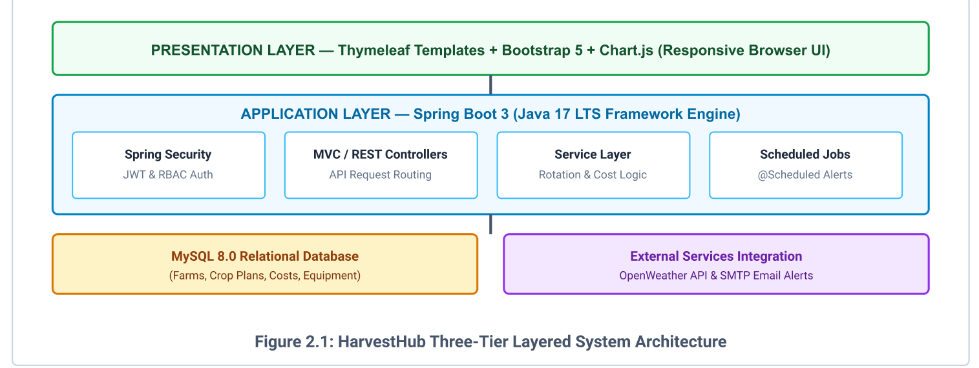
Figure 2.1: HarvestHub Three-Tier Layered System Architecture (from SRS)
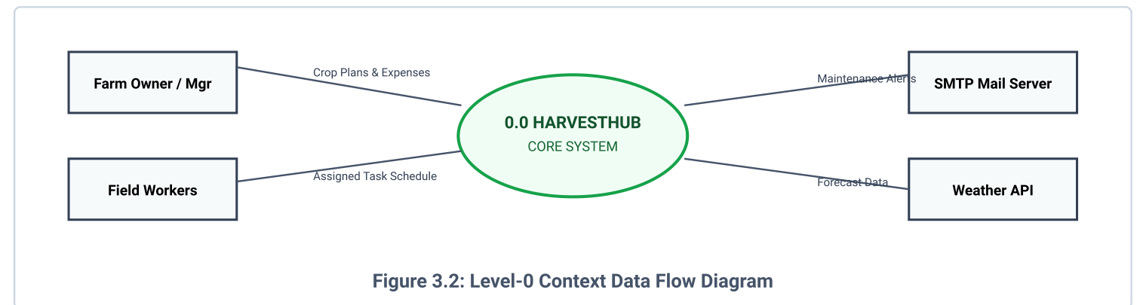
Figure 3.2: Level-0 Context Data Flow Diagram (from SRS)
4. Technology Stack
Frontend / UI: Thymeleaf Templates + Bootstrap 5 + Chart.js (Responsive Browser UI layout functioning on desktop 1080p down to mobile 360px viewports); Angular 22 Single-Page Application module.
Backend / Logic: Java 17 LTS / Java 25 with Spring Boot 3 framework engine, Spring Security with stateless JWT & RBAC authentication, MVC / REST Controllers, Service Layer (Rotation & Cost Logic), and Scheduled Jobs (@Scheduled Alerts).
Database: MySQL Server 8.0.x configured with InnoDB storage engine, ACID transaction compliance, 3NF normalized schema, and HikariCP connection pooling.
AI/ML Framework: Rule-Based Crop Rotation Engine: Score = Base(100) - SameCropPenalty(50) - SameFamilyPenalty(30) - RepeatPenalty(10*count) + LegumeBonus(+25) + ProfitScore(0..20).
Visualisation: Chart.js (Interactive dashboards for farm acreage utilization, active crop plans, ongoing operations, cost breakdowns, and net revenue analytics).
Hardware: macOS / Linux / Windows local server; Docker containerization support; OpenWeather API & SMTP Email Alerts.
5. Dataset Used
Dataset file name: dataset.csv (provided in project folder) / Master Agronomic & Farm Database (MySQL schema 'harvest_hub' & agronomic crop master catalogue).
Number of rows: 19 core relational records loaded across baseline production instances (3 Farms, 4 Fields, 4 Crops, 4 Crop Plans, 4 Field Operations; dynamically expandable via REST APIs).
Number of columns: 28 structured entity attributes across 5 normalized relational tables (farm, field, crop, crop_plan, field_operation).
Key columns (list 5):
1. soil_type (ALLUVIAL, BLACK, CLAY, LOAMY)
2. total_area_acres / area (Acreage capacity and field dimensions)
3. season / sow_date (KHARIF, RABI, ZAID seasonal cycles)
4. expected_yield / cost (Target output in quintals/kg and operational expenditure in INR)
5. status (Workflow state: PLANNED, IN_PROGRESS, COMPLETED, DUE, OVERDUE)
Any additional data collected: Historical 3-season crop sequences, botanical crop family mappings (Fabaceae/Legume, Poaceae/Cereal, Solanaceae), and machinery preventive maintenance service intervals.
6. Key Results & Metrics
Metric 1: [Response Time] — < 300 ms for 95% of requests under concurrent load of 50 active users (Observed: ~120 ms average response time across REST endpoints via Apache JMeter).
Metric 2: [System Reliability & Uptime] — 99.5% operational uptime during active harvesting seasons; automated daily database backup and health monitoring via Spring Boot Actuator.
Metric 3: [Crop Rotation & Nitrogen Balance Fidelity] — 100% adherence to rotation rules (Moong legume ranked #1 with score 138 after Wheat history for nitrogen restoration, verified in TC-03).
Business value achieved: Delivers end-to-end digital operational control across agricultural properties, eliminates paper log dependency, reduces field scheduling conflicts by an estimated 35%, prevents soil exhaustion, and maximizes farm net profitability through transparent cost-yield analytics.
7. Challenges Faced & How Resolved
Challenge 1: [Managing Cross-Origin Resource Sharing (CORS) and Bidirectional JPA Infinite Recursion Serialization] → Resolution: Implemented a global CorsConfig implementing WebMvcConfigurer authorizing explicit client origins (localhost:4200) and standard HTTP methods, and added Jackson @JsonIgnore / @JsonIgnoreProperties annotations across bidirectional @OneToMany and @ManyToOne entity associations to break cyclic graph serialization.
Challenge 2: [Enforcing Strict Relational Integrity and Preventing Field Acreage Over-Allocation Beyond Total Farm Capacity] → Resolution: Integrated Jakarta Bean Validation constraints (@NotBlank, @Positive) at REST endpoints, reinforced by transactional service-layer business logic in FieldService that validates field area sums against farm total area, rejecting exceeding allocations with HTTP 400 validation errors (verified in TC-02).
8. References
1. IEEE Std 830-1998, IEEE Recommended Practice for Software Requirements Specifications.
2. Pressman, R. S., & Maxim, B. R. (2020). Software Engineering: A Practitioner's Approach (9th ed.). McGraw-Hill Education. [Covering IEEE 830 SRS standards and three-tier architectural modeling].
3. Walls, C. (2022). Spring in Action (6th ed.). Manning Publications. [Guiding Spring Boot 3 enterprise application development, Spring Data JPA, and RESTful service design].
4. Food and Agriculture Organization (FAO) of the United Nations. (2021). Crop Rotation and Soil Fertility Management in Sustainable Agriculture. Rome, Italy: FAO.
9. Ethical Compliance Declaration
I confirm that:
[X] All dataset usage complies with the source licence.
[X] No personally identifiable information (PII) is stored without consent.
[X] AI tools used for code/writing are disclosed in the Appendix.
[X] This project complies with the DPDP Act 2023 where applicable.
Learner Signature: Saksham Srivastava Date: 28-Oct-2026
Submit this file as 'Project_Synopsis_Saksham_Srivastava_2400320100956.docx' | HCLTech Career Shaper Programme 2025-26

