**BIRLA INSTITUTE OF TECHNOLOGY AND SCIENCE, PILANI**

**HYDERABAD CAMPUS**

FIRST **SEMESTER** 2022-2023

**ME F366 LABORATORY PROJECT**

**PROJECT TITLE & PLAN OF WORK**

**Date**: 07/09/2022

**Title of the project -** QuadCopter Navigation

**Need for the study**

QuadCopter Navigation is the primary step which needs to be explored to step into the implementation-based drone making. Various drone sub-fields, such as autonomous drones, drone swarms, Object Avoidance Drones etc., require essential communication between drones or drones to the ground station, which serves as the backbone for the other work to be commenced on other subsystems.

Through this project, we want to establish a communication channel between two drones and between the drone and the ground station. Through motion planning, we would make two drones fly synchronously.

**Objectives**

* Run the assembled drones with ArduPilot & Pixhawk
* Motion planning with Mission planner software and collecting sensor data at the ground station
* Synchronous motion of the two drones

**Literature Review**

The existing drone work has been substantial to help start the project. Various tutorials are available for assembling Raspberry Pi-based drones.MAVLink is being used for communication purposes in this project, which acts as the primary communication link between Ground stations and Unmanned Vehicles, ensuring messages' integrity through cyclic redundancy check(CRC).

For motion planning, various approaches are being read about and evaluated to be better suited for our purpose.

**Work Plan**

The following timeline is proposed:

| **Sr No.** | **Task** | **Timeline(Proposed)** |
| --- | --- | --- |
| 1. | Assembly of both drones and flying them using RC Controller. | 23/09/2022 |
| 2. | Attachment of Various Sensors and trying to figure out Communication with Raspberry Pi via MAVLink | 07/10/2022 |
| 3. | Figuring out if two different flight controllers can be used for communication | 15/10/2022 |
| 4. | Test Flight with all Sensor Data Communication Link Between QuadCopter and Ground Station | 20/11/2022 |
| 5. | Simultaneous Work on Motion Planning for Synchronous Motion of Drones | 20/11/2022 |

**References**

1. <https://www.youtube.com/watch?v=kB9YyG2V-nA>
2. <https://www.youtube.com/watch?v=DGAB34fJQFc>
3. <https://www.linkedin.com/pulse/communication-between-drone-raspberry-pi-via-mavlink-yan-pang/>
4. <https://ardupilot.org/dev/docs/raspberry-pi-via-mavlink.html>
5. <https://www.researchgate.net/publication/329522616_Communicating_with_Raspberry_Pi_via_MAVLink>
6. <https://en.wikipedia.org/wiki/MAVLink#:~:text=MAVLink%20or%20Micro%20Air%20Vehicle,header%2Donly%20message%20marshaling%20library>.
7. <https://www.mdpi.com/2072-4292/13/21/4481>
8. <https://www.mdpi.com/2504-446X/6/5/126/pdf>
9. <https://www.researchgate.net/publication/361242038_Motion_planning_of_quadcopters_for_enhanced_autonomy_in_complex_environments>
10. <https://core.ac.uk/download/pdf/33496956.pdf>

**Expected Knowledge to be gained after completion of the project (Bullet points)**

* Assembly of Raspberry Pi based Drone
* Setting up of Ground Station for Drones
* Establishing Communication Channel for various types of data to be transferred
* Motion Planning
* Through this work, we could step into more niche fields like Drone Swarm and Autonomous Drone Systems

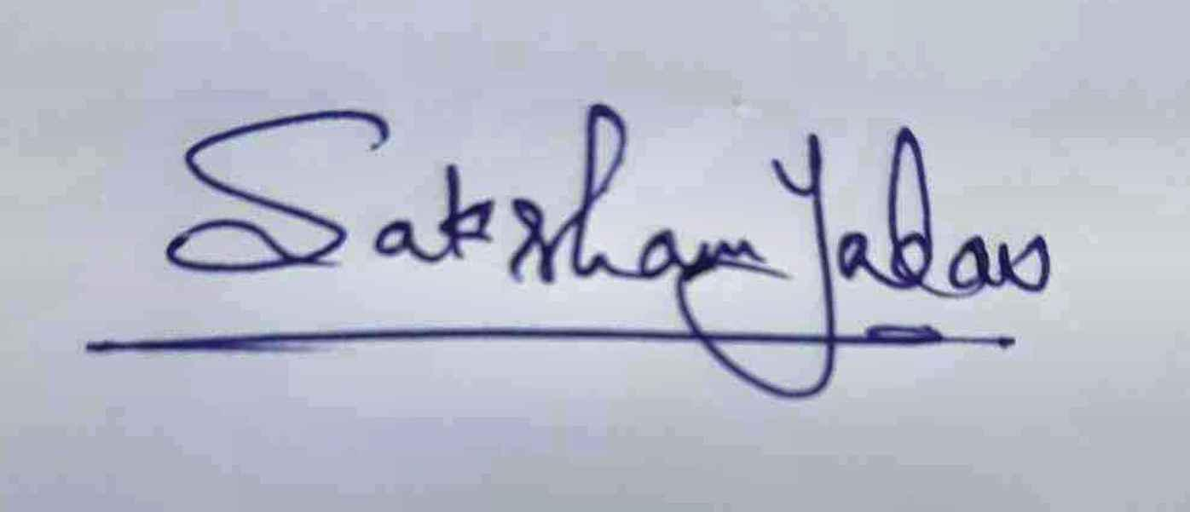

Signature of the student

Name: Saksham Subhash Yadav

ID No:2020A8PS2156H