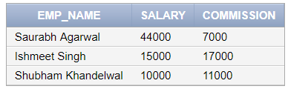

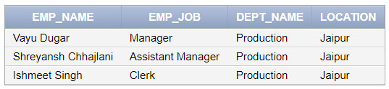

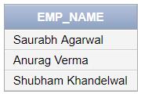

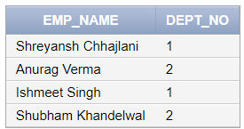

query to display name, salary & commission of employees whose commission > salary. increase salary by 5%

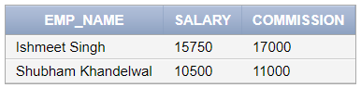

update emp_024 set salary = salary*1.05 where commission > salary;

select emp_name, salary, commission from emp_024 where commission > salary;