Programming in PHP

Unit I
Introduction to PHP, Installation of PHP and MySQL, PHP configuration in IIS & wamp; Apache Web Server and features of PHP, Writing PHP, How PHP code is parsed, Embedding PHP and HTML Executing PHP and viewing in Browser.

What is PHP?
PHP is a server side scripting language that is used to develop Static websites or Dynamic websites or Web applications. PHP stands for Hypertext Pre-processor, that earlier stood for Personal Home Pages.PHP scripts can only be interpreted on a server that has PHP installed.

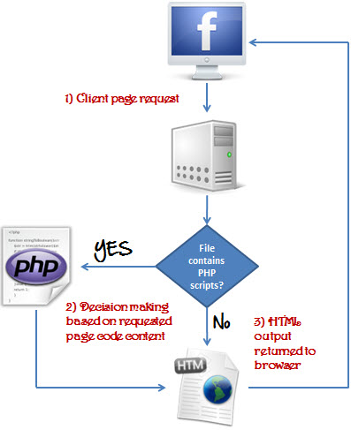

What is a PHP File?
- PHP files can contain text, HTML, CSS, JavaScript, and PHP code
- PHP code are executed on the server, and the result is returned to the browser as plain HTML
- PHP files have extension ".php"

What Can PHP Do?
- PHP can generate dynamic page content
- PHP can create, open, read, write, delete, and close files on the server
- PHP can collect form data
- PHP can send and receive cookies
- PHP can add, delete, modify data in your database
- PHP can be used to control user-access
- PHP can encrypt data
With PHP you are not limited to output HTML. You can output images, PDF files, and even Flash movies. You can also output any text, such as XHTML and XML.

Why PHP?
- PHP is a recursive acronym for "PHP: Hypertext Preprocessor".
- PHP runs on various platforms (Windows, Linux, Unix, Mac OS X, etc.)
- PHP is compatible with almost all servers used today (Apache, IIS, etc.)
- PHP supports a wide range of databases(Oracle,Sybase,Sql,PostgreSql, Informix)
- PHP is free. Download it from the official PHP resource: www.php.net
- PHP is easy to learn and runs efficiently on the server side
- PHP is a server side scripting language that is embedded in HTML. It is used to manage dynamic content, databases, session tracking, even build entire e-commerce sites.
- PHP is pleasingly zippy in its execution, especially when compiled as an Apache module on the Unix side. The MySQL server, once started, executes even very complex queries with huge result sets in record-setting time.
- PHP supports a large number of major protocols such as POP3, IMAP, and LDAP. PHP4 added support for Java and distributed object architectures (COM and CORBA), making n-tier development a possibility for the first time.
- PHP is forgiving: PHP language tries to be as forgiving as possible.
- PHP Syntax is C-Like.

What's new in PHP 7
- PHP 7 is much faster than the previous popular stable release (PHP 5.6)
- PHP 7 has improved Error Handling
- PHP 7 supports stricter Type Declarations for function arguments
- PHP 7 supports new operators (like the spaceship operator: <=> )

What is a Scripting Language?
A script is a set of programming instructions that is interpreted at runtime.A scripting language is a language that interprets scripts at runtime. Scripts are usually embedded into other software environments.
The purpose of the scripts is usually to enhance the performance or perform routine tasks for an application.
Server side scripts are interpreted on the server while client side scripts are interpreted by the client application.
PHP is a server side script that is interpreted on the server while JavaScript is an example of a client side script that is interpreted by the client browser. Both PHP and JavaScript can be embedded into HTML pages.

Programming Language Vs Scripting Language
Programming language | Scripting language
Has all the features needed to develop complete applications. | Mostly used for routine tasks
The code has to be compiled before it can be executed | The code is usually executed without compiling
Does not need to be embedded into other languages | Is usually embedded into other software environments.
PHP code may be embedded into HTML code, or it can be used in combination with various web template systems, web content management system and web frameworks.

Why to Learn PHP?

Characteristics of PHP
Five important characteristics make PHP's practical nature possible −
- Simplicity
- Efficiency
- Security
- Flexibility
- Familiarity

Php Syntax
A PHP script can be placed anywhere in the document. A PHP script starts with <?php and ends with ?>:
<?php
// PHP code goes here
?>
The default file extension for PHP files is ".php".
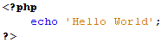
A PHP file can also contain tags such as HTML and client side scripts such as JavaScript.
- HTML is an added advantage when learning PHP Language. You can even learn PHP without knowing HTML but it’s recommended you at least know the basics of HTML.
- Database management systems DBMS for database powered applications.
- For more advanced topics such as interactive applications and web services, you will need JavaScript and XML.

Hello World using PHP.
Live Demo
<html>

<head>
<title>Hello World</title>
</head>

<body>
<?php echo "Hello, World!";?>
</body>

</html>
Below, we have an example of a simple PHP file, with a PHP script that uses a built-in PHP function "echo" to output the text "Hello World!" on a web page:

Example
<!DOCTYPE html>
<html>
<body>
<h1>My first PHP page</h1>
<?php
echo "Hello World!";
?>
</body>
</html>
Note: PHP statements end with a semicolon (;).

PHP Case Sensitivity
In PHP, NO keywords (e.g. if, else, while, echo, etc.), classes, functions, and user-defined functions are case-sensitive.
In the example below, all three echo statements below are equal and legal:

Example
<!DOCTYPE html>
<html>
<body>
<?php
ECHO "Hello World!<br>";
echo "Hello World!<br>";
EcHo "Hello World!<br>";
?>
</body>
</html>
Note: However; all variable names are case-sensitive!
Look at the example below; only the first statement will display the value of the $color variable! This is because $color, $COLOR, and $coLOR are treated as three different variables:

Example
<!DOCTYPE html>
<html>
<body>
<?php
$color = "red";
echo "My car is " . $color . "<br>";
echo "My house is " . $COLOR . "<br>";
echo "My boat is " . $coLOR . "<br>";
?>
</body>
</html>
PHP was designed to work with HTML, and as such, it can be embedded into the HTML code.

You can create PHP files without any html tags and that is called Pure PHP file .
PHP is a case sensitive language, “VAR” is not the same as “var”. The PHP tags themselves are not case-sensitive, but it is strongly recommended that we use lower case letter.
<?php … ?>
We will be referring to the PHP lines of code as statements. PHP statements end with a semi colon (;). If you only have one statement, you can omit the semi colon. If you have more than one statement, then you must end each line with a semi colon. For the sake of consistency, it is recommended that you always end your statement(s) with a semi colon. PHP scripts are executed on the server. The output is returned in form of HTML.

How PHP Code is Parsed
So you have a file, and in that file you have some HTML and some PHP code. This is how it all works, assuming a PHP document with an extension of .php.
- The web browser requests a document with a .php extension.
- The web server says, "Hey! Someone wants a PHP file, which means this is a file that needs to be parsed," and sends the request on to the PHP parser.
- The PHP parser finds the requested file and scans it for PHP code.
- When the PHP parser finds PHP code, it executes that code and places the resulting output (if any) into the place in the file formerly occupied by the code.
- This new output file is sent back to the web server.
- The web server sends it along to the web browser.
- The web browser displays the output.
Because the PHP code is parsed on the server, this method of code execution is called server-side code. When code is executed in a browser, such as JavaScript, it is called client-side code.
How PHP Works?
The flowchart diagram shown below illustrates the basic architecture of a PHP web application and how the server handles the requests.

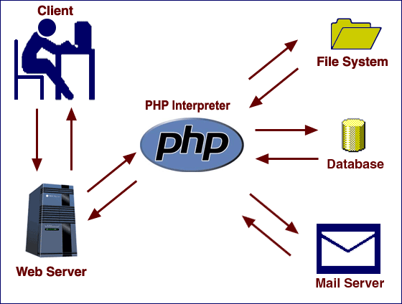

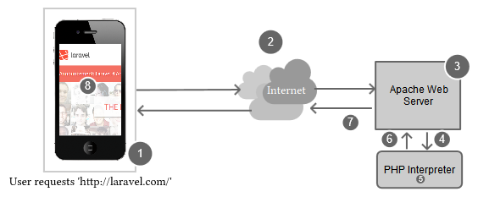
Step 1 The user enters `http://laravel.com` into their browser and taps/hits 'enter'.
Step 2 After the user has tapped/hit 'enter', the browser sends the page request over the Internet to the web server.
Step 3 The web server gets the request and analyzes the request information. Apache realizes that we didn't specify a file, so it looks for a directory index and finds `index.php`.
Step 4 Since Apache knows to send files that end with the `.php` file extension to the PHP interpreter, it asks PHP to execute the file.
Step 5 In this step, PHP is executing the code contained in the `index.php` file from the request. During this step, PHP may interact with databases, the file system or make external API calls, amongst other things.
Step 6 After PHP has finished executing the `index.php` file, it sends the output back to Apache.
Step 7 Apache receives the output from PHP and sends it back over the Internet to a user's web browser. This is called the `web response`.
Step 8 The user's web browser receives the response from the server, and renders the web page on a computer or device

PHP | echo and print
We have seen echo statement quite frequently in PHP codes. It is the most basic way for displaying output in PHP.
However, there are two basic ways to get output in PHP:-
- echo
- print

PHP echo statement

In PHP ‘echo’ statement is a language construct and never behaves like a function, hence no paranthesis required. The end of echo statement is identified by the semi-colon (‘;’).
We can use ‘echo’ to output strings or variables. Below is some of the usage of echo statement in PHP:
- Displaying Strings: We can simply use the keyword echo followed by the string to be displayed within quotes. Below example shows how to display strings with PHP:

<?php
echo "Hello,This is a display string example!";
?>
Output:
Hello,This is a display string example!

- Displaying Strings as multiple arguments: We can pass multiple string arguments to the echo statement instead of single string argument, separating them by comma (‘,’) operator. For example, if we have two strings say “Hello” and “World” then we can pass them as (“Hello”,”World”). Below example shows how to do this:
<?php
echo "Multiple ","argument ","string!";
?>
Output:
Multiple argument string!

- Displaying Variables: Displaying variables with echo statement is also as easy as displaying normal strings. Below example shows different ways to display variables with the help of PHP echo statement:-

<?php
//defining the variables
$text = "Hello, World!";
$num1 = 10;
$num2 = 20;
//echoing the variables
echo $text."<br>";
echo $num1."+". $num2."=";
echo ($num1 + $num2);
?>
Output:
Hello, World!
10+20=30
The (.) operator in the above code can be used to concatenate two strings in PHP and the “<br>” is used for a new line and is also known as line-break.

PHP print statement

The PHP print statement is similar to the echo statement and can be used alternative to echo at many times. It is also language construct and so we may not use parenthesis: print or print(). The main difference between the print and echo statement is that print statement can have only one argument at a time and thus can print a single string. Also, print statement always returns a value 1.
Like echo, print statement can also be used to print strings and variables. Below are some examples of using print statement in PHP:

- Displaying String of Text: We can display strings with print statement in the same way we did with echo statements. The only difference is we cannot display multiple strings separated by comma (,) with a single print statement. Below example shows how to display strings with the help of PHP print statement:-
<?php
print "Hello, world!";
?>
Output:
Hello, world!
- Displaying Variables: Displaying variables with print statement is also same as that of echo statement. The example below shows how to display variables with the help of PHP print statement:-
<?php
//defining the variables
$text = "Hello, World!";
$num1 = 10;
$num2 = 20;
//echoing the variables
print $text."\n";
print $num1."+". $num2."=";
print ($num1 + $num2);
?>
Output:
Hello, World!
10+20=30
Comparison between Echo and Print in PHP:
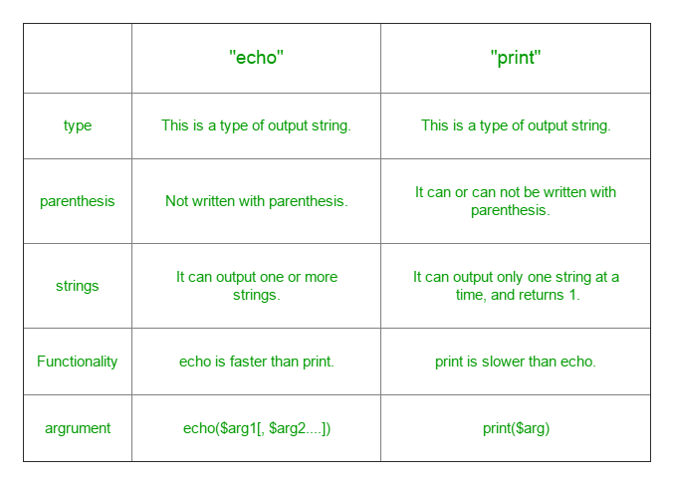

For PHP to run we need:-
1. Desktop/Laptop
2. Editors (to write the code such as Dreamweaver, notepad++, sublime text, NetBeans.
PHPStorm.
3. Server (XAMPP, WAMP, LAMP, MAMP)
- XAMPP is for X-OS (cross-platform, Apache, Mysql, PHP, and Perl).
- WAMP is for (Windows, Apache, Mysql, and PHP).
- LAMP is for Linux ,Apache, Mysql, PHP
- MAMP is for Mac OS X, Apache, Mysql, PHP
4. Browser (For output viewing)(e.g. chrome, firefox)

What is XAMPP?
XAMPP is an open source cross platform web server, MySQL database engine, and PHP and Perl package. It is compiled and maintained by apache. The acronym XAMPP stands for;
- X – [cross platform operating systems] meaning it can run on any OS Mac OX , Windows , Linux etc.
- A – Apache - this is the web server software.
- M – MySQL - Database.
- P – PHP
- P – Perl – scripting language

Why use XAMPP?
- In order to use PHP, you will need to install PHP, Apache and may be even MySQL. It’s not easy to install Apache and configure it. If you install Apache on its own, you will still have to set it up and integrate it with PHP and Perl among other things. XAMPP deals with all the complexity in setting up and integrating with PHP and Perl. Unlike Java that runs with the Java SDK only, PHP requires a web server to work
- XAMPP provides an easy to use control panel to manage Apache, MySQL and other programs such as Tomcat, filezilla etc. You don’t have to memorize commands for starting apache, MySQL etc.

How to Download and Install XAMPP
We look into step by step process to install XAMPP for Windows. For Other Operating Systems, installation steps are similar.
- Download the XAMPP installer at http://www.apachefriends.org/en/xampp-windows.html
- Installation XAMPP is just like installing any other windows program. There are however, a few things that we must note.
- After you have downloaded XAMPP, run the setup. The warning message dialog window shown below appears.
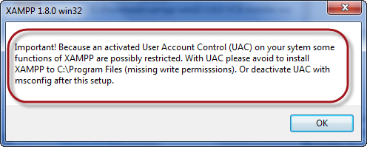
- If you are using windows Vista or Windows 7, make sure that you deactivate the User Account Control feature. To do this, Select Control Panel > User Accounts > Change User Access Control settings. The diagram below illustrates the main steps.
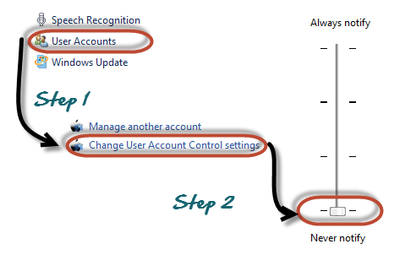
- After you have deactivated the User Account Control, click on OK button on the warning message box.
- This time you get following message
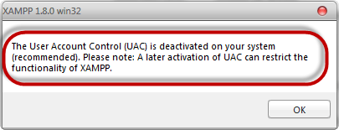
- In the succeeding screen, click next
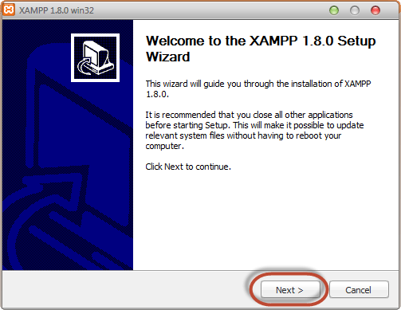
- In the next screen, Change the installation path if required. Click Next
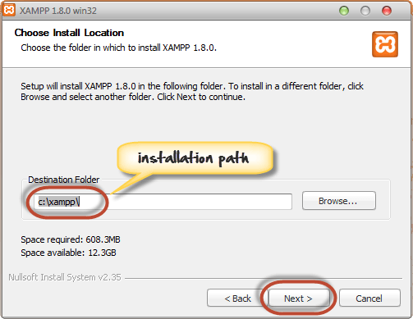
- In the next screen select Apache and MySQL. You may optionally select FileZilla (FTP Client) if needed. Click Install
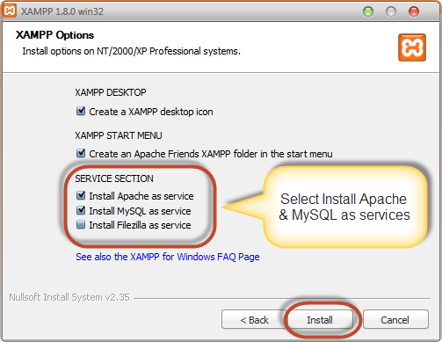
Note a service is a long-running program in windows that does not require user intervention. Services can be set to run automatically whenever the windows operating system is started. For you to use Apache and MySQL, they are supposed to be running in the background. Installing them as services runs both Apache and MySQL automatically in the background whenever you power up your computer. If you have not installed Apache and MySQL as services, then you have to manually start them every time that you want to use them. You will have to do this from the XAMPP control panel.PHP and
- On successful completion of installation, you will see following window
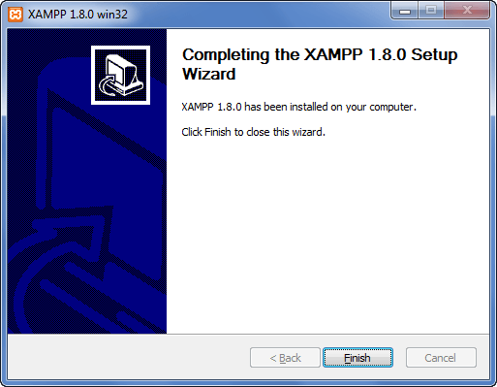
- Click on Finish button
Before we test our XAMPP installation, let’s first look at the basic directories that we will be working with.

Basic Web server configuration
This tutorial assumes that you have installed XAMPP on drive C in Windows using the steps mentioned above. The following is a list of the basic directories that you are supposed to be aware of.
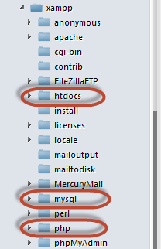

- htdocs; this is the web root directory. All of our PHP codes will be placed in this directory.
- mysql – this directory contains all the information related to MySQL database engine, by default it runs on port 3306.
- php – this directory contains PHP installation files. It contains an important file named php.ini. This directory is used to configure how PHP behaves on your server.
By default, the Apache web server runs on port 80. If port 80 is taken by another web server, you can use a different port number. For this tutorial we will assume we are using port 80. Note,If you use SKYPE , it uses the same port. Close Skype if you want to use Apache on port 80

XAMPP Control Panel
The control panel is used to manage programs installed via XAMPP. To open the XAMPP control panel,
- Click on start menu
- Explore the programs directory and locate Apace Friends then XAMPP as shown in the diagram below
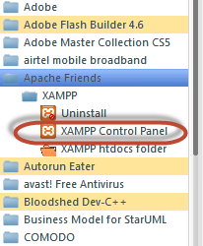
- The diagram below shows the control panel.
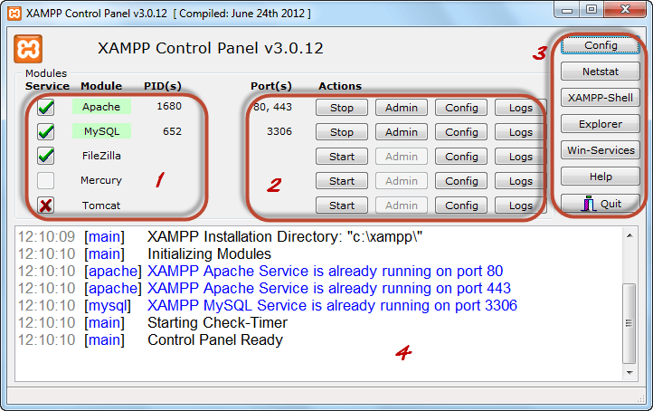
1) This section lists the installed services, modules and the process IDs PID(s). A green tick means the module has been installed as a service. The red mark means it has not been installed as a service. To install a service, click on the red mark. If the button shows a green tick and you click on it, the control panel will ask you if you want to uninstall the system.
2) This section shows Port(s) associated with the modules. The actions section is for;
- starting and stopping modules
- Open the administrative windows for Apache and MySQL
- Open configuration files for Apache, MySQL etc. to make changes
- View log files for the modules
3) This section contains useful utilities such as Netsat, windows services short cuts etc.
4) This section displays status information on the modules. The control panel can be used to;
- Install and uninstall services such as Apache, MySQL etc. that are installed via XAMPP
- Start and stop services.
- Open configure files etc.

Configure XAMPP
Let’s now look at the basic configurations required before we start using our XAMPP installation for developing PHP powered web sites. Type the URL http://localhost/xampp/ in your favorite browser. For this tutorial, we will be using Firefox as our web browser.
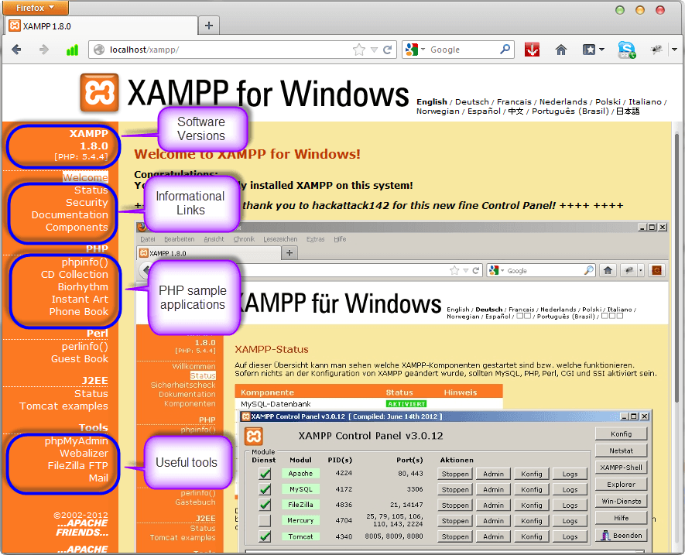
If you are able to see the above screen then you have installed XAMPP successfully. The panel on the left hand side contains links to useful information such as;
- The version of PHP installed
- Security settings of XAMPP
- Access to utilities such as phpMyAdmin etc.
Executing PHP and viewing in Browser
If you double click on a HTML file (files with .html or .htm extension), it would open on your web browser. But same won’t happen if you double clicked on a PHP file (probably it would open in an editor). The reason is PHP files first need be processed in a web server before sending their output to the web browser.
Therefore before running PHP files, they should be placed inside the web folder of a web server and then make a request to desired PHP file by typing its URL in the web browser. If you installed a web server in your computer, usually the root of its web folder can be accessed by typing http://localhost in the web browser. So, if you placed a file called hello.php inside its web folder, you can run that file by calling http://localhost/hello.php.
Web folder can be changed based on your web host (if you hosted your web site online) or the method you installed the web server in your computer. If you used XAMPP to install Apache (web server) in your computer then the web folder would be htdocs which is under the root directory of XAMPP.

RUN YOUR FIRST PHP SCRIPT
The following is an example about how to run a PHP script. What this program does is show a "Hello World!" text on the screen or webpage.

1 Go to XAMPP server directory
I'm using Windows, so my root server directory is "C:\xampp\htdocs\".

2 Create hello.php
Create a file and name it "hello.php"

3 Code Inside hello.php
Open hello.php and put the following code.
<?php
echo "Hello World!";
?>

4 Open New Tab
Run it by opening a new tab in your browser

5 Load hello.php
On you browser window, type http://localhost/hello.php

6 Output

You should see the following output.
