A

Lab file

“H.T.M.L. Lab

Bachelor of Computer Application (BCA)



Under the Guidance of :- Submited by :

Dr. Reema Ajmera Saksham tanja

Assistant professor Roll no. – 18BCAN036

BCA II Sem

Department of Information Technology & computer Application

**JECRC UNIVERSITY, JAIPUR**

cONTENT

1. Screenshot
2. Index.html
3. Resume.html
4. Resume.js

Screen 1

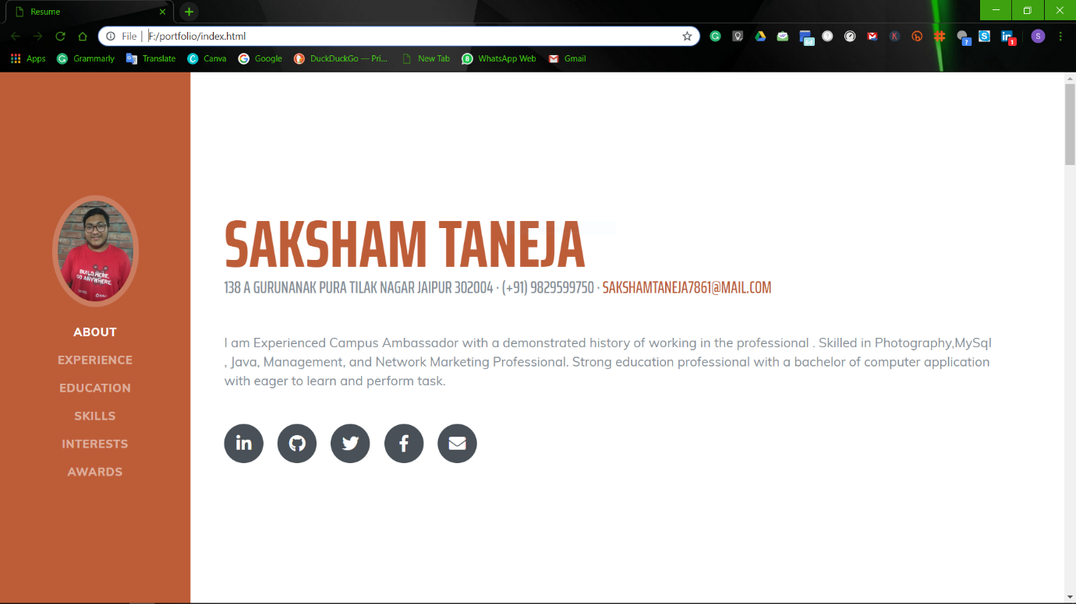

Screen 2

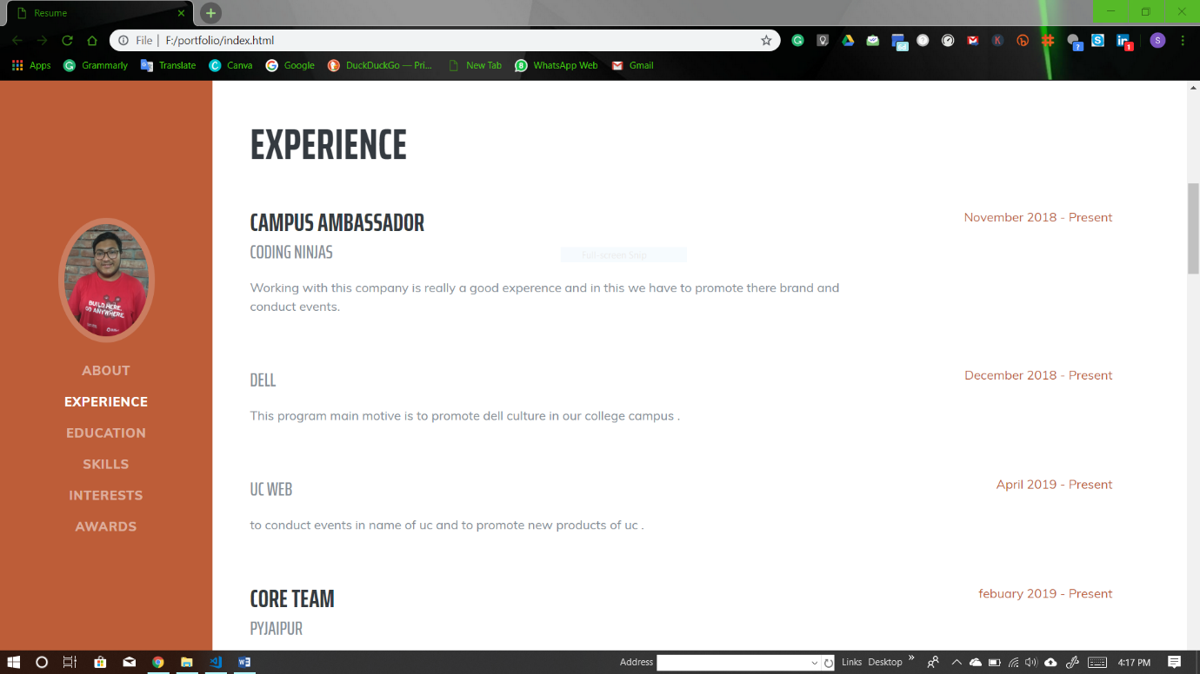

Screen 3

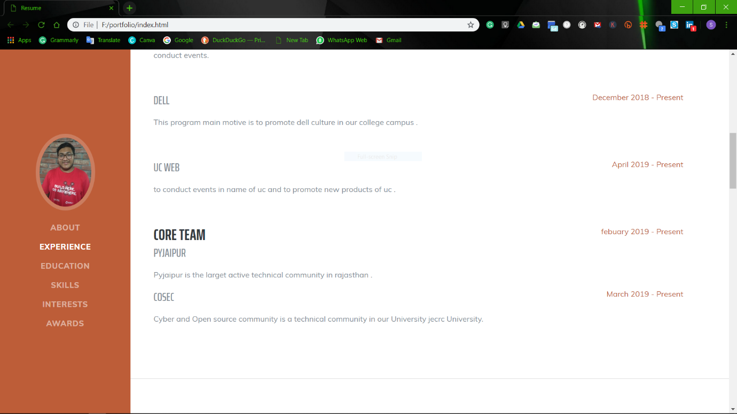

Screen 4 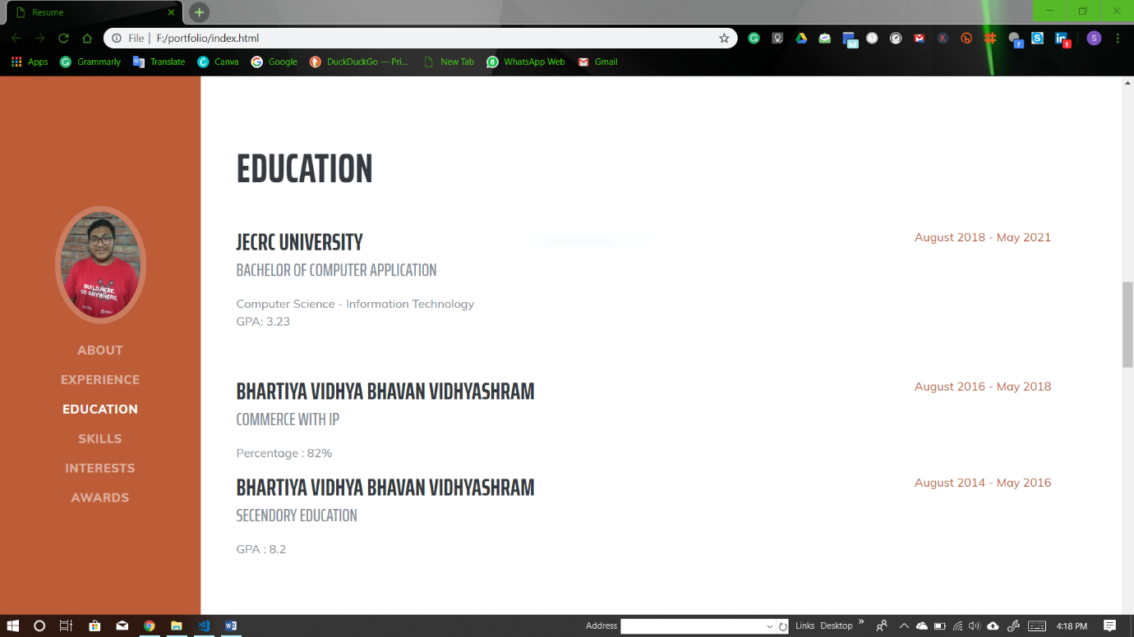

Screen 5 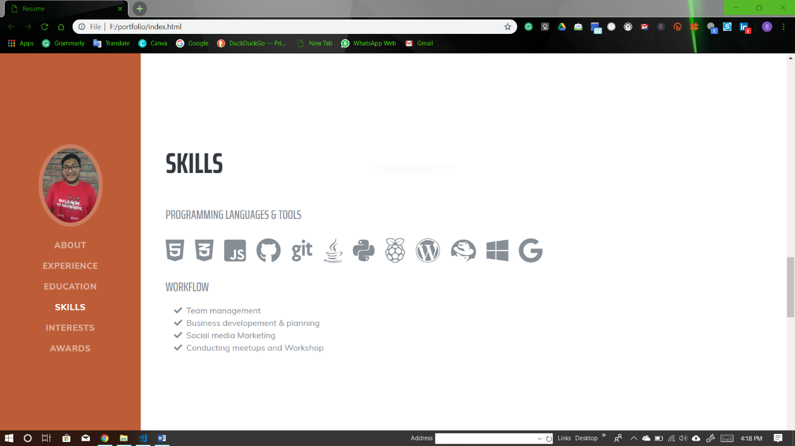

Screen 6

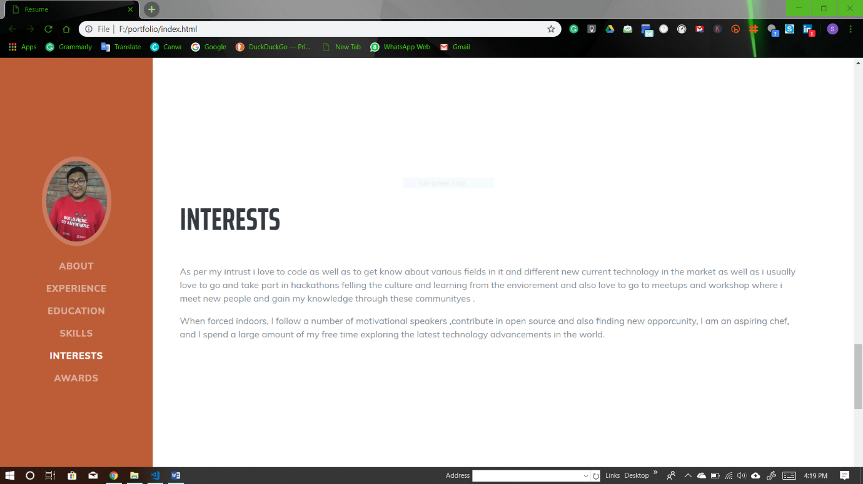

Screen 7

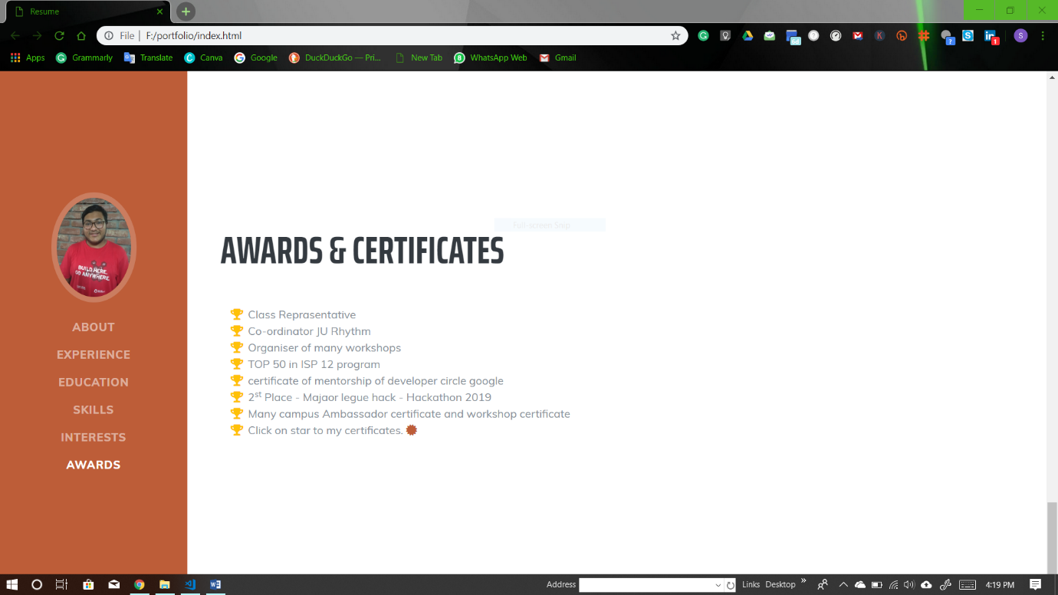

---------------XXXXX-------------

INDEX.html

<!DOCTYPE html>

<html lang="en">

<head>

<meta charset="utf-8">

<meta name="viewport" content="width=device-width, initial-scale=1, shrink-to-fit=no">

<meta name="description" content="">

<meta name="author" content="">

<title>Resume</title>

<!-- Bootstrap core CSS -->

<link href="vendor/bootstrap/css/bootstrap.min.css" rel="stylesheet">

<!-- Custom fonts for this template -->

<link href="https://fonts.googleapis.com/css?family=Saira+Extra+Condensed:500,700" rel="stylesheet">

<link href="https://fonts.googleapis.com/css?family=Muli:400,400i,800,800i" rel="stylesheet">

<link href="vendor/fontawesome-free/css/all.min.css" rel="stylesheet">

<!-- Custom styles for this template -->

<link href="css/resume.min.css" rel="stylesheet">

</head>

<body id="page-top">

<nav class="navbar navbar-expand-lg navbar-dark bg-primary fixed-top" id="sideNav">

<a class="navbar-brand js-scroll-trigger" href="#page-top">

<span class="d-block d-lg-none">Saksham Taneja</span>

<span class="d-none d-lg-block">

<img class="img-fluid img-profile rounded-circle mx-auto mb-2" src="img/profile.jpg" alt="">

</span>

</a>

<button class="navbar-toggler" type="button" data-toggle="collapse" data-target="#navbarSupportedContent" aria-controls="navbarSupportedContent" aria-expanded="false" aria-label="Toggle navigation">

<span class="navbar-toggler-icon"></span>

</button>

<div class="collapse navbar-collapse" id="navbarSupportedContent">

<ul class="navbar-nav">

<li class="nav-item">

<a class="nav-link js-scroll-trigger" href="#about">About</a>

</li>

<li class="nav-item">

<a class="nav-link js-scroll-trigger" href="#experience">Experience</a>

</li>

<li class="nav-item">

<a class="nav-link js-scroll-trigger" href="#education">Education</a>

</li>

<li class="nav-item">

<a class="nav-link js-scroll-trigger" href="#skills">Skills</a>

</li>

<li class="nav-item">

<a class="nav-link js-scroll-trigger" href="#interests">Interests</a>

</li>

<li class="nav-item">

<a class="nav-link js-scroll-trigger" href="#awards">Awards</a>

</li>

</ul>

</div>

</nav>

<div class="container-fluid p-0">

<section class="resume-section p-3 p-lg-5 d-flex align-items-center" id="about">

<div class="w-100">

<h1 class="mb-0">

<span class="text-primary">Saksham Taneja</span>

</h1>

<div class="subheading mb-5">138 A Gurunanak Pura Tilak Nagar Jaipur 302004 · (+91) 9829599750 ·

<a href="mailto:sakshamtaneja7861@gmail.com">sakshamtaneja7861@mail.com</a>

</div>

<p class="lead mb-5">I am Experienced Campus Ambassador with a demonstrated history of working in the professional . Skilled in Photography,MySql , Java, Management, and Network Marketing Professional. Strong education professional with a bachelor of computer application with eager to learn and perform task. </p>

<div class="social-icons">

<a href="https://www.linkedin.com/in/tanejasaksham/">

<i class="fab fa-linkedin-in"></i>

</a>

<a href="https://github.com/sakshamtaneja21">

<i class="fab fa-github"></i>

</a>

<a href="https://twitter.com/sakshamtaneja00">

<i class="fab fa-twitter"></i>

</a>

<a href="https://www.facebook.com/tanejasaksham">

<i class="fab fa-facebook-f"> </i>

</a>

<a href="https://mail.google.com/mail/?view=cm&amp;fs=1&amp;tf=1&amp;to=sakshamtaneja7861@gmail.com">

<i class="fas fa-envelope"></i>

</a>

</div>

</div>

</section>

<hr class="m-0">

<section class="resume-section p-3 p-lg-5 d-flex justify-content-center" id="experience">

<div class="w-100">

<h2 class="mb-5">Experience</h2>

<div class="resume-item d-flex flex-column flex-md-row justify-content-between mb-5">

<div class="resume-content">

<h3 class="mb-0">Campus Ambassador</h3>

<div class="subheading mb-3">Coding ninjas</div>

<p>Working with this company is really a good experence and in this we have to promote there brand and conduct events.</p>

</div>

<div class="resume-date text-md-right">

<span class="text-primary">November 2018 - Present</span>

</div>

</div>

<div class="resume-item d-flex flex-column flex-md-row justify-content-between mb-5">

<div class="resume-content">

<h3 class="mb-0"></h3>

<div class="subheading mb-3">Dell</div>

<p>This program main motive is to promote dell culture in our college campus .</p>

</div>

<div class="resume-date text-md-right">

<span class="text-primary">December 2018 - Present</span>

</div>

</div>

<div class="resume-item d-flex flex-column flex-md-row justify-content-between mb-5">

<div class="resume-content">

<h3 class="mb-0"></h3>

<div class="subheading mb-3">UC web </div>

<p>to conduct events in name of uc and to promote new products of uc .</p>

</div>

<div class="resume-date text-md-right">

<span class="text-primary">April 2019 - Present</span>

</div>

</div>

<div class="resume-item d-flex flex-column flex-md-row justify-content-between">

<div class="resume-content">

<h3 class="mb-0">Core Team</h3>

<div class="subheading mb-3">PyJaipur</div>

<p>Pyjaipur is the larget active technical community in rajasthan .</p>

</div>

<div class="resume-date text-md-right">

<span class="text-primary">febuary 2019 - Present</span>

</div>

</div>

<div class="resume-item d-flex flex-column flex-md-row justify-content-between mb-5">

<div class="resume-content">

<h3 class="mb-0"></h3>

<div class="subheading mb-3">Cosec </div>

<p> Cyber and Open source community is a technical community in our University jecrc University.</p>

</div>

<div class="resume-date text-md-right">

<span class="text-primary">March 2019 - Present</span>

</div>

</div>

</div>

</section>

<hr class="m-0">

<section class="resume-section p-3 p-lg-5 d-flex align-items-center" id="education">

<div class="w-100">

<h2 class="mb-5">Education</h2>

<div class="resume-item d-flex flex-column flex-md-row justify-content-between mb-5">

<div class="resume-content">

<h3 class="mb-0">JECRC University</h3>

<div class="subheading mb-3">Bachelor of Computer Application</div>

<div>Computer Science - Information Technology</div>

<p>GPA: 3.23</p>

</div>

<div class="resume-date text-md-right">

<span class="text-primary">August 2018 - May 2021</span>

</div>

</div>

<div class="resume-item d-flex flex-column flex-md-row justify-content-between">

<div class="resume-content">

<h3 class="mb-0">Bhartiya Vidhya bhavan Vidhyashram</h3>

<div class="subheading mb-3">Commerce with IP</div>

<p>Percentage : 82%</p>

</div>

<div class="resume-date text-md-right">

<span class="text-primary">August 2016 - May 2018</span>

</div>

</div>

<div class="resume-item d-flex flex-column flex-md-row justify-content-between">

<div class="resume-content">

<h3 class="mb-0">Bhartiya Vidhya bhavan Vidhyashram</h3>

<div class="subheading mb-3">Secendory Education</div>

<p>GPA : 8.2</p>

</div>

<div class="resume-date text-md-right">

<span class="text-primary">August 2014 - May 2016</span>

</div>

</div>

</div>

</section>

<hr class="m-0">

<section class="resume-section p-3 p-lg-5 d-flex align-items-center" id="skills">

<div class="w-100">

<h2 class="mb-5">Skills</h2>

<div class="subheading mb-3">Programming Languages &amp; Tools</div>

<ul class="list-inline dev-icons">

<li class="list-inline-item">

<i class="fab fa-html5"></i>

</li>

<li class="list-inline-item">

<i class="fab fa-css3-alt"></i>

</li>

<li class="list-inline-item">

<i class="fab fa-js-square"></i>

</li>

<li class="list-inline-item">

<i class="fab fa-github"></i>

</li>

<li class="list-inline-item">

<i class="fab fa-git"></i>

</li>

<li class="list-inline-item">

<i class="fab fa-java"></i>

</li>

<li class="list-inline-item">

<i class="fab fa-python"></i>

</li>

<li class="list-inline-item">

<i class="fab fa-raspberry-pi"></i>

</li>

<li class="list-inline-item">

<i class="fab fa-wordpress"></i>

</li>

<li class="list-inline-item">

<i class="fab fa-redhat"></i>

</li>

<li class="list-inline-item">

<i class="fab fa-windows"></i>

</li>

<li class="list-inline-item">

<i class="fab fa-google"></i>

</li>

</ul>

<div class="subheading mb-3">Workflow</div>

<ul class="fa-ul mb-0">

<li>

<i class="fa-li fa fa-check"></i>

Team management </li>

<li>

<i class="fa-li fa fa-check"></i>

Business developement &amp; planning</li>

<li>

<i class="fa-li fa fa-check"></i>

Social media Marketing</li>

<li>

<i class="fa-li fa fa-check"></i>

Conducting meetups and Workshop </li>

</ul>

</div>

</section>

<hr class="m-0">

<section class="resume-section p-3 p-lg-5 d-flex align-items-center" id="interests">

<div class="w-100">

<h2 class="mb-5">Interests</h2>

<p>As per my intrust i love to code as well as to get know about various fields in it and different new current technology in the market as well as i usually love to go and take part in hackathons felling the culture and learning from the enviorement and also love to go to meetups and workshop where i meet new people and gain my knowledge through these communityes .</p>

<p class="mb-0">When forced indoors, I follow a number of motivational speakers ,contribute in open source and also finding new opporcunity, I am an aspiring chef, and I spend a large amount of my free time exploring the latest technology advancements in the world.</p>

</div>

</section>

<hr class="m-0">

<section class="resume-section p-3 p-lg-5 d-flex align-items-center" id="awards">

<div class="w-100">

<h2 class="mb-5">Awards &amp; Certificates</h2>

<ul class="fa-ul mb-0">

<li>

<i class="fa-li fa fa-trophy text-warning"></i>

Class Reprasentative </li>

<li>

<i class="fa-li fa fa-trophy text-warning"></i>

Co-ordinator JU Rhythm </li>

<li>

<i class="fa-li fa fa-trophy text-warning"></i>

Organiser of many workshops </li>

<li>

<i class="fa-li fa fa-trophy text-warning"></i>

TOP 50 in ISP 12 program

</li>

<li>

<i class="fa-li fa fa-trophy text-warning"></i>

certificate of mentorship of developer circle google

</li>

<li>

<i class="fa-li fa fa-trophy text-warning"></i>

2<sup>st</sup>

Place - Majaor legue hack - Hackathon 2019</li>

<li>

<i class="fa-li fa fa-trophy text-warning"></i>

Many campus Ambassador certificate and workshop certificate

</li>

<li> <i class="fa-li fa fa-trophy text-warning"></i>

Click on star to my certificates.

<a href="https://drive.google.com/open?id=1-8voIYTUodqDyWrlj_e6L5FKkcj0dmEy">

<i class="fas fa-certificate"></i>

</li>

</ul>

</div>

</section>

</div>

<!-- Bootstrap core JavaScript -->

<script src="vendor/jquery/jquery.min.js"></script>

<script src="vendor/bootstrap/js/bootstrap.bundle.min.js"></script>

<!-- Plugin JavaScript -->

<script src="vendor/jquery-easing/jquery.easing.min.js"></script>

<!-- Custom scripts for this template -->

<script src="js/resume.min.js"></script>

</body>

</html>

Resume.css

body {

font-family: 'Muli', -apple-system, BlinkMacSystemFont, 'Segoe UI', Roboto, 'Helvetica Neue', Arial, sans-serif, 'Apple Color Emoji', 'Segoe UI Emoji', 'Segoe UI Symbol', 'Noto Color Emoji';

padding-top: 54px;

color: #868e96;

}

@media (min-width: 992px) {

body {

padding-top: 0;

padding-left: 17rem;

}

}

h1,

h2,

h3,

h4,

h5,

h6 {

font-family: 'Saira Extra Condensed', -apple-system, BlinkMacSystemFont, 'Segoe UI', Roboto, 'Helvetica Neue', Arial, sans-serif, 'Apple Color Emoji', 'Segoe UI Emoji', 'Segoe UI Symbol', 'Noto Color Emoji';

font-weight: 700;

text-transform: uppercase;

color: #343a40;

}

h1 {

font-size: 6rem;

line-height: 5.5rem;

}

h2 {

font-size: 3.5rem;

}

h3 {

font-size: 2rem;

}

p.lead {

font-size: 1.15rem;

font-weight: 400;

}

.subheading {

text-transform: uppercase;

font-weight: 500;

font-family: 'Saira Extra Condensed', -apple-system, BlinkMacSystemFont, 'Segoe UI', Roboto, 'Helvetica Neue', Arial, sans-serif, 'Apple Color Emoji', 'Segoe UI Emoji', 'Segoe UI Symbol', 'Noto Color Emoji';

font-size: 1.5rem;

}

.social-icons a {

display: inline-block;

height: 3.5rem;

width: 3.5rem;

background-color: #495057;

color: #fff !important;

border-radius: 100%;

text-align: center;

font-size: 1.5rem;

line-height: 3.5rem;

margin-right: 1rem;

}

.social-icons a:last-child {

margin-right: 0;

}

.social-icons a:hover {

background-color: #BD5D38;

}

.dev-icons {

font-size: 3rem;

}

.dev-icons .list-inline-item i:hover {

color: #BD5D38;

}

#sideNav .navbar-nav .nav-item .nav-link {

font-weight: 800;

letter-spacing: 0.05rem;

text-transform: uppercase;

}

#sideNav .navbar-toggler:focus {

outline-color: #d48a6e;

}

@media (min-width: 992px) {

#sideNav {

text-align: center;

position: fixed;

top: 0;

left: 0;

display: -webkit-box;

display: -ms-flexbox;

display: flex;

-webkit-box-orient: vertical;

-webkit-box-direction: normal;

-ms-flex-direction: column;

flex-direction: column;

width: 17rem;

height: 100vh;

}

#sideNav .navbar-brand {

display: -webkit-box;

display: -ms-flexbox;

display: flex;

margin: auto auto 0;

padding: 0.5rem;

}

#sideNav .navbar-brand .img-profile {

max-width: 10rem;

max-height: 10rem;

border: 0.5rem solid rgba(255, 255, 255, 0.2);

}

#sideNav .navbar-collapse {

display: -webkit-box;

display: -ms-flexbox;

display: flex;

-webkit-box-align: start;

-ms-flex-align: start;

align-items: flex-start;

-webkit-box-flex: 0;

-ms-flex-positive: 0;

flex-grow: 0;

width: 100%;

margin-bottom: auto;

}

#sideNav .navbar-collapse .navbar-nav {

-webkit-box-orient: vertical;

-webkit-box-direction: normal;

-ms-flex-direction: column;

flex-direction: column;

width: 100%;

}

#sideNav .navbar-collapse .navbar-nav .nav-item {

display: block;

}

#sideNav .navbar-collapse .navbar-nav .nav-item .nav-link {

display: block;

}

}

section.resume-section {

padding-top: 5rem !important;

padding-bottom: 5rem !important;

max-width: 75rem;

}

section.resume-section .resume-item .resume-date {

min-width: none;

}

@media (min-width: 768px) {

section.resume-section {

min-height: 100vh;

}

section.resume-section .resume-item .resume-date {

min-width: 18rem;

}

}

@media (min-width: 992px) {

section.resume-section {

padding-top: 3rem !important;

padding-bottom: 3rem !important;

}

}

.bg-primary {

background-color: #BD5D38 !important;

}

.text-primary {

color: #BD5D38 !important;

}

a {

color: #BD5D38;

}

a:hover, a:focus, a:active {

color: #824027;

}

Resume.js

(function($) {

"use strict"; // Start of use strict

$('a.js-scroll-trigger[href*="#"]:not([href="#"])').click(function() {

if (location.pathname.replace(/^\//, '') == this.pathname.replace(/^\//, '') && location.hostname == this.hostname) {

var target = $(this.hash);

target = target.length ? target : $('[name=' + this.hash.slice(1) + ']');

if (target.length) {

$('html, body').animate({

scrollTop: (target.offset().top)

}, 1000, "easeInOutExpo");

return false;

}

}

});

$('.js-scroll-trigger').click(function() {

$('.navbar-collapse').collapse('hide');

});

$('body').scrollspy({

target: '#sideNav'

});

})(jQuery); // End of use strict