12 AUGUST 2022

HOUSE PRICE PREDICTION

**SUBMITTED BY :** 

IQMAN SINGH BHATIA

ABHINAV BAINS

DIVYANSH AGGARWAL

SAKSHAM KAUSHIK

**SUBMITTED TO :**

MRS. URVASHI NAG

MR. AMRENDRA

SHARAN SIR

B.TECH CSE CCET, SECTOR-26

INTRODUCTION

**- Due to increase in urbanisation, there is an increase in demand for renting houses and purchasing houses. Therefore, to determine a more effective way to calculate house price that accurately reflects the market price becomes a hot topic.**

**- The paper focuses on finding the house price accurately by using machine learning. - This will be helpful for both the sellers and buyers for finding the best price for the house.**

LANGUAGES AND

LIBRARIES USED : 

**- PYTHON**

**- PANDAS**

**- NUMPY**

**- MATPLOTLIB**

**- The Jupyter Notebook is the original web application for**

**creating and sharing computational documents**

DATA SET SOURCE :

**Our Data comes from a Kaggle competition named “banglore_home_prices”.**

! NOW LETS START WITH OUR MODEL !

IMPORTING LIBRARIES : 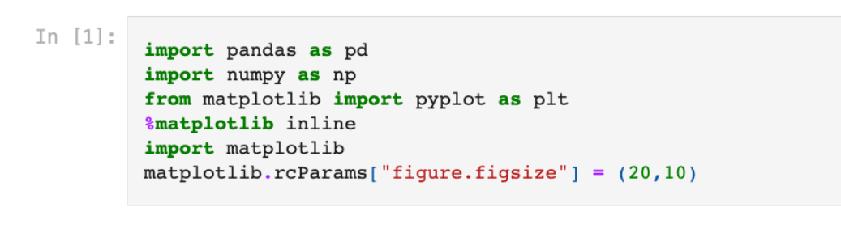

DATA LOAD : LOAD BANGLORE HOME PRICES INTO A DATAFRAME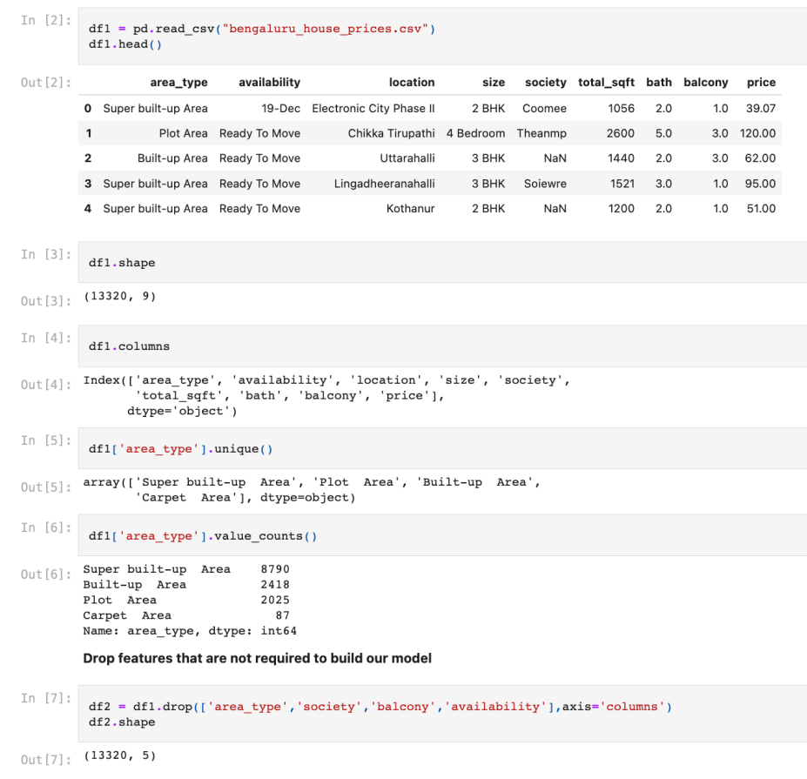

DATA CLEANING : HANDLE NA VALUES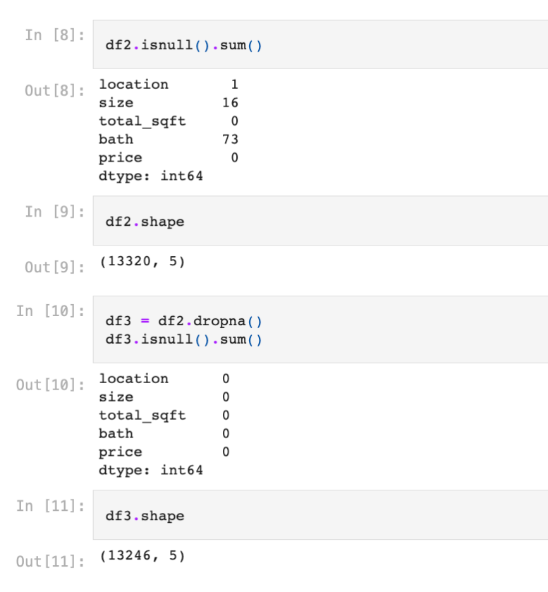

FEATURE ENGINEERING

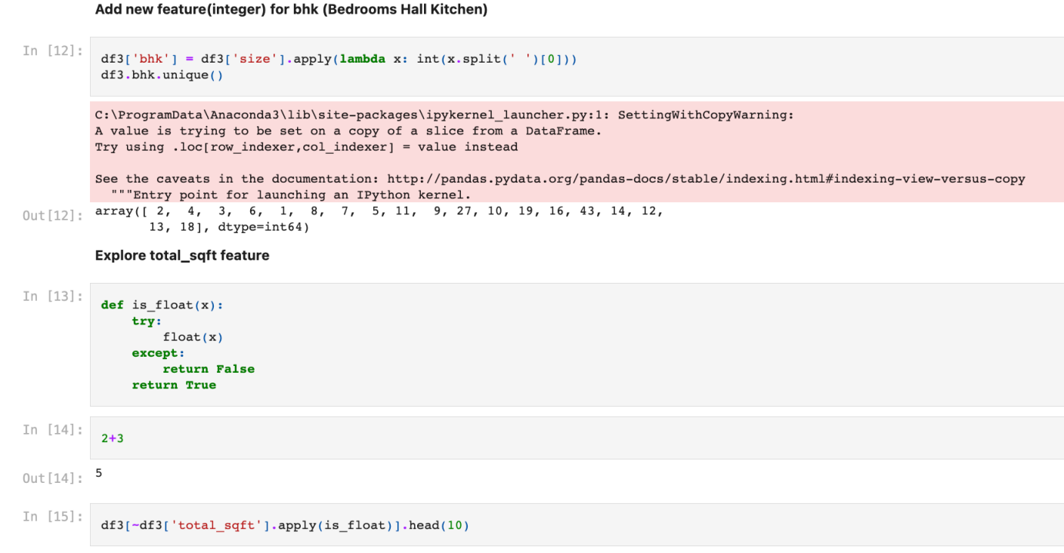

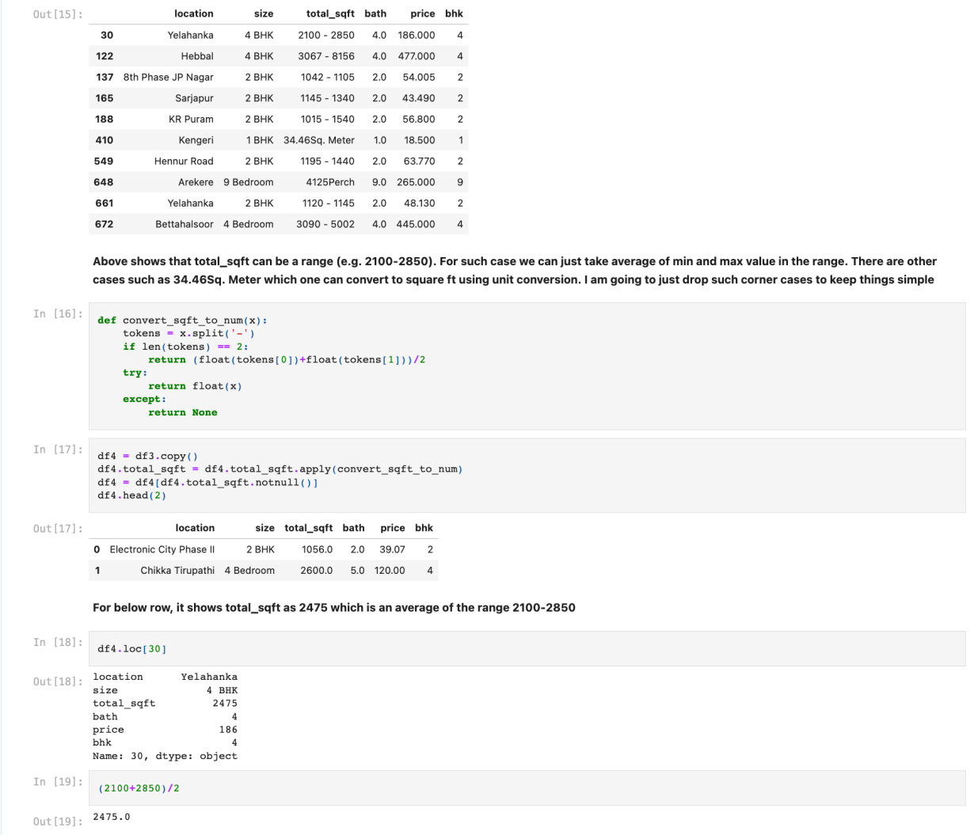

FEATURE ENGINEERING

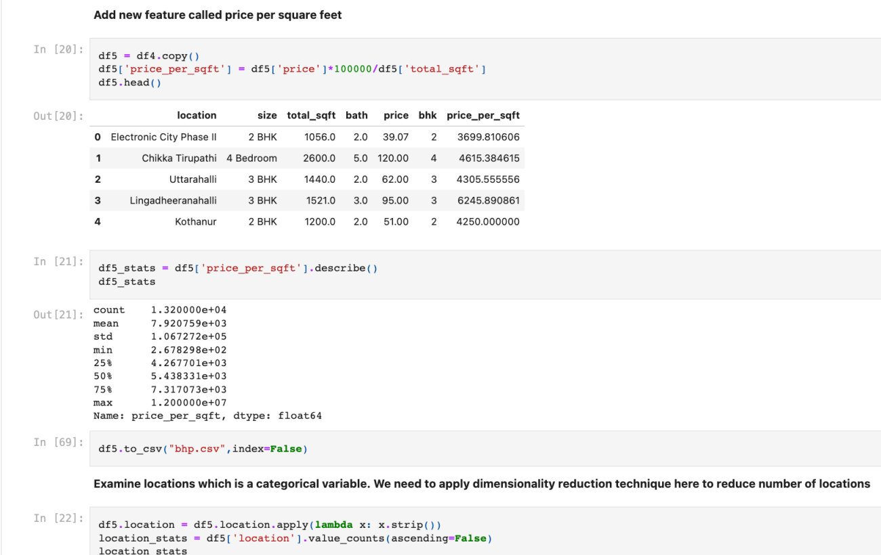

**[1]** 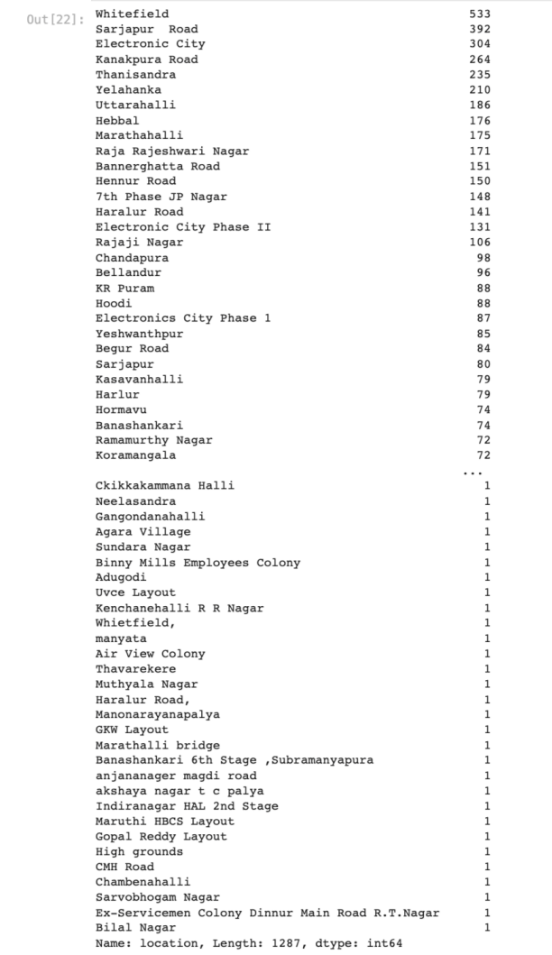

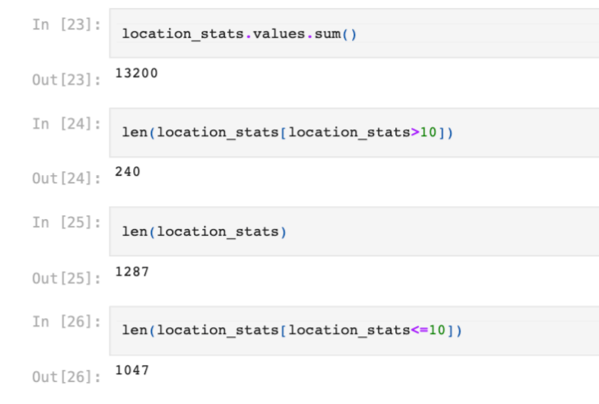**[2]**

DIMENSIONALITY REDUCTION

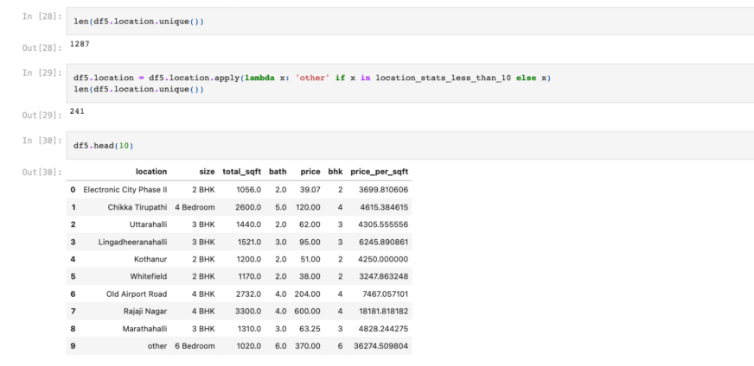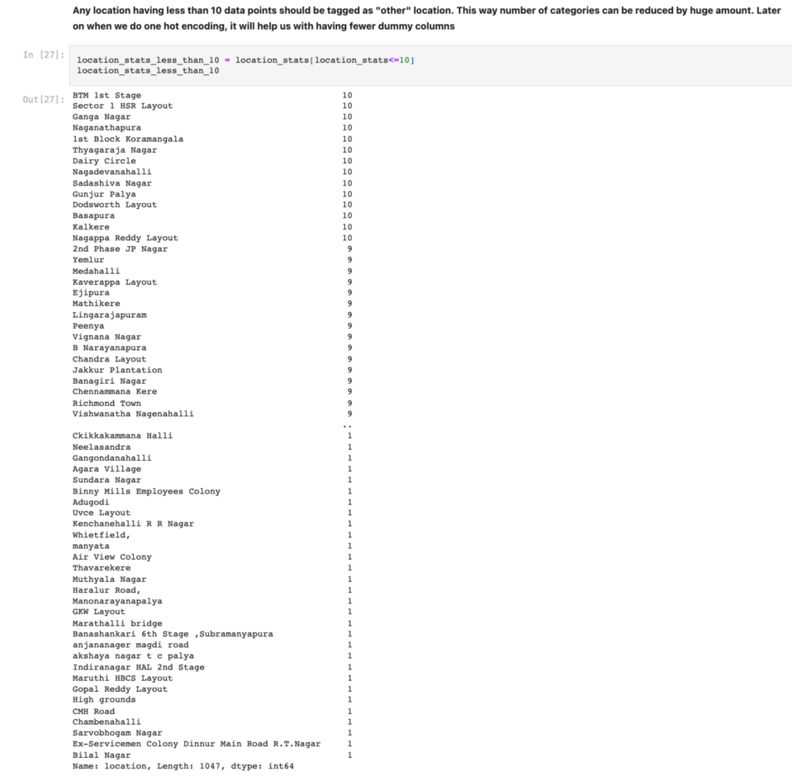

**[1]**

**[2]**

OUTLIER REMOVAL USING BUSINESS LOGIC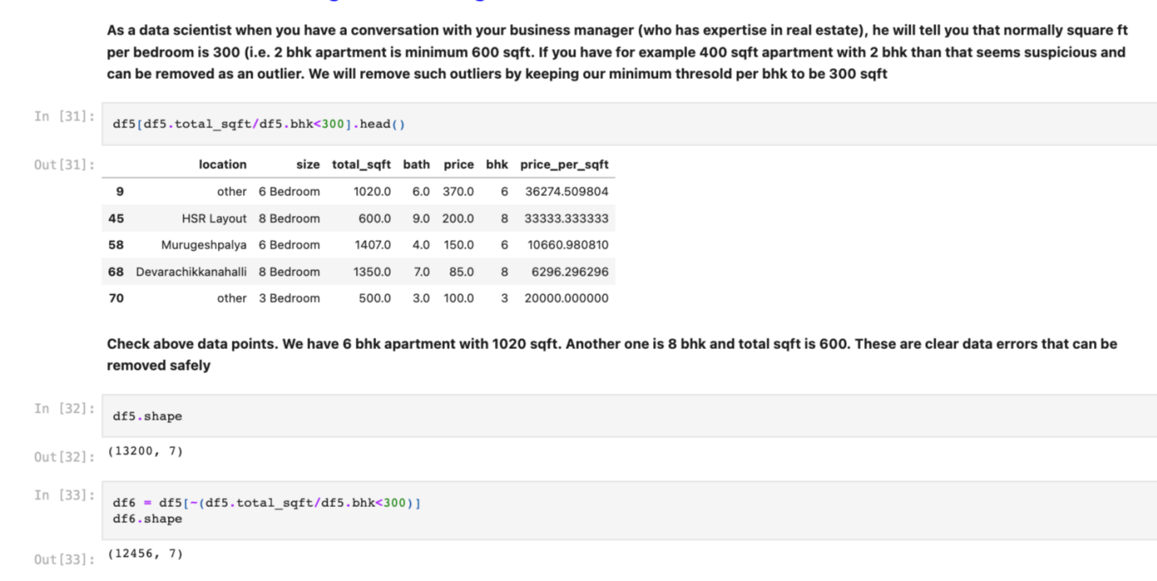

OUTLIER REMOVAL USING STANDARD DEVIATION AND MEAN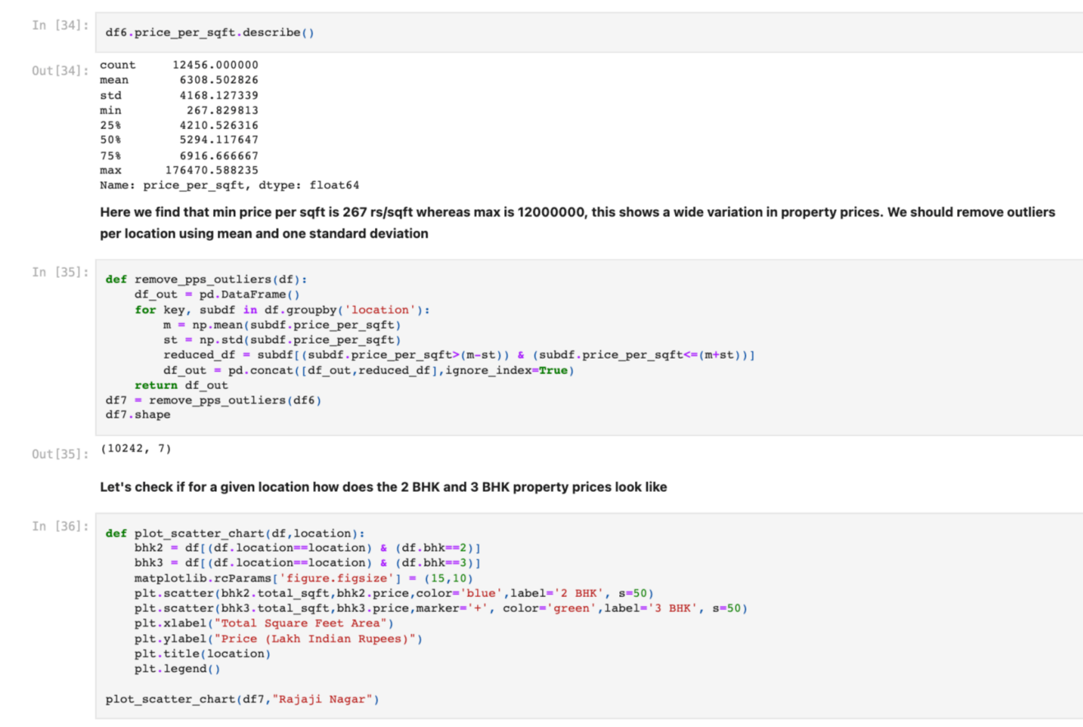

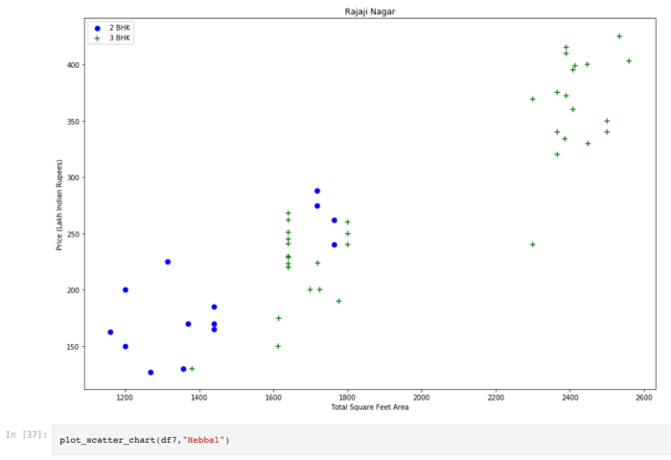**[1] [2]**

**[4]**

**[3]**

**[1] [2]**

**[3]**

**[4]**

OUTLIER REMOVAL USING BATHROOMS FEATURE



USE ONE HOT ENCODING FOR LOCATION



BUILD A MODEL NOW...



USE K FOLD CROSS VALIDATION TO MEASURE ACCURACY OF OUR LINEARREGRESSION MODEL

FIND BEST MODEL USING GRIDSEARCHCV

TEST THE MODEL FOR FEW PROPERTIES

EXPORT THE TESTED MODEL TO A PICKLE FILE



EXPORT LOCATION AND COLUMN INFORMATION TO A FILE THAT WILL BE USEFUL LATER ON IN OUR PREDICTION APPLICATION



SETTING OF FLASK SERVER

FLASK DATA FUNCTIONS



APP.HTML <!DOCTYPE html>

APP.CSS APP.JS

@import url(https://fonts.googleapis.com/css?family=Roboto:300);

function getBathValue() {

<html>

<head>

<title>Banglore Home Price Prediction</title>

<script src="https://ajax.googleapis.com/ajax/libs/jquery/3.4.1/jquery.min.js"></script> <script src="app.js"></script>

<link rel="stylesheet" href="app.css">

</head>

<body>

<div class="img"></div>

<form class="form">

<h2>Area (Square Feet)</h2>

<input class="area" type="text" id="uiSqft" class="floatLabel" name="Squareft" value="1000"> <h2>BHK</h2>

<div class="switch-field">

<input type="radio" id="radio-bhk-1" name="uiBHK" value="1"/>

<label for="radio-bhk-1">1</label>

<input type="radio" id="radio-bhk-2" name="uiBHK" value="2" checked/> <label for="radio-bhk-2">2</label>

<input type="radio" id="radio-bhk-3" name="uiBHK" value="3"/>

<label for="radio-bhk-3">3</label>

<input type="radio" id="radio-bhk-4" name="uiBHK" value="4"/>

<label for="radio-bhk-4">4</label>

<input type="radio" id="radio-bhk-5" name="uiBHK" value="5"/>

<label for="radio-bhk-5">5</label>

</div>

</form>

<form class="form">

<h2>Bath</h2>

<div class="switch-field">

<input type="radio" id="radio-bath-1" name="uiBathrooms" value="1"/>

<label for="radio-bath-1">1</label>

<input type="radio" id="radio-bath-2" name="uiBathrooms" value="2" checked/>

.switch-field {

display: flex;

margin-bottom: 36px;

overflow: hidden;

}

.switch-field input {

position: absolute !important;

clip: rect(0, 0, 0, 0);

height: 1px;

width: 1px;

border: 0;

overflow: hidden;

}

.switch-field label {

background-color: #e4e4e4;

color: rgba(0, 0, 0, 0.6);

font-size: 14px;

line-height: 1;

text-align: center;

padding: 8px 16px;

margin-right: -1px;

border: 1px solid rgba(0, 0, 0, 0.2);

box-shadow: inset 0 1px 3px rgba(0, 0, 0, 0.3), 0 1px rgba(255, 255, 255, 0.1); transition: all 0.1s ease-in-out;

}

.switch-field label:hover {

cursor: pointer;

}

var uiBathrooms = document.getElementsByName("uiBathrooms");

for(var i in uiBathrooms) {

if(uiBathrooms[i].checked) {

return parseInt(i)+1;

}

}

return -1; // Invalid Value

}

function getBHKValue() {

var uiBHK = document.getElementsByName("uiBHK");

for(var i in uiBHK) {

if(uiBHK[i].checked) {

return parseInt(i)+1;

}

}

return -1; // Invalid Value

}

function onClickedEstimatePrice() {

console.log("Estimate price button clicked");

var sqft = document.getElementById("uiSqft");

var bhk = getBHKValue();

var bathrooms = getBathValue();

var location = document.getElementById("uiLocations");

var estPrice = document.getElementById("uiEstimatedPrice");

// var url = "http://127.0.0.1:5000/predict_home_price"; //Use this if you are NOT using nginx which is first 7 tutorials var url = "/api/predict_home_price"; // Use this if you are using nginx. i.e tutorial 8 and onwards

$.post(url, {

total_sqft: parseFloat(sqft.value),

WEB APPLICATION



CONCLUSION AND FUTURE SCOPE :

TILL NOW WE HAVE TAKEN THE DATA ON BANGLORE ALONE. IN FUTURE WE HOPE TO TAKE THE DATA OF OTHER STATES ALSO

OUR MODEL HAS AN ACCURACY OF 86 % TILL TODAY. WE HOPE TO INCREASE THE ACCURACY IN NEAR FUTURE.

THANKYOU