**Maximization of Coverage with Minimum Directed Sensors in a Randomly Deployed Wireless Sensor Network using Graph Theoretic Approach**

Sakshar Chakravarty (1305002) and Laboni Sarker (1305115)

Computer Science & Engineering, BUET

Email: [pappa2350@gmail.com](mailto:pappa2350@gmail.com), [labonisarker15@gmail.com](mailto:labonisarker15@gmail.com)

1. Introduction

Coverage problem is one of the principal problems in the context of wireless sensor network. There have been extensive studies on this so that maximum coverage can be ensured using least activated sensors. Till now, elaborate studies have been done for isotropic wireless sensors. Isotropic sensors have a circular or disk shaped uniform sensing range. Different algorithms have been developed for coverage maximization for isotropic sensors. But very few works are done for directed sensors with tunable orientation. A directed sensor can sense in a particular direction at a time by fixing its orientation. Nowadays, there are lots of applications of directed sensor networks. Visual sensor network (VSN), surveillance, monitoring and tracking systems are developed using this type of sensors. A very common example of directed sensor can be cameras which have become a familiar device in the maintenance of security.

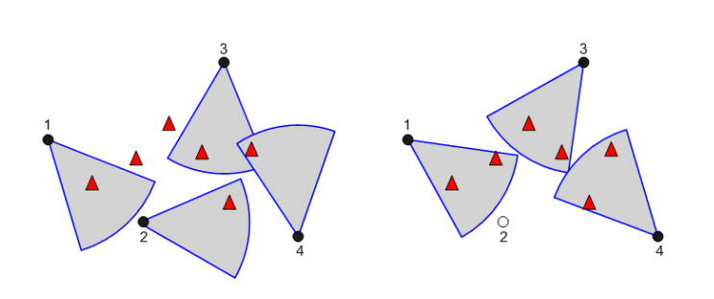

Fig: A random deployment

The solution to coverage problem focuses on two aspects; maximization of coverage area or maximization of the number of discrete targets covered and at the same time minimizing the number of active sensors at any instant. Here, the process of selecting a sensor follows two steps; firstly, selecting a sensor and next fixing its orientation. We can prove that this is an NP-complete problem. Therefore, to get a near optimal solution in polynomial time, we use different heuristics approach. All the existing works on directed sensor network are implemented using Greedy approach. However, greedy approach can give near optimal solution in most cases, there are many cases where it fails. Another issue with greedy approach is that the process of selecting a sensor and fixing its orientation is merged together. Splitting these two steps can give more flexibility for using different heuristics.

In this thesis, we have tried a different approach for problem formulation and solution than the existing works. We have tried to model the problem using graph theoretic approach. Graph theoretic approach provides us the opportunity to experiment with so many well-known graph algorithm having polynomial time complexity. We model a weighted multi graph from the configurations of sensors and targets. We term this graph as a conflict graph. Using the information from the graph, we can develop different heuristics for choosing a sensor. Then we fixed the orientation of the chosen sensor greedily. We have considered a random deployment environment since deterministic deployment is more complex. In inclement scenario, random deployment is more suitable. Here, a fixed number of targets and sensors are randomly deployed. The location of all the targets are known to each sensor. So, each sensor knows which targets are covered by it in each orientation. From this we can develop a conflict graph; each sensor acts as a vertex and a weighted edge is added between two vertices if there is any target covered by both sensors for an orientation of them each. The weight of each edge represents the number of common targets covered by the two sensors at their particular orientations. We then implement different heuristics on this conflict graph to solve the problem.

Besides, the problem can be viewed from two different perspectives; sensor-oriented and target-oriented. All the existing works are done based on either one of them. We have tried to combine the merits of both the approaches in our heuristics to attain better performance.

In greedy approach, each selection affects the problem model in such a way that it requires sorting of the remaining sensor-orientation pairs based on the number of targets covered by them. But conflict graph approach localizes this effect of sensor selection within the neighbors only. So, conflict graph approach has an upper hand over greedy approach with respect to time complexity. Besides, most VSN are overprovisioned systems. Greedy approach performs well for under provisioned systems. But, it gives poor performance in an overprovisioned system. Our conflict graph approach provides a way around this drawback of the greedy approach.

1. Background & Problem Formulation

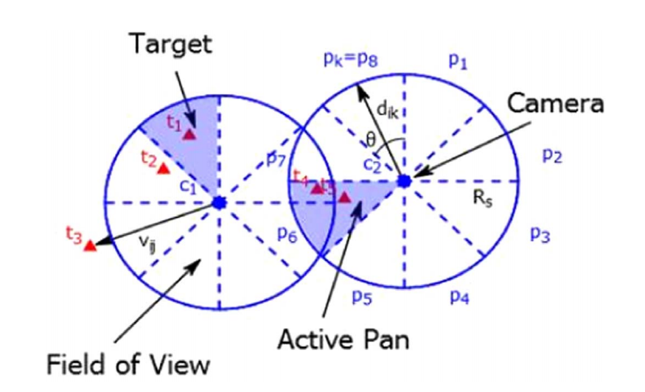

1. Literature Review

Extensive works have been done over the past years in the area of wireless sensor networks for isotropic sensors. Only a few works are done with directional sensors. Generally, directional sensors are considered as visual sensors since they can sense only along a particular direction at any time. The primary goals of the research works in the area of VSN are design issues related to optimal placement and orientation of the visual sensors, energy efficient scheduling techniques to increase network lifetime, cost-effective transmission system for obtained sensor data, and fault tolerant network design to attain secured connectivity of the network. Yap and Yen (2014) have worked on these design issues. Liu et al. (2016) have done a comprehensive survey on different design aspects of VSN.

There has been some works regarding optimal placement and orientation of sensors to achieve some predefined goals. Chakrabarty et al. (2002) investigated on optimal placement problem considering the deployment area as a grid of coordinates. Only one visual sensor can be placed at a coordinate within the grid. They designed an Integer Linear Programming (ILP) model for solving small scale instances of the problem and for solving large scale instances, followed a Divide and Conquer approach. Horster and Lienhart (2006) deviced a rank based greedy heuristic for placing the sensors where rank of sensor was calculated based on its cost and achievable target coverage. Sensor placement is a very important problem for VSNs. But it this thesis, we only focus on the problem of selection and orientation of the randomly deployed sensors.

In a randomly deployed environment, it is required to keep the number of active sensors at a time to a minimum due to limitation on energy consumption. So, the most important question in this context is how to select the sensors in an appropriate manner? The solution to this problem can be viewed from two directions: - (i) sensor-oriented approach, and (ii) target-oriented approach. There has been several works focusing on these two approaches. All of them aimed at maximizing target coverage with minimum number of sensors. Ai and Abouzeid (2006) proposed an ILP formulation that gave an exact optimal solution to this MCMS problem. But it is not suitable for large-scale scenario due to its high computational complexity and low computational capabilities of the deployed sensors. As a solution to this issue they proposed a Centralized Greedy Algorithm (CGA) and a Distributed Greedy Algorithm (DGA). DGA was introduced to achieve scalability in place of CGA. But CGA had some shortcomings in case of resolving tie between sensors. To come round the shortcomings of CGA, Munishwar and Abu-Ghazaleh (2013) proposed another heuristic based on greedy approach. They called it Centralized Force-directed Algorithm (CFA). The modification they made was that if a sensor covered some targets in only one pan, that sensor is selected first. So, they created a way to assign priority to each sensor pans. Instead of activating a sensor having maximum number of uncovered targets in some pans, they decided to activate the sensor having targets only in a single pan first and cover those targets. To find out such sensors, they introduced a concept, force which is the measurement of priority assigned to each pan. The force of a sensor-pan pair is the ration of coverable targets in that pan of the sensor to the total number of uncovered targets available in all pans of that sensor. The higher the value of force, the higher is the priority. The value of force equal to 1 indicated that that sensor covered targets only in that pan and subsequently got selected first. Munishwar et al. (2011) also suggested a distributed algorithm to achieve coverage maximization. Here, they overlooked the idea of minimizing active sensors. Initially, all sensors assign a unique priority value by themselves. Then each sensor detects the total number of targets it can cover in each direction and orients itself to the direction of maximum target coverage. This orientation information is exchanged among the sensors located within twice of the sensing range. If there are more than one sensor covering a particular region, the orientation of the highest priority sensor prevails. For assigning priority they proposed two approaches: - (i) an area based approach, and (ii) a target based approach. In area based approach higher priority is assigned to the sensor with lower degrees of overlap in coverage with other sensors. In target based approach, a sensor’s priority is higher if it has lower number of useful pans, in other words, it has coverable targets in fewer pans than other sensors. All research works discussed till now are based on sensor oriented approach.

There has been works on target oriented approach too. H. Zannat et al. (2016) proposed three different heuristics for target oriented approach. The proposed algorithms are Greedy Target Oriented Heuristic (GTOH), Pure Target Oriented Heuristic (PTOH), and Hybrid Target Oriented Heuristic (HTOH). This approach differs from sensor oriented approach in a very vital aspect. In sensor oriented approach, priority is assigned to sensor and all targets are treated equally. But here, targets are assigned some priority and in each iteration, higher priority targets are selected and a sensor-pan pair is assigned to it. In GTOH, targets coverable by a single sensor (lonely targets) is given the highest priority. However, targets coverable by more than one sensors are assigned equal priority without any consideration of number of sensors covering them. PTOH differs from GTOH in the weight assignment of targets and the sensor selection criteria at each iteration. HTOH combines the ideas of both GTOH and PTOH. The weight assignment of targets and rank calculation of sensor-pan pairs are similar to PTOH. But the rule for selecting sensor-pan pairs follows GTOH.

There has been a few works (Fusco and Gupta, 2009; Lu and Yu, 2014; Costa et al., 2014) focusing at k-coverage problem in directional sensor networks. These works are designed to allow redundant sensor activation so that multiple coverage can be ensured to all or prioritized targets. Costa et al. (2014) proposed an algorithm to achieve a high level of monitoring redundancy for some critical targets by concurrently viewing them using more than one visual sensor. The optimal solution to k-coverage problem has been proved to be NP-hard by Fusco and Gupta (2009). They provided a centralized greedy solution to the problem assuming that each sensor has overlapping pans instead of discrete pans. They also proposed approximation algorithms to some related problems on directional sensors: (i) orient all the given sensors in order to maximize coverage, (ii) place and orient a minimum number of sensors in order to cover the given area, and (iii) place and orient the given number of sensors to maximize the area covered. Malek et al. (2016) identified a novel issue called coverage balancing in k-coverage problem and provided centralized solutions to jointly solve k-coverage and coverage balancing. The solutions to k-coverage problems address fault tolerance issue which is beyond the scope of this paper and we limit ourselves only to 1-coverage.

1. Motivation

All the related works are formulated based on greedy approach. They have designed their solution either in a sensor-oriented or a target-oriented way. Each of the existing algorithm fuse the selection of a sensor and fixing its orientation into a single step. Most of them focused only on target coverage maximization, giving less priority towards sensor minimization. All of the discussed works have another limitation in the process of eliminating targets which get covered at each iteration after the selection of a sensor. To remove targets that are covered at the current selection, they required to search the total set of inactive sensors each time.

In this thesis we are proposing to model the problem in graph theoretic approach which will add a new dimension to this problem. After modeling the problem we can apply well known graph algorithms which may help us to find better heuristics to find the solution of the problem. Again in our proposed system, the single step of selecting the sensor and orientation is split into two steps: (i) selecting the sensor and (ii) selecting the best orientation from that selected sensor. The traditional methods that we have studied or discussed are either sensor-oriented or target-oriented. When we complete modeling the problem using graph, we can implement both at the same time depending on different heuristics. In the previous methods, we have no prior information about the targets which are covered by more than one sensor. Because of it, after the selection of a sensor we have to search all the sensors and each of their orientations for removing the targets covered at the current selection from the target set of the inactive sensors. But in our proposed one, this search will be more localized which will reduce the runtime.

1. Work Plan

First of all, we have to model the problem in graph theoretic approach. The nodes of the graph will be the sensors deployed. The edges between two sensors will be on the basis of the conflict targets. The targets which are covered by more than one sensor