Visualization of Urban Trajectory Dataset

Using D3

**Name: Sakshat Surve.**

**UNCC Id: 801080533.**

**Introduction:**

This dataset is about the taxi trajectory of Porto, Portugal. The data is stored in json format in the js folder as *trips.js*. We scrap the data based on the highlighted part of the map. The highlighting is done by a simple pick and drag function of the mouse on the map. After selecting a particular section we get the taxi routes that go through that section of the map. After that based on the UI you can select the type of visualization you need and a graph is plotted accordingly. The programming language used in this project is JavaScript and tool used is D3.

The home page looks like this:

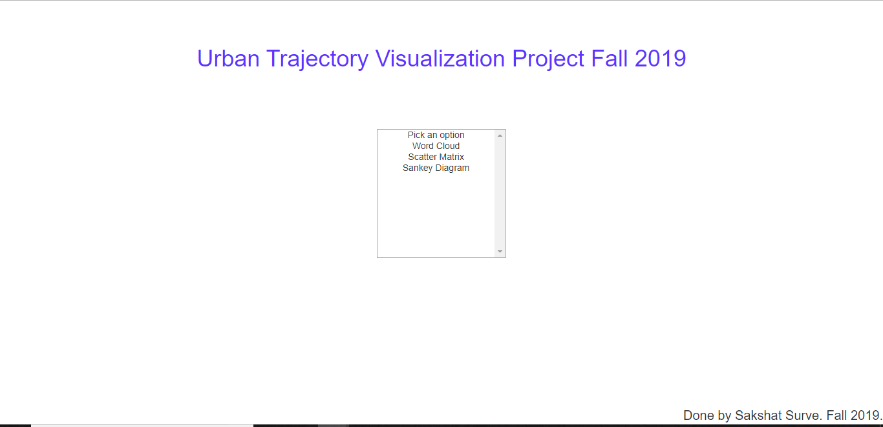

After selecting any option you directed to that page with a map of Porto and once you select a region, the taxi trajectories are highlighted in red as follows:

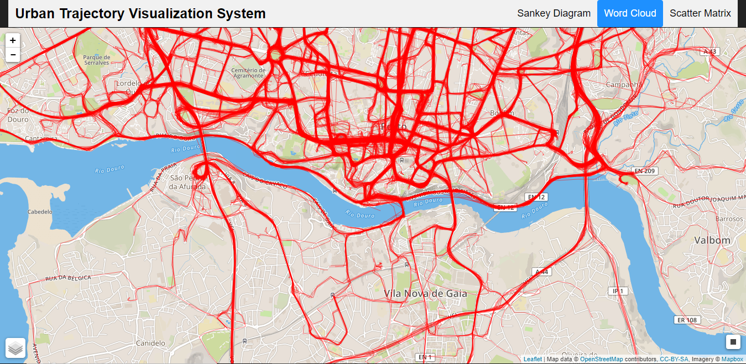

**Visualizations:**

Word Cloud:

The word cloud is a representation of words that gives a preference to words with higher frequency. Thus, here a word cloud is made on the top 30 most common (start, destination) pairs present in the selected area. The word cloud is made by using streetnames from the highlighted section and taking a count of every time a street name has occurred.

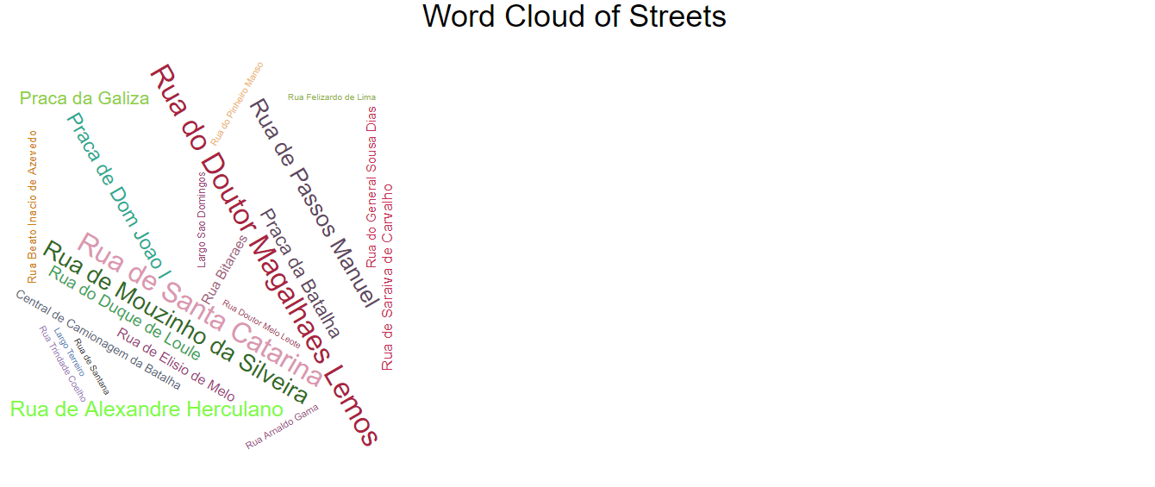

Sankey Diagram:

It is a diagram where the width of an arrow indicates the flow rate, in our diagram we can relate this to the most travelled path. This can be calculated by counting the most travelled path from the starting and ending points of the streetnames. The Sankey diagram is made by using Google visualizations. The visualization gives us the top 10 most travelled streets.

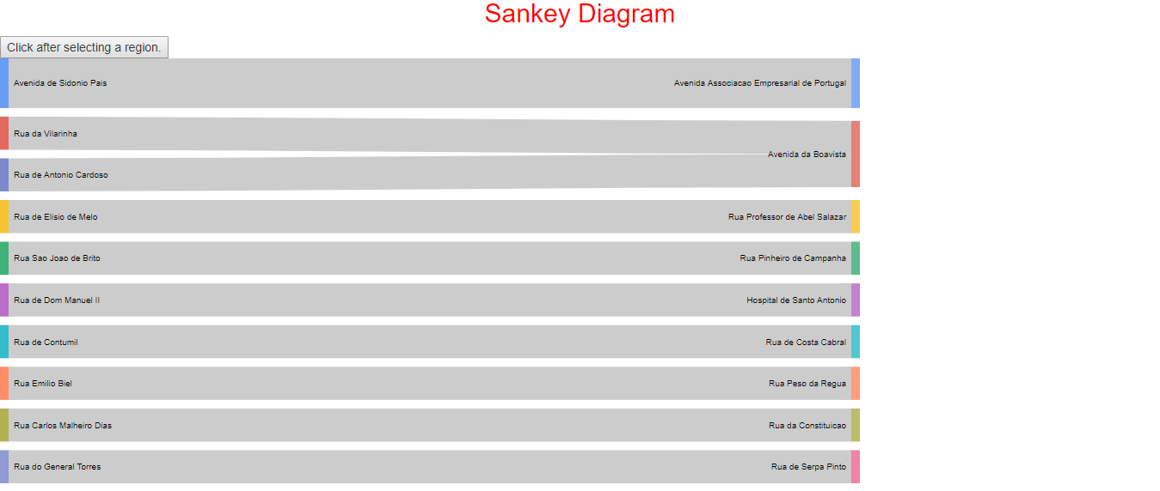

Scatter Matrix:

The Scatter Matrix is nothing but a visual representation of the covariance matrix. In this the attributes chosen are Average Speed, Distance and Duration.

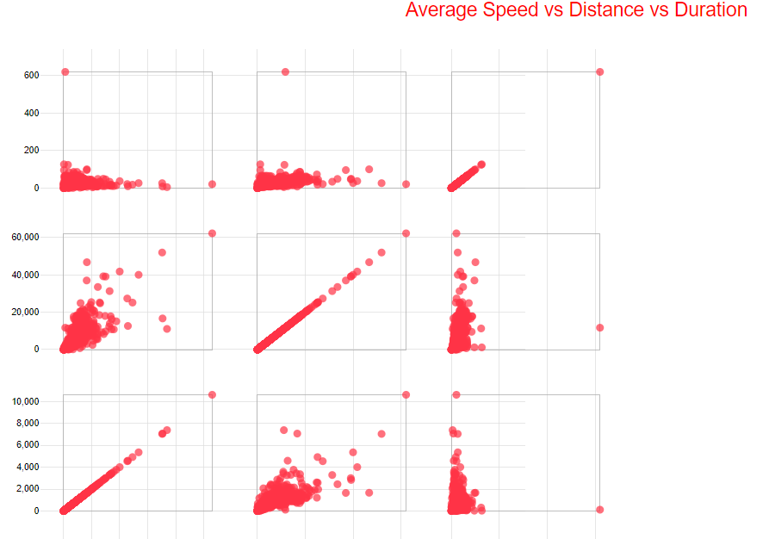

**Conclusion:**

Thus, we have successfully designed different visualisations for this project.