VIT BHOPAL UNIVERSITY
Real-Time Object Detection Using YOLO11
Computer Vision – Final Project Report
Submitted by | Sakshee Kumari
Registration Number | 24BAI10384
Course / Subject | Computer Vision
Faculty | Dr Vikas Pal
Academic Year | 2026–2027
Submission Date | 18 September 2026
Repository
github.com/sakshee-101/Object-Detection-Model.git
Development and testing environment: Windows 11

Abstract
This project implements a real-time webcam object detection application using Python, OpenCV and the pretrained YOLO11n model provided through Ultralytics. The application captures live frames, performs object detection, draws bounding boxes with class names and confidence values, and shows basic live statistics such as FPS and object counts. Keyboard controls are provided for saving a snapshot, resetting statistics, changing the confidence threshold and exiting the application. A JSON session summary is written when the program closes.
The work in this project focuses on the application and its integration around a pretrained model rather than training a new model. The final version was developed and tested on Windows 11. The automated test suite currently passes 72 tests, and a real Windows webcam run confirmed the complete capture, inference, display and output flow. The measured values shown in this report are observations from the supplied demonstration screenshots and are not presented as formal modelaccuracy results.

Table of Contents
1. Introduction 3
2. Problem Statement 3
3. Objectives 3
4. Scope 3
5. Functional Requirements 5
6. Non-Functional Requirements 5
7. Tools and Technologies 5
8. Dataset and Model Information 7
9. Model Selection Rationale 7
10. System Architecture 7
11. Workflow / Methodology 8
12. Design Diagrams 8
13. Implementation 13
14. User Controls 14
15. Testing 14
16. Evaluation Methodology 15
17. Actual Experimental / Demonstration Results 15
18. Screenshots and Evidence 17
19. Limitations 18
20. Challenges Encountered 18
21. Learning Outcomes 18
22. Future Enhancements 19
23. Conclusion 19
24. References 20

1. Introduction

1.1 Computer Vision
Computer Vision is used to make computers understand useful information from images and videos. Common tasks include image classification, object detection and image segmentation. This project uses object detection because the application needs both the object category and its location in each webcam frame.

1.2 Object Detection
Object detection identifies objects in an image and places a bounding box around each detected object. Along with the box, a detector normally provides a class label and a confidence value. In this application, these results are drawn directly over the live camera feed. 1.3 Real-Time Detection
The input here is a continuous webcam stream rather than a single image. Each frame has to be captured, processed and displayed in sequence, so model size and processing speed affect the responsiveness of the application. The YOLO11n variant was used to keep the model practical for a desktop webcam application.

2. Problem Statement
A normal webcam provides a video feed but does not automatically describe the objects visible in the scene. The problem addressed by this project is to build a simple desktop application that reads a live webcam feed, detects supported objects automatically, shows the results on screen and provides useful live statistics and controls.

3. Objectives
- Capture live video from a webcam using OpenCV.
- Run pretrained YOLO11n inference on each frame.
- Display bounding boxes, class names and confidence values.
- Show FPS and object-count information while the program is running.
- Provide keyboard controls for common actions.
- Save an annotated snapshot and a JSON session summary.
- Keep the application divided into separate modules and test important logic independently.

4. Scope

4.1 Included
- One webcam input using camera index 0 in the supplied Windows test.
- Real-time inference with pretrained YOLO11n.
- The 80 COCO object classes supported by the pretrained model.
- Live bounding boxes, labels, confidence values and basic statistics.
- Snapshot saving, statistics reset, confidence-threshold control and clean exit.
- A JSON session summary written on exit. 4.2 Not Included
- Custom model training or fine-tuning
- Object tracking
- Multiple-camera support
- Image-upload interface
- Cloud deployment or web dashboard
- Distance estimation
- Voice control
- A custom labelled dataset for formal accuracy evaluation

5. Functional Requirements
ID | Requirement
FR1 | Webcam Capture – open the selected camera and read frames.
FR2 | Object Detection – run YOLO11n on each frame and return detected objects.
FR3 | Visualisation – draw boxes, labels and confidence values.
FR4 | Live Analytics – show FPS, current object count and class counts.
FR5 | User Controls – respond to Q/ESC, S, C and +/− keys.
FR6 | Snapshot – save the current annotated frame as a JPEG.
FR7 | Session Summary – save session statistics as JSON on exit.

6. Non-Functional Requirements
Requirement | Expected behaviour
Performance | The program should remain responsive enough for live webcam use.
Usability | The application should start with one command and show controls on screen.
Reliability | Camera/model errors should be reported clearly and resources released on exit.
Maintainability | The code should be separated into modules with clear responsibilities.
Portability | The application should use an appropriate desktop camera backend.
Testability | Important logic should be testable without requiring a live camera.

7. Tools and Technologies
Technology | Use in the project
Python 3.12.10 | Main programming language.
OpenCV 5.0.0 | Webcam capture, drawing and display window.
Ultralytics 8.4.155 | YOLO11 API and pretrained model interface.
YOLO11n | Pretrained object-detection model used for inference.
PyTorch 2.14.0+cpu | Underlying model computation in the tested Windows environment.
NumPy 2.5.3 | Array and numerical data handling.
pytest 9.1.1 | Automated testing.
Git / GitHub | Version control and project submission.

7.1 Development Environment
The final project version described in this report was developed and tested on Windows 11 using an x64 Python environment. The Windows camera backend used successfully in the supplied run was Media Foundation, with camera index 0.

8. Dataset and Model Information

8.1 YOLO11n
The application loads yolo11n.pt through the Ultralytics API. This is a pretrained model; no custom training or fine-tuning was performed for this project. The student work is the desktop application, module integration, controls, analytics, testing and the surrounding inference pipeline.

8.2 COCO Classes
The pretrained model supports 80 common COCO object classes, including examples such as bottle, book, chair, laptop, dog and car. The application can only detect classes supported by the pretrained model.

8.3 Accuracy and Evaluation
No custom labelled test dataset was created. Therefore, this report does not claim a formal accuracy, precision, recall, F1 or mAP score. Confidence values displayed by YOLO11 are model output scores for individual detections and should not be treated as overall model accuracy.

9. Model Selection Rationale
YOLO11n was selected because the project requires repeated inference on webcam frames. The nano variant is smaller than the larger YOLO11 variants and is intended for practical inference on relatively limited desktop hardware. The goal was to build and test the complete live application rather than spend the project time on model training.

10. System Architecture
The application follows a modular frame-processing loop. The main module obtains a frame from the camera, sends it to the detector, updates analytics, renders the results and displays the annotated frame. Keyboard input is checked before the next frame is processed.
Module | Responsibility
camera.py | Webcam handling and frame capture.
detector.py | YOLO11 loading and inference; converts raw output into detection data.
analytics.py | FPS calculation and object/session statistics.
renderer.py | Bounding boxes, labels, statistics and controls on the frame.
controls.py | Keyboard actions and confidence-threshold changes.
main.py | Command-line arguments and main application loop.
__main__.py | Allows execution using python -m app.

11. Workflow / Methodology
- Start the application and read command-line options.
- Load the pretrained YOLO11n model.
- Open camera index 0 using the Windows camera backend.
- Read a webcam frame.
- Run YOLO11n inference on the frame.
- Update FPS and object counts.
- Draw detections and statistics.
- Display the annotated frame.
- Check for keyboard input.
- Repeat until the user exits.
- Release the camera and write the session summary JSON.

12. Design Diagrams
The following diagrams are retained from the existing report because they describe the application structure and flow without relying on the obsolete Mac/person evidence.
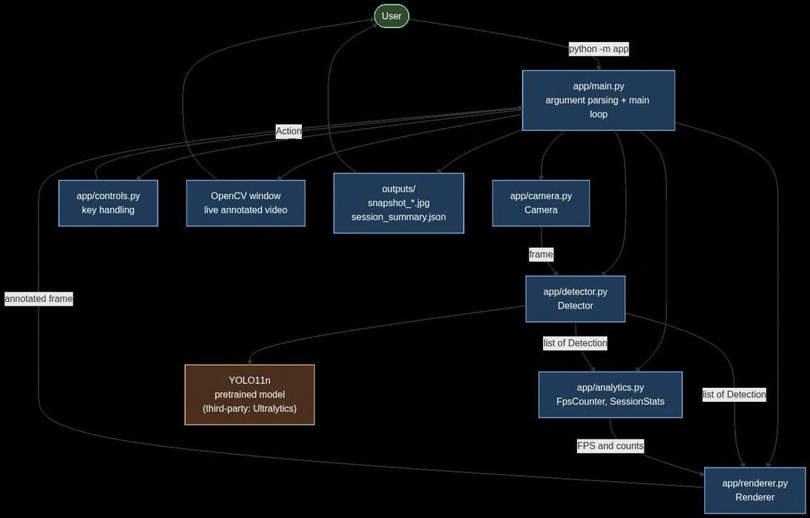
Figure 1. System architecture diagram.

12.1 Workflow Diagram
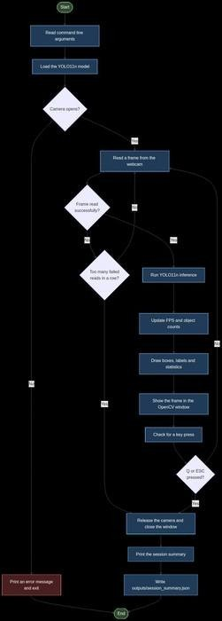
Figure 2. Workflow diagram.

12.2 Use Case Diagram
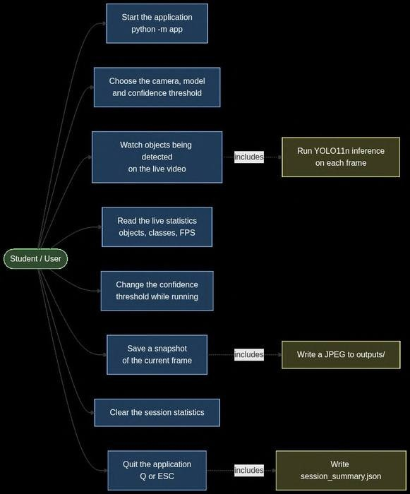
Figure 3. Use case diagram.

12.3 Sequence Diagram
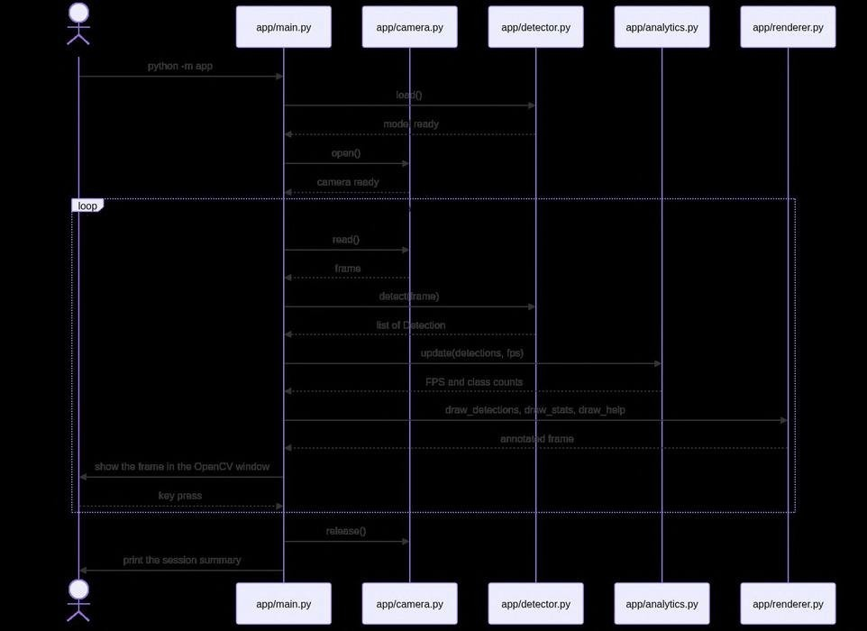
Figure 4. Sequence diagram.

12.4 Component / Class Diagram
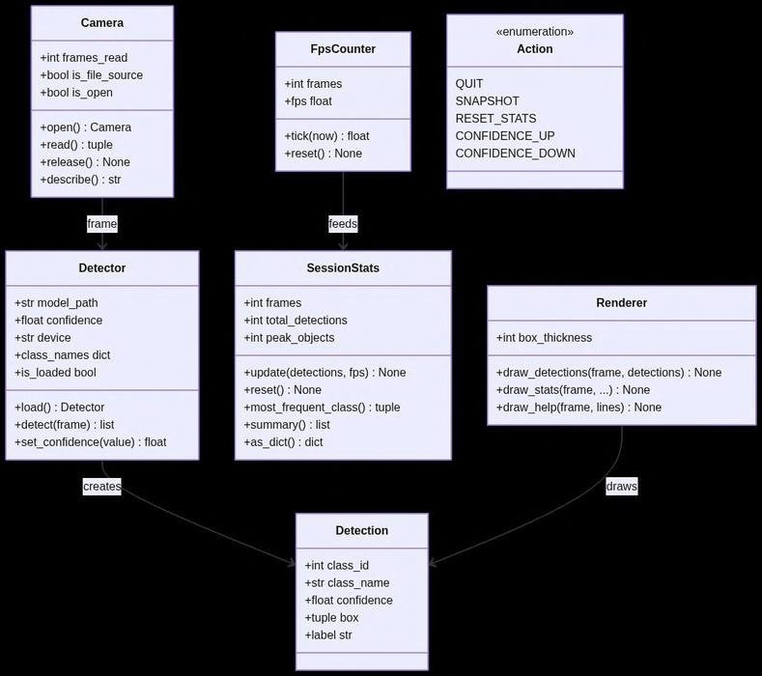
Figure 5. Component and class diagram.

13. Implementation

13.1 Webcam Capture
OpenCV VideoCapture is used to open the webcam and read frames. The application selects the appropriate capture backend for the operating system when possible. In the supplied Windows run, Media Foundation was used successfully and camera index 0 delivered real frames. If the camera cannot be opened, the application reports the problem instead of continuing with invalid input.

13.2 Detection
The detector module loads YOLO11n once at application start and performs inference for each frame. The model output is converted into a simple detection representation containing the class ID, class name, confidence and bounding-box coordinates. This keeps the rest of the application independent of the raw model-result format.

13.3 Visualisation
The renderer draws a box around each detection and writes the class name and confidence above the box. The same display also shows the current FPS, object information and keyboard controls. This makes the live result useful without needing a separate interface.

13.4 Analytics
The analytics module records frame rate, number of detections and class totals. These values are displayed while the application runs and are also included in the final session summary.

13.5 Confidence Threshold
The default confidence threshold is 0.25. The + and − keys change the threshold by 0.05 within the allowed range. A lower threshold can allow weaker detections to appear, while a higher threshold keeps fewer detections.

13.6 Output Files
Pressing S saves the current annotated frame to the outputs/ directory. When the program exits, the application writes outputs/session_summary.json containing the main session statistics.

14. User Controls
Key | Action
Q / ESC | Quit the application
S | Save a snapshot
C | Clear/reset session statistics
+ | Increase confidence threshold
− | Decrease confidence threshold
The controls are also shown inside the application window. This keeps the main actions visible during a live run and reduces the need to remember command names separately.

15. Testing
The final codebase currently passes 72 automated tests. These tests are intended to check the application logic without depending on a live webcam or a model download, making them suitable for repeatable development testing.
Testing area | Evidence / purpose
Automated test suite | 72 tests passed.
Webcam integration | Windows camera index 0 opened successfully through Media Foundation.
Detection pipeline | YOLO11n loaded and produced real detections in the webcam run.
Display | Bounding boxes, labels, confidence and statistics were visible in the application window.
Snapshot | The S control was verified as working in the Windows test.
Statistics reset | The C control was verified as working.
Threshold controls | The +/− controls were verified as working.
Exit and summary | Clean exit and session-summary generation were verified.
The supplied evidence does not provide a reliable breakdown of the 72 current automated tests by test file, so this report does not invent a per-file count.

16. Evaluation Methodology
Evaluation was performed at two levels. First, automated tests were used to check application logic such as controls, data handling and processing behaviour. Second, the complete application was run with the physical Windows webcam to confirm that camera capture, YOLO inference, rendering and output actions worked together.
Because there is no custom labelled dataset, the webcam run is treated as a practical demonstration rather than a formal model benchmark. The numerical values below are observations visible in the supplied Windows screenshots. They should not be interpreted as accuracy measurements.

17. Actual Experimental / Demonstration Results

17.1 Windows Environment Used
Parameter | Value
Operating system | Windows 11
Python | 3.12.10, x64
OpenCV | 5.0.0
NumPy | 2.5.3
PyTorch | 2.14.0+cpu
Ultralytics | 8.4.155
pytest | 9.1.1
Model | yolo11n.pt (pretrained YOLO11n)
Camera | Index 0, Media Foundation
Confidence threshold shown | 0.25

17.2 Screenshot-visible live detection
Observed value | Value
Objects in the displayed frame | 2
Classes shown | bottle, book
FPS shown | 7.2
Confidence threshold | 0.25
Bottle detections in displayed statistics | 1
Book detections in displayed statistics | 1
Frames shown | 841
Detections shown | 1715
Bottle box confidence | 0.79
Book box confidence | 0.36

17.3 Session summary shown in Windows CMD
Measurement | Value
Frames processed | 900
Total detections | 1822
Most objects in one frame | 5
Average detections/frame | 2.02
Average confidence | 0.548
Average FPS | 6.4
Peak FPS | 7.4
Duration | 0:02:36
Most frequent class | bottle (834)
These values describe the supplied demonstration session only. In particular, they show that the application was processing real webcam frames and producing detections. They do not establish the overall accuracy of YOLO11n.

18. Screenshots and Evidence
Only the new Windows screenshots supplied for this final version are used as evidence. The earlier person photograph and old Mac terminal/session evidence are intentionally excluded.
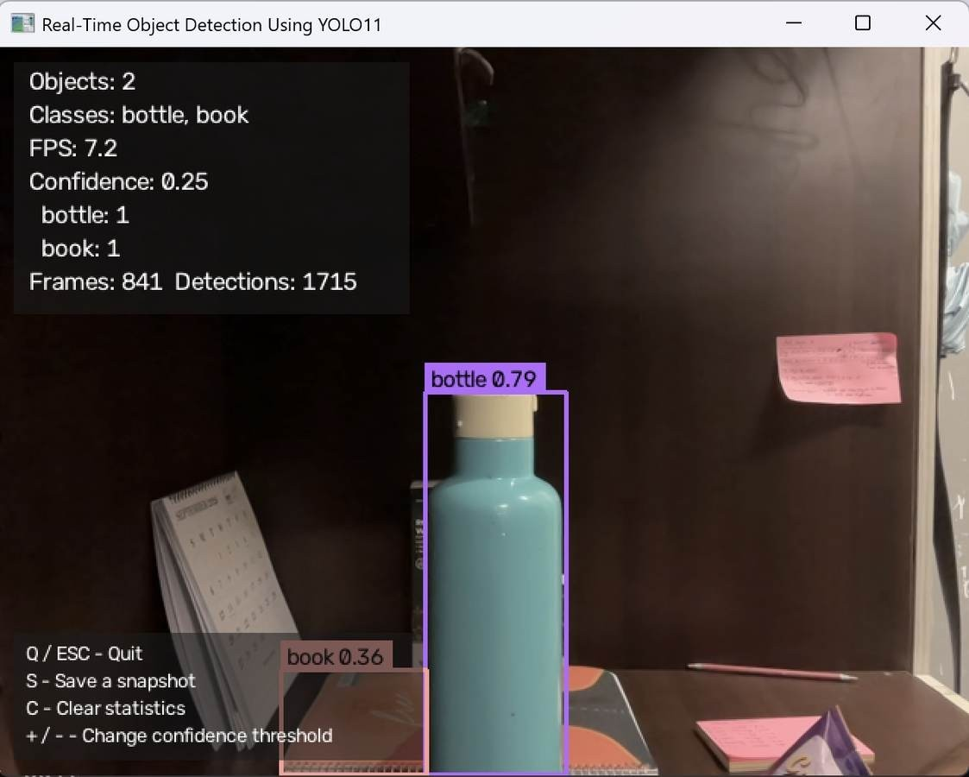
Figure 6. Windows YOLO11 application showing live bottle and book detection.
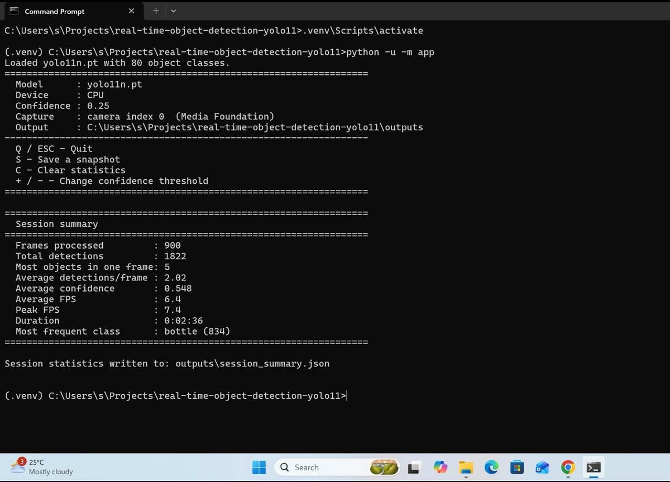
Figure 7. Windows Command Prompt showing application startup and session summary.

19. Limitations
- The detector is limited to the classes supported by the pretrained COCO model.
- Detection quality can change with lighting, motion blur, small objects and partial occlusion.
- FPS depends on the computer, camera resolution and model size.
- Only one webcam is used at a time.
- Objects are detected independently in each frame; the project does not track identities across frames.
- No custom labelled dataset was created, so formal precision, recall, F1 and mAP results are not reported.

20. Challenges Encountered
The main practical challenges were getting reliable camera access, installing compatible packages, loading the model correctly and keeping the live display usable while inference was running. It was also useful to keep application logic testable without depending on a physical webcam for every test run. Moving the final development and testing workflow to Windows required checking the camera backend and confirming the complete pipeline with a real camera.

21. Learning Outcomes
- Using OpenCV for real-time video capture and display.
- Integrating a pretrained YOLO model into a Python application.
- Working with bounding boxes, class labels and confidence values.
- Organising a project into modules with separate responsibilities.
- Implementing keyboard-based controls and output handling.
- Writing and running automated tests with pytest.
- Using Git/GitHub as part of a project workflow.
- Understanding the difference between detection confidence and formal model accuracy.

22. Future Enhancements
- Add object tracking so the same detected object can be followed across frames.
- Train or fine-tune a model on a project-specific labelled dataset when a custom detection task is required.
- Support video-file input in addition to a webcam.
- Add line-crossing or region-based counting.
- Experiment with adaptive inference resolution to balance speed and visual quality.
- Create a larger labelled test set and report precision, recall, F1 and mAP for a formal evaluation.

23. Conclusion
The project implements a complete real-time webcam object detection application using the pretrained YOLO11n model. The application captures frames, performs inference, draws detections, displays basic analytics and provides practical controls for snapshots, statistics and confidence threshold changes. The modular structure separates camera capture, detection, analytics, rendering and controls, while automated tests provide repeatable checks of the application logic.
The final Windows evidence confirms that the live pipeline worked with camera index 0 through Media Foundation and that YOLO11n produced real detections of objects such as a bottle and a book. The reported session numbers are kept as demonstration observations rather than model-accuracy claims. Overall, the project provided hands-on experience in computer vision, real-time processing, model integration, modular Python development and testing.

24. References
- Ultralytics. “YOLO11 – Ultralytics Documentation.”
- Ultralytics. “Predict Mode – Ultralytics Documentation.”
- Ultralytics. Ultralytics YOLO software repository.
- OpenCV Documentation.
- Redmon, J., Divvala, S., Girshick, R. and Farhadi, A. (2016). “You Only Look Once: Unified, Real-Time Object Detection.” Proceedings of CVPR.
- Lin, T.-Y. et al. (2014). “Microsoft COCO: Common Objects in Context.” ECCV.
- Project GitHub repository: github.com/sakshee-101/Object-Detection-Model-CV.git.Project Information
Item | Value
Student | Sakshee Kumari
Registration Number | 24BAI10384
Subject | Computer Vision
Faculty | Dr Vikas Pal
Institution | VIT Bhopal University
Academic Year | 2026–2027
Submission Date | 18 September 2026
Repository | github.com/sakshee-101/Object-Detection-Model-CV.git
Report note: All experimental values and visual evidence in this final version are based on the supplied Windows screenshots and the supplied project instructions. No synthetic screenshots, fabricated benchmarks or custom-training claims have been added.

