DATA SCIENCE FUNDAMENTALS ASSESSMENT
Retail Transactions: Data Cleaning, Statistical Analysis and Business Insights
Internship task report | Dataset: UCI Online Retail

1. Executive Summary
This project explores the UCI Online Retail transaction dataset to demonstrate Python-based data preparation, descriptive statistics, exploratory data analysis and business interpretation. The original dataset contained 541,909 rows and 8 columns. After removing 5,268 exact duplicate rows and filling missing product descriptions with “Unknown product,” the cleaned dataset contains 536,641 rows and 9 columns, including a calculated Revenue field.
A positive-sales subset contained 524,878 rows, 19,960 unique invoices, 3,922 unique product codes and records from 38 countries. Revenue in this subset totalled 10,642,110.80 in the dataset's currency units. The United Kingdom was the leading country by revenue, and November 2011 was the strongest month in the observed period.

2. Project Objectives
- Understand the dataset's structure, columns, data types and retail context.
- Use Python, Pandas and NumPy to inspect and prepare transaction data.
- Identify missing values, duplicate rows, returns/cancellations and unusual prices.
- Calculate descriptive statistics and correlations.
- Summarize revenue by month, country and product and derive practical recommendations.

3. Dataset and Business Context
The UCI Online Retail dataset contains transactions from a UK-based online retailer. The data covers 1 December 2010 through 9 December 2011. Each row represents a transaction line, rather than necessarily one complete invoice. The columns include InvoiceNo, StockCode, Description, Quantity, InvoiceDate, UnitPrice, CustomerID and Country. The dataset was loaded from the Excel file using Pandas read_excel().
Column | Data type observed | Meaning
InvoiceNo | object | Invoice or transaction identifier; values beginning with C indicate cancellations
StockCode | object | Product identifier
Description | object | Product description
Quantity | int64 | Number of units on the transaction line; can be negative for returns/cancellations
InvoiceDate | datetime64[ns] | Transaction date and time
UnitPrice | float64 | Price per unit
CustomerID | float64 | Customer identifier; some values are missing
Country | object | Country associated with the transaction
Revenue | float64 | Calculated transaction-line revenue: Quantity × UnitPrice

4. Data Quality Assessment
The initial inspection found 1,454 missing Description values and 135,080 missing CustomerID values. There were 5,268 exact duplicate rows, 10,624 rows with negative Quantity, 2,515 rows with zero UnitPrice, 2 rows with negative UnitPrice, and 9,288 invoice rows whose InvoiceNo began with C. There were no zero-quantity rows. Negative quantities may reflect returns or cancellations and were not assumed to be errors automatically.

5. Data Cleaning and Preparation
A separate copy of the original DataFrame was created to preserve the source data. Exact duplicate rows were removed, reducing the dataset from 541,909 to 536,641 rows. Missing product descriptions were replaced with “Unknown product” so that the transaction records could be retained without assuming the product names were known. Missing CustomerID values were retained because transactions without customer identifiers can still be useful for overall sales analysis. A new column, Revenue, was calculated by multiplying Quantity by UnitPrice.
For the positive-sales analysis, records were filtered to exclude invoice numbers beginning with “C”, quantities less than or equal to zero, and unit prices less than or equal to zero. This produced a subset of 524,878 rows. These filtering rules were used to focus on positive sales, not to reconcile the retailer’s complete financial accounts. Returns, cancellations, zero-price items and negative-price records would require separate investigation.

6. Statistical Analysis
Measure | Quantity | UnitPrice
Mean | 10.6166 | 3.9226
Median | 4.00 | 2.08
Mode | 1 | 1.25
Standard deviation (sample) | 156.2800 | 36.0930
Variance (sample) | 24,423.4480 | 1,302.7066

For Quantity, the mean (10.62) is greater than the median (4), suggesting that some large orders pull the average upward. The most frequent quantity is 1. For UnitPrice, the mean (3.92) is greater than the median (2.08), suggesting a right-skewed distribution. Both measures show substantial spread, so averages alone do not describe every transaction well.
The observed correlation between Quantity and UnitPrice was approximately -0.0038, indicating almost no linear relationship in this subset. The correlation between Quantity and Revenue was 0.9074, while UnitPrice and Revenue had a correlation of 0.1374. Since Revenue is calculated using Quantity and UnitPrice, its correlation with those variables is partly mathematical and should not be interpreted as evidence of causation.

7. Exploratory Analysis and Visualizations
The following charts summarize results calculated from the positive-sales subset. The monthly chart shows revenue rising in September, October and November 2011, with November as the highest observed month. December 2011 is incomplete because the dataset ends on 9 December.
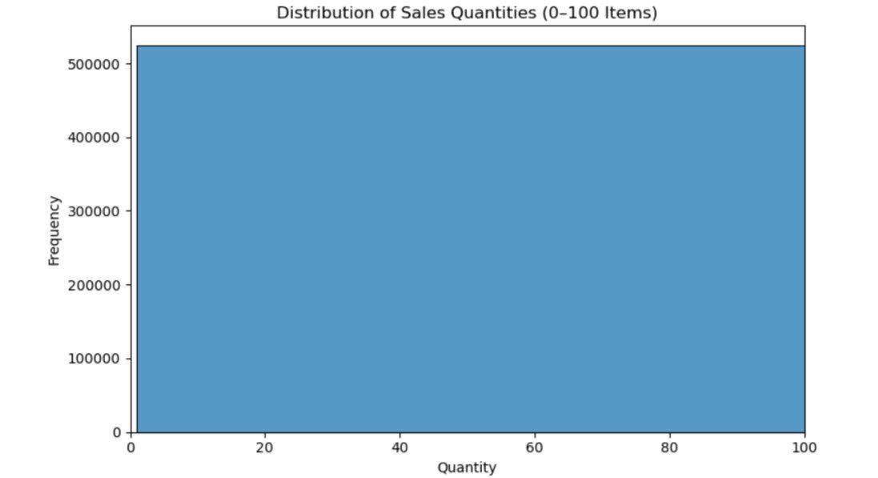
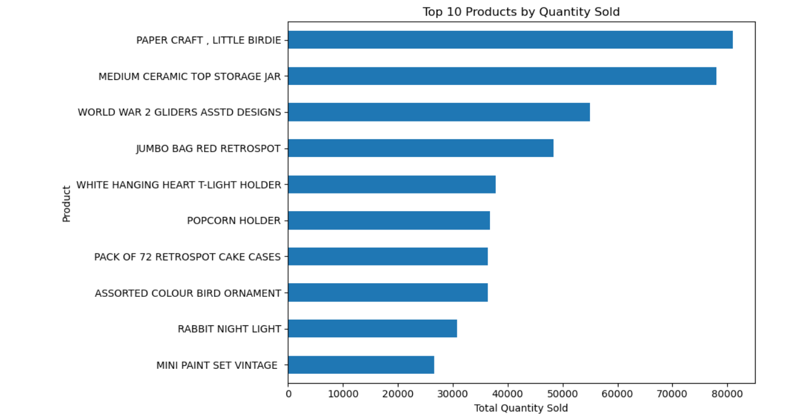
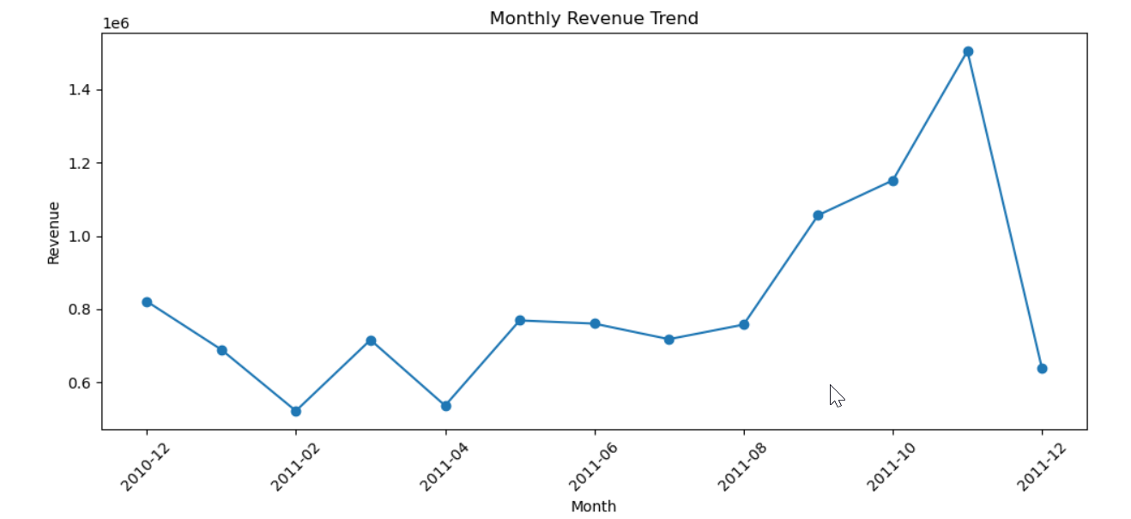

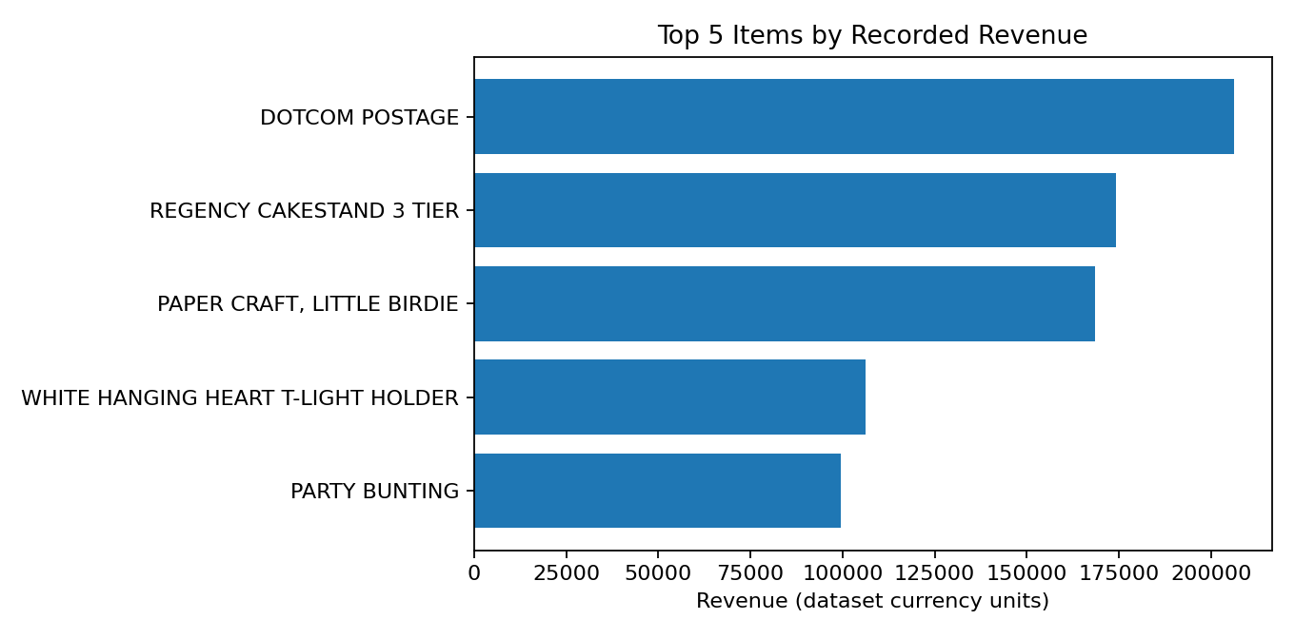

8. Key Results
The positive-sales subset contained 524,878 transaction lines, representing 5,572,420 items sold across 19,960 unique invoices, 3,922 unique product codes and 38 countries. Total recorded revenue for this subset was £10,642,110.80.
Top 5 countries by revenue
- United Kingdom: £9,001,744.09
- Netherlands: £285,446.34
- EIRE: £283,140.52
- Germany: £228,678.40
- France: £209,625.37

Top 5 items by recorded revenue
- DOTCOM POSTAGE: £206,248.77
- REGENCY CAKESTAND 3 TIER: £174,156.54
- PAPER CRAFT, LITTLE BIRDIE: £168,469.60
- WHITE HANGING HEART T-LIGHT HOLDER: £106,236.72
- PARTY BUNTING: £99,445.23
Selected monthly revenue results
- September 2011: £1,056,435.19
- October 2011: £1,151,263.73
- November 2011: £1,503,866.78
November 2011 had the highest revenue among these selected months. December 2011 is incomplete because the dataset ends on 9 December 2011.

9. Business Insights and Recommendations
- 1. Focus on the UK market while exploring international growth.
The United Kingdom generated £9,001,744.09 in revenue, considerably more than any other country in the top five. The business could study purchasing patterns in the UK while investigating customer preferences, demand and growth opportunities in other markets.
- 2. Investigate the November sales peak.
November 2011 recorded £1,503,866.78 in revenue, the highest among the selected months. The business could review seasonal demand, promotional campaigns, product availability and order patterns to understand what may have contributed to this increase.
- 3. Use multiple statistical measures for inventory planning.
The average quantity per transaction line was approximately 10.62, while the median was 4. This difference suggests that some large quantities influence the average. Inventory decisions should consider medians, distributions and product-level demand rather than relying on the mean alone.
- 4. Separate postage charges from physical-product performance.
DOTCOM POSTAGE ranked first by recorded revenue at £206,248.77. Since postage is not a typical physical product, the business should analyze postage charges separately when evaluating product popularity and merchandising performance.
- 5. Investigate unusual and non-positive transactions.
The dataset contains cancellations, negative quantities, zero-price items and negative-price records. These should be examined separately to understand returns, corrections and exceptional transactions before using the results for financial reporting.

10. Limitations
The data represents a limited historical period and does not establish why sales changed. December 2011 is incomplete. Missing customer IDs limit customer-level analysis. The positive-sales filter excludes returns/cancellations and non-positive-price lines, so the reported revenue is specific to that filter and should not be treated as a reconciled accounting total. The top item ranking includes postage.

11. Conclusion
This project applied Python and Pandas to inspect and clean retail transaction data, calculate descriptive statistics, examine correlations and summarize sales by country, month and product. The analysis found that the United Kingdom dominated revenue in the selected positive-sales subset and November 2011 was the strongest observed month. The project demonstrates a repeatable data-analysis workflow and shows how descriptive findings can inform further investigation, stock planning and market analysis.

12. Tools and References
Tools: Python, Pandas, NumPy, Matplotlib, Seaborn, Jupyter Notebook and Microsoft Word.
Dataset source: UCI Machine Learning Repository, Online Retail dataset.
Website : https://archive.ics.uci.edu/dataset/352/online+retail?

