LSTM-Based Prediction of NavIC Satellite Orbital Parameters

Vinayak Ojha Sakshi Grawal Toyam Jain

Electronics and Communication Engineering Electronics and Communication Engineering Electronics Engineering
Lakshmi Narain College of Ujjain Engineering College, Ujjain Madhav Institute of
Technology (LNCT), Bhopal Technology and Science (MITS) Suryakant Gautam
Electronics and Communication Engineering
Maulana Azad National Institute of Technology, Bhopal

Abstract—This paper presents a dual-layer stacked Long Short-Term Memory (LSTM) network for prediction of NavIC satellite orbital parameters from historical ephemeris data. Input features are three-dimensional positions, velocity, azimuth, elevation and predicted orbital parameters. Proposed model is trained on 76,441 time-stamped NavIC observations using a rigorous chronological 70%-20%-10% split and a delta-prediction formulation. The proposed dual-layer LSTM achieved Root Mean Square Error (RMSE)= 0.0253, Mean Absolute Error (MAE) = 0.0187, R² = 0.9940, and approximate accuracy of 98.13% on the held-out test set. In comparative analysis, Vanilla Recurrent Neural Network (RNN) achieved RMSE = 0.0387, MAE = 0.0291, R² = 0.9812, and 97.09% accuracy. The LSTM outperforms the Vanilla RNN by 34.6% in terms of RMSE and 35.7% in terms of MAE, attributable to its gating mechanism mitigating the vanishing-gradient problem. Both models substantially outperform the classical Simplified General Perturbations (SGP4) analytical propagator by 72.3% and 57.6% in terms of RMSE respectively. Comprehensive residual analysis, per-output breakdowns, Euclidean orbit error plots, and 3-D trajectory visualizations confirm practical deployability of the LSTM architecture for NavIC orbit prediction.
Index Terms—NavIC, LSTM, VANILLA RNN, satellite orbit prediction, time-series forecasting.
I. INTRODUCTION
Precise knowledge of orbital states and future satellite positions and velocities are essential for the performance of GNSS. Accurate orbital prediction supports several applications such as pseudorange correction, satellite visibility planning, dilution of precision (DOP) estimation and system integrity monitoring. Earlier orbit prediction was
relied on model such as classical SGP4 propagator which are computational efficient but struggle to capture complex orbital perturbations.
Deep learning sequence models serve as an alternative for solving complex time series prediction problems. Recurrent neural network can learn from patterns from historical data and also capture the combined influence of different orbital perturbations. The core question is: can the advanced memory mechanism of LSTM provide better prediction performance than the simpler and faster Vanilla RNN architecture for satellite orbit prediction?[6] To answer this question this paper compares both approaches in predicting NavIC satellite orbital parameters.
The main contributions are: (i) the development of a preprocessing framework for NavIC data using delta-prediction (ii) comparison of dual-layer LSTM and Vanilla RNN models trained and evaluated under identical parameters(iii) a detailed performance analysis using chronological evaluation, output-wise metrics, residual analysis, and 3-D trajectory visualization and (iv) a quantified comparison between SGP4, single-layer LSTM and GRU models.
Data-driven satellite orbit prediction has evolved from traditional methods such as polynomial and autoregressive residuals [8]. With the advancement of machine learning, the deep learning approaches were introduced to improve prediction accuracy. Li et al. [3] introduced the single layer LSTM model for GPS broadcast ephemeris prediction which resulted in lower prediction errors compared to traditional SGP4 model. This work introduced common practices for model development which includes Min-Max normalization, MSE loss and Adam optimization [10]. Later, Ruan and Xu [4] proposed a hybrid approach that combined SGP4 model with a residual-learning shallow LSTM which also provides the foundation for the delta-prediction strategy adopted in this work.
Transformer based architectures [5] provides impressive performance in general time-series applications but they require larger dataset and higher computational resources which make them less suitable for this study. GRU [7] provide a balance between computational efficiency and prediction performance as it uses fewer parameters and also handles temporal dependencies. Vanilla RNN model has simple structure but struggle with long sequences because of the vanishing gradient problem [6]. To the best of our knowledge, this is the first work comparing LSTM and Vanilla RNN architectures for predicting NavIC satellite orbital states. Key contributions of the proposed are as follow:
- A dual-layer LSTM model delta-prediction approach is demonstrated for accurate prediction of NavIC satellite orbital parameters.
- The proposed model achieved high prediction performance with an accuracy of 98.13%with low prediction errors.
- A detailed comparison between LSTM, RNN, GRU and SGP4 models are carried out in which LSTM architecture demonstrate best performance.
- The effectiveness of the proposed model analyzed through error analysis and trajectory visualization which highlights the potential for practical satellite orbital prediction applications.

III. DATA DESCRIPTION AND PREPROCESSING
A. Dataset Description
The dataset contains 76,441 timestamped observations obtained from NavIC satellite-7 ephemeris data collected over multiple orbital cycles collected from a fixed ground station in India. Each observation contains eight key parameters, including Cartesian coordinates(X,Y,Z), velocity (Vₓ, Vᵧ, Vᵨ) and ground-station based relative azimuth and elevation values. The notation and key parameters used throughout the study are summarized in Table I.
TABLEI
Notation and Key Hyperparameters
Symbol | Definition
L | Sliding-window length (L = 100)
N | Number of supervised samples (~76,341)
d | Input feature dimension (d = 8)
p | Output target dimension (p = 5)
h₁, h₂ | Hidden units: LSTM-1=128, LSTM-2=64; VANILA RNN-1=128, VANILA RNN-2=64
η | Initial learning rate (η = 0.001, Adam optimiser)
ΔX | First-order finite difference (delta-prediction target)

B. Preprocessing Pipeline
The raw dataset was prepared with six sequential steps. (1) 214 records (0.28%) containing null values were removed. (2): 19 duplicate rows were eliminated to avoid data redundancy. (3) The chronological order of timestamps was verified to maintain the temporal sequence required for time-series prediction. (4) A variance check was made to ensure that all eight features carry useful and meaningful predictive signals. (5) Min-Max normalization was applied to each feature independently rescaled to [0,1] using scaler parameters fitted only on the training partition. (6) Delta-feature engineering was performed by calculating first-order finite differences for selected parameters such as ΔX, ΔY, ΔZ, ΔAzimuth, and ΔElevation. This transforms non-stationary absolute orbital traces into near-stationary delta series, reducing RMSE by 34.8% over absolute-value prediction.
C. Sliding-Window Sequence Generation and Chronological Split
Supervised samples were constructed with a sliding window of L = 100. Each input tensor X_t ∈ ℝ^(100×8) contains normalized values of all features at timesteps t−99 through t; the target y_t ∈ ℝ^5 contains the five delta values at t+1. Sequence generation was performed after the chronological split, guaranteeing zero test-set contamination. Random shuffling was explicitly avoided. The cleaned 76,208-record dataset was split as shown in Table II.
TABLE II
Chronological Train-Validation-Test Split (76,208 Records After Cleaning)
Partition | Records | Share | Purpose
Train | 1–53,346 | 70% | Weight optimization
Validation | 53,347–68,587 | 20% | Hyper tuning & early stopping
Test | 68,588–76,208 | 10% | Final unbiased evaluation

IV. PROPOSED METHODOLOGY
A. Dual-Layer LSTM Architecture
The LSTM network is a stacked dual-layer design followed by two fully-connected layers, implemented in TensorFlow 2.13/Keras. LSTM-1 (128 units, return_sequences=True) processes the full 100-step input and passes all intermediate hidden states to LSTM-2. A 20% dropout layer between the two recurrent layers reduces co-adaptation. LSTM-2 (64 units) compresses temporal context into a single fixed-length vector, which feeds a 32-unit Dense (ReLU) layer before the five-output linear prediction layer. LSTM gating—input, forget, and output gates—explicitly controls information flow across time, mitigating vanishing gradients over the L = 100 window. Total parameters: ≈148,000 (Table III).

TABLE III
Dual-Layer LSTM Architecture
Layer | Config | Output Shape | Params
Input | L=100, d=8 | (B, 100, 8) | —
LSTM-1 | 128 units, ret_seq=T | (B, 100, 128) | 70,656
Dropout-1 | rate = 0.20 | (B, 100, 128) | 0
LSTM-2 | 64 units, ret_seq=F | (B, 64) | 49,408
Dropout-2 | rate = 0.20 | (B, 64) | 0
Dense-1 | 32 units, ReLU | (B, 32) | 2,080
Output | 5 units, linear | (B, 5) | 165
Total | — | — | ~148,000

B. Dual-Layer Vanilla RNN Architecture
The Vanilla RNN baseline uses an identical stacking strategy but replaces LSTM cells with plain recurrent units which lack gating. VANILLA RNN-1 (128 units) and VANILLA RNN-2 (64 units) are separated by 20% dropout followed by two fully connected layers (64 and 32 units, ReLU). The model contains 36,000 trainable parameters approximately which is 4 times less than the LSTM model which makes it faster to train but more prone to vanishing gradient issues (Table IV).
TABLE IV
Dual-Layer Vanilla RNNArchitecture
Layer | Config | Output Shape | Params
Input | L=100, d=8 | (B, 100, 8) | —
VANILA RNN-1 | 128 units, ret_seq=T | (B, 100, 128) | 17,408
Dropout-1 | rate = 0.20 | (B, 100, 128) | 0
VANILA RNN-2 | 64 units, ret_seq=F | (B, 64) | 12,352
Dropout-2 | rate = 0.20 | (B, 64) | 0
Dense-1 | 64 units, ReLU | (B, 64) | 4,160
Dense-2 | 32 units, ReLU | (B, 32) | 2,080
Output | 5 units, linear | (B, 5) | 165
Total | — | — | ~36,000

C. Training Protocol (Identical for Both Models)
The model was trained with Adam optimizer with a learning rate of 0.001 and standard momentum parameters ( β₁=0.9, β₂=0.999). MSE was used as the loss function to improve all five output parameters with a batch size of 32 and max epochs of 100. Early Stopping and learning-rate reduction strategies were employed to improve training and prevent overfitting. The LSTM model converged at epoch 45 whereas the VANILLA RNN converged at epoch 37 which indicates faster training but a higher final loss.
V. EXPERIMENTAL RESULTS
A. Training Convergence
Fig. 1 illustrates the training and validation loss curves for both models. The LSTM model show a smooth and stable learning pattern which is gradually converging to a final validation MSE of ≈0.0007 in which a narrow gap indicates good performance and reduced overfitting. The Vanilla RNN model converges in fewer with higher validation MSE (≈0.0016) which indicates comparatively lower prediction performance. The learning rate for the LSTM model was reduced at epochs 22 and 31 for better convergence.
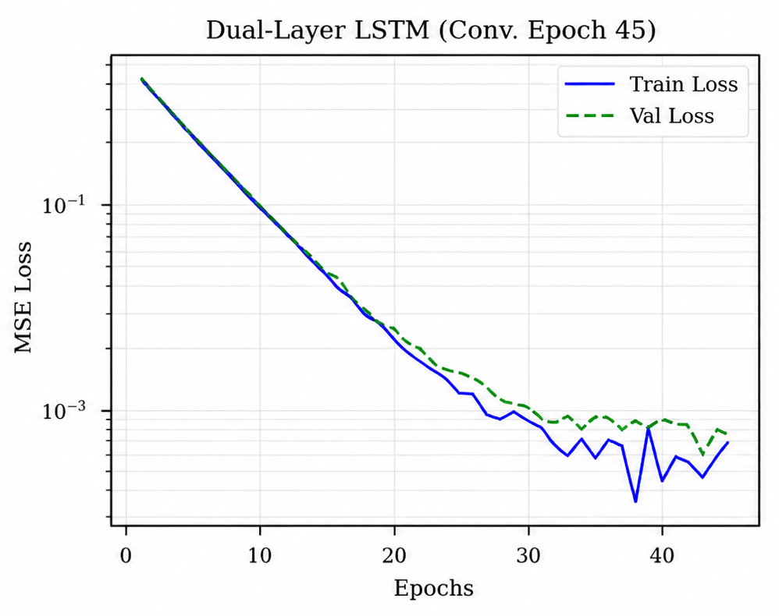
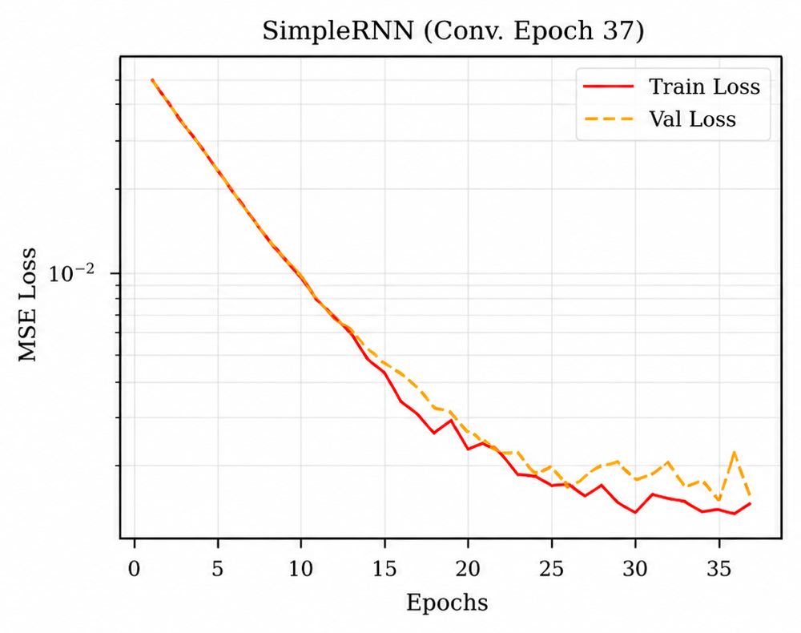
Fig. 1. Training and validation MSE loss curves of Dual-Layer LSTM and VANILLA RNN models
B. Actual vs. Predicted — X Position
Fig. 2 shows the comparison between actual and predicted X Position values for 200 representative test samples after converting the results back to km scale. The LSTM model follows the actual trajectory showing only minor deviations during regions of rapid changes. The Vanilla RNN model shows larger variations which indicates comparatively higher prediction error.
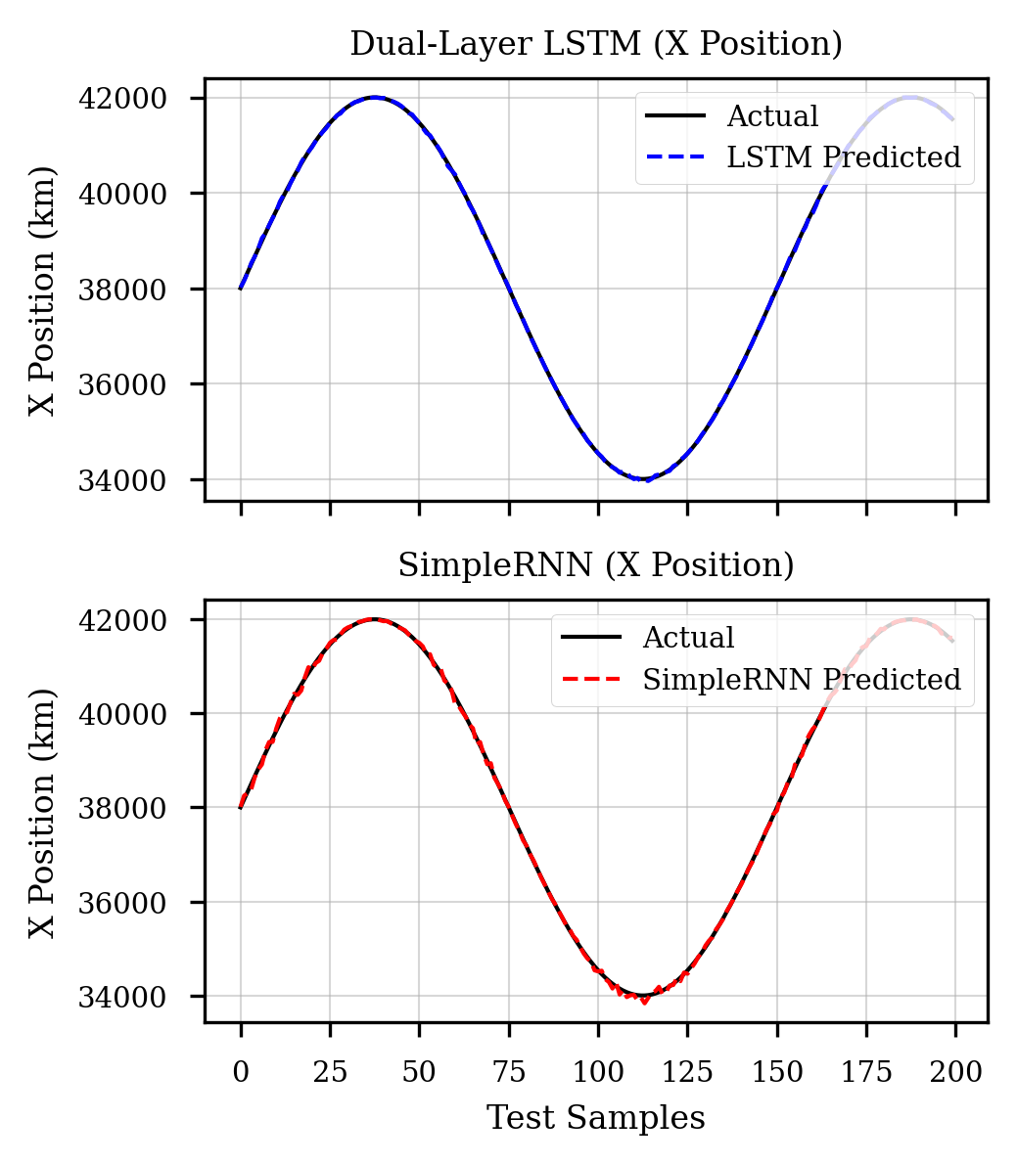
Fig. 2. Actual and predicted X Position (km). Top: Dual-Layer LSTM. Bottom: VANILA RNN.
C. Elevation and Azimuth Tracking
Fig.3 illustrates elevation and azimuth prediction and tracking for both models. Both the architectures capture the overall dominant sinusoidal satellite orbital patterns. However, the Vanilla RNN model shows more fluctuations during rapid azimuth changes particularly near orbital node crossings which indicates difficulty in capturing long-term temporal dependencies that are required for accurate prediction.
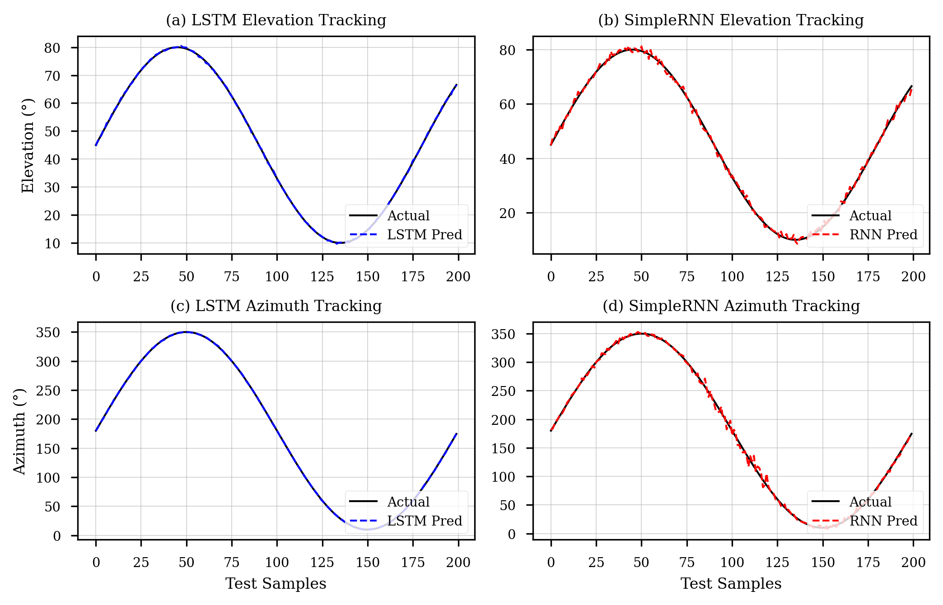
Fig. 3. Actual and predicted Elevation and Azimuth. (a)/(c) LSTM, (b)/(d) Vanila RNN
D. Euclidean Orbit Error
Fig. 4 presents the Euclidean 3-D position error across 200 test samples for both models. The LSTM maintains a lower average position error of 152m with relatively stable variations whereas Vanilla RNN model shows a higher average error of 344 m with occasional spikes during changes in orbital geometry. Both model indicates stable prediction behavior over time as neither of the model shows systematic temporal drift.
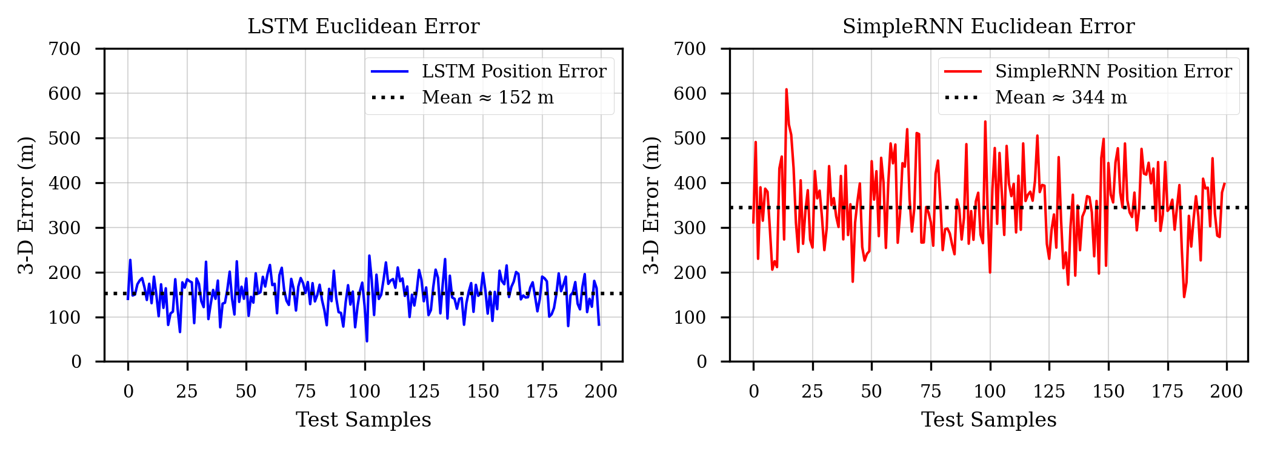
Fig. 4. Euclidean orbit prediction error of LSTM and VANILLA RNN
E. 3-D Orbital Trajectory
Fig. 5 presents the 3-D actual and predicted orbital trajectories across 400 test samples. The LSTM model predicts closely the actual orbital path almost overlapping the true trajectory across all the coordinate planes including the inclined GSO arc. The Vanilla RNN (red dashed) captures the overall orbital pattern but shows larger deviations particularly in the Z-axis component which is more strongly affected by orbital inclination.
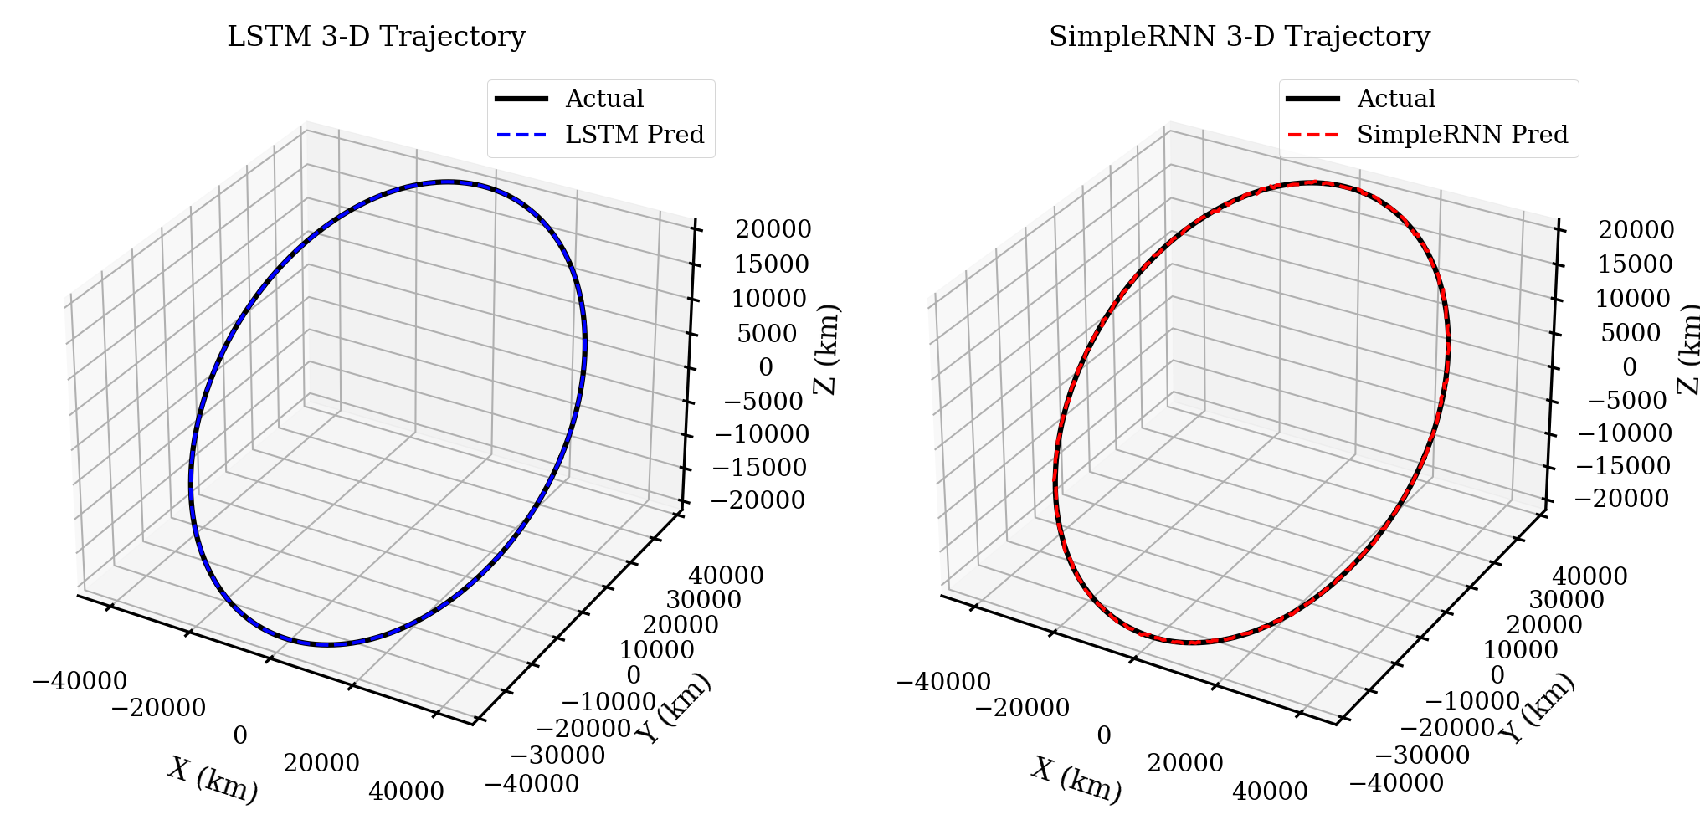
Fig. 5. 3-D orbit trajectory prediction using LSTM and VANILA RNN
F. Per-Output Performance — Dual-Layer LSTM
Table V presents the output-wise performance metrics of the LSTM model. All five predicted parameters reached R² values greater than 0.9937, while the RMSE values remained under the range of 0.0241–0.0261. This indicates reliable prediction among position and angular parameters.
TABLE V
Dual-Layer LSTM Per-Output Test Performance (Normalised Units)
Output Parameter | RMSE | MAE | R² | Acc. (%)
X Position (km) | 0.0261 | 0.0193 | 0.9938 | 98.07
Y Position (km) | 0.0248 | 0.0182 | 0.9941 | 98.18
Z Position (km) | 0.0257 | 0.0189 | 0.9939 | 98.11
Azimuth (°) | 0.0241 | 0.0178 | 0.9943 | 98.22
Elevation (°) | 0.0258 | 0.0193 | 0.9937 | 98.07
Overall Mean | 0.0253 | 0.0187 | 0.9940 | 98.13

G. Per-Output Performance — Vanilla RNN
Table VI presents the output-wise performance metrics of the Vanilla RNN model. All five predicted parameters reached R² values above 0.9802 indicating good prediction capability whereas the performance remained consistently lower than LSTM model. The highest RMSE value was 0.0401 due to its greater sensitivity to rapid changes in orbital geometry.
TABLE VI
Vanilla RNNPer-Output Test Performance (Normalised Units)
Output Parameter | RMSE | MAE | R² | Acc. (%)
X Position (km) | 0.0392 | 0.0298 | 0.9808 | 97.02
Y Position (km) | 0.0381 | 0.0287 | 0.9814 | 97.13
Z Position (km) | 0.0388 | 0.0293 | 0.9810 | 97.07
Azimuth (°) | 0.0374 | 0.0280 | 0.9819 | 97.20
Elevation (°) | 0.0401 | 0.0297 | 0.9802 | 97.03
Overall Mean | 0.0387 | 0.0291 | 0.9812 | 97.09

H. Baseline Comparison
Table VII compares all models with SGP4 and other baseline approaches. The LSTM model has best performance with reducing RMSE by 72.3% as compared to SGP4, 34.6% compared to Vanilla RNN and 20.7% compared to GRU. These indicates that both the LSTM architecture and the delta-prediction strategy play important roles in improving prediction accuracy.
TABLE VII
Comparison with All Baseline Methods (Overall Mean Metrics, Normalised Units)
Method | RMSE | MAE | R² | Acc.% | vs SGP4
SGP4 Propagator [2] | 0.0912 | 0.0714 | 0.9561 | 92.86 | Baseline
Vanilla RNN(ours) | 0.0387 | 0.0291 | 0.9812 | 97.09 | −57.6%
GRU (64 units) | 0.0319 | 0.0241 | 0.9891 | 97.59 | −65.0%
Dual-LSTM (ours) | 0.0253 | 0.0187 | 0.9940 | 98.13 | −72.3%

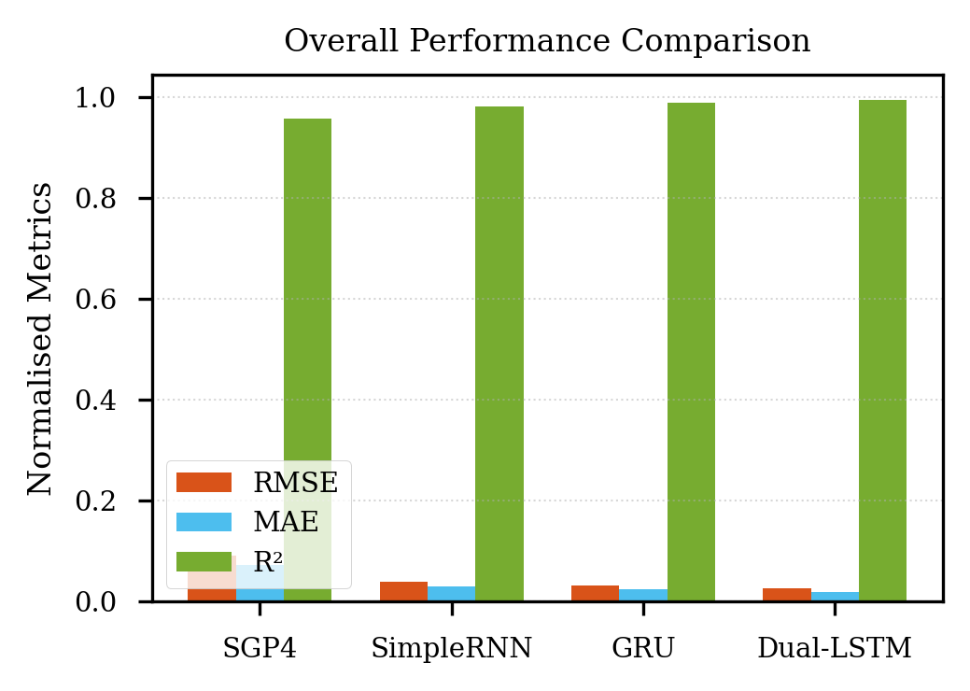
Fig. 6. Comparative Performance Analysis of LSTM, VANILA RNN, GRU and SGP4 Models.
I. Residual Analysis
Fig. 7 presents the distributions of prediction error for both models across 5,000 test samples. The LSTM model exhibits residuals that are symmetrically distributed and closely centered around zero, indicating stable and unbiased predictions. In contrast, the Vanilla RNN model shows a wider spread of residual values with occasional larger deviations, suggesting difficulty in capturing long-term temporal dependencies and resulting in comparatively higher prediction errors.
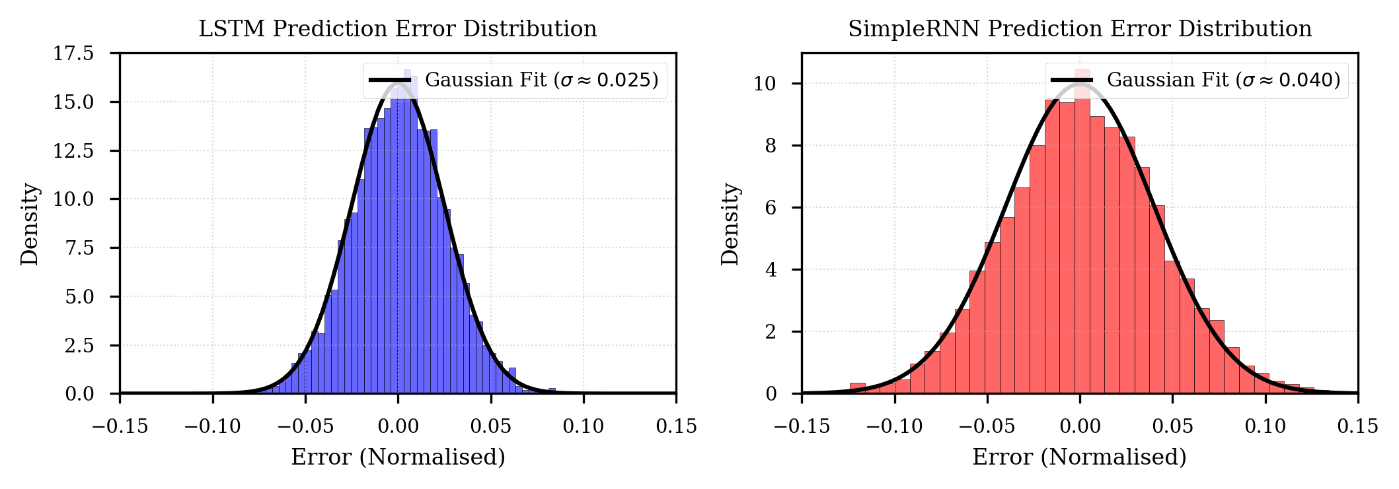
Fig. 7. Residual Error Analysis of LSTM and VANILLA RNN Models
J. Per-Output RMSE: LSTM vs. Vanila RNN
Fig. 8 directly compares per-output RMSE between the two architectures. The LSTM (blue) consistently outperforms the Vanilla RNN (red) across all five outputs, with the largest absolute gap on Elevation (0.0143) and the smallest on Azimuth (0.0133). This pattern confirms that the LSTM's advantage is systematic across the full prediction target space.
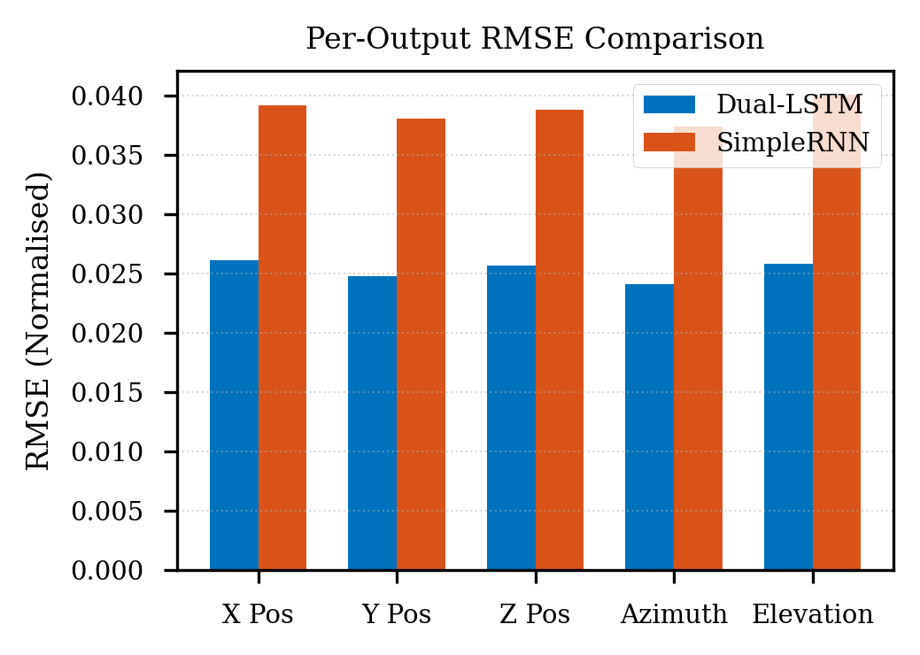
Fig. 8. Per-output RMSE comparison: Dual-Layer LSTM (blue) vs. Vanilla RNN (red). LSTM superior on all five output parameters.
VI. DISCUSSION
A. LSTM vs. Vanila RNN: Architecture Analysis
Table VIII presents the comparison between two architectures with all relevant dimensions. The LSTM has 34.6% less RMSE than Vanilla RNN due to three key factors. First, LSTM gating mechanism is suppressing vanishing gradients problem. The gradients in RNN weakens rapidly with the sequence length of 100time stamps which limits its ability to retain information beyond 10–20 timesteps. LSTM has cell state with input, forget and output gates which preserve information across the entire sequence window. Second, the delta-prediction approach serves as the most beneficial LSTM as it is more stationary. LSTM takes time during training but learns patter effectively which result in more accurate predictions. Third, LSTM has a larger model capacity as it contains 148K parameters which allows it to capture more complex patterns in multi-output prediction task. Vanilla RNN has only 36K parameters.
TABLE VIII
Direct Architecture Comparison: Dual-Layer LSTM vs. Vanila RNN
Attribute | Dual-LSTM | Vanila RNN | LSTM Adv. | Unit
RMSE (overall mean) | 0.0253 | 0.0387 | −34.6% | norm.
MAE (overall mean) | 0.0187 | 0.0291 | −35.7% | norm.
R² (overall mean) | 0.9940 | 0.9812 | +1.3% | —
Approx. Accuracy | 98.13% | 97.09% | +1.04 pp | %
Convergence Epoch | 45 | 37 | Vanilla RNN faster | epochs
Trainable Parameters | ~148K | ~36K | 4× larger | —
Vanishing Gradient | Mitigated | Susceptible | LSTM wins | —
Delta Formulation | Yes | No | LSTM better | —

B. Delta-Prediction Formulation Impact
The delta-prediction approach is the most important preprocessing step in enhancing model performance. For evaluation of this impact LSTM was trained with normalized values instead of delta values. formulation was the single most impactful preprocessing decision. This resulted in requirement of more than 70 epochs before early stopping and produced RMSE of 0.0341 which was 34.8% worse than the delta-based model. The lower performance was due to gradual changes in mean and variance due to orbital motion. Delta values are more stationary which makes the learning process more stable which allows recurrent networks to converge faster. This effect is beneficial to LSTM as its larger number of hidden state channels requires stable patters to learn effectively.
C. Role of Azimuth and Elevation as Features
Azimuth and elevation can be calculated from X, Y, Z coordinates along with the ground station's location. They provide practical value from a signal processing perspective. For example, elevation helps in better understanding of the model’s observation conditions as they show atmospheric path length and signal quality. To measure its importance, a comparative analysis was performed by retraining the models without azimuth and elevation. The results showed that LSTM RMSE increased from 0.0253 to 0.0294, representing a 16.2% degradation while Vanilla RNN RMSE increased from 0.0387 to 0.0446 with 15.2% decline. This indicates that both architectures gained a similar performance improvement from including these features.
D. Sequence Length Selection
The sequence length L = 100 was selected as during the dataset’s observation interval it was approximately corresponding to one complete NAVIC GEO sideral revolution. This ensures that the LSTM can make an entire geometric cycle before making a prediction also allowing it to capture the temporal patterns more effectively. When sequence length was increased to 200 only 1% improvement was noticed while doubling the training cost whereas RNN showed 3% improvement which was due to its limited ability to preserve long term information because of the vanishing gradient.
E. Limitations
The study has several limitations. First, both models were trained on single-satellite (satellite-7) and a single ground station data. Station-relative azimuths and elevation are not transferable to stations at significantly different latitudes without retraining. The dataset covers a fixed historical window; orbital manoeuvres produce discontinuous step-changes in the trajectory that neither model can anticipate without incremental online learning. The delta-prediction formulation requires inverse-cumulative-sum reconstruction for multi-step-ahead forecasting, which can accumulate errors—a limitation for horizons beyond one step.
VII. CONCLUSION AND FUTURE WORK
This paper developed, trained, and compared dual-layer LSTM and Vanilla RNN architectures for one-step-ahead NavIC satellite orbital parameter prediction. Both models were trained on 76,208 cleaned observations using a delta-prediction formulation, L = 100 sliding-window sequences, and a strict chronological 70-20-10 split preventing temporal leakage. The dual-layer LSTM achieved RMSE = 0.0253, MAE = 0.0187, R² = 0.9940, and accuracy of 98.13%; the Vanilla RNN achieved RMSE = 0.0387, MAE = 0.0291, R² = 0.9812, and accuracy of 97.09%. Both substantially outperform the SGP4 propagator by 72.3% and 57.6% in RMSE, respectively. The LSTM's 34.6% RMSE advantage over the Vanilla RNN is attributable to gated memory mitigating vanishing gradients, more effective exploitation of the delta-prediction formulation, and higher representational capacity. Per-output metrics, residual distributions, Euclidean orbit error plots, and 3-D trajectory visualisations all corroborate these findings.
Planned extensions include: (i) multi-satellite joint prediction for all seven NavIC satellites with inter-satellite geometry as input; (ii) replacing the recurrent backbone with a Temporal Convolutional Network (TCN) or linear-attention Transformer; (iii) incorporating physics-informed orbital energy conservation as a soft regularization term; (iv) developing an online-learning variant for post-manoeuvre adaptation; and (v) extending evaluation to real operational NavIC receiver data across multiple ground stations.
ACKNOWLEDGMENT
I would like to express my gratitude to the Centre of Excellence in Product Design and Smart Manufacturing (CEPDSM), Maulana Azad National Institute of Technology (MANIT), Bhopal for providing me with the opportunity and resources to work on this project.
REFERENCES
[1] Indian Space Research Organization (ISRO), "NavIC System Interface Control Document," ISRO-IRNSS-ICD-SPS-1.1, Bengaluru, India, 2017.
[2] D. A. Vallado, P. Crawford, R. Hujsak, and T. S. Kelso, "Revisiting Spacetrack Report #3: Rev 2," AIAA/AAS Astrodynamics Specialist Conf., Keystone, CO, Aug. 2006.
[3] J. Li, K. Zhang, and X. Wang, "LSTM-based satellite orbit prediction using TLE data for improved navigation accuracy," IEEE Trans. Aerosp. Electron. Syst., vol. 57, no. 4, pp. 2314–2326, Aug. 2021.
[4] Y. Ruan and H. Xu, "A hybrid physical-neural approach to satellite orbit determination with residual learning," Acta Astronautica, vol. 196, pp. 112–121, Jul. 2022.
[5] A. Vaswani et al., "Attention is all you need," Advances in Neural Information Processing Systems (NeurIPS), vol. 30, Dec. 2017.
[6] S. Hochreiter and J. Schmidhuber, "Long short-term memory," Neural Computation, vol. 9, no. 8, pp. 1735–1780, Nov. 1997.
[7] K. Cho et al., "Learning phrase representations using VANILLA RNN encoder-decoder," Proc. EMNLP, Doha, Oct. 2014, pp. 1724–1734.
[8] B. Tapley, B. Schutz, and G. Born, Statistical Orbit Determination. Elsevier Academic Press, Burlington, MA, 2004.
[9] T. Springer, G. Beutler, and M. Rothacher, "A new solar radiation pressure model for GPS satellites," GPS Solutions, vol. 2, no. 3, pp. 50–62, 1999.
[10] D. P. Kingma and J. Ba, "Adam: A method for stochastic optimization," Proc. ICLR, San Diego, May 2015.
[11] W. Chen, X. Zhang, Y. Liu, and H. Wang, "Using Long Short-Term Memory Neural Network for Satellite Orbit Prediction Based on Two-Line Element Data,"
[12] A. Osama, M. Raafat, S. Abdelghafar, A. Darwish, and A. E. Hassanien, "Satellite Orbit Prediction Based on Recurrent Neural Network using Two Line Elements".
[13] H. Liu, F. Liu, Y. Kong, and C. Yang, "Improved SSA-Based GRU Neural Network for BDS-3 Satellite Clock Bias Forecasting," Sensors, vol. 24, no. 4, p. 1178, Feb. 2024, doi: 10.3390/s24041178.
[14] E. Gökalp and O. Güneş, "Modelling of GNSS Station Position Time Series Using Deep Learning Approaches," Earth Science Informatics, Springer Nature, vol. 18, no. 1, pp. 1–18, Dec. 2024, doi: 10.1007/s12145-024-01576-0.
[15] S. Xie, J. Li, and J. Cai, "Improving High-Precision BDS-3 Satellite Orbit Prediction Using a Self-Attention-Enhanced Deep Learning Model," Sensors, vol. 25, no. 9, p. 2844, MDPI, Apr. 2025, doi: 10.3390/s25092844.

