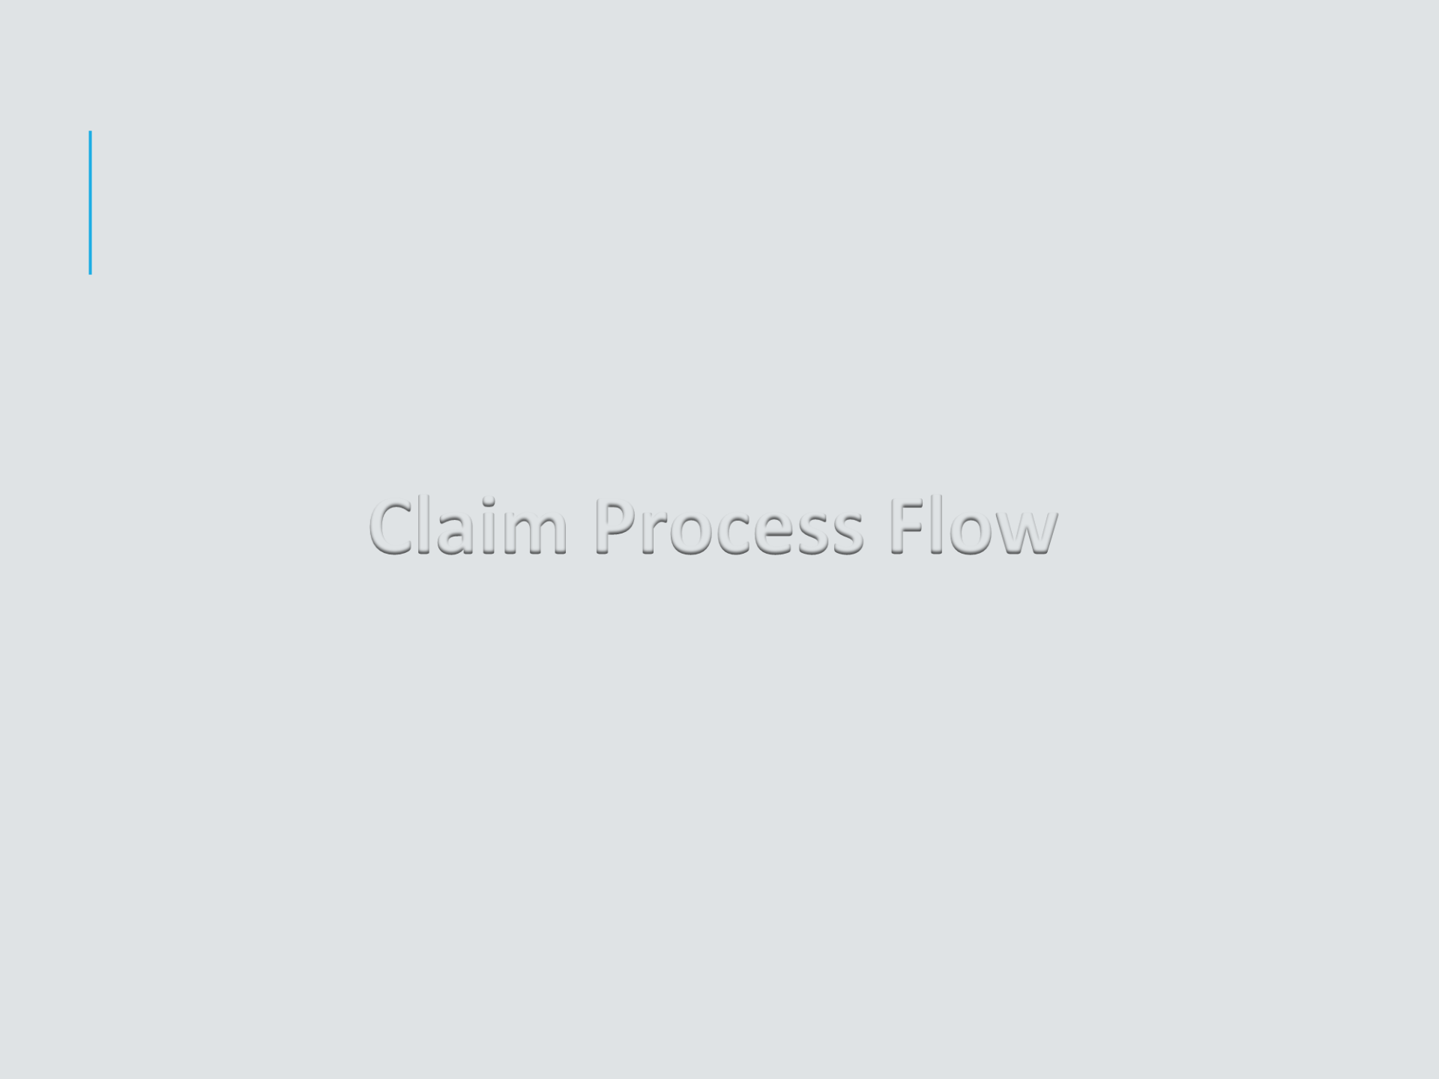

**Claim Process Flow**



**CLAIM INTIMATION**

**Insured should send intimation of hospitalization to The TPA on**

**the following intimation mail ID’s :**

▪[**frd@healthindiatpa.com**](mailto:frd@healthindiatpa.com)

▪**Your HR/TPA within 24 hours of admission**

**Intimation should be given to the TPA or HR :**

▪**24 hours before admission incase of planned Hospitalization.**

▪**Within 24 hours after admission incase of Emergency**

**Hospitalization for Reimbursement Process.**

**CLAIMS INTIMATION**

**The details which are mandatory on the mail are:**

* **Employee Name**
* **Employee Number**
* **Health India TPA ID & Employee ID No.**
* **Name of the Hospital**
* **Address of the Hospital**
* **Date Of Admission**
* **Ailment**

**HOW TO AVAIL BASIC INSURANCE SERVICES**?

▪**HOSPITALISATION AT NETWORK HOSPITAL**

* **If the hospitalization is in the Network Hospital of Health India (TPA) Services Private Ltd. You need to fill up Cashless Request Form & follow process of Cashless Route**

▪**HOSPITALISATION AT NON NETWORK HOSPITAL**

* **If the hospitalization is in the Non-network Hospital, you complete your hospitalization, pay the bills & follow process of Reimbursement of expenses.**

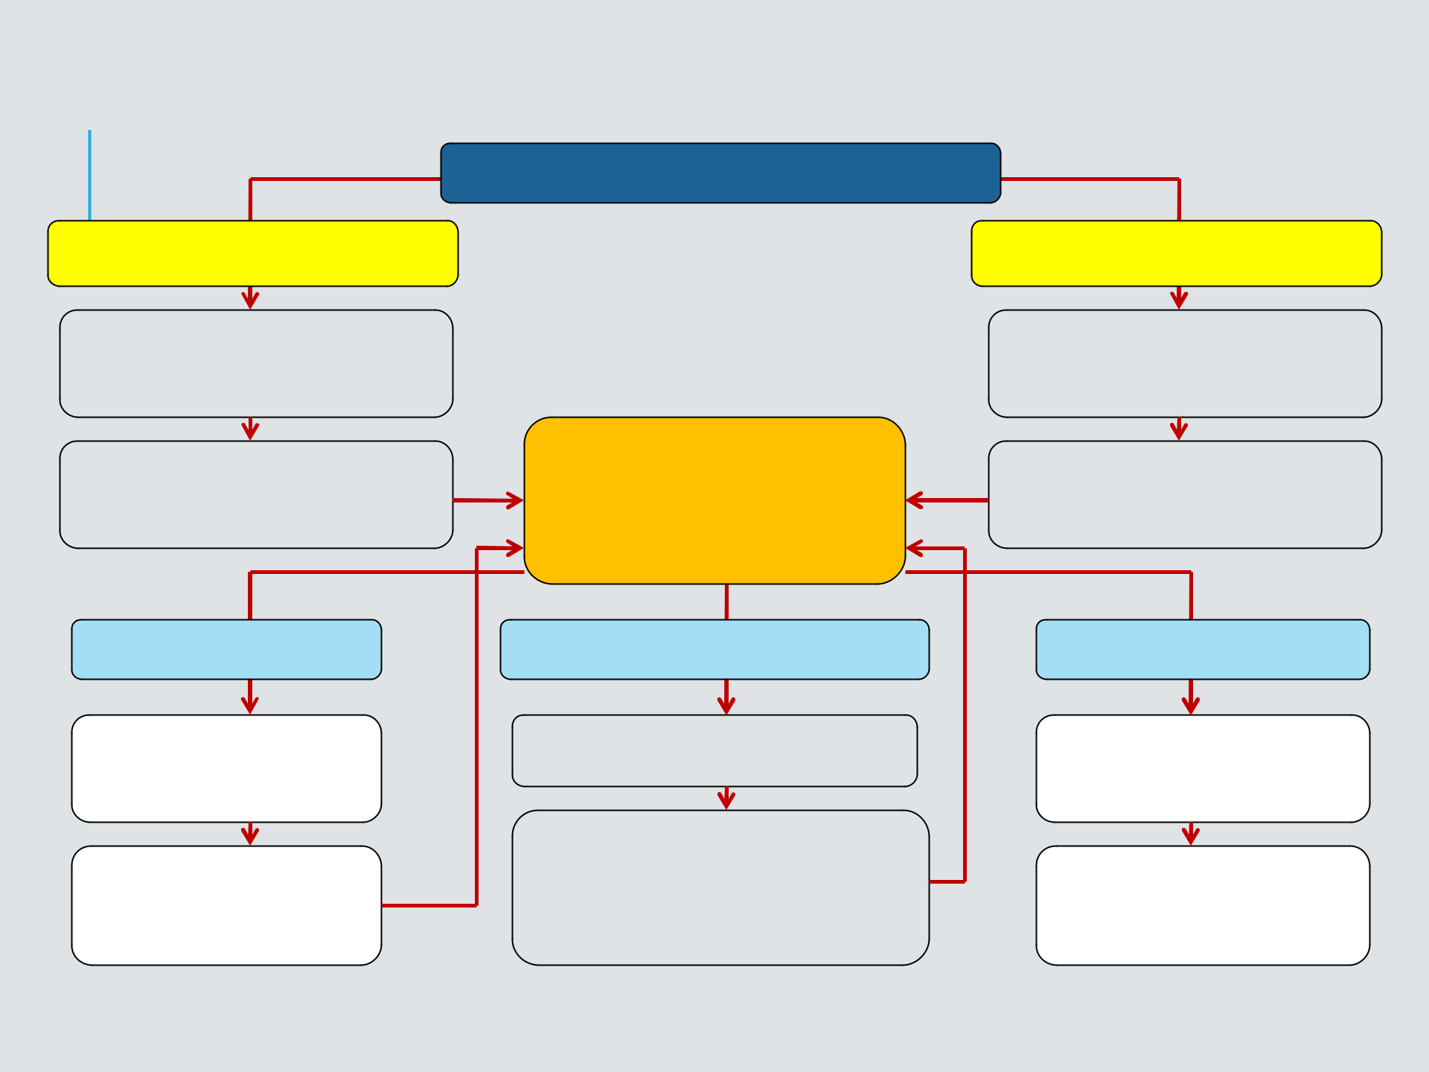**Claim Process- Cashless**

**Emergency Admission**

Get Admit as per Hospital Norm & Contact TPA desk of Hospital for cashless

Hospital applies for pre-

authorization to the TPA

within 24 hrs of admission

**Query (s) by TPA**

A Query letter sent by TPA through Fax/ E-mail to Hospital

Hospital replies to query raised by TPA through Email/Fax

**Cashless Hospitalization**

**TPA verifies policy**

**coverage & details and responds to hospital by Fax/E-mail**

**Approval given by TPA**

Initial Approval letter sent to hospital by TPA by fax/ Email

4 hours prior to Discharge

approach TPA Desk of hospital to complete formalities for full and final approval from TPA

**Planned Admission**

Approach TPA desk of Hospital 48 hours prior to admission for cashless

Hospital applies for pre-authorization to the TPA prior to admission

**Denied Cashless by**

**TPA**

Denial letter sent by TPA through Fax/ E-mail to Hospital

Patient pays the bill and submit papers for reimbursement process

**CASHLESS HOSPITALIZATION**

▪**Please Remember….**

* **Health India TPA will only pay for the Medical Expenses**
* **You need not make any payment for any of the non medical expenses.**
* **You must pay for the non-medical expenses on discharge or whenever asked by hospital**
* **The bills for medical expenses would be sent to Health India TPA by the hospital & they would directly settle the same with hospital**

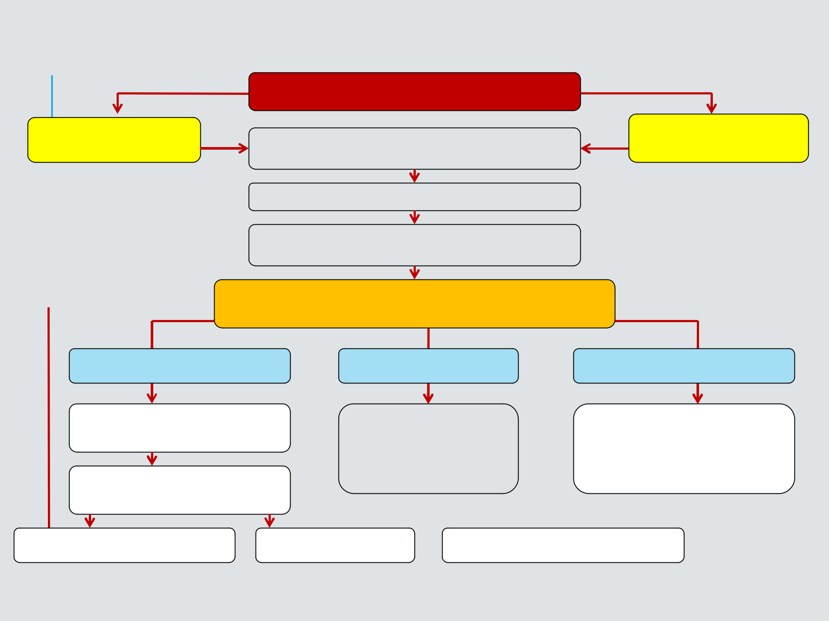**Claim Process- Reimbursement**

**Non Network Hospital Admission**

|  |  |
| --- | --- |
| **Emergency** | Get Admitted in the Hospital/ Nursing home |
| **Admission** |
| as per their Norms |
|  |
|  | Intimate the claim to TPA |
|  | Submit all relevant & mandatory Claim |
|  | Documents to TPA at the earliest |

**TPA verifies/scrutiny the documents & claim  submitted as per the policy coverage & conditions**

**Planned**

**Admission**

**Deficiency / Queries**

A Query letter sent by TPA

mentioning requirement

Few Reminders at fixed

intervals sent by TPA

|  |  |
| --- | --- |
| **Approved** | **Rejected/ Denial** |
| TPA/ Insurer arrange | Repudiation letter |
| for claim cheque sent | mentioning the reason for |
| to corporate OR | rejection will be sent to |
| execute NEFT | corporate |

Reply/ Documents Received Reply Not Received  Claim Closed without payment



**DOCUMENTS FOR REIMBURSEMENT CLAIMS**

**All documents mentioned herein should be submitted in ORIGINAL along with signed claim form:**

▪ **Discharge Card**

▪ **Detailed Hospital Bill**

▪ **Pre-numbered Cash Paid Receipts for payments made to hospital**

▪ **Prescriptions, Reports & Bills for all Diagnostics Tests**

▪ **Prescriptions & Bills for all Medicines purchased**

▪ **All Main Hospitalization bills should be submitted for claim within 30 days from Date Of Discharge.**

▪ **All Pre-Hospitalization bills should be submitted for claim along with the main bills only.**



**THANK YOU**