Project Report

**Software Requirement Specification**

ON

Hospital Management

BACHELOR OF TECHNOLOGY

IN

INFORMATION TECHNOLOGY

SUBMITTED BY

**ANKITA UDGATA - 19070124007**

**SAKSHI BUDHIA - 19070124012**

**SNEHA DARADE - 19070124015**



Under the Guidance of

PROF. SHREYA AHIRE

SYMBIOSIS INSTITUTE OF TECHNOLOGY

(A CONSTITUTENT OF SYMBIOSIS INTERNATIONAL UNIVERSITY)

Pune - 412115

2020- 2021

Software Requirement Specification

Table of Contents ....................................................................................................................

1. Introduction .......................................................................................................................3
   1. Purpose....................................................................................................................3
   2. Product Scope ..................................................................................................................................3
   3. References ...............................................................................................................3
   4. Intended Audience...................................................................................................3
2. Overall Description ............................................................................................................ 4
   1. Product Perspective .................................................................................................4
   2. Product Functions.....................................................................................................4
   3. User Classes and Characteristics ..............................................................................5
   4. Operating Environment ........................................................................................... 6
   5. Design and Implementation Constraints ................................................................. 6
   6. User Documentation ............................................................................................... 9
   7. Assumptions and Dependencies ............................................................................. 9
3. Functional Requirements ................................................................................................... 9
4. Non-Functional Requirements .......................................................................................... 10
5. Analysis Models .................................................................................................................10
   1. Use-Case DDiagram...................................................................................................................11
   2. Class Diagram............................................................................................................ 12

6. Results (Code and output Snippets)……………………………………………………………………………………….

7. Project Outcomes .................................................................................................................

8. Conclusion ...........................................................................................................................

9. Future Scope .........................................................................................................................

10. References ............................................................................................................................

**1.INTRODUCTION**

This is a Software Requirements Specification (SRS) for the Hospital Management System. It describes the functions, goals and tasks that the system can perform. This is used to describe the scope of the project and to plan for the system’s design and implementation. The following features are the high-level requirements that this system satisfies:

• Work Scheduling - Assigning nurses to doctors and doctors to patients

• Admissions - Admitting patients, assigning the patients to appropriate wards

• Patient Care - Monitoring patients while they are in the hospital

• Surgery Management - Planning and organizing the work that surgeons and nurses perform in the operating rooms

• Ward Management - Planning and coordinating the management of wards and rooms

• Waiting list - Monitoring to see if there are any patients waiting for available beds, assigning them to doctors and beds once these become available

**1.1 PURPOSE**

Hospital Management system is a medical informatics solution element that mainly focuses on the hospital administration requirements. HMS is a web based or computer application that takes care of complete hospital functionalities. The integrated system can be customized and are developed to control all hospital operations like patient details, appointment booking , billing , drug, management, electronic medical record, administration , patient medical history, inventory management, bed management.

Top benefits of implementing an HMS are role based access control , data accuracy, revenue management, appointment booking , overall cost , reduction and data security.

**1.2 PRODUCT SCOPE**

The software product is the Hospital Management System. The system will be used to allocate beds to patients on a priority basis, and to assign doctors to patients in designated wards as need arises. Doctors will also use the system to keep track of the patients assigned to them. Nurses who are in direct contact with the patients will use the system to keep track of available beds, the patients in the different wards, and the types of medication required for each patient. Doctors must make rounds to pick up patients’ treatment cards in order to know whether they have cases to treat or not. The intentions of the system are to reduce over-time pay and increase the number of patients that can be treated accurately. Requirements statements in this document are both functional and non-functional.

**1.3 REFERENCES**

[**https://en.wikipedia.org/wiki/Hospital_information_system**](https://en.wikipedia.org/wiki/Hospital_information_system)

**for srs -**

[**https://www.perforce.com/blog/alm/how-write-software- requirements-specification-srs-document**](https://www.perforce.com/blog/alm/how-write-software-%20%20%20%20%20%20requirements-specification-srs-document)

**1.4 INTENDED AUDIENCE**

This Software Requirements Specification document is intended for software engineers, system testers and software designers in developing, testing, and producing the SHMS and for the project.

**2.OVERALL DESCRIPTION**

**2.1 PRODUCT PERSPECTIVE**

Hospital centre follow manual approach to keep track of its day to day activities which include important activities such as maintaining patient database, employee handling, financial analysis. Due to improperly managed details, the hospital has to face a lot of issues for accessing past and present data.

Our new software will replace the manual system by eliminating the disadvantages caused by manual systems by improving reliability efficiency and performance. This will help in reducing the excess storage required to keep the manual data. Our automated records would be easier to access, retrieve and manipulate. As access would be limited it would enhance system security. Overall the system will facilitate convenient management of the entire system.

**2.2 PRODUCT FUNCTIONS**

**Registration**

when the patient is admitted the receptionist checks whether the patient has been registered before

->if he/ she is already a member the patient id is entered, otherwise a new id I given to the patient

-> the patient’s information such date of birth, gender, addresses and phone number are entered into the software.

**Pharmacy management**

->drug stock management

->check for expiry

->billing

->look for medicines

**Employee management**

->employment or removal of staff

->attendance of staff

->schedule management of staff

->deciding and giving salary

**Treatment and equipment management**

->doctor detail

->patient details

->equipment stock management

->issue reports

->payment

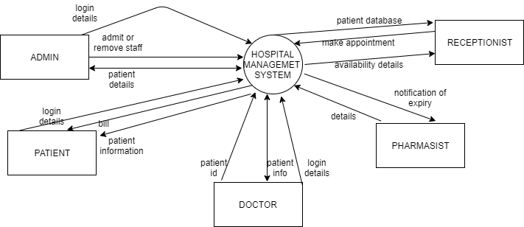

**2.3 USER CLASSES AND CHARACTERISTICS**

ADMIN

* Can login, update, view and search the details of the doctors, patient, receptionist and lower staff.
* Can check availability of beds. Add and delete beds.
* Can view different departments and add and delete them
* Can approve doctors who have applied for jobs

PATIENT

* Can book appointments
* Check if appointment is approved
* Check appointment details
* *online consultation

DOCTOR

* Can apply for jobs
* Login if already is a doctor at the hospital
* Check patient details
* Can check appointment

RECEPTIONIST

* Approve appointment made by patient
* Assign doctor to the patient
* Check patient details

PHARMACY

* Insert delete and modify medicine detail
* Get an notification when medicine is expired

**2.4 OPERATING ENVIRONMENT**

* Java
* Intellij Idea

**2.5 DESIGN AND IMPLEMENTATION CONSTRAINTS**

System modeling: functional modeling:

Dfd level 0

In Software engineering DFD (data flow diagram) can be drawn to represent the system of different levels of abstraction. Higher level DFDs are partitioned into low levels-hacking more information and functional elements. Levels in DFD are numbered 0, 1, 2 or beyond. Here, we will see mainly 3 levels in data flow diagram, which are: 0-level DFD, 1-level DFD, and 2-level DFD.

Functional modeling:

DFD level 0

A data flow diagram (DFD) is a graphical representation of the "flow" of data through an information system, modelling its process aspects. A DFD is often used as a preliminary step to create an overview of the system without going into great detail, which can be later be elaborated. data flow diagrams are one of the three essential perspectives of the structured system analysis and design method SSADM

DFD level 0 is also called a context diagram. It's a basic overview of the whole system or process being analysed or moulded. It's designed to be an at a glance view. it should be easily understood by a wide audience, including stakeholders, business analysts, data analysts, and developers.

The major information flows between the entities and the system,

A context diagram address only one process.

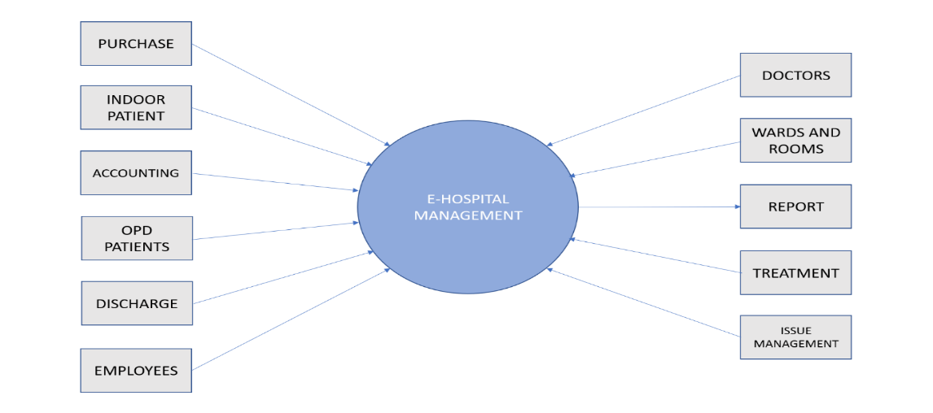

**Level 1 DFD:**

A level 1 data flow diagram (DFD) is more detailed than a level 0 DFD but not as detailed as a level 2 DFD. It breaks down the main processes into subprocesses that can then be analyzed and improved on a more intimate level.

In 1-level DFD, context diagram is decomposed into multiple bubbles/processes.in this level we highlight the main functions of the system and breakdown the high-level process of 0-level DFD into subprocesses.

**Level 2 DFD:**

A level 2 data flow diagram (DFD) offers a more detailed look at the processes that make up an information system than a level 1 DFD does. It can be used to plan or record the specific makeup of a system.

2-level DFD goes one step deeper into parts of 1-level DFD. It can be used to plan or record the specific/necessary detail about the system’s functioning.

**Level 1 DFD:**

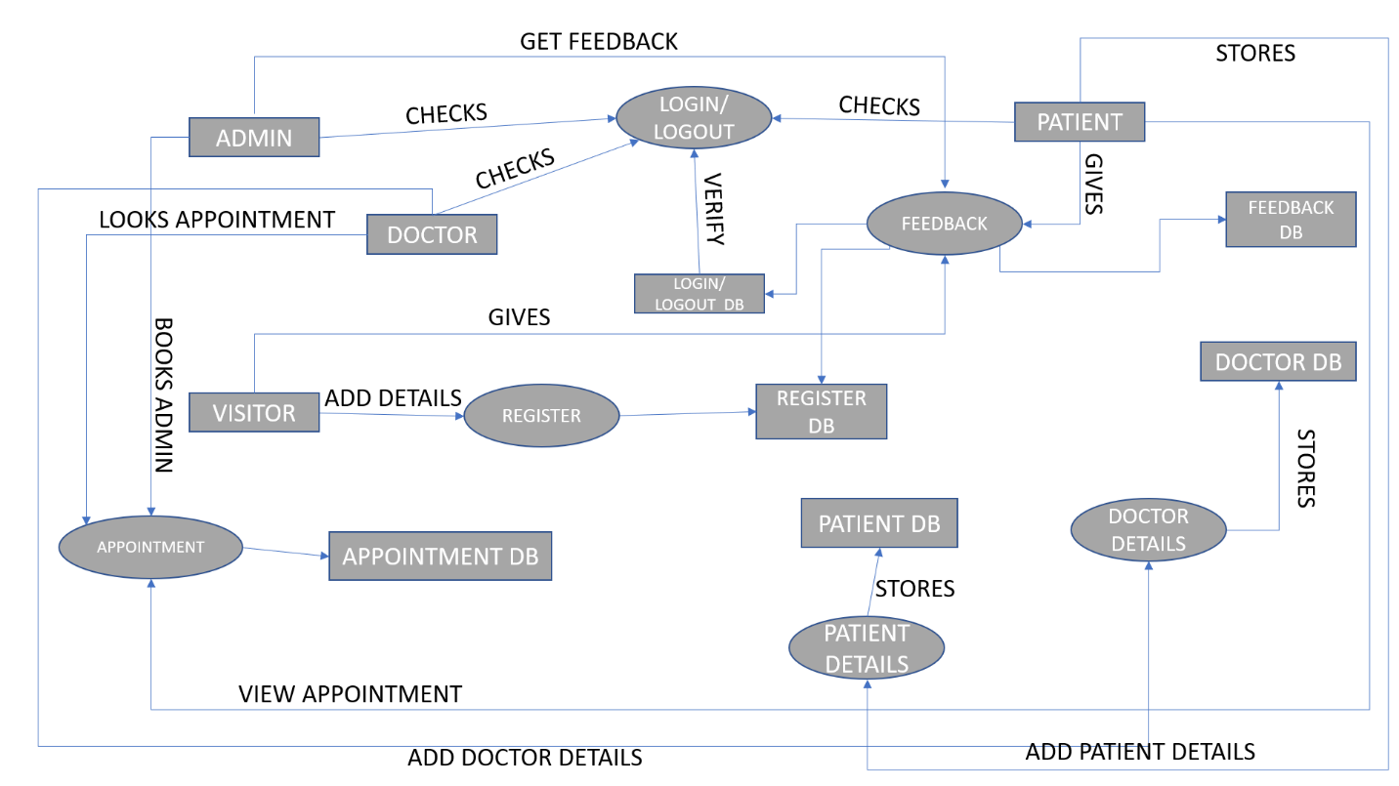 **E-HOSPITAL MANAGEMENT SYSTEM**

**Level 2 DFD:**

**E-HOSPITAL MANAGEMENT SYSTEM**

**EXPANDING PATIENT DETAILS FROM LEVEL 1 DFD**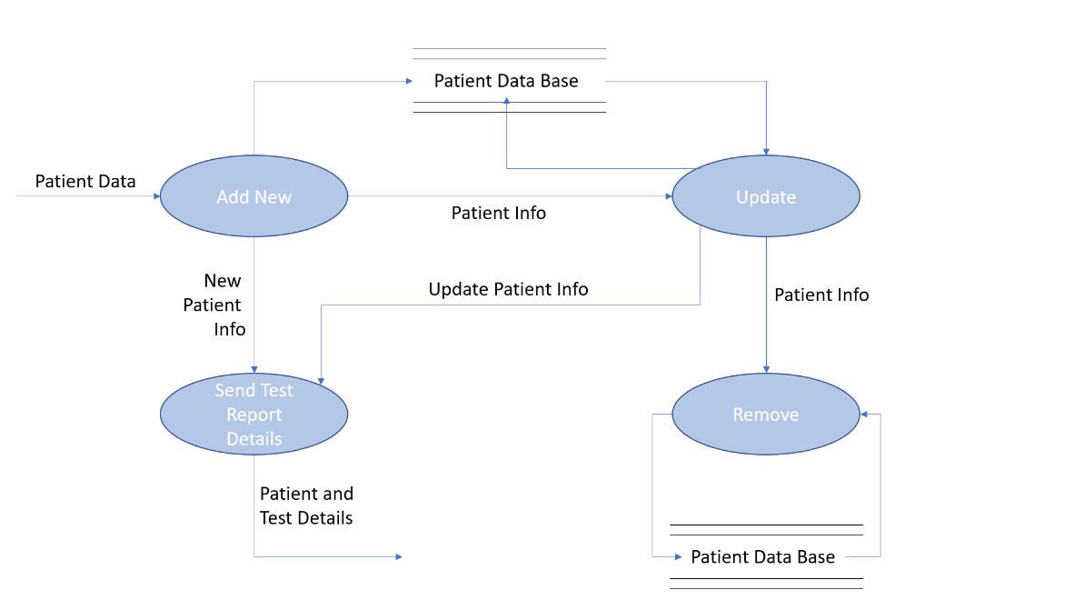

**Level 2 DFD:**

**E-HOSPITAL MANAGEMENT SYSTEM**

**EXPANDING ADMIN DETAILS FROM LEVEL 1 DFD**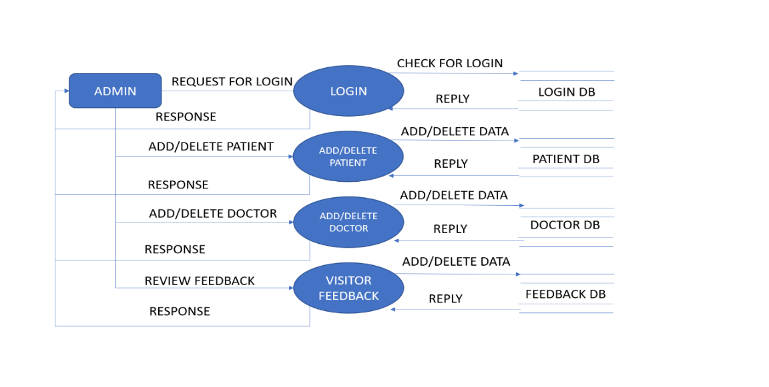

**Level 2 DFD:**

**E-HOSPITAL MANAGEMENT SYSTEM**

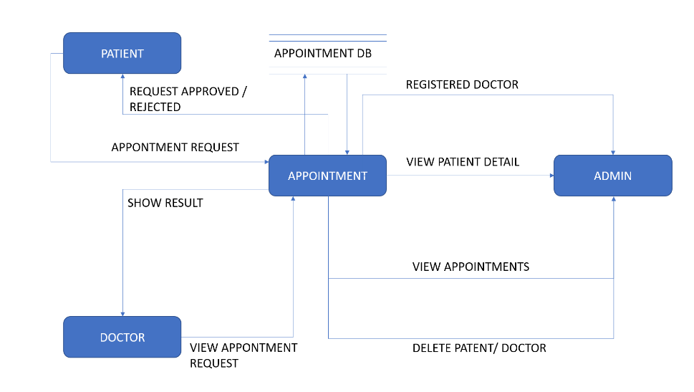**INTEGRATING PATENTS APPOINTMENTS WITH DOCTOR DETAILS**

**2.6 USER DOCUMENTATION**

The software is developed to make the product more user friendly. General users with basic computer skills can use this software.All external interfaces are mentioned in the document.. This manual will be updated with each new service pack.

**2.7 ASSUMPTIONS AND DEPENDENCIES**

• It is assumed that compatible computers will be available before the system is installed and tested.

• It is assumed that the Hospital will have enough trained staff to take care of the system

**3 . Functional Requirements**

There are a lot of software requirement specification include in the functional requirement of the hospital management system . Which contains various process mainly registration. Check out, report generation and database.

1. Module
2. In this process registraction of patient happens in dta base

* Adding patient
* Assigning an ID to patients

1. **CHECK OUT OF SRS**

* Deleting patient ID
* Adding beds available list

1. **REPORT GENERATION**

* Information of the patient
* Availability of the bed

1. **DATABASE OF SRS**

* Mandatory patient information
* Updating information of the patient

**4 .Non-Functional Requirements**

There are a lot of software requirements specification involved in the non-functional requirements of the hospital management system which contains various process, mainly security performance, maintainability and reliability.

1. **SECURITY**

* Patient identification
* Login ID
* Modifications
* Front deskstaff rights
* Administration rights

1. **PERFORMANCE**

* Response time
* Capacity
* User interface
* Conformity

1. **MAINTAINABILITY**

* Back up
* Error

1. **RELIABLITY**

* Available 24/7

**5. Analysis Models**

**USE CASE AND ER DIAGRAM**

**Primary Actor:**The primary actor of a use case is the stakeholder that calls on the system to deliver one of its services.

**Supporting Actors:** A supporting actor (secondary actor) in a use case in an external actor that provides a service to the system under design

**Use cases** They are usually referred to as system functionalities that a system should perform in collaboration with one or more external users of the system (actors).

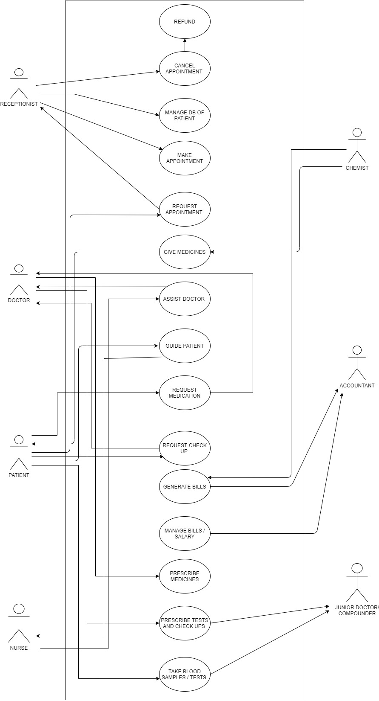 **5.1 USECASE DIAGRAM**

**5.2 ER DIAGRAM**

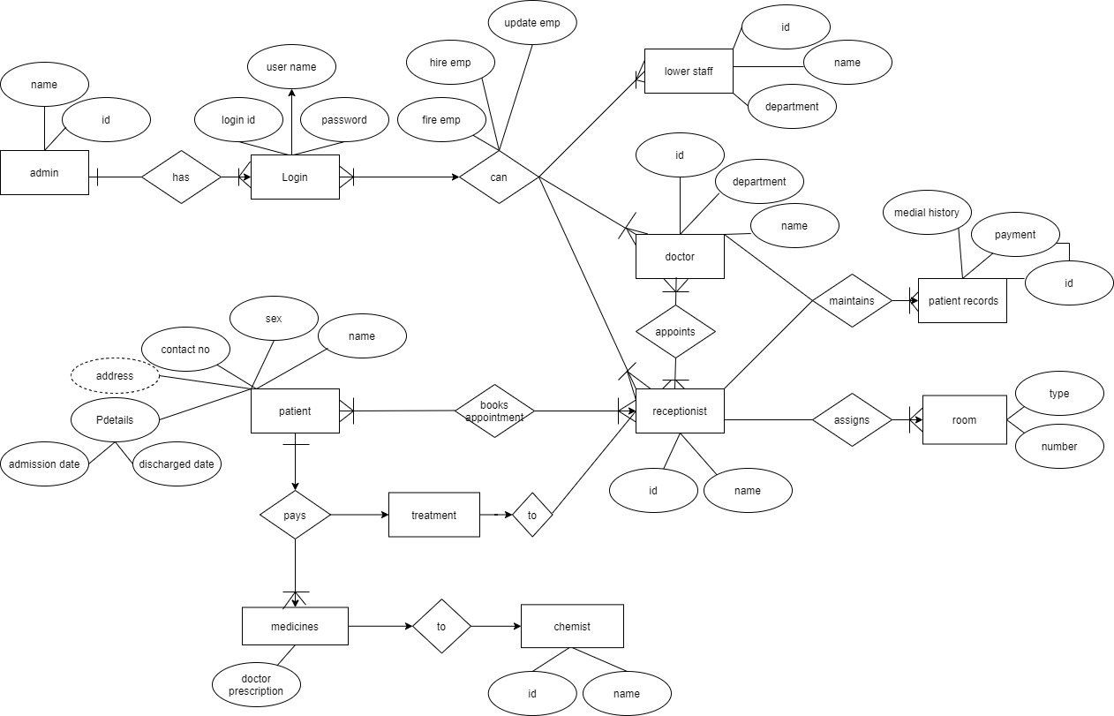

**6.** **RESULTS (CODE AND OUTPUT SNIPPETS)**

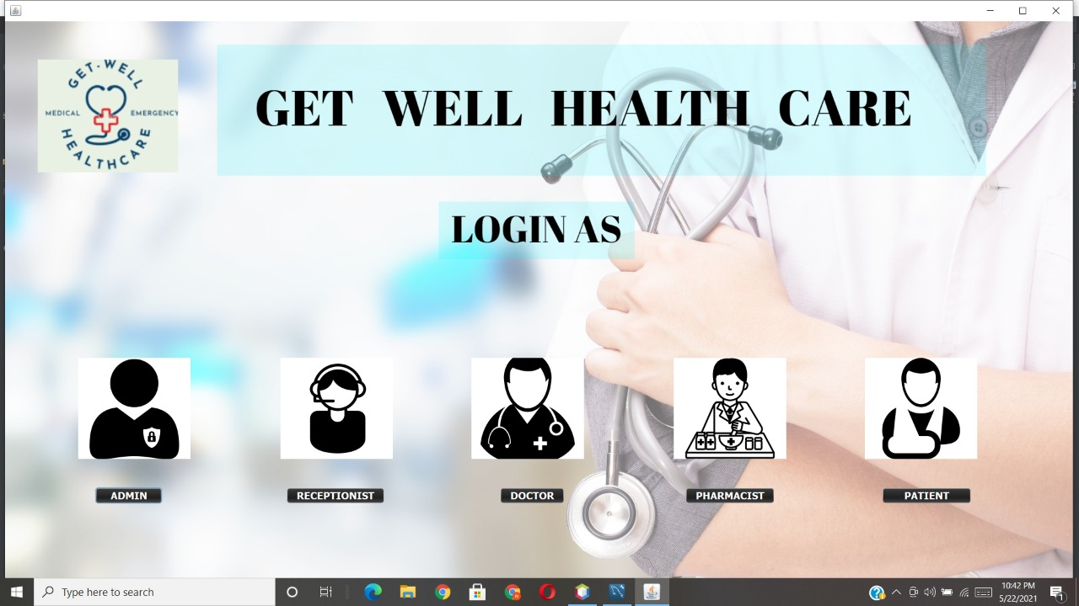

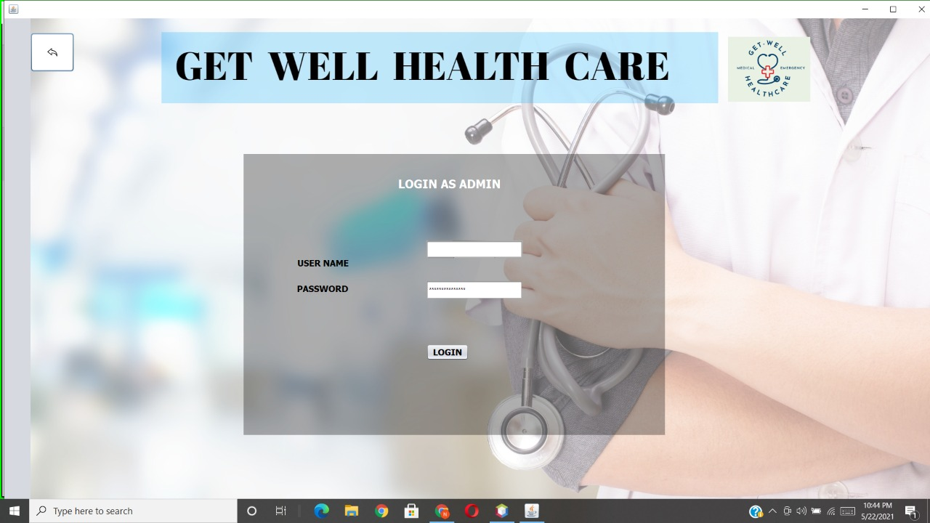

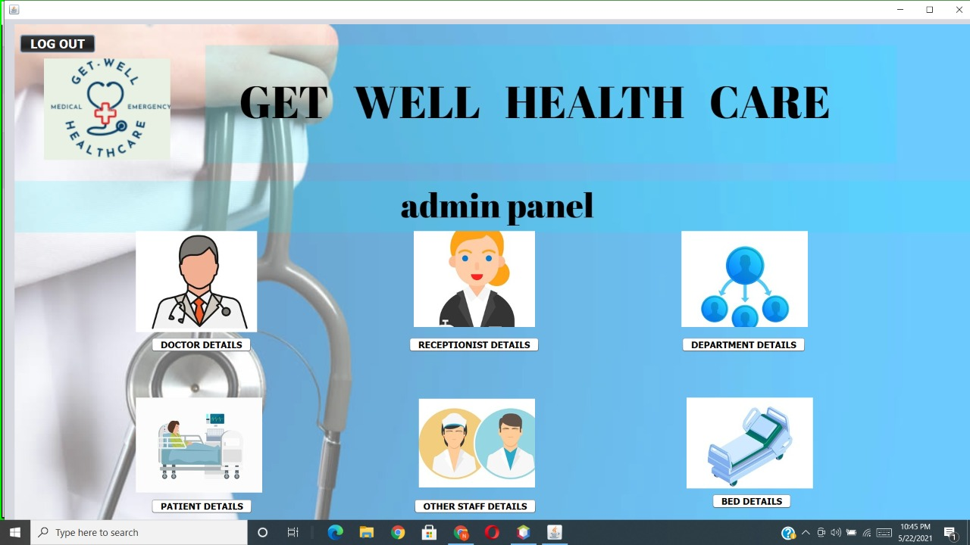

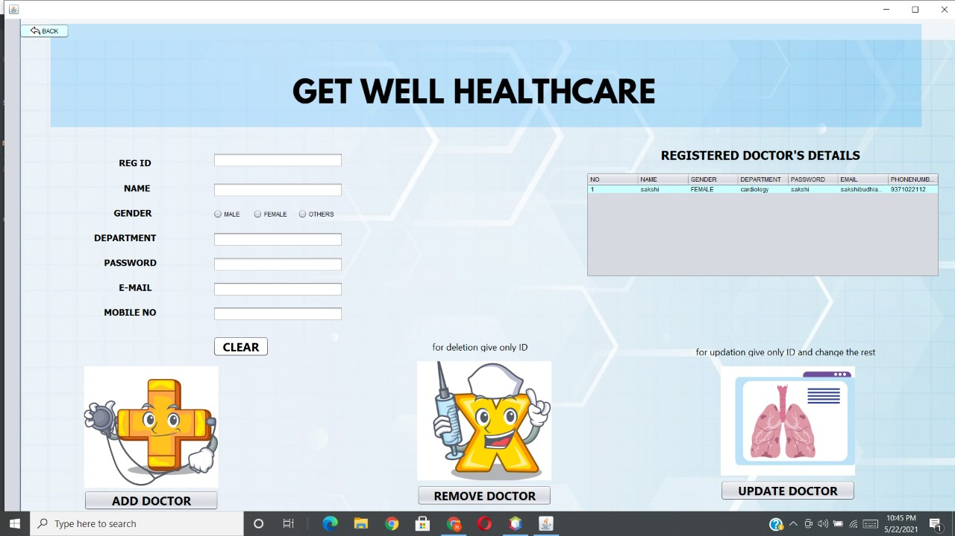

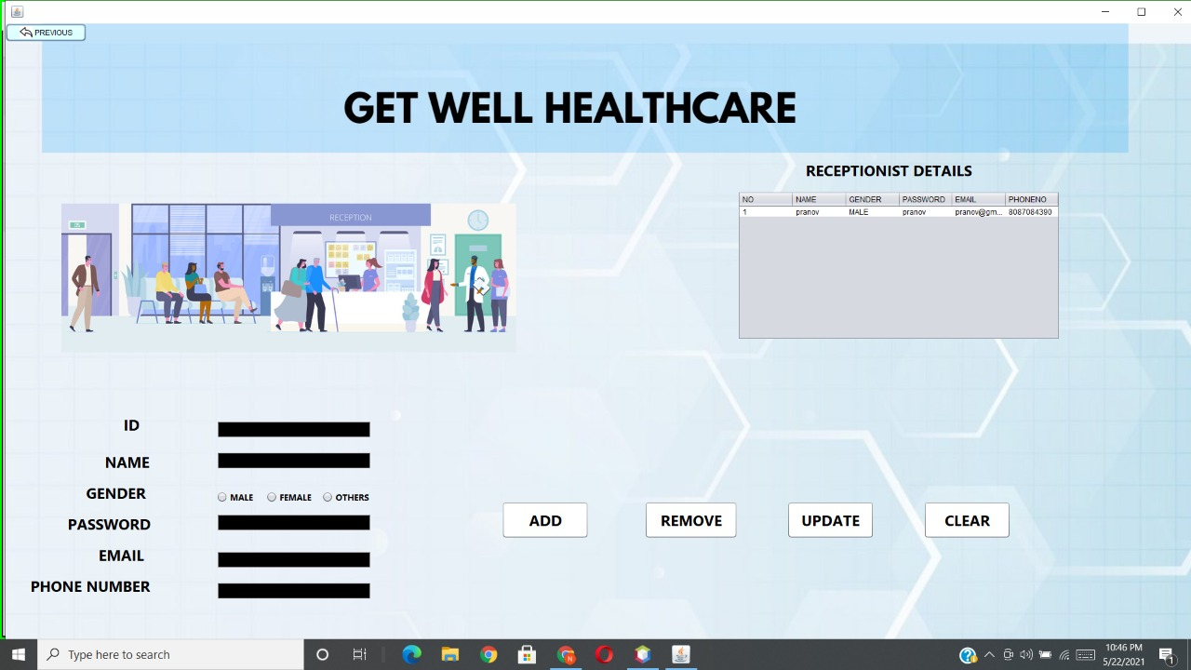

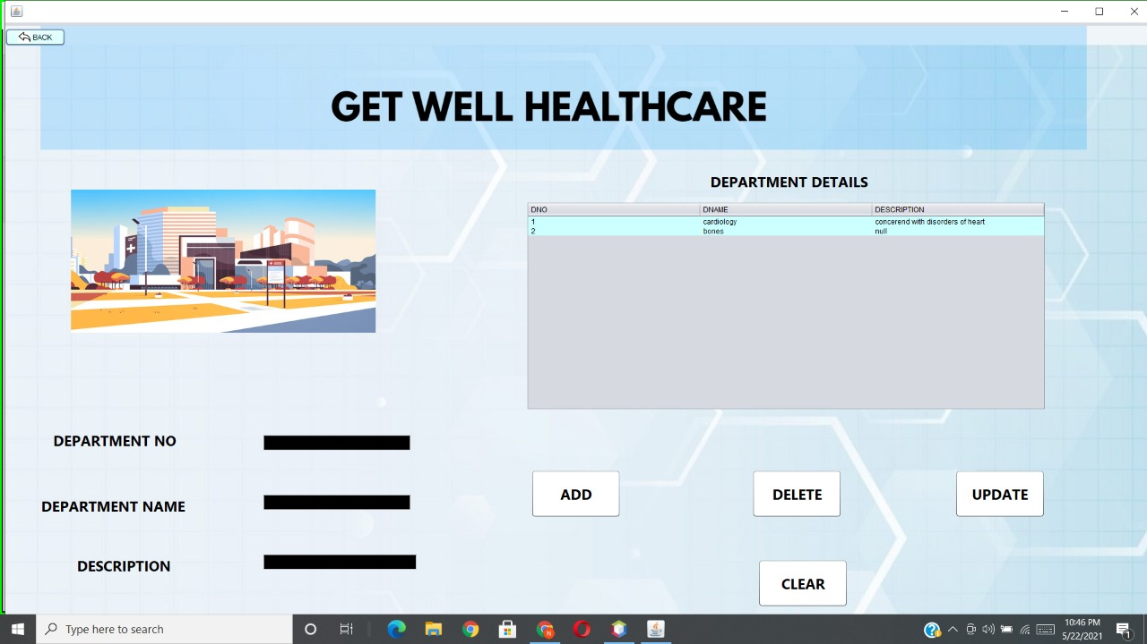

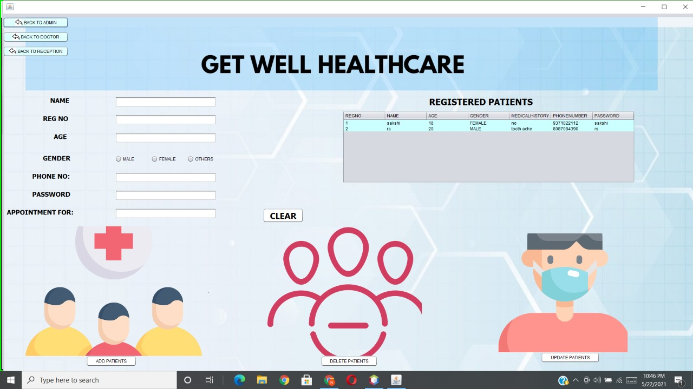

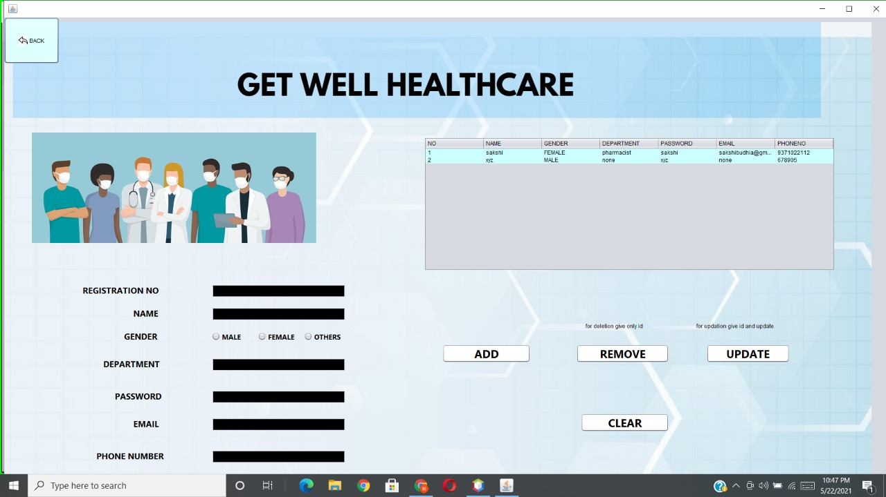

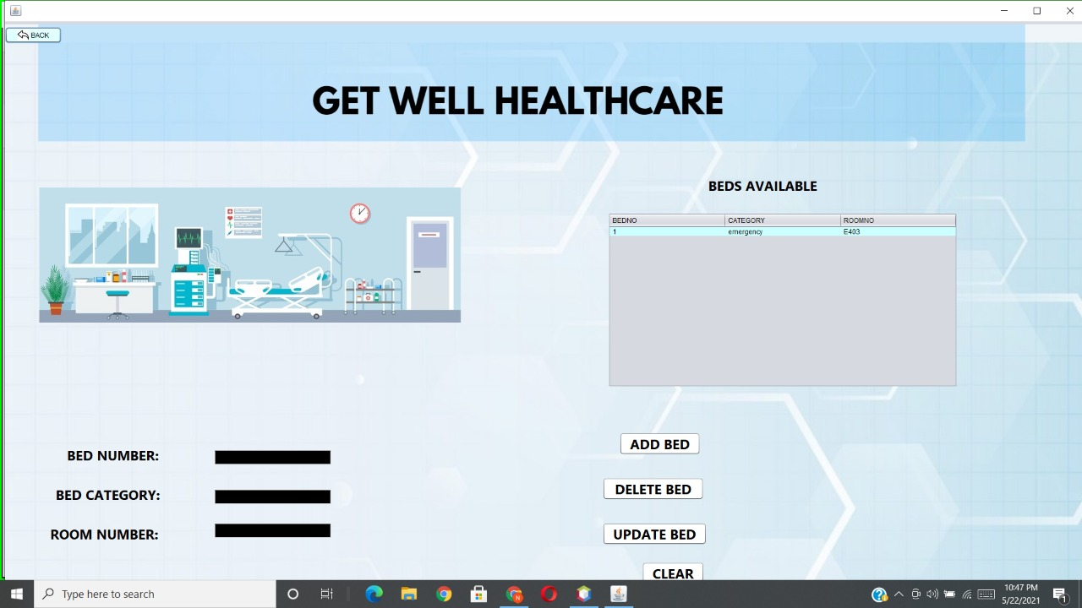

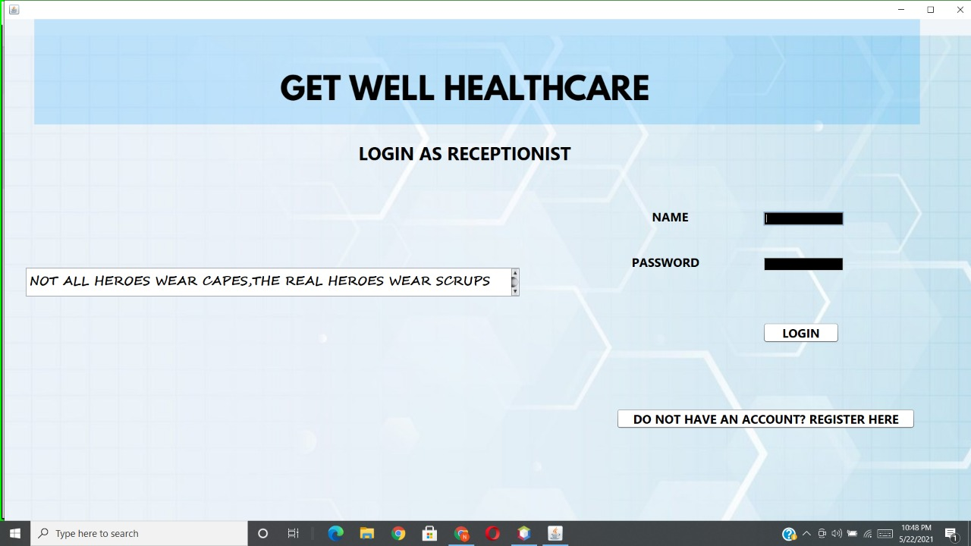

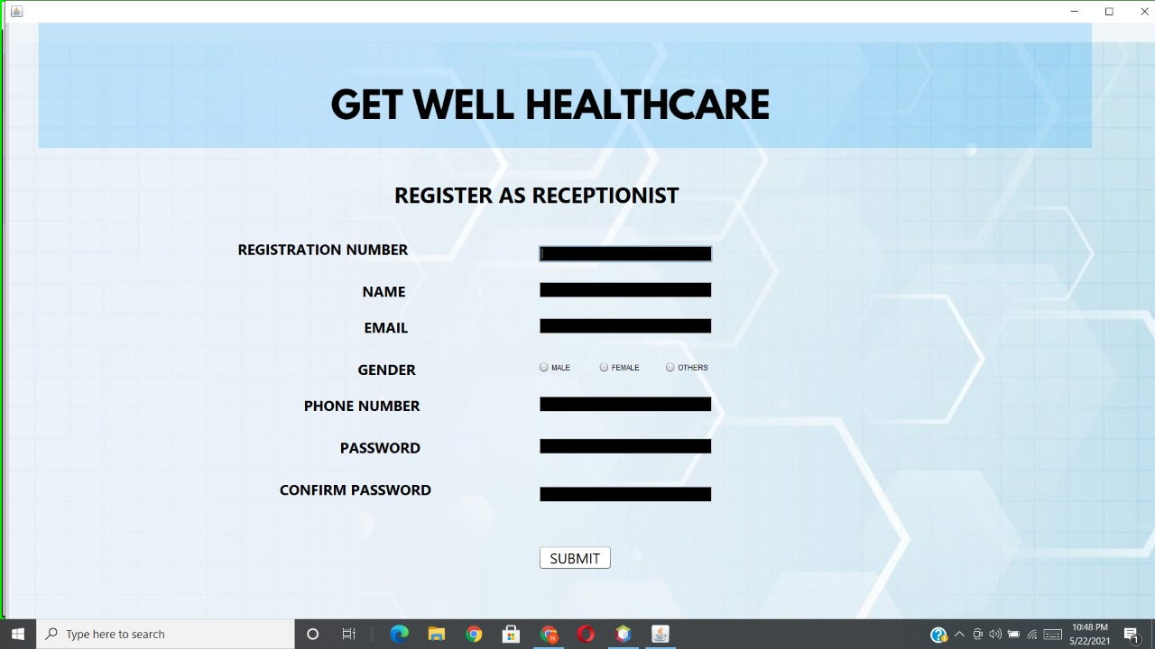

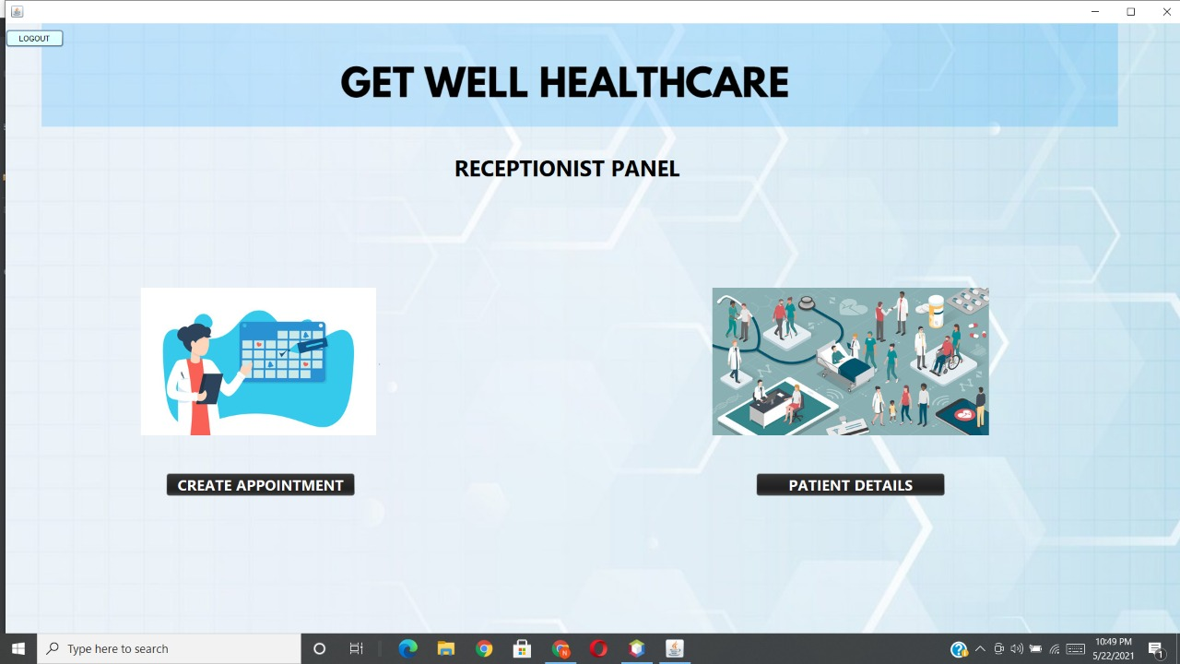

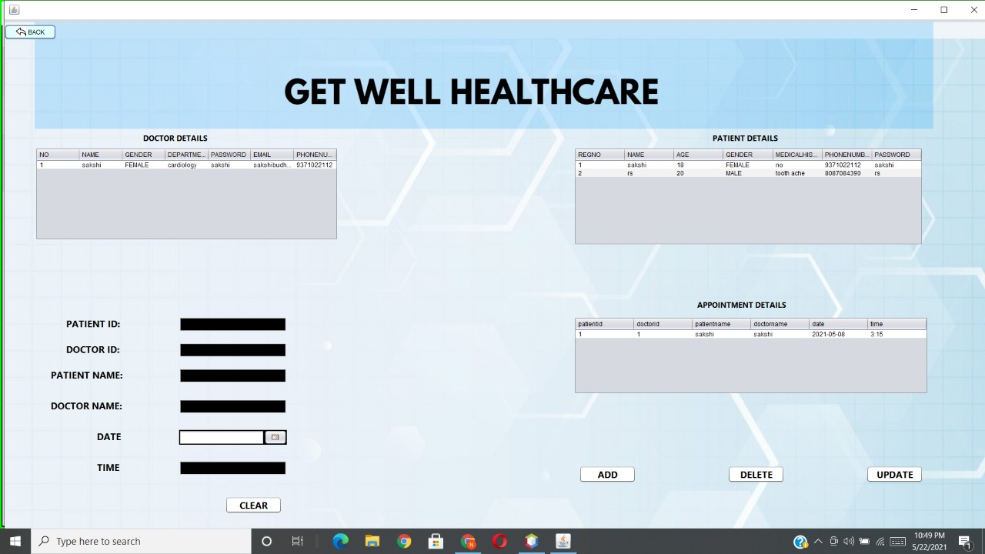

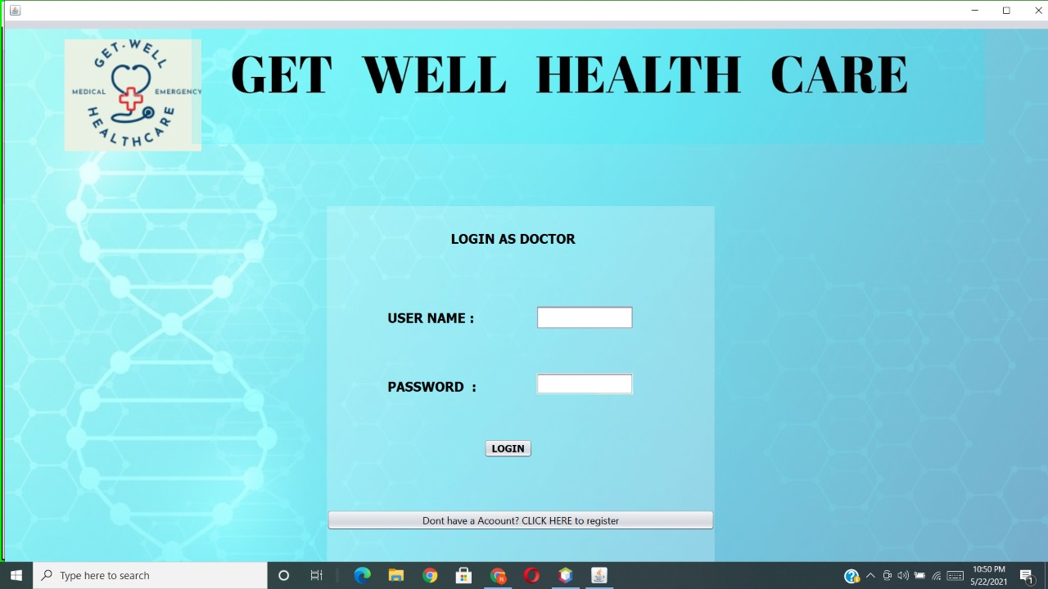

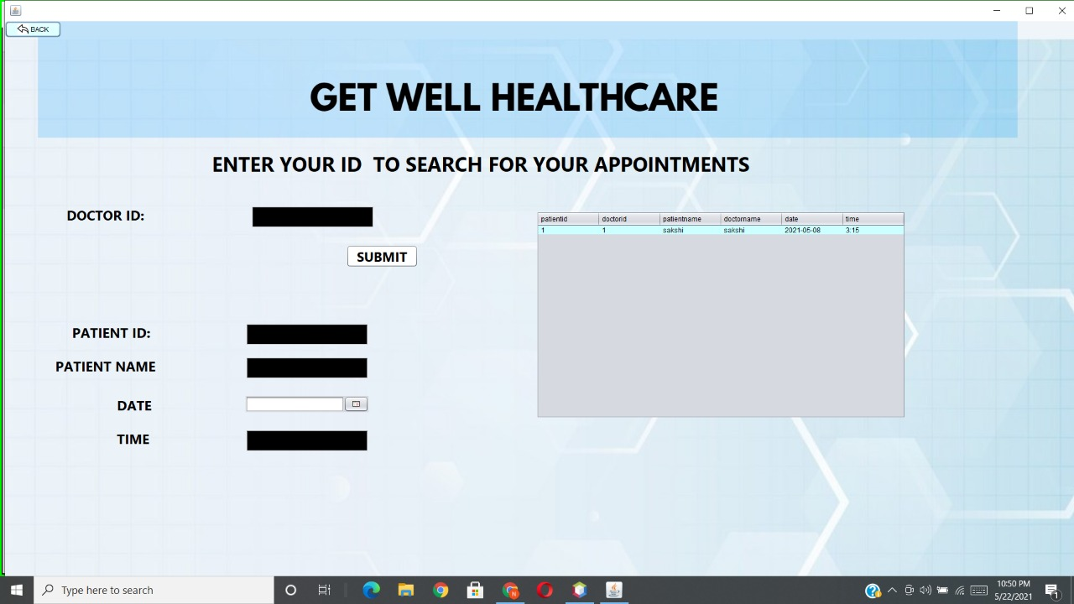

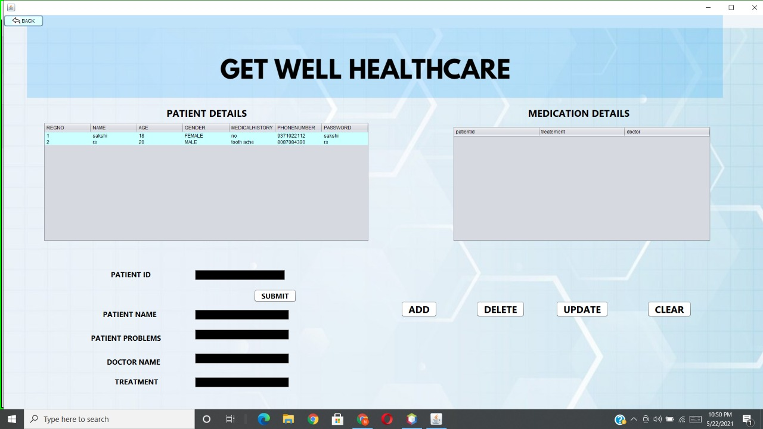

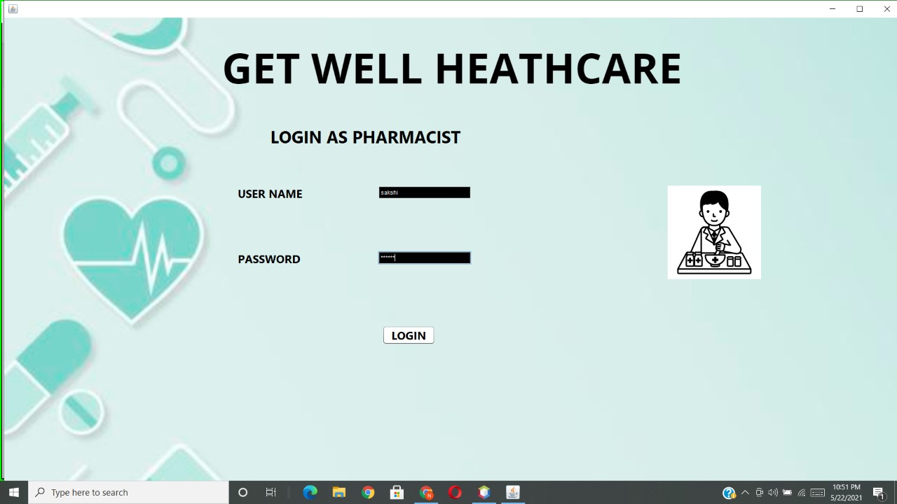

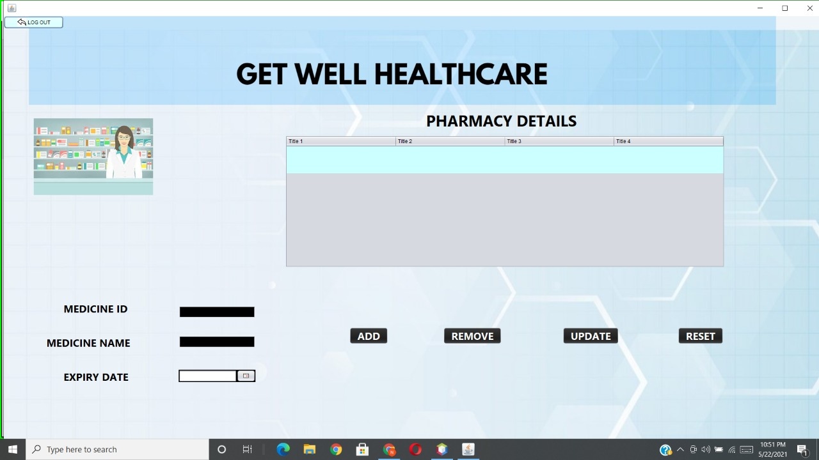

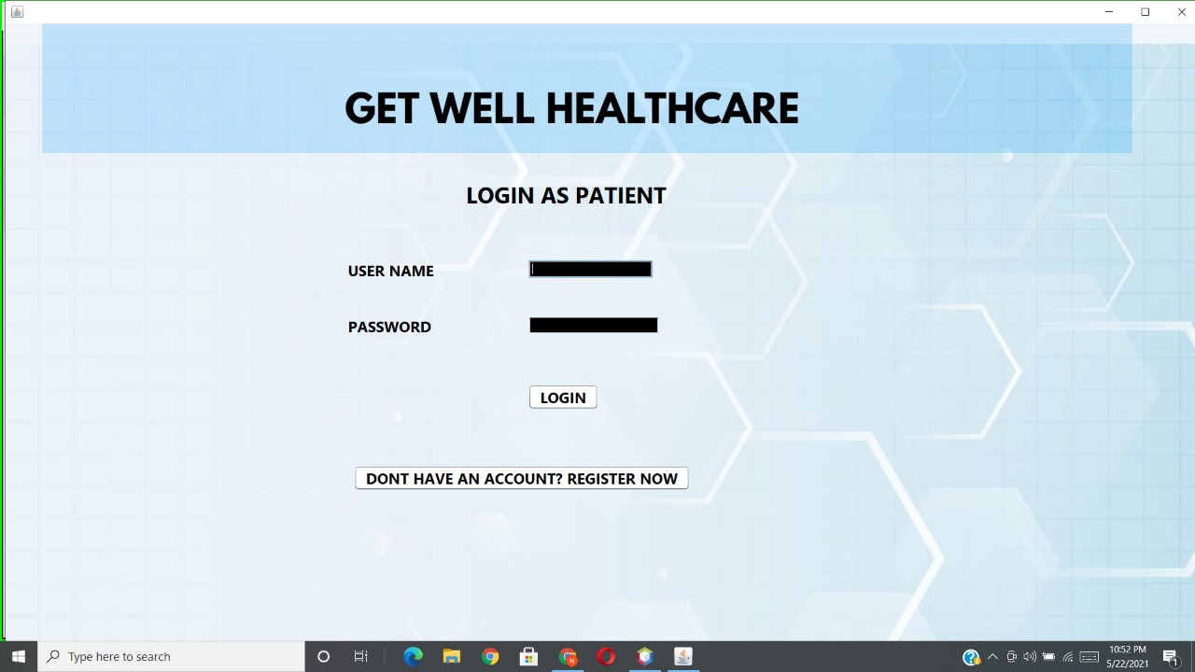

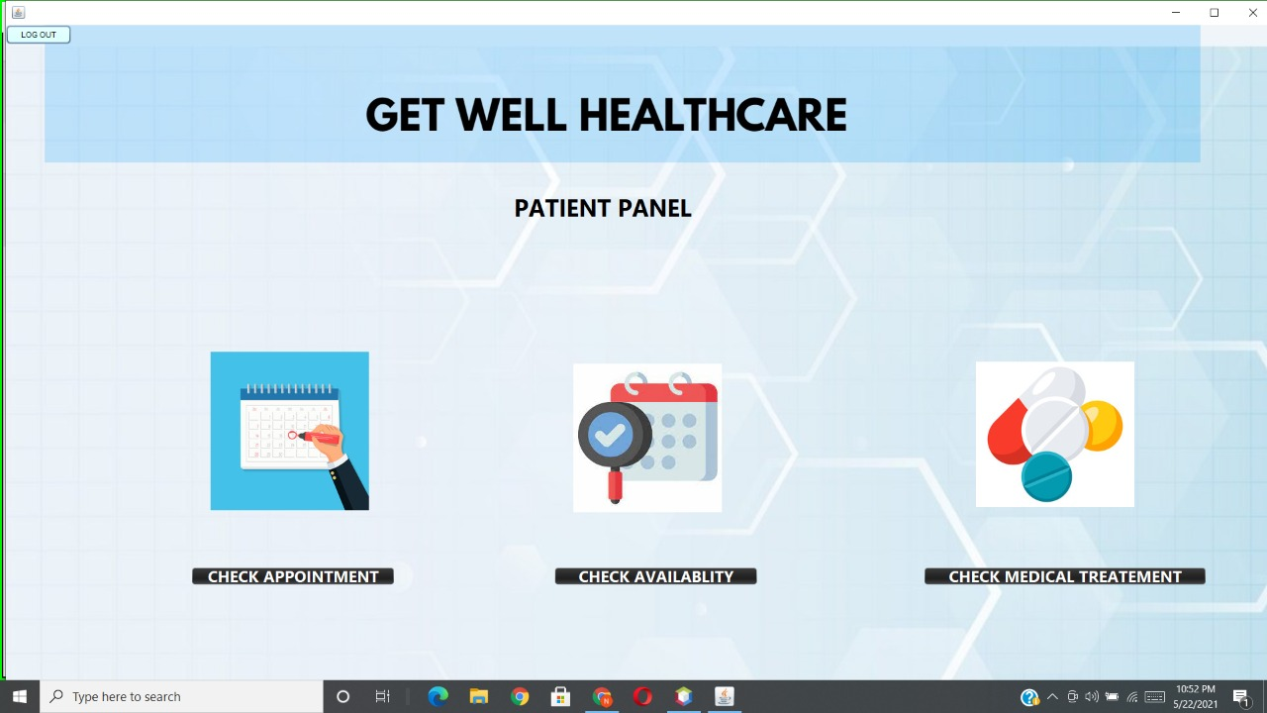

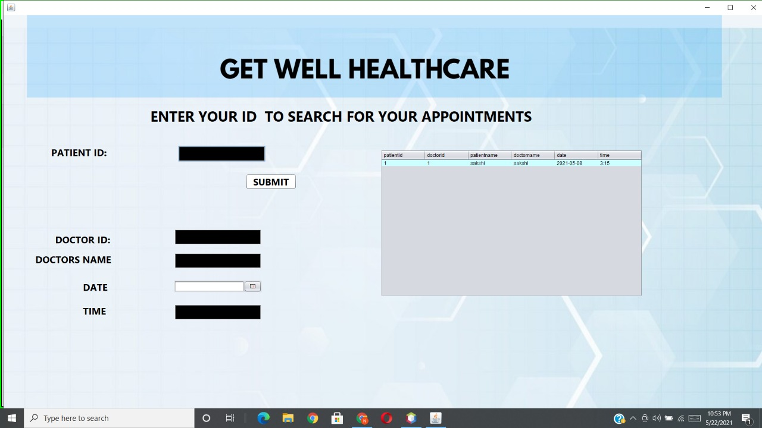

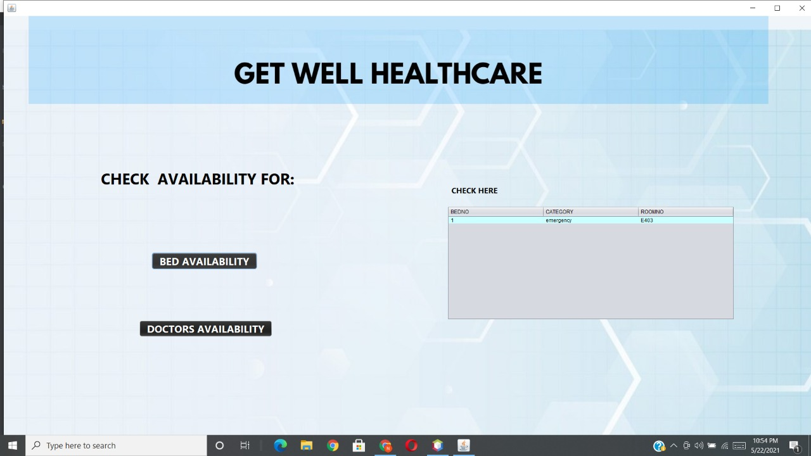

**7. PROJECT OUTCOMES**

Hospital Management System project outcomes are as follows :

* All hospital operations like patient details, appointment booking , billing , drug, management, electronic medical record, administration , patient medical history, inventory management, bed management are running well.
* Role based access control , data accuracy, revenue management, appointment booking , overall cost , reduction and data security is achieved.
* Work Scheduling is done easily by assigning nurses to doctors and doctors to patients.
* Admissions are done by admitting patients, assigning the patients to appropriate wards.
* Patient Care is taken by monitoring patients while they are in the hospital.
* Surgery Management is done by Planning and organizing the work that surgeons and nurses perform in the operating rooms.
* Ward Management is done by planning and coordinating the management of wards and rooms .
* Waiting list and Monitoring is done to see if there are any patients waiting for available beds, assigning them to doctors and beds once these become available.

**8. CONCLUSION**

Hospital Management System is a project for hospital administration requirements.The software takes care of all the requirements of complete hospital functionalities and is capable to control all hospital operations like patient details, appointment booking , billing , drug, management, electronic medical record, administration , patient medical history, inventory management, bed management.

Hospital management system provide role based access control, data accuracy, revenue management, appointment booking, overall cost, reduction and data security.

According to our design and needs we have almost satisfied our work till 100% of what we planned in our project to do.

The whole group was a part of the project.

The application is working properly.

The project was submitted on time.

**9. FUTURE SCOPE**

The proposed system is Hospital Management System . We can enhance this system by including more facilities like pharmacy system for the stock details of medicines in the pharmacy . Providing such features enable the users to include more comments into the system .

**10. REFERENCE**

[**https://en.wikipedia.org/wiki/NetBeans**](https://en.wikipedia.org/wiki/NetBeans)

[**https://dev.mysql.com/doc/relnotes/mysql/8.0/en/**](https://dev.mysql.com/doc/relnotes/mysql/8.0/en/)

[**https://www.tutorialspoint.com/mysql/index.htm**](https://www.tutorialspoint.com/mysql/index.htm)

[**www.udemy.com**](http://www.udemy.com)

[**www.stackoverflow.com**](http://www.stackoverflow.com)

[**www.javapoint.com**](http://www.javapoint.com)

[**www.geeksforgeeks.com**](http://www.geeksforgeeks.com)