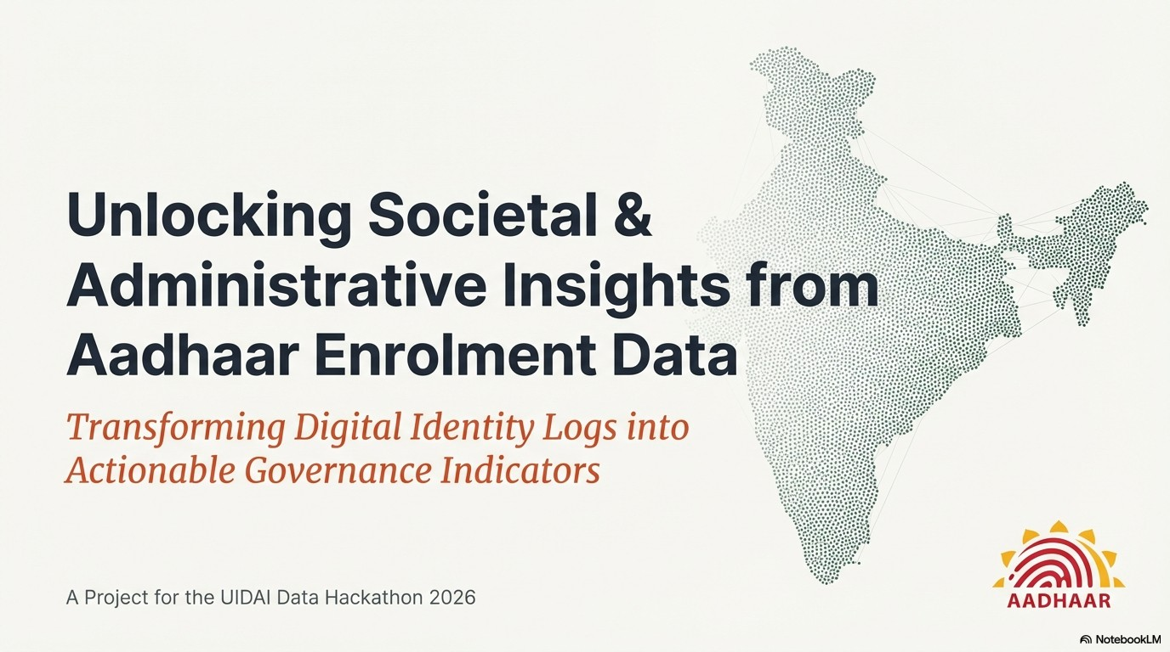

From Data to Governance Action

Name: Sakshi Srivastava
Email: sakshianujay341@gmail.com
Team ID:UIDAI_5837

PROBLEM STATEMENT

Aadhaar enrolment data captures large-scale demographic and geographic movements of India’s population. While this data is routinely collected, its potential for anticipatory governance remains underutilised.

Government agencies face persistent challenges such as:

Sudden migration-driven pressure on enrolment infrastructure

Uneven access to Aadhaar services across regions

Planning gaps for welfare portability and service delivery

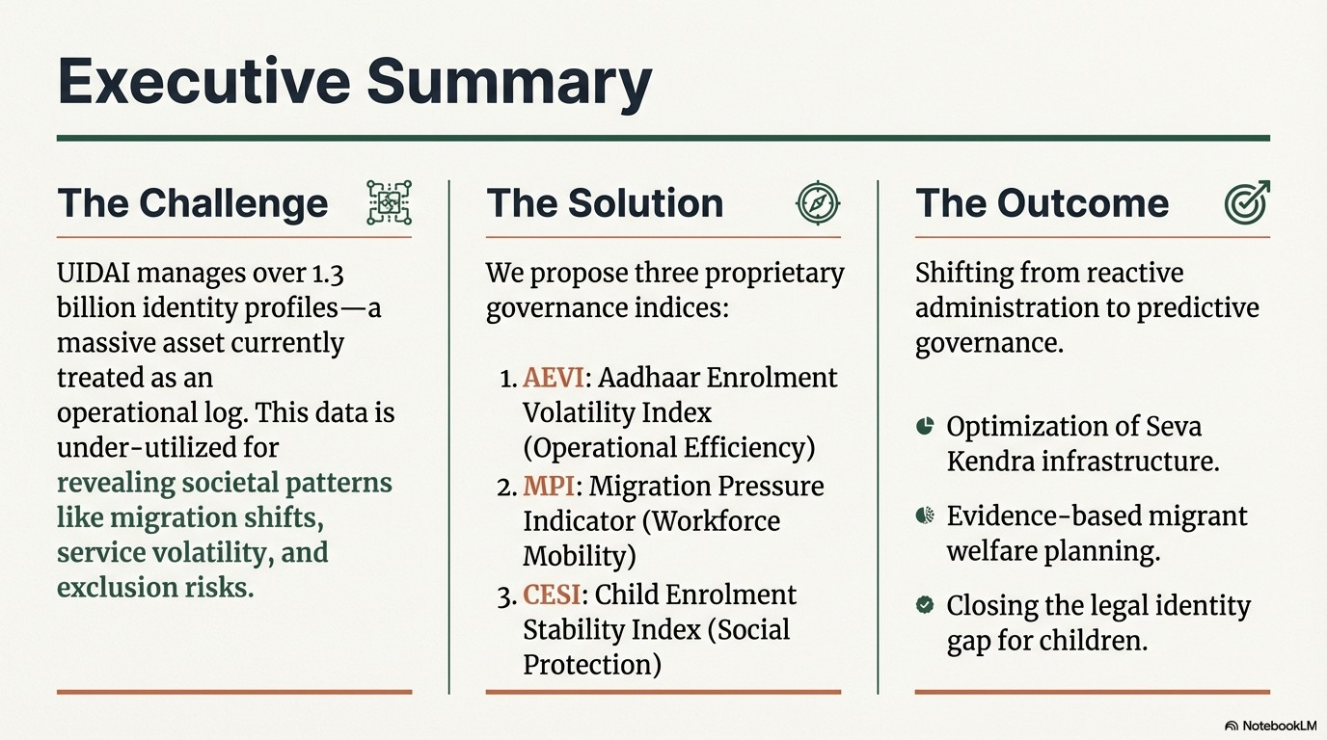
Currently, decision-making relies largely on reactive measures rather than early indicators.

Objective
To identify meaningful patterns, trends, and volatility signals within Aadhaar enrolment data that can:
- Support proactive infrastructure planning
- Indicate migration and access stress
- Enable data-driven governance without compromising privacy

DATASET USED
Dataset: Aadhaar Enrolment Dataset (UIDAI)
Nature: Aggregated and anonymised
Key attributes:
- Dataset: Aadhaar Enrolment Dataset
- Source: UIDAI (event.data.gov.in)
- Records: 1,006,029 aggregated entries
- Time Range: Up to December 2025
- Granularity: State, District, PIN code, Date
- Age Categories:
- 0–5 years
- 5–17 years
- 18+ years
The dataset contains over 1 million records spanning multiple states and time periods.
No individual-level or biometric data is used.

METHODOLOGY
Data Cleaning & Standardisation
- Standardised inconsistent state names
- Converted dates into year and month
- Created total enrolment counts
- Removed non-informative or invalid entries
Feature Engineering
- Monthly and yearly enrolment aggregation
- Age-group-wise enrolment proportions
- Normalisation for cross-state comparison
Exploratory Analysis
- Temporal enrolment trends
- State-wise and age-wise distribution
- Volatility and concentration patterns

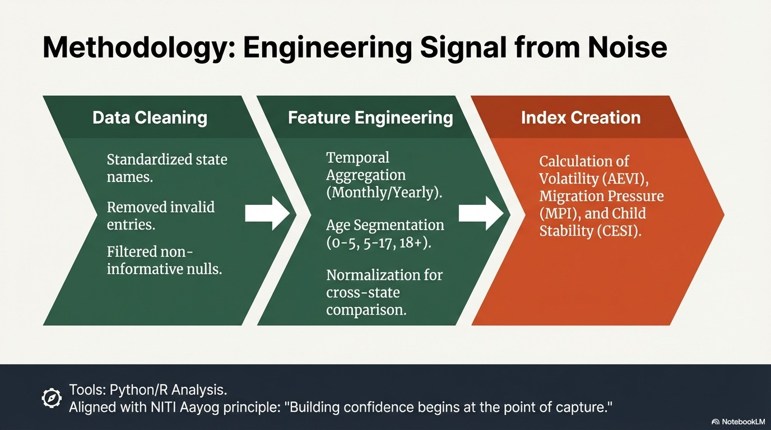

Analytical Pipeline
Raw CSV Files
↓
Data Cleaning & Standardisation
↓
Date Parsing & Feature Engineering
↓
Aggregation (Monthly, State-wise)
↓
Indicator Construction
↓
Visual & Statistical Analysis
Key Processing Steps
- State name normalisation (case & spelling unification)
- Date conversion to Year, Month, Month Name
- Creation of Total Enrolments feature
- Monthly aggregation for temporal stability
- Outlier-resilient normalisation

DATA ANALYSIS
Univariate Analysis
- Distribution of enrolments across age groups
- Identification of high-volume states
Bivariate Analysis
- Relationship between time and enrolment volumes
- State vs age-group dependency patterns
Trivariate Analysis
- State × Month × Age-group dynamics
- Detection of seasonal and migration-linked trends
Key Observation:
States with high adult enrolment volatility also exhibit pressure on enrolment infrastructure.

LOGIC BEHIND THE CODE
AEVI — Aadhaar Enrolment Volatility Index
Purpose: Measure enrolment instability over time
Policy use: Staffing optimisation and resource allocation
High AEVI values indicate irregular enrolment patterns due to migration, awareness drives, or operational inefficiencies.
Standard Deviation of Monthly Enrolments
AEVI = -----------------------------------------------
Mean Monthly Enrolments

MPI — Migration Pressure Indicator
Purpose: Detect migration-linked enrolment surges
Policy use: Infrastructure planning and temporary service scaling
Repeated adult (18+) enrolment spikes indicate migration inflow regions.

CESI — Child Enrolment Stability Index
Purpose: Assess stability of child enrolment (0–5, 5–17)
Policy use: Welfare outreach and accessibility planning
Low CESI values suggest gaps in child enrolment coverage

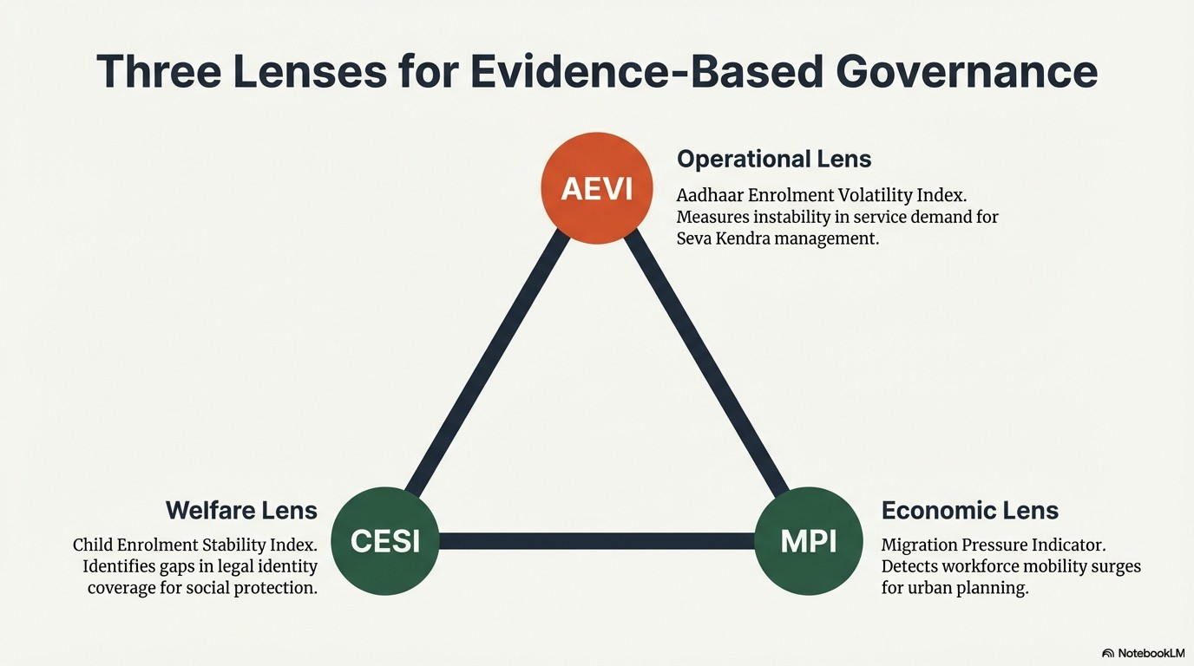

VISUALISATIONS

📌 STATE-WISE ENROLMENT DISTRIBUTION
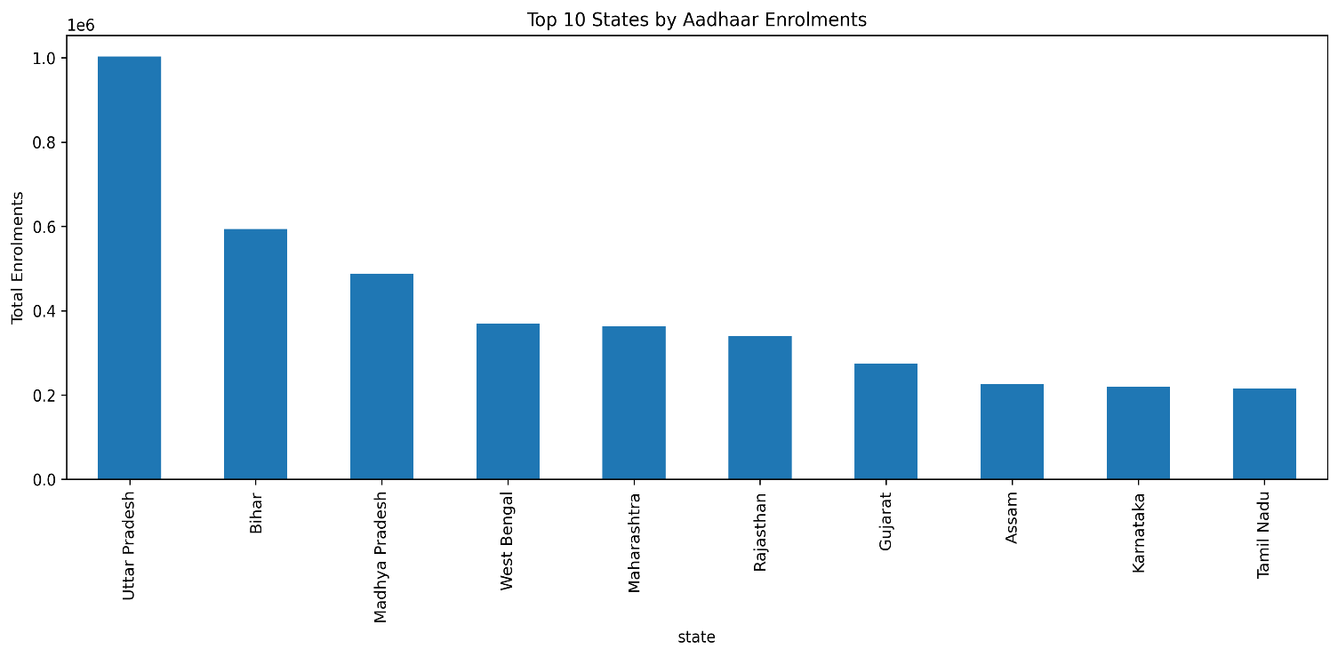

This graph shows:
- Total enrolment aggregated state-wise
- Bar chart with average reference line
Insight:
The state-wise enrolment distribution reveals significant concentration in a limited number of states, creating operational pressure points. States above the national average require higher staffing and infrastructure support.

📌 AEVI (AADHAAR ENROLMENT VOLATILITY INDEX)

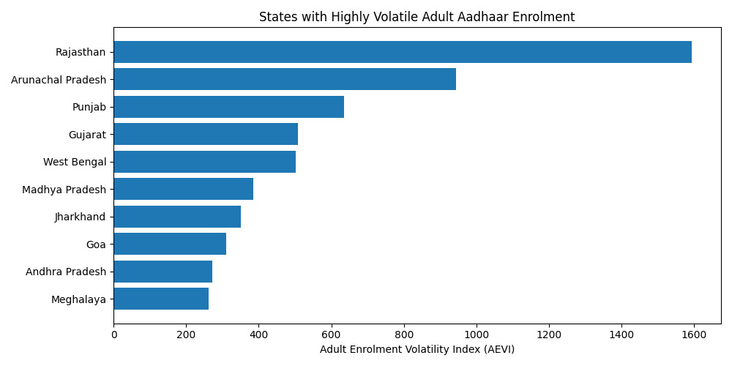
This graph shows:
- Computation of AEVI per state
- Based on monthly enrolment fluctuations
- Measures irregularity over time
Insight: The Aadhaar Enrolment Volatility Index (AEVI) quantifies temporal instability in enrolment demand. States with higher AEVI values experience irregular service demand, often linked to migration, awareness campaigns, or operational inefficiencies.

📌 Time-Series Trend of Total Enrolments

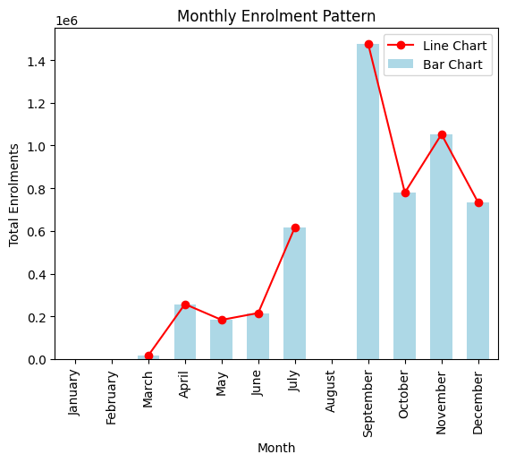

This graph shows: Shows demand evolution over time
Highlights volatility and seasonal demand patterns
Insight:
The time-series trend reveals periods of enrolment surges and stabilisation, enabling UIDAI to distinguish between structural demand growth and temporary spikes driven by campaigns or migration.

📌 Age-wise Enrolment Volatility Heatmap
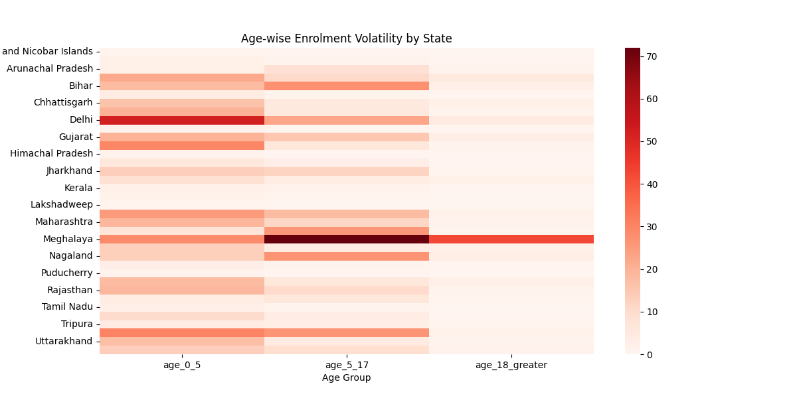
This graph shows:
- Heatmap of age-group-wise enrolment volatility
- Compares enrolment instability across:
  - States
  - Age groups (0–5, 5–17, 18+)
Insight:
This heatmap highlights age-group-specific enrolment volatility across states. Higher instability in child age groups indicates potential gaps in awareness, accessibility, or administrative outreach, while stable patterns reflect mature enrolment ecosystems.

📌 Migration Pressure Indicator (MPI) — Adult (18+) Enrolment Spikes
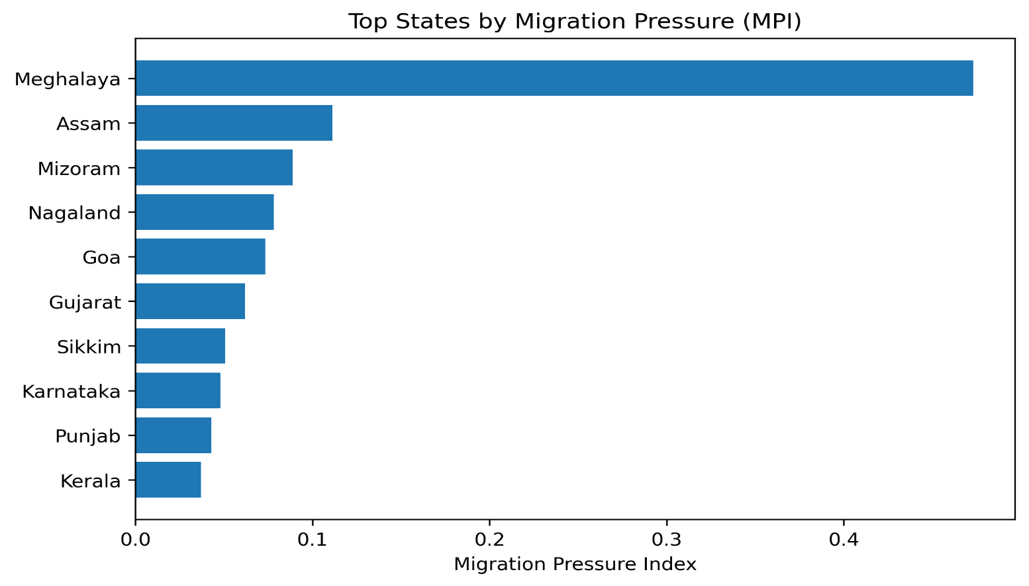
This Graph shows: Migration + governance relevance
During seasonal migration months, MPI spikes can trigger mobile enrolment units.
Insight:
Repeated spikes in adult enrolment indicate migration-linked service demand. States exhibiting consistent adult enrolment surges can be flagged as migration inflow regions requiring adaptive infrastructure.

📌 Child Enrolment Stability Index (CESI) by State

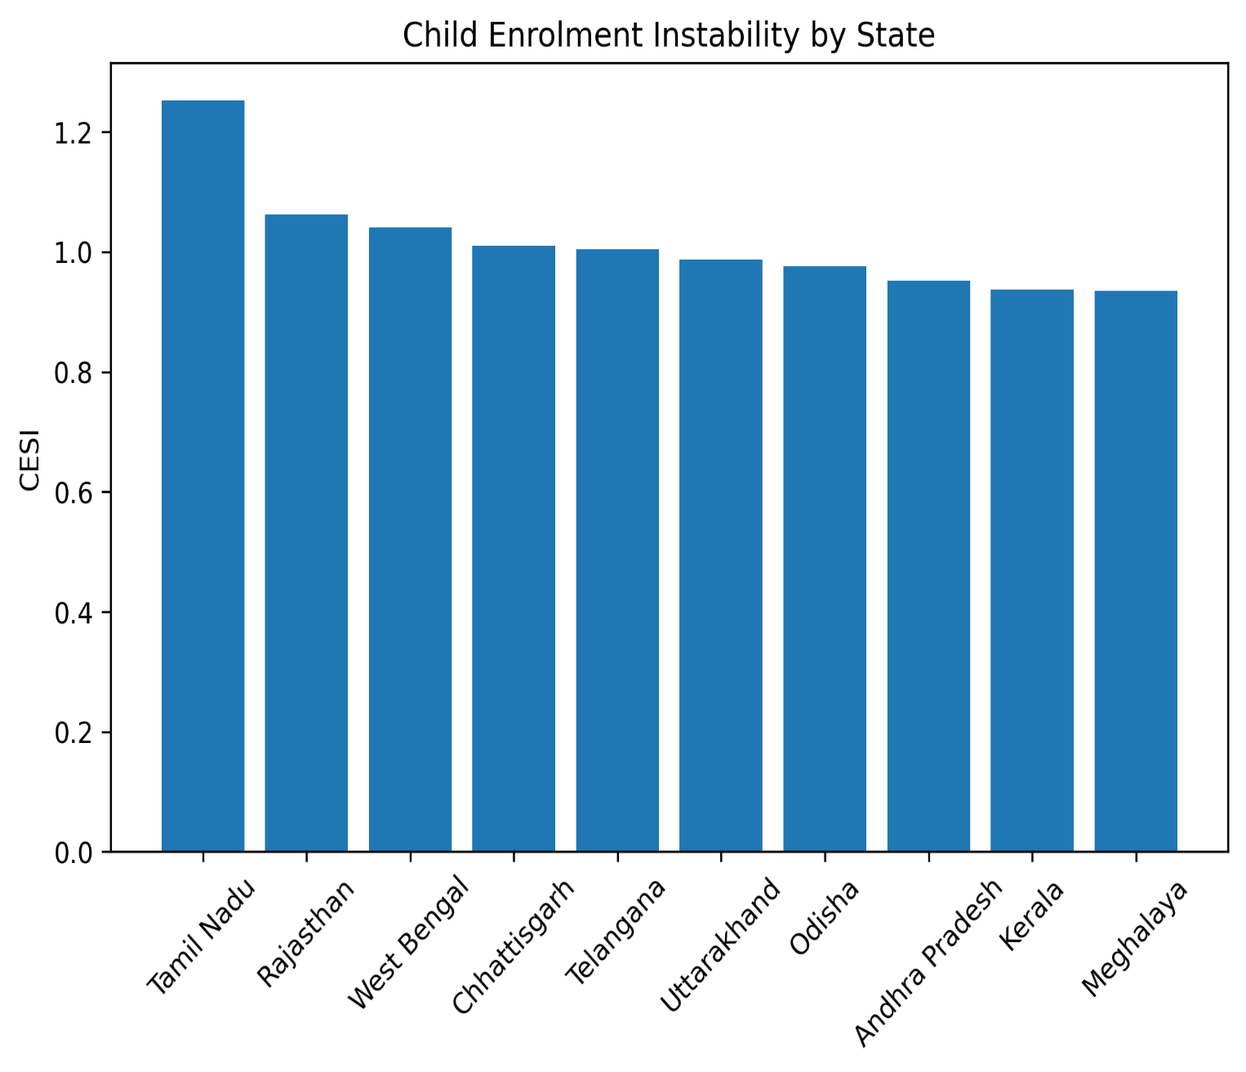

This graph shows: Welfare + inclusion focus
Insight:
CESI highlights disparities in child Aadhaar enrolment stability. Lower CESI values suggest regions where child coverage may be affected by accessibility, awareness, or administrative reach.

📌 Enrolment Volatility Ranking (Top & Bottom States)

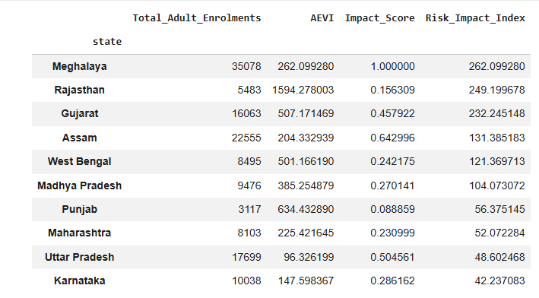

This Graph shows: Clear decision support
Insight:
Ranking states by enrolment volatility enables UIDAI to distinguish stable regions from high-risk regions, supporting proactive staffing and contingency planning.

📌 Age-Group Contribution to Total Enrolments EDI

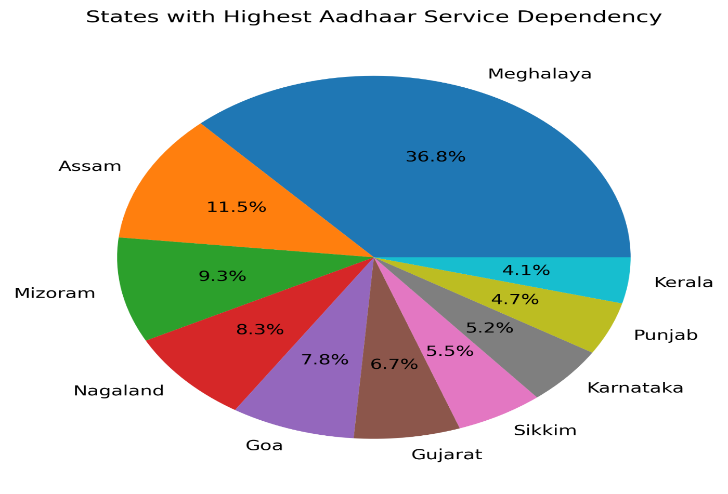

Insight:
Age-group contribution analysis shows demographic demand structure. Dominance of adult enrolments in certain states reinforces migration-driven service pressure, while balanced distributions reflect stable enrolment ecosystems.

SOURCE CODE &REPRODUCIBILITY
- Entire analysis implemented in Python
- Libraries used: Pandas, NumPy, Matplotlib, Seaborn
- Executed via Google Colab
- Fully reproducible pipeline
- Clean, modular code blocks
Colab Notebook

IMPACT AND APPLICABILITY
This project demonstrates how anonymised Aadhaar enrolment data can be transformed into policy-relevant indicators without exposing individual-level information.
Applications include:
- Data-driven staffing decisions
- Proactive infrastructure planning
- Improved accessibility for migrant and vulnerable populations
The proposed indices support scalable and privacy-preserving governance analytics.

LIMITATIONS AND CONCLUSION
Limitations
- Analysis is limited to aggregated enrolment data
- District-level deep dives can enhance localisation
Future Scope
- Integration with demographic and update datasets
- Improved predictive accuracy for service demand
Conclusion
By introducing governance-oriented indicators beyond descriptive statistics, this project aligns Aadhaar data analysis with UIDAI’s mandate of efficiency, inclusion, and transparency.
