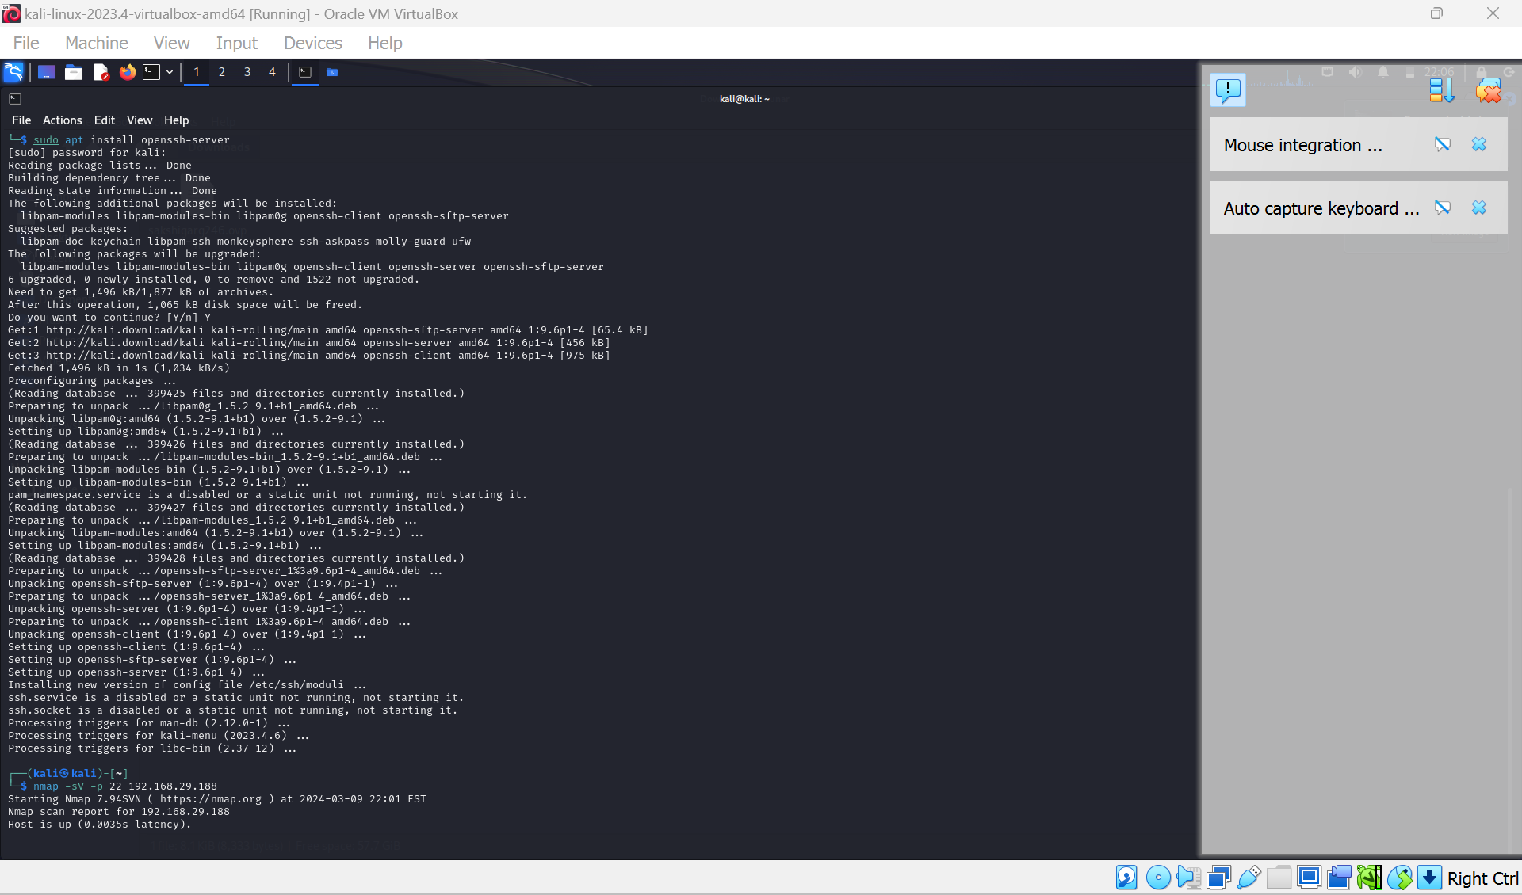

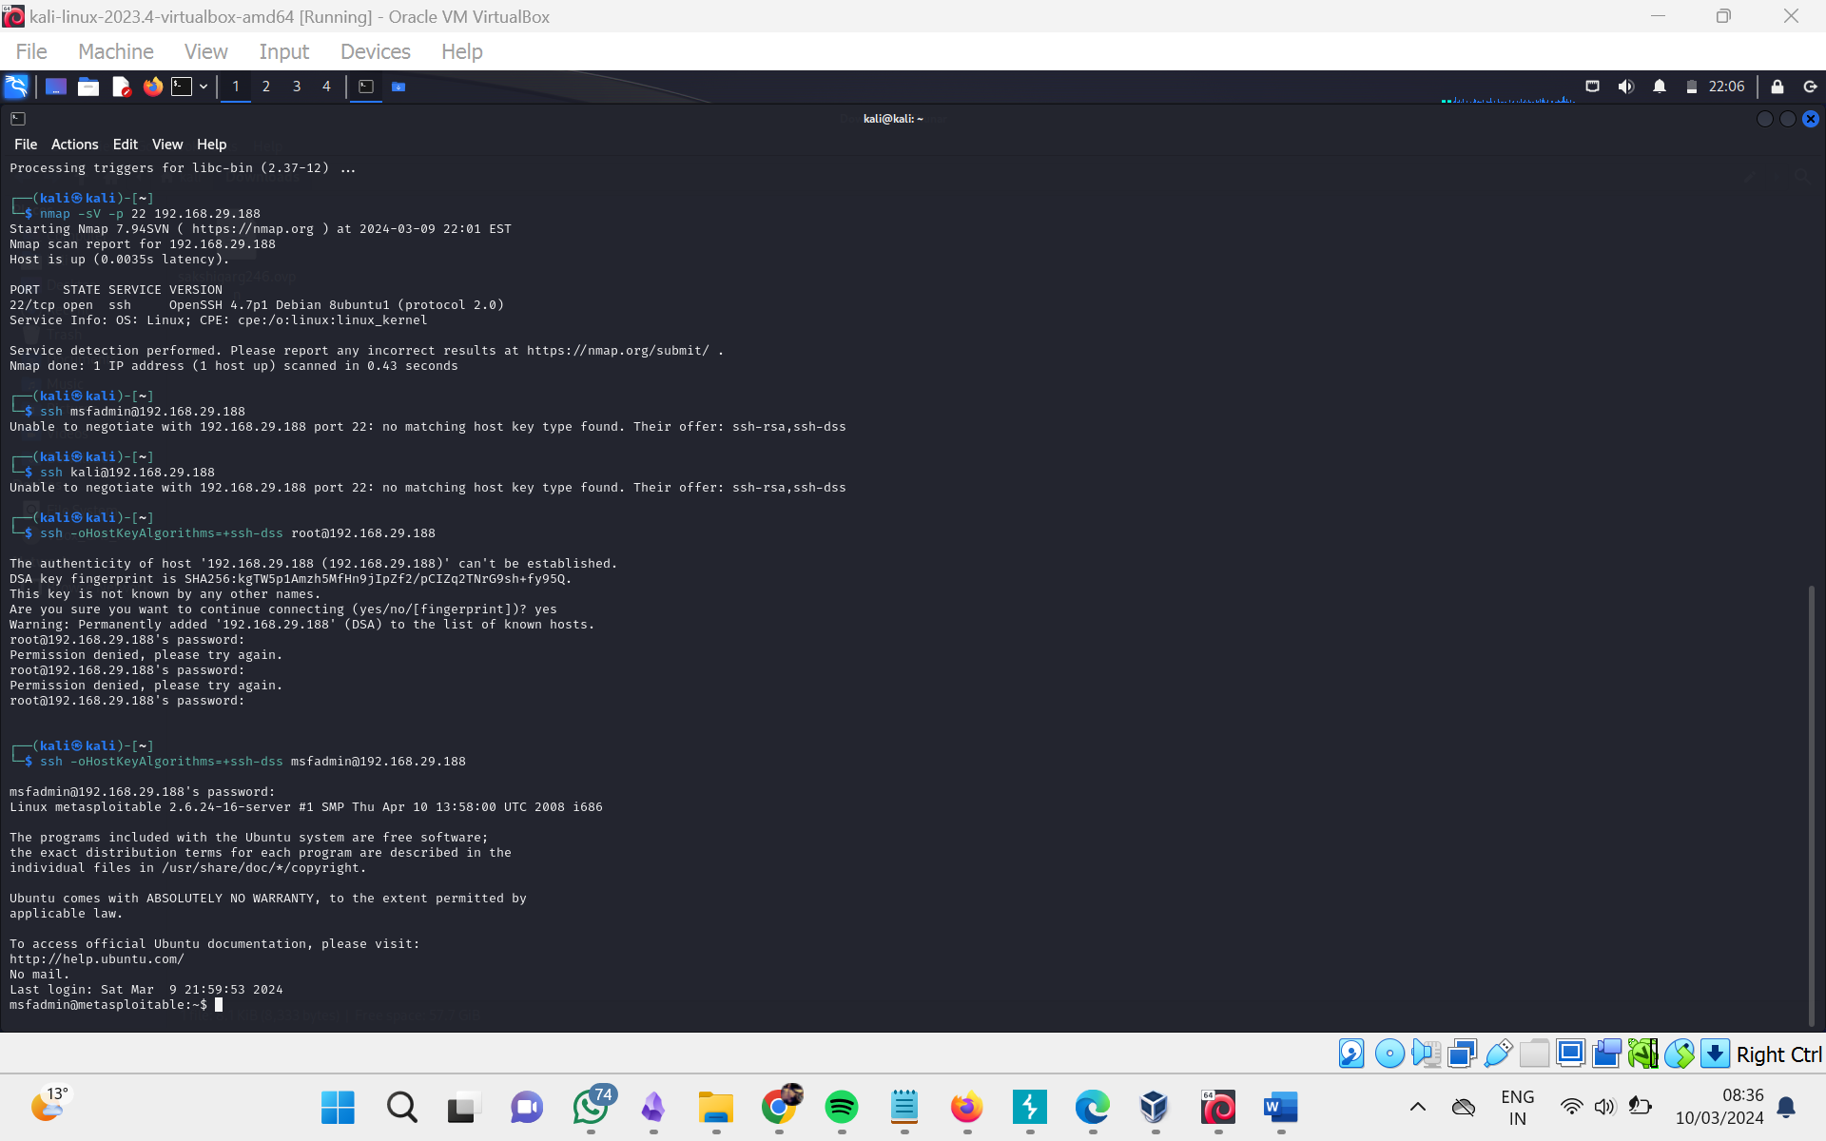

<https://www.openssh.com/legacy.html>

<https://askubuntu.com/questions/836048/ssh-returns-no-matching-host-key-type-found-their-offer-ssh-dss>