LINUX BASICS ASSIGNMENT

Student Name: Sakshi Ghogare
Subject: Linux Basics

Operating Environment: Ubuntu on Windows Subsystem for Linux (WSL)

1. Introduction
Linux is an open-source operating system widely used in servers, software development, networking, and cybersecurity. It provides a command-line interface (CLI) that allows users to perform various operations by entering commands.

2. Objective
The objective of this assignment is to learn and practise basic Linux commands related to file and directory management, system information, file permissions, process management, networking, and package management.

3. Tools Used
- Windows operating system
- Windows Subsystem for Linux (WSL)
- Ubuntu Linux terminal

4. Practical Work
The assignment covers 37 Linux commands. Each command is explained with its purpose and practical execution evidence through terminal screenshots.

Group 1: Basic File and Directory Commands

1. "ls" — List Files and Directories
Purpose: Displays the files and directories present in the current directory.
Example: "ls"

2. "pwd" — Present Working Directory
Purpose: Displays the full path of the current working directory.
Example: "pwd"

3. "cd" — Change Directory
Purpose: Changes the current working directory.
Example: "cd Documents"

4. "mkdir" — Make Directory
Purpose: Creates a new directory.
Example: "mkdir practice"

5. "mv" — Move or Rename Files
Purpose: Moves a file to another location or renames it.
Example: "mv old.txt new.txt"

6. "cp" — Copy Files
Purpose: Creates a copy of a file.
Example: "cp notes.txt notes_copy.txt"

7. "rm" — Remove Files
Purpose: Deletes a file.
Example: "rm notes_copy.txt"

8. "touch" — Create an Empty File
Purpose: Creates a new empty file if it does not already exist.
Example: "touch notes.txt"

9. "ln" — Create Links
Purpose: Creates a link to a file. A hard link can provide another name for the same file data.
Example: "ln notes.txt notes_link.txt"

10. "cat" — Display File Contents
Purpose: Displays the contents of a text file in the terminal.
Example: "cat notes.txt"

Screenshot evidence: Insert "Group_1.png" below this section.
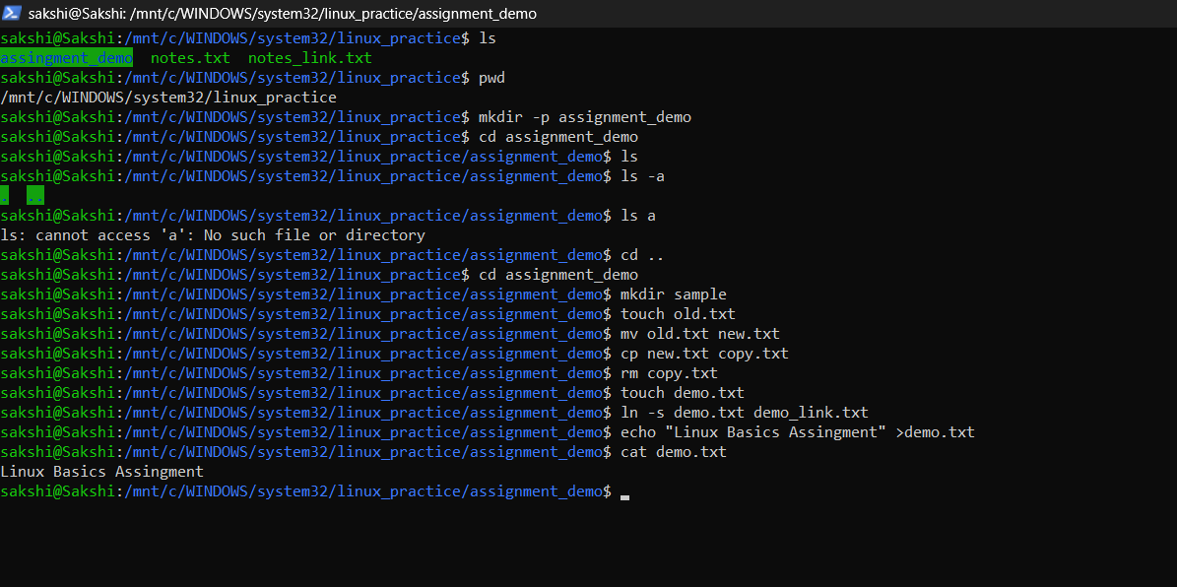
Group 2: System Information and Text-Processing Commands

11. "clear" — Clear the Terminal
Purpose: Clears the visible contents of the terminal screen.
Example: "clear"

12. "echo" — Display Text
Purpose: Displays text or the value of a variable in the terminal.
Example: "echo "Hello Linux""

13. "man" — Manual Pages
Purpose: Displays the user manual for a Linux command.
Example: "man ls"

14. "uname" — System Information
Purpose: Displays information about the operating system and kernel.
Example: "uname -a"

15. "whoami" — Current User
Purpose: Displays the username of the currently logged-in user.
Example: "whoami"

16. "tar" — Archive Files
Purpose: Creates or extracts archive files.
Example: "tar -cvf backup.tar notes.txt"

17. "grep" — Search Text
Purpose: Searches for a specific word or pattern in a file.
Example: "grep "Linux" notes.txt"

18. "head" — Display First Lines
Purpose: Displays the first ten lines of a file by default.
Example: "head notes.txt"

19. "tail" — Display Last Lines
Purpose: Displays the last ten lines of a file by default.
Example: "tail notes.txt"

20. "export" — Set Environment Variables
Purpose: Creates or modifies an environment variable for the current shell and its child processes.
Example: "export COURSE="Linux Basics""

Screenshot evidence: Insert "Group_2.png" below this section.
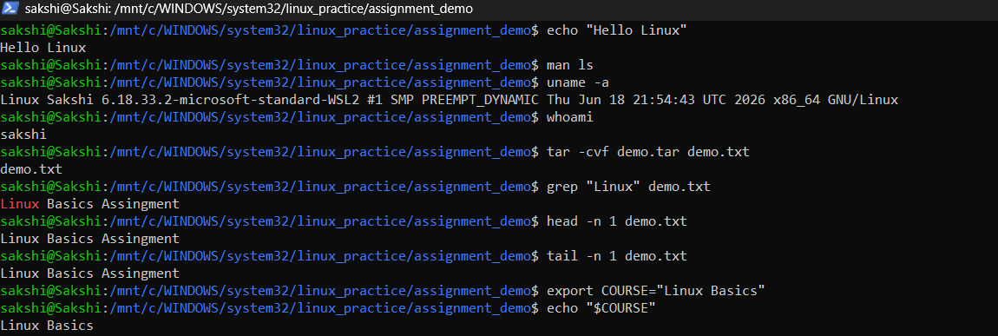
Group 3: File Compression, Networking, Processes, and Permissions

21. "zip" — Compress Files
Purpose: Compresses files into a ZIP archive.
Example: "zip files.zip notes.txt"

22. "unzip" — Extract ZIP Files
Purpose: Extracts files from a ZIP archive.
Example: "unzip files.zip"

23. "ssh" — Secure Shell
Purpose: Connects securely to a remote computer over a network.
Example: "ssh username@hostname"

24. "service" — Manage Services
Purpose: Checks or manages system services.
Example: "service --status-all"

25. "ps" — Process Status
Purpose: Displays information about running processes.
Example: "ps"

26. "kill" and "killall" — Terminate Processes
Purpose: "kill" sends a signal to a process using its PID, while "killall" targets processes by name.
Example: "kill PID"
Example: "killall process_name"

27. "df" — Disk Space Usage
Purpose: Displays disk space usage for mounted file systems.
Example: "df -h"

28. "chmod" — Change Permissions
Purpose: Changes file or directory permissions.
Example: "chmod 644 notes.txt"

29. "ifconfig" — Network Interface Information
Purpose: Displays or configures network interfaces when the utility is installed.
Example: "ifconfig"

30. "wget" — Download Files
Purpose: Downloads files from the internet using a URL.
Example: "wget https://example.com"
Screenshot evidence: Insert your Group 3 screenshots ("Group_3_1.png" and "Group_3_2.png") below this section.

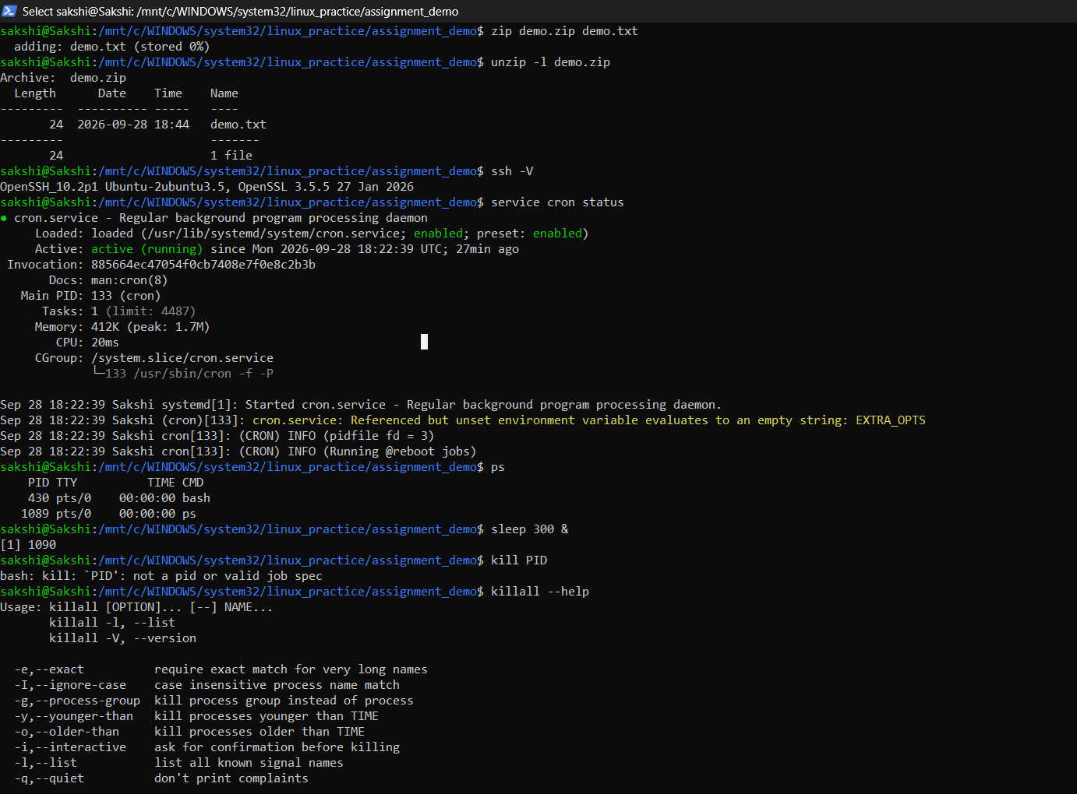
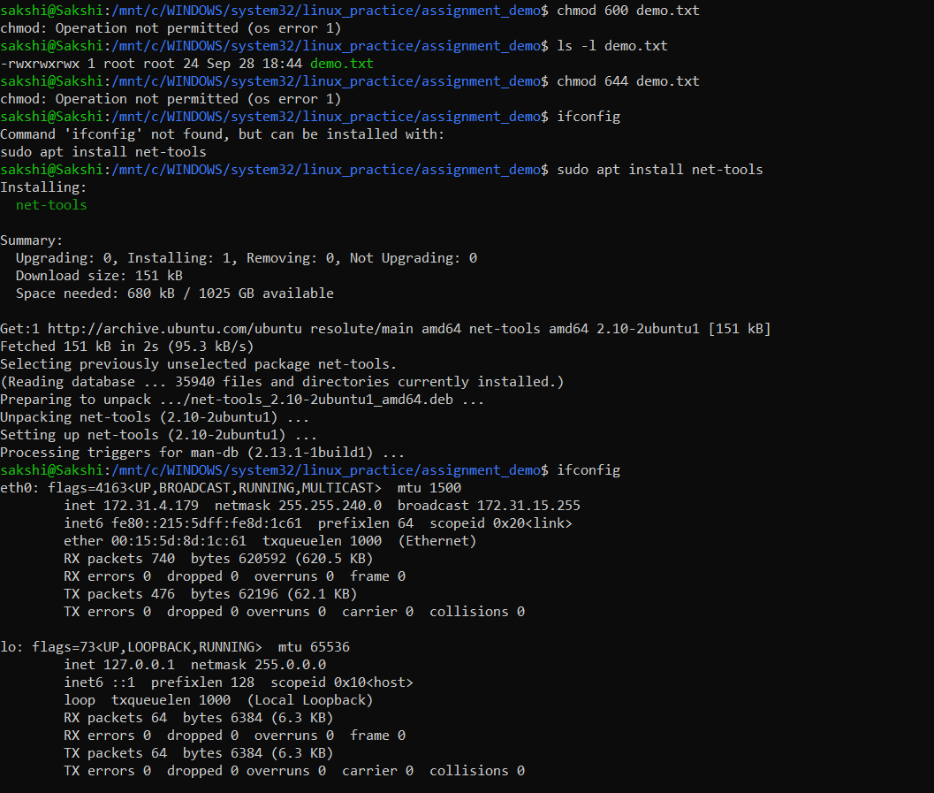

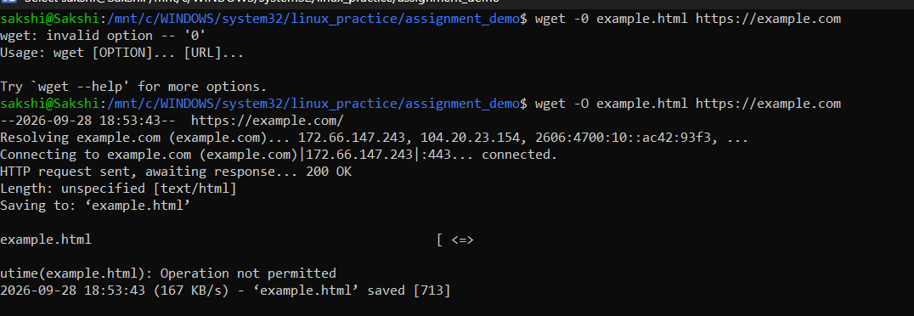

Group 4: System Administration and Utility Commands

31. "ufw" — Uncomplicated Firewall
Purpose: Manages firewall rules to control incoming and outgoing network traffic.
Example: "sudo ufw status"

32. Package Managers — "apt", "pacman", "yum", "rpm"
Purpose: Package managers are used to install, update, remove, and manage software packages. Ubuntu uses "apt" by default. Other Linux distributions use tools such as "pacman", "yum", or "rpm".
Example: "apt --version"
33. "sudo" — Superuser Do
Purpose: Runs a command with administrative privileges when permitted.
Example: "sudo apt update"

34. "alias" — Create Command Shortcuts
Purpose: Creates a shortcut name for a command.
Example: "alias ll='ls -l'"

35. "whereis" — Locate Command Files
Purpose: Locates the binary, source, and manual files associated with a command.
Example: "whereis ls"

36. "whatis" — Command Description
Purpose: Displays a short description of a command using the manual database.
Example: "whatis ls"

37. "top" — Monitor Running Processes
Purpose: Displays running processes and system resource usage, such as CPU and memory.
Example: "top"
Screenshot evidence: Insert your Group 4 screenshot
