ONLINE RETAIL CUSTOMER SEGMENTATION
Capstone Project Documentation
Retail / Clustering
RFM Analysis + K-Means Clustering
Dataset: online_retail_customers
Observation period: 01-Dec-2010 to 09-Dec-2011

1. Executive Summary
This project performs customer segmentation on an online retail transaction dataset. Transaction-level data was cleaned and transformed into customer-level Recency, Frequency and Monetary (RFM) features. The RFM features were analyzed for skewness, transformed using log1p, standardized, and then used for K-Means clustering.
The detailed K=3 interpretation identifies three behavioral groups: Highly Active / High Value, Regular / Moderate Value, and Inactive / Low Value. The high-value group contains only 16.92% of customers but contributes 66.73% of total monetary value in the analyzed data.
Silhouette analysis gave K=2 the highest score (0.4327). K=3 was also evaluated because it provides a more granular and business-interpretable segmentation. This distinction is explicitly retained in the documentation.

2. Problem Statement
Identify meaningful customer groups from historical retail transaction behavior so that customers with similar purchasing patterns can be analyzed and addressed using differentiated business strategies.

3. Dataset Overview
The supplied database guidelines identify online_retail_customers as a dataset in the Clustering database and prescribe SQLite/Pandas for loading the selected table.
Item | Value
Initial rows | 541,909
Initial columns | 8
Columns | InvoiceNo, StockCode, Description, InvoiceDate, Quantity, UnitPrice, CustomerID, Country
Date range | 2010-12-01 08:26:00 to 2011-12-09 12:50:00
Customers after cleaning/RFM | 4,339

4. Data Quality Analysis
Check | Result
Missing Description | 1,454
Missing CustomerID | 135,080
Duplicate rows | 5,268
Negative Quantity | 10,624
Zero Quantity | 0
Zero UnitPrice | 2,515
Negative UnitPrice | 2
Cancelled invoices | 9,288

5. Data Cleaning
- Removed records with missing CustomerID because customer-level RFM requires a known customer.
- Converted InvoiceDate to datetime.
- Removed cancelled invoices where InvoiceNo begins with C.
- Created TotalPrice = Quantity × UnitPrice.
- Aggregated transactions by CustomerID to calculate RFM.
Stage | Rows
Initial | 541,909
After removing missing CustomerID | 406,829
After removing cancelled invoices | 397,924

6. RFM Feature Engineering
Metric | Definition | Interpretation
Recency | Days since latest purchase | Lower = more recent
Frequency | Number of unique invoices | Higher = more frequent
Monetary | Sum of TotalPrice | Higher = greater monetary contribution
Metric | Min | Q1 | Median | Q3 | Max | Mean
Recency | 1 | 18 | 51 | 142 | 374 | 92.52
Frequency | 1 | 1 | 2 | 5 | 210 | 4.27
Monetary | 0 | 307.25 | 674.45 | 1661.64 | 280206.02 | 2053.79

7. Distribution, Skewness and Transformation
Histograms and boxplots showed strong right-skew, especially for Frequency and Monetary. High-value observations were not automatically removed because they may represent genuine customers.
Metric | Skewness before log1p | Skewness after log1p
Recency | 1.2464 | -0.3787
Frequency | 12.1 | 1.2089
Monetary | 19.327 | 0.3606
log1p(x) = log(1+x) was used because it compresses large values while safely handling zero values. It reduces skewness without deleting legitimate high-value customers.

8. Standardization
StandardScaler was applied after log transformation because K-Means uses distance calculations and the three RFM variables have different units and numerical ranges. The scaled features have approximately mean 0 and standard deviation 1.

9. Choosing the Number of Clusters
The Elbow Method suggested a bend around K=4–5, but it was not decisive. Silhouette analysis was therefore used as an additional validation metric.
K | Silhouette
2 | 0.4327
3 | 0.3390
4 | 0.3363
5 | 0.3161
6 | 0.3135
7 | 0.3090
8 | 0.3031
9 | 0.2817
10 | 0.2785
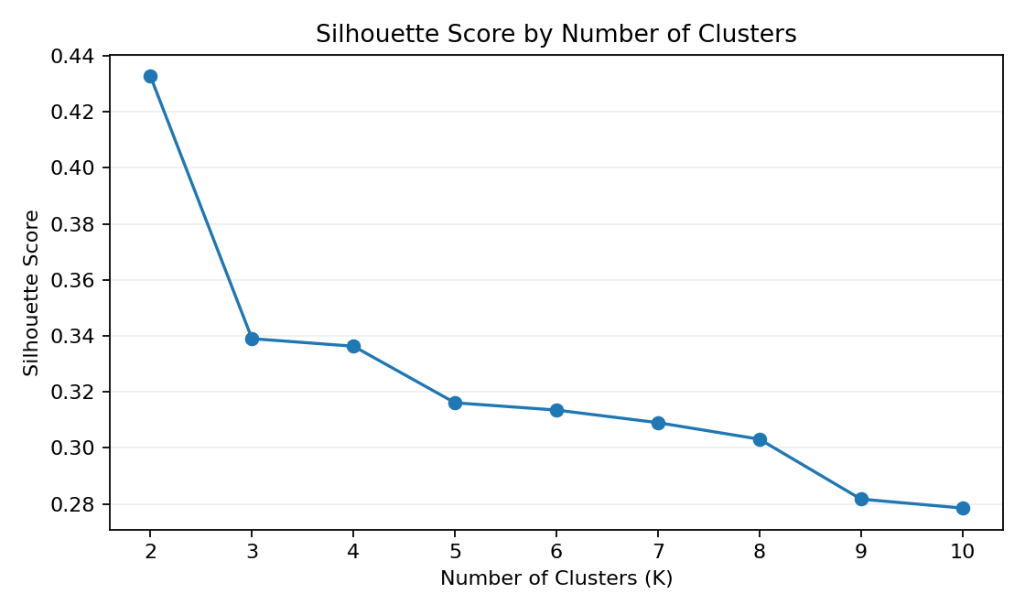
K=2 had the highest silhouette score (0.4327). K=3 scored 0.3390 and K=4 scored 0.3363. K=3 was retained for business interpretation because it produces three meaningful behavioral profiles.

10. K-Means Results
K-Means was run with random_state=42 and n_init=10. Cluster numbers are arbitrary identifiers and do not represent rank.
K=2 Cluster | Customers | Avg Recency | Avg Frequency | Avg Monetary
0 | 2672 | 134.09 | 1.67 | 497.55
1 | 1667 | 25.88 | 8.44 | 4548.26
K=4 Cluster | Customers | Avg Recency | Avg Frequency | Avg Monetary
0 | 839 | 18.73 | 2.09 | 538.23
1 | 723 | 12.11 | 13.63 | 8015.42
2 | 1183 | 70.7 | 4.08 | 1791.09
3 | 1594 | 184.02 | 1.32 | 342.42

11. Final K=3 Customer Segments
Cluster | Segment | Customers | Customer % | Avg Recency | Avg Frequency | Avg Monetary | Revenue %
0 | Highly Active / High Value | 734 | 16.92% | 15.89 | 13.70 | 8101.50 | 66.73%
1 | Inactive / Low Value | 1913 | 44.09% | 164.89 | 1.36 | 365.51 | 7.85%
2 | Regular / Moderate Value | 1692 | 39.00% | 43.93 | 3.47 | 1339.06 | 25.42%
Median profile:
Cluster | Median Recency | Median Frequency | Median Monetary
0 | 9.0 | 10.0 | 3774.17
1 | 156.0 | 1.0 | 300.85
2 | 30.0 | 3.0 | 1011.25

12. PCA Visualization
PCA was used only to visualize the standardized RFM data in two dimensions; it was not used to create the K-Means clusters.
Component | Explained variance
PC1 | 75.0054%
PC2 | 18.8193%
PC1 + PC2 | 93.8247%
 | Recency | Frequency | Monetary
PC1 | -0.511933 | 0.618196 | 0.596454
PC2 | 0.849257 | 0.259809 | 0.459633
PC1 broadly represents engagement/value because Frequency and Monetary have positive loadings while Recency has a negative loading. Lower Recency means more recent purchasing.

13. Customer Distribution
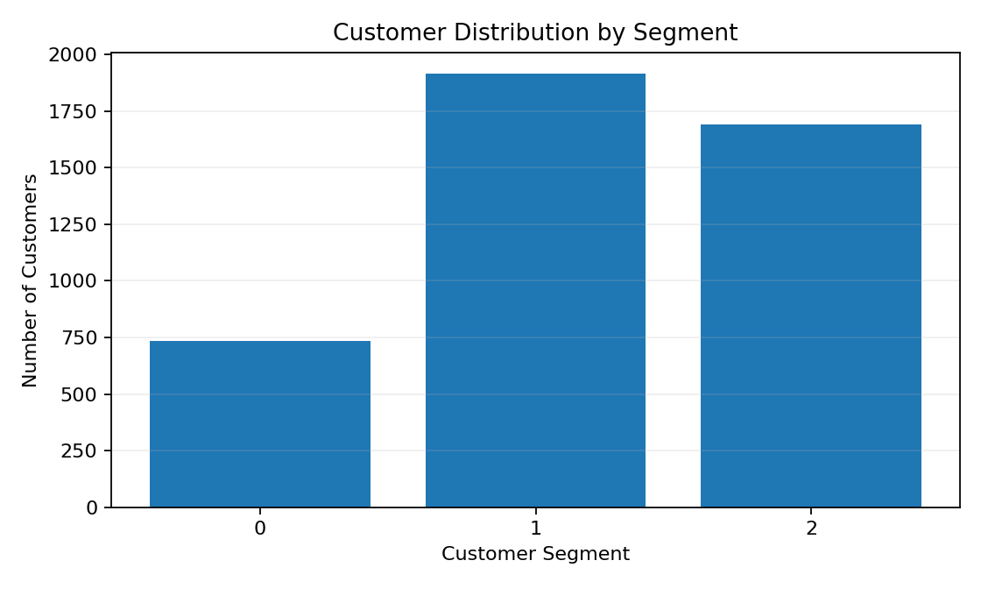
Segment 1 is the largest customer group (44.09%), followed by Segment 2 (39.00%) and Segment 0 (16.92%).

14. Revenue Contribution
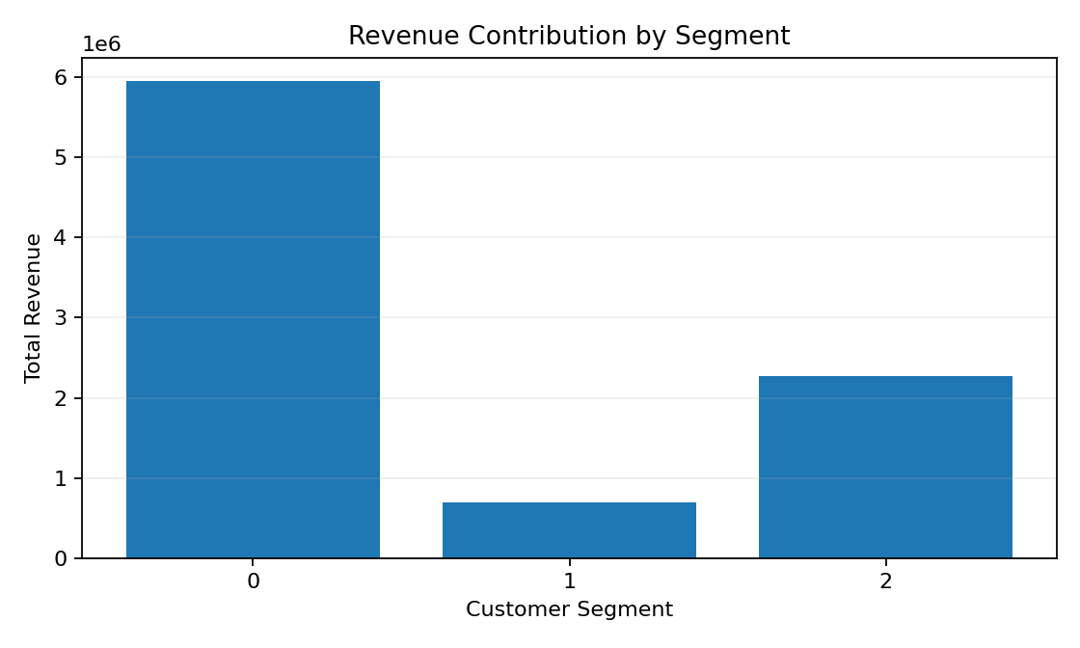
Segment 0 contains only 16.92% of customers but contributes 66.73% of monetary value. Segment 1 contains 44.09% of customers but contributes only 7.85%.

15. RFM Segment Profile
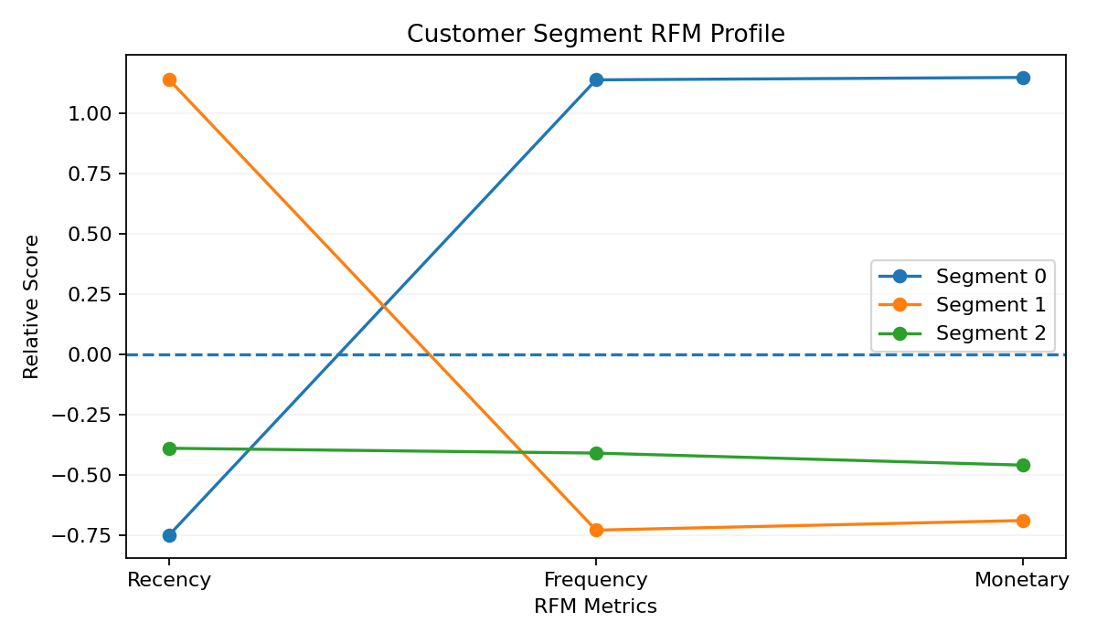
The profile chart uses standardized cluster averages only for visualization. Recency must be interpreted inversely: lower is more recent.

16. Key Business Insights
- Customer value is highly concentrated: 16.92% of customers account for 66.73% of total monetary value.
- 44.09% of customers are in the Inactive / Low Value segment but contribute only 7.85% of monetary value.
- 39.00% of customers are Regular / Moderate Value and contribute 25.42% of monetary value.
- RFM segmentation provides a practical way to differentiate customer strategies.

17. Business Recommendations
Segment | Observed behavior | Recommended focus
Highly Active / High Value | Recent, frequent, high monetary contribution | Retention, loyalty, personalization, relevant cross-sell/upsell, targeted rewards
Regular / Moderate Value | Moderate recency, frequency and monetary value | Increase purchase frequency through relevant recommendations, bundles and repeat-purchase incentives
Inactive / Low Value | Longer time since purchase, low frequency and low monetary value | Targeted re-engagement; test whether incentives generate cost-effective reactivation
These are business hypotheses based on observed RFM behavior and should be validated using campaign KPIs or controlled experiments.

18. KPI Framework
Segment | Suggested KPIs
Highly Active / High Value | Retention rate, repeat purchase rate, average order value, revenue/customer, purchase frequency
Regular / Moderate Value | Repeat purchase rate, frequency growth, average order value, movement toward higher-value behavior
Inactive / Low Value | Reactivation rate, campaign response, post-reactivation purchase rate, incremental revenue, marketing cost per reactivated customer

19. Segment Movement and Future Monitoring
Segmentation can be repeated periodically. Customers may move between segments as their behavior changes. Monitoring transitions can reveal whether customers are becoming more active or less active over time.

20. Limitations
- Only three RFM variables are used; product preference, demographics, satisfaction and marketing response are not directly modeled.
- The data covers a historical observation period from December 2010 to December 2011.
- K=2 has the highest silhouette score; K=3 is a more granular business-oriented interpretation rather than the geometrically strongest solution according to silhouette alone.
- RFM does not prove permanent churn. High Recency means the customer has not purchased recently within the observation period.
- Extreme but legitimate transactions can influence monetary values; log transformation reduces their influence without automatically deleting them.
- Business recommendations require KPI monitoring and experimentation before being treated as causal or proven.

21. Conclusion
The project successfully transformed transaction-level online retail data into customer-level RFM profiles and used K-Means clustering to identify distinct purchasing behaviors. After cleaning, skewness reduction and standardization, the analysis produced interpretable customer segments.
The central finding is that the Highly Active / High Value group represents only 16.92% of customers but contributes 66.73% of monetary value. The segmentation therefore provides a useful framework for differentiated retention, engagement and reactivation strategies.

22. Viva Preparation
Q: What is RFM?
A: Recency, Frequency and Monetary: how recently, how often and how much a customer purchased.
Q: Why log1p?
A: To reduce strong right-skew while safely handling zero values.
Q: Why StandardScaler?
A: K-Means relies on distance, so features need comparable scale.
Q: Why K-Means?
A: Customer segmentation is an unsupervised clustering problem and K-Means groups similar RFM profiles.
Q: Why K=3 when K=2 has the highest silhouette?
A: K=2 is strongest geometrically, but K=3 provides more granular and interpretable business profiles.
Q: What does PCA do?
A: It reduces dimensions for visualization; it was not used for clustering.
Q: Can Segment 1 be called churned?
A: No. The data shows inactive purchasing behavior, not proven permanent churn.
Q: What is the biggest business insight?
A: 16.92% of customers contribute 66.73% of monetary value.

Appendix – Core Modeling Code
from sklearn.cluster import KMeans
kmeans = KMeans(
n_clusters=3,
random_state=42,
n_init=10
)
rfm["Cluster_3"] = kmeans.fit_predict(rfm_scaled)

