README for OCC MED DASHBOARD

-----------------------------------------------------------------------------------------------

Dependencies:

1. npm install axios
2. npm install qs
3. npm install --save moment react-moment
4. npm install font-awesome
5. npm install --save react-html-table-to-excel
6. npm install react-bootstrap bootstrap
7. npm install --save react-router
8. npm install --save react-router-dom
9. npm install pm2 –g
10. npm install express
11. npm install path

Connecting the database for the first time:

1. Go to phpmyadmin.
2. Create a database with the name specified in the connect.php in the om_comm_backend folder of the codes.
3. Import the sql file into this (sql file is in the Occ Med codes folder)

-----------------------------------------------------------------------------------------------

To connect with the backend:

1. Make sure xampp is installed on the PC.
2. Go to command prompt and do ipconfig
3. This will give you the ip address of you PC
4. Copy that ip-address and change the ip-address in the url in all the files in om_comm_dashboard folder (front end connecting to back end) 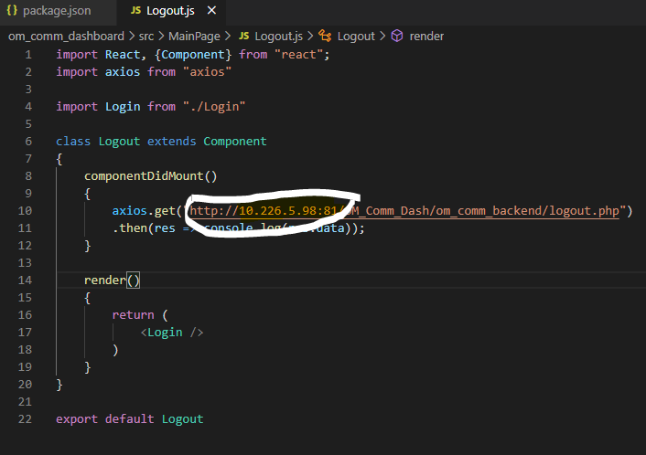
5. After that, you will need to change the configuration based on your xampp credentials. For this, go to the om_comm_backend folder -> connect.php
   1. Change the username, password on line 4 and 5. 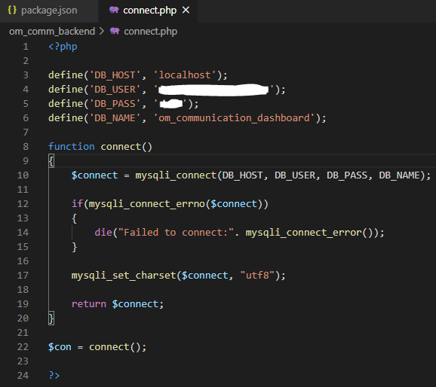

Changing Employer list:

The Employer dropdown gets the data from backend i.e. the employers table of the database.

When we get a new csv file from Melissa or Jolene (every month or every quarter:

1. Make sure to keep a copy of the old file and the new file as received along with the headers.
2. Open a new excel – blank document:
   1. Go to data, select “From Text”, browse to where the old and new csv files are saved. (do not open those files at all) 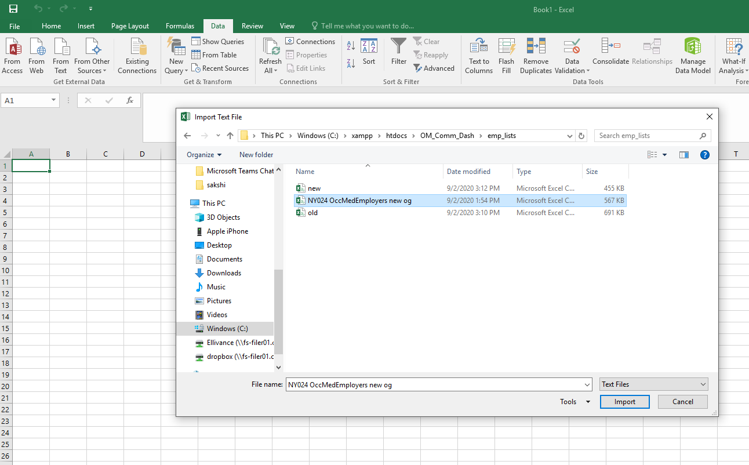
   2. Select the file you want to open.
   3. 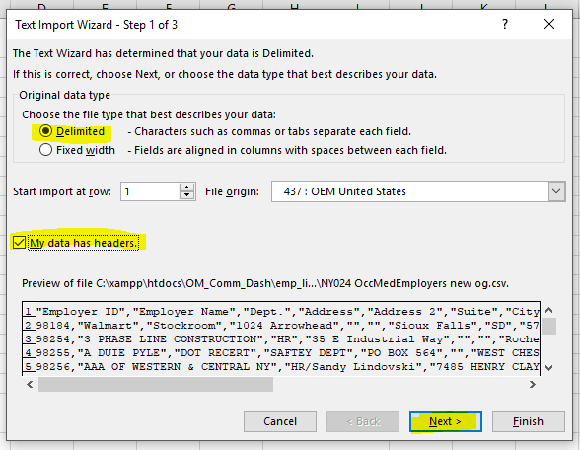
   4. 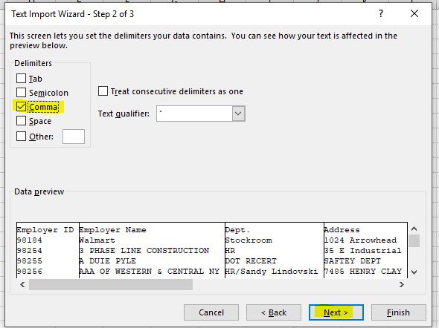
   5. 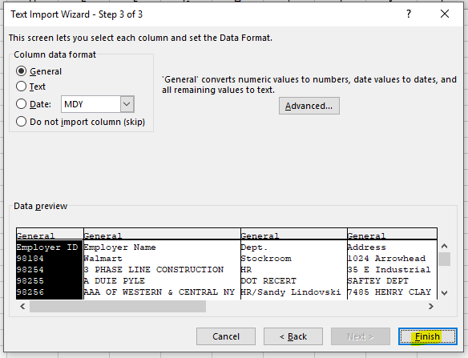
   6. Then save the file – if new, save as new.csv and if old, save as old.csv (MAKE SURE to save as CSV)
3. Now go to the python code at C:\Users\w501738\Desktop\Python\OM COMM Dashboard\ finding changed and new emps code.ipynb - Employer List check and check the file names on cell2 and run the code. (Kernel Restart and Run All Cells)
4. When this is done, a new excel sheet with output.xlsx name will be formed.
5. In the tab named: Changed Employers, the employer details will be present that are already in the database, but a particular value might be changed.
   1. In this case, go to the database – phpmyadmin and to the employers table.
   2. Find this employer name (search by employer name and the department) and see which field has changed and update it there itself.
6. In the tab named: Newly Added Employers, the employer details of the new employers will be present.
   1. Go to the insert tab in phpmyadmin for the employers table and enter these detail as new entry. The primary key will update on its own. So you only have to enter the new employer details in the employer table.

Start XAMPP CONTROL on startup (boot / reboot):

1. Go to C:/xampp
2. Select the xampp control (application) and right click to create a shortcut.
3. Now enter Win button + R and enter **shell:startup** and click ok.
4. Drag the shortcut of xampp-control created into this new window.

Deploying the React App on local serve (ip address):

1. Cd to the om_comm_dashboard folder in the terminal.
2. Run the command: **npm run build**
3. Now open command prompt and cd to the om_comm_dashboard folder.
4. Run the command pm2 ls
5. If you see this website already running, run the command pm2 del <number>. This <number> will be the index number of the processes. In this case it should be 0.
6. Now run the command pm2 start server.js –watch
7. The website should be live on http://<ip address>:8080
8. If you get an error on pm2 when you do pm2 ls:
   1. Go to the path C:\Users\w501738\AppData\Roaming\npm and delete the pm2.ps1 file
   2. Then go to C:\Users\w501738\AppData\Roaming\npm-cache and clear that folder.
   3. Now again try the same command in the command prompt.