RESUME
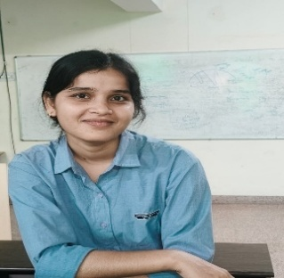

Sakshi Singh

Phone: 9341866464

Linkedin : https://www.linkedin.com/in/sakshi-singh-4877503a0?utm_source=share_via&utm_content=profile&utm_medium=member_android
Email: sakshisingh05002@gamil.com
City: Jaipur, Rajasthan

Career Objective
Motivated 1st year B.Tech student seeking a paid internship opportunity to enhance programming skills and gain real-world experience.

Education
B.Tech (Computer Science) – Vivekananda Global University (2025–2029)
12th – M.V.College Buxar – 87.8%
10th – Nehru Smark High School ,Buxar – 87%

Technical Skills
- Programming : Java(OOPS), C Programming
- Basic Data Structures
- Web : HTML , CSS
- Tools : MS Office , MS Excel , Power Point

Projects
1. Student Management System (Java)
- Add, delete and display student records.
2. Simple Calculator (Java)
- Performs basic arithmetic operations.

Strengths
- Quick learner
- Hardworking
- Good problem-solving skills
- Team player

