
ORIENTAL EDUCATION SOCIETY’S
SANPADA COLLEGE OF COMMERCE AND TECHNOLOGY
SANPADA, NAVI MUMBAI
A.Y.2025-26

Project (Dissertation) Report On:
“Digital Access Challenges Study in Rural Schools”

Prepared by:
Name of the Student: Sandesh Rajvant Yadav
Course: Bachelor of Computer Science
Semester- III
Roll No. 50
Group No.: 10

Under the Guidance of:
Asst. Prof. Anwar Chougle

Department Of Computer Science (BSC.CS)
Academic Year – 2025-26

Analysis of Data Collected in Relation to the Study Objectives

● The fieldwork strongly aligns with the project objective of promoting digital access awareness in rural schools.
● Data collected shows that while digital infrastructure exists in some schools, the utilization is very low due to lack of training and awareness.
● The majority of students showed interest in digital learning once demonstrated, which indicates a strong potential for improvement with proper guidance.
● Teachers need structured training modules to integrate digital platforms in daily teaching.
● Parents’ involvement is minimal; many consider phones only for communication, not education, highlighting the need for community awareness sessions.

Observation
● Digital Divide: There was a clear gap in access between rural and urban students.
● Awareness Gap: Students associated digital devices mostly with entertainment (games, social media) rather than education.
● Teacher Training Need: Teachers were enthusiastic but lacked proper training in online resources.
● Infrastructure Issues: Power cuts, limited internet, and insufficient working devices were major challenges.
● Positive Response: Students were highly curious and motivated when exposed to digital tools like YouTube educational videos and DIKSHA app during workshops.

Copy of Questionnaire

● Do you have access to a smartphone or computer at home?
● If yes, who mainly uses the device?
● Do you have access to the internet in your village/school?
● How often do you use digital devices for study?
● Which digital tools/apps do you use for learning?
● What challenges do you face in using digital technology?
● Do you think digital education is important for rural students? Why?

Tables, Raw Data, and Pie Diagrams
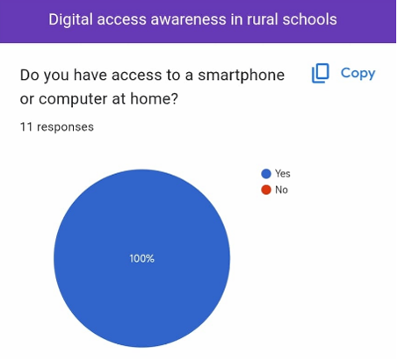
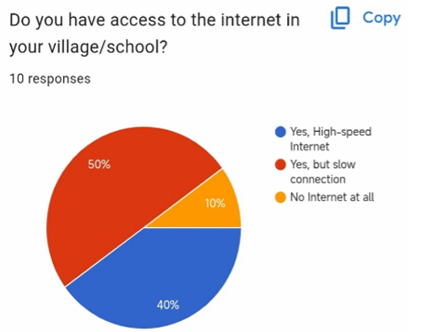
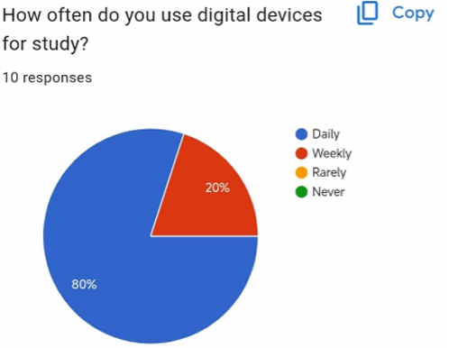

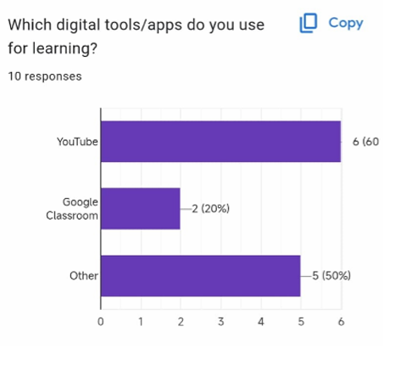

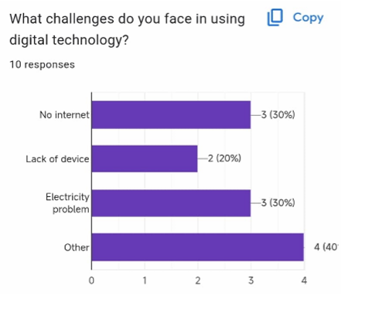

Interview with Lab Assistant
As part of the fieldwork, an interview was conducted with the college lab assistant to gather qualitative insights about student behaviour, digital access challenges in Rural Schools.
Q1. What is meant by ‘Digital Access’ in the context of rural schools?
Ans: Digital access refers to the availability and ability to use digital tools such as computers, tablets, internet, and online educational resources in schools. In rural schools, it means ensuring that students and teachers can access technology for learning without barriers.
Q2. Why is digital access important for students in rural schools?
Ans: Because it bridges the knowledge gap between rural and urban students, provides access to quality educational content, supports online learning platforms, and helps students develop 21st-century skills like computer literacy and critical thinking.
Q3. What role do teachers play in digital access in rural schools?
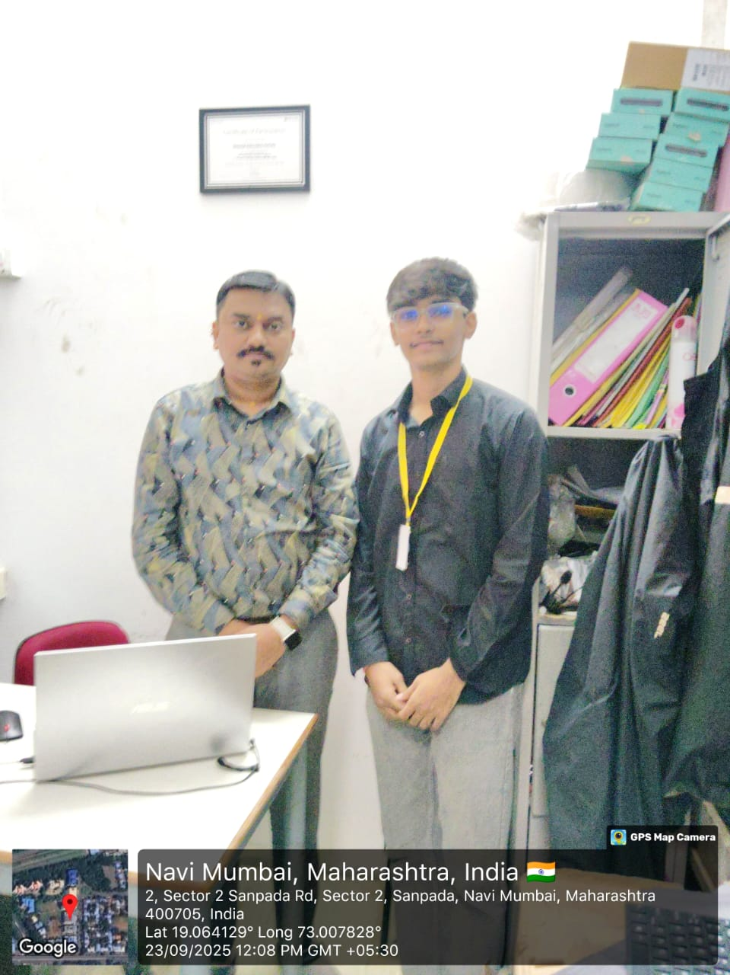
Ans: Teachers act as facilitators. Even if infrastructure exists, teachers need digital literacy training to effectively integrate technology into classrooms. Without their active participation, digital access remains underutilized.

