PRACTICAL 1
A) Write a program using Kotlin to implement control structures & loops.
//If expression
fun main() {
val a = 2
val b = 3
var max = a
if (a < b) max = b
print(max)
Output:
3
// With else
fun main() {
val a = 2
val b = 3
var max = a
if (a > b) {
max = a
}
else {
max = b
}
Output:
3
// As expression
fun main() {
val a = 2
val b = 3
var max = a
max = if (a > b) a else b
Output:
3
// You can also use `else if` in expressions:
val maxLimit = 1
val maxOrLimit = if (maxLimit > a) maxLimit else if (a > b) a else b
println("max is $max")
println("maxOrLimit is $maxOrLimit")
}
Output:
max is 3
maxOrLimit is 3
//When expressions and statements
fun main() {
val x = 2
when (x) {
1 -> print("x == 1")
2 -> print("x == 2")
else -> print("x is neither 1 nor 2")
}
// x == 2
}
Output:
x == 2
//Combine when Conditions
fun main(args: Array<String>) {
val day = 2
when (day) {
1, 2, 3, 4, 5 -> println("Weekday") else -> println("Weekend")
}
}
Output:
Weekday
//Expression in when Conditions
fun main(args: Array<String>) {
val x = 20
val y = 10
val z = 10
when (x) {
(y+z) -> print("y + z = x = $x")
else -> print("Condition is not satisfied") }
}
Output:
y + z = x = 20
//Kotlin when with block of code
fun main(args: Array<String>) { val day = 2
when (day) {
1 -> {
println("First day of the week") println("Monday")
}
2 -> {
println("Second day of the week") println("Tuesday")
}
3 -> {
println("Third day of the week") println("Wednesday")
}
4 -> println("Thursday")
5 -> println("Friday")
6 -> println("Saturday")
7 -> println("Sunday")
else -> println("Invalid day.")
}
}
Output:
Second day of the week
Tuesday
//While loop
var i = 0
while (i < 5) { println(i)
i++
}
Output:
0
1
2
3
4
//Do while loop
var i = 0
do {
println(i)
i++
}
while (i < 5)
Output:
0
1
2
3
4
//For Loop:
fun main(args: Array<String>) { for (item in 1..5) {
println(item)
}
}
Output:
1
2
3
4
5
//Example 2:
fun main(args: Array<String>) { for (item in 5 downTo 1 step 2) { println(item)
}
}
Output:
5
3
1
//Example 3:
fun main() {
for (chars in 'a'..'g') {
println(chars)
}
}
Output:
a
b
c
d
e
f
g
//Iterate Through an Array
fun main(args: Array<String>) {
var fruits = arrayOf("Orange", "Apple", "Mango", "Banana")
for (item in fruits) {
println(item)
}
}
Output:
Orange
Apple
Mango
Banana
//Will iterate through the array using its index.
fun main(args: Array<String>) {
var fruits = arrayOf("Orange", "Apple", "Mango", "Banana")
for (index in fruits.indices) {
println(fruits[index])
}
}
Output:
Orange
Apple
Mango
Banana
//Break Statement
fun main(args: Array<String>) {
var i = 0;
while (i++ < 100) {
println(i)
if( i == 3 ){
break
}
}
}
Output:
1
2
3
//Continue
var i = 0
while (i < 10) {
if (i == 4) {
i++
continue
}
println(i)
i++
}
Output:
0
1
2
3
5
6
7
8
9
//Labeled Break Statement
fun main(args: Array<String>) {
outerLoop@ for (i in 1..3) {
innerLoop@ for (j in 1..3) {
println("i = $i and j = $j") if (i == 2){
break@outerLoop
}
}
}
}
Output:
i = 1 and j = 1
i = 1 and j = 2
i = 1 and j = 3
i = 2 and j = 1
//Labeled Continue Statement
fun main() {
outerLoop@ for (i in 1..3) {
for (j in 1..3) {
if (i == 2 && j == 2) {
println("Skipping i: 2, j: 2")
continue@outerLoop
}
println("i: $i, j: $j")
}
}
}
Output:
i: 1, j: 1
i: 1, j: 2
i: 1, j: 3
i: 2, j: 1
Skipping i: 2, j: 2
i: 3, j: 1
i: 3, j: 2
i: 3, j: 3
B) Write a program to implement object-oriented concepts in Kotlin.
// Encapsulation: Using private variables with public getter and setter methods class Person(private var name: String, private var age: Int) { // Getter for name
fun getName(): String {
return name
}
// Setter for name
fun setName(newName: String) {
name = newName
}
// Getter for age
fun getAge(): Int {
return age
}
// Setter for age
fun setAge(newAge: Int) {
age = newAge
}
// Display details
fun displayDetails() {
println("Name: $name, Age: $age")
}
}
// Inheritance: Base class
open class Animal {
open fun sound() {
println("This animal makes a sound.")
}
}
// Derived class
class Dog : Animal() {
override fun sound() {
println("\nInheritance Concept")
println("The dog barks.")
}
}
// Polymorphism: Overloading
class Calculator {
fun add(a: Int, b: Int): Int {
return a + b
}
fun add(a: Int, b: Int, c: Int): Int {
return a + b + c
}
}
// Abstraction: Abstract class with abstract and non-abstract methods abstract class Shape {
abstract fun area(): Double
fun displayType() {
println("This is a shape.")
}
}
class Circle(private val radius: Double) : Shape() {
override fun area(): Double {
return Math.PI * radius * radius
}
}
// Interface example
interface Vehicle {
fun start()
fun stop()
}
class Car : Vehicle {
override fun start() {
println("Car is starting.")
}
override fun stop() {
println("Car is stopping.")
}
}
fun main() {
// Encapsulation example
println("Encapsulation concept")
val person = Person("John", 25)
person.displayDetails()
person.setName("Jane")
person.setAge(30)
println("Updated Details:")
person.displayDetails()
// Inheritance and Polymorphism example
val animal: Animal = Dog() // Polymorphism: Animal reference, Dog object
animal.sound()
// Polymorphism example (Overloading)
val calculator = Calculator()
println("\nPolymorphism Concept")
println("Sum of 2 numbers: ${calculator.add(5, 10)}") println("Sum of 3 numbers: ${calculator.add(5, 10, 15)}")
// Abstraction example
val circle = Circle(7.0)
println("\nAbstraction Concept")
circle.displayType()
println("Area of the circle: ${circle.area()}")
// Interface example
val car: Vehicle = Car()
println("\nInterface Concept")
car.start()
car.stop()
}
Output:
Encapsulation concept
Name: John, Age: 25
Updated Details:
Name: Jane, Age: 30
Inheritance Concept
The dog barks.
Polymorphism Concept
Sum of 2 numbers: 15
Sum of 3 numbers: 30
Abstraction Concept
This is a shape.
Area of the circle: 153.93804002589985
Interface Concept
Car is starting.
Car is stopping.

PRACTICAL 2
Write an android application demonstrating response to event/user interaction for
a. Checkbox b. Radio button c. Button d. Spinner
Overview: In this practical, we will create an Android app that displays a course form. The user will be able to fill out the form, and upon submission, a summary of their selections will be displayed.
We will cover the usage of checkboxes, radio buttons, spinners, and buttons, and also demonstrate how to use explicit intents in the app.
STEP 1: Create a New Android Project
1.1 Open Android Studio: Launch Android Studio on your computer.
1.2 Create a New Project: Click on "Start a new Android Studio project".
1.3 Choose a Project Template: Select "Empty views Activity" as the template.
1.4 Configure Your Project:
- Enter a name for your project.
- Set the Save Location where your project will be stored.
- Choose Kotlin as the programming language.
- Set the Minimum API level based on your target devices (API 26 is a good choice).
  - Finish: Click "Finish" to create the project.
Note: If the loading bar is displayed, please do not take any action and wait patiently.
Step 2: Setting Up the Environment
- MainActivity.kt
After the loading process, Android Studio will open the MainActivity.kt file. You'll notice some prewritten code in the file, which we won't be using. Simply delete this portion of the code related to ViewCompat.
Make sure there are two closing curly braces at the end, and verify that the
setContentView line is also present.
Step 3: activity_main.xml
- Open the activity_main.xml file. By default, it should look like this. In activity_main.xml, open the code editor window by clicking the three lines icon, or use the shortcut Alt + Shift + Right Arrow.
- Select all the code (Shift + A) and delete it.
- Now, add the following code to the activity_main.xml file.
<LinearLayout xmlns:android="http://schemas.android.com/apk/res/android "
android:layout_width="match_parent"
android:layout_height="match_parent"
android:orientation="vertical"
android:padding="16dp">
<!-- CheckBoxes for Programming Languages -->
<TextView android:id="@+id/text_languages"
android:layout_width="wrap_content"
android:layout_height="wrap_content"
android:text="Programming Languages You Know"
android:textSize="18sp"
android:layout_marginBottom="8dp" />
<CheckBox android:id="@+id/checkbox_java"
android:layout_width="wrap_content"
android:layout_height="wrap_content" android:text="Java" />
<CheckBox android:id="@+id/checkbox_kotlin"
android:layout_width="wrap_content"
android:layout_height="wrap_content"
android:text="Kotlin" />
<CheckBox android:id="@+id/checkbox_python"
android:layout_width="wrap_content"
android:layout_height="wrap_content"
android:text="Python" />
<CheckBox android:id="@+id/checkbox_javascript"
android:layout_width="wrap_content"
android:layout_height="wrap_content"
android:text="JavaScript" />
<!-- RadioGroup for Interested in Applying -->
<TextView android:layout_width="wrap_content"
android:layout_height="wrap_content"
android:text="Interested in Applying for the Course?"
android:textSize="18sp"
android:layout_marginTop="16dp" />
<RadioGroup android:id="@+id/radioGroup_interest"
android:layout_width="wrap_content"
android:layout_height="wrap_content"
android:orientation="horizontal">
<RadioButton android:id="@+id/radioYes"
android:layout_width="wrap_content"
android:layout_height="wrap_content"
android:text="Yes" />
<RadioButton android:id="@+id/radioNo"
android:layout_width="wrap_content"
android:layout_height="wrap_content"
android:text="No" />
</RadioGroup>
<!-- Spinner for Mode of Attending -->
<TextView android:id="@+id/text_mode"
android:layout_width="wrap_content"
android:layout_height="wrap_content"
android:text="Mode of Attending the Course"
android:textSize="18sp"
android:layout_marginTop="16dp" />
<Spinner android:id="@+id/spinnerMode"
android:layout_width="match_parent"
android:layout_height="42dp" />
<!-- Submit Button -->
<Button android:id="@+id/submitButton"
android:layout_width="wrap_content"
android:layout_height="wrap_content"
android:text="Submit"
android:layout_marginTop="16dp" />
</LinearLayout>
Step 4: activity_summary.xml
Since we will summarize our selections on the next page, let's create it now. Go to the Resource Manager (shapes icon on the left side).
Click on the Layout tab.
Click on the '+' icon and select Layout Resource File.
Enter the file name. I'm using 'activity_summary' as an example.
Note: If you choose a different name instead of activity_summary, make sure to update it
consistently throughout all areas of the code.
In activity_summary.xml, go to the code window again.
Select all the code and delete it. Then, write the following code in the file.
<LinearLayout xmlns:android="http://schemas.android.com/apk/res/android "
android:layout_width="match_parent"
android:layout_height="match_parent"
android:orientation="vertical"
android:padding="16dp">
<TextView android:id="@+id/text_summary"
android:layout_width="match_parent"
android:layout_height="wrap_content"
android:text="Summary"
android:textSize="22sp"
android:textStyle="bold" />
<TextView android:id="@+id/text_details"
android:layout_width="match_parent"
android:layout_height="wrap_content"
android:text=""
android:textSize="18sp"
android:layout_marginTop="16dp" />
<Button
android:id="@+id/backButton"
android:layout_width="wrap_content"
android:layout_height="wrap_content"
android:text="Back to Form"
android:layout_marginTop="16dp" />
</LinearLayout>
Done with activity_summary.xml file.
Step 5: MainActivity.kt
Navigate to the MainActivity.kt file and paste the following code into it.
import android.os.Bundle
import android.widget.Spinner
import android.widget.Button
import android.widget.RadioGroup
import android.widget.CheckBox
import android.widget.ArrayAdapter
import android.content.Intent
import androidx.appcompat.app.AppCompatActivity
class MainActivity : AppCompatActivity() {
private lateinit var spinner: Spinner
private lateinit var radioGroup: RadioGroup
private lateinit var submitButton: Button
private lateinit var checkBoxJava: CheckBox
private lateinit var checkBoxKotlin: CheckBox
private lateinit var checkBoxPython: CheckBox
private lateinit var checkBoxJavaScript: CheckBox
override fun onCreate(savedInstanceState: Bundle?) {
super.onCreate(savedInstanceState)
setContentView(R.layout.activity_main)
// Find views by their IDs
spinner = findViewById(R.id.spinnerMode)
radioGroup = findViewById(R.id.radioGroup_interest)
submitButton = findViewById(R.id.submitButton)
checkBoxJava = findViewById(R.id.checkbox_java)
checkBoxKotlin = findViewById(R.id.checkbox_kotlin)
checkBoxPython = findViewById(R.id.checkbox_python)
checkBoxJavaScript = findViewById(R.id.checkbox_javascript)
// Create an ArrayAdapter for the Spinner (Mode of Attending)
val modes = arrayOf("Online", "Offline", "Hybrid")
val adapter = ArrayAdapter(this, android.R.layout.simple_spinner_item,
modes)
adapter.setDropDownViewResource(android.R.layout.simple_spinner_dropd
own_item)
spinner.adapter = adapter
// Handle button click to submit the form
submitButton.setOnClickListener {
val selectedLanguages = getSelectedLanguages()
val interestedInCourse = getInterestedInCourse()
val modeOfAttending = spinner.selectedItem.toString()
// Create an Intent to pass data to the summary page
val intent = Intent(this, SecondaryActivity::class.java)
intent.putExtra("languages", selectedLanguages)
intent.putExtra("interestedInCourse", interestedInCourse)
intent.putExtra("modeOfAttending", modeOfAttending)
startActivity(intent)
}
}
// Function to get selected programming languages
private fun getSelectedLanguages(): String {
val languages = mutableListOf<String>()
if (checkBoxJava.isChecked) languages.add("Java")
if (checkBoxKotlin.isChecked) languages.add("Kotlin")
if (checkBoxPython.isChecked) languages.add("Python")
if (checkBoxJavaScript.isChecked)
languages.add("JavaScript")
return languages.joinToString(", ")
}
// Function to get if the user is interested in applying
private fun getInterestedInCourse(): String {
return when (radioGroup.checkedRadioButtonId) {
R.id.radioYes -> "Yes"
R.id.radioNo -> "No"
else -> "Not selected"
}
}
}
Note: Make sure to add this line at the top of your code and replace project_name with the name you provided when creating the project (in my case, manual_xyz).
package com.example.project_name
Step 6: SecondaryActivity.kt
Let's create a .kt file for the second page.
Go to the Project tab (on the sidebar or use the shortcut ALT + 1), then navigate to the location of the MainActivity.kt file: app -> kotlin + Java -> com.example.project_name
Now, click once on the MainActivity.kt file, right-click to open the context menu, select New, and then choose Kotlin Class/File.
Click on the Name field, enter 'SecondaryActivity', and press Enter.
Android Studio will create a .kt file and open it. Please wait for this process to
complete.
Once the Secondary Activity window opens, delete all the existing code, except
for the first line (package com.example.project_name), and replace it with the
following code:
import android.os.Bundle
import androidx.appcompat.app.AppCompatActivity
import android.widget.TextView
import android.widget.Button
class SecondaryActivity : AppCompatActivity() {
private lateinit var textDetails: TextView
private lateinit var backButton: Button
override fun onCreate(savedInstanceState: Bundle?) {
super.onCreate(savedInstanceState)
setContentView(R.layout.activity_summary)
textDetails = findViewById(R.id.text_details) backButton =
findViewById(R.id.backButton)
// Get the data from the Intent
val selectedLanguages = intent.getStringExtra("languages")
val interestedInCourse = intent.getStringExtra("interestedInCourse")
val modeOfAttending = intent.getStringExtra("modeOfAttending")
// Display the data in the TextView
val summary = """
Programming Languages You Know:
$selectedLanguages
Interested in Applying: $interestedInCourse
Mode of Attending the Course: $modeOfAttending """.trimIndent()
textDetails.text = summary
// Handle back button to go back to the form
backButton.setOnClickListener {
finish() // Finishes this activity and goes back to the previous one
}
}
}
Step 7: Final Tweaks
We need to declare our SecondaryActivity in the AndroidManifest.xml file.
In the Project tab, navigate to the AndroidManifest.xml file app -> manifests -> AndroidManifest.xml
Double-click the AndroidManifest.xml file to open it.
Now, let's declare SecondaryActivity.kt. Place your cursor before </application> and after </activity>.
Add the following line there.
<activity android:name=".SecondaryActivity" />
Step 8: Run the application:Click the play button at the top or use the shortcut 'SHIFT + F10'.
Wait patiently.
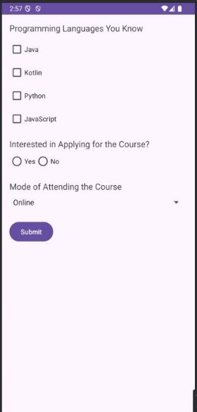
Possible errors:
1. Cross-check all names to ensure consistency throughout the
application.
2. If an SDK error occurs, click the link and refactor accordingly.

PRACTICAL 3
Create an application to create Image Flipper and Image Gallery. On click on
the image display the information about the image.
STEP 1:-Working with the activity_main.xml file
Navigate to the app > res > layout > activity_main.xml and paste the following code to activity_main.xml file.Below is the code for the activity_main.xml file. Comments are added inside the code to understand the code in more detail.
Code:-
<?xml version="1.0" encoding="utf-8"?>
<RelativeLayout
xmlns:android="http://schemas.android.com/apk/res/androi
d" xmlns:tools="http://schemas.android.com/tools"
android:layout_width="match_parent"
android:layout_height="match_parent"
android:orientation="vertical"
tools:context=".MainActivity">
<!--on below line we are adding view pager -->
<androidx.viewpager.widget.ViewPager
android:id="@+id/idViewPager"
android:layout_width="343dp"
android:layout_height="272dp"
android:layout_centerInParent="true"
android:layout_gravity="center"
android:layout_marginStart="10dp"
android:layout_marginLeft="10dp"
STEP 2:- Create a layout file for ImageView in View Pager
Navigate to the app > res > layout > Right-click on it > New > Layout Resource file and specify the name as image_slider_item. Paste the following code to the image_slider_item file. Comments are added in the code to understand the code in detail.
Code:-
<?xml version="1.0" encoding="utf-8"?>
<RelativeLayout
xmlns:android="http://schemas.android.com/apk/res/android"
android:layout_width="match_parent"
android:layout_height="match_parent">
<!--on below line we are creating an image view-->
<ImageView
android:id="@+id/idIVImage"
android:layout_width="200dp"
android:layout_height="200dp"
android:layout_centerInParent="true" />
STEP 3:-Create a new kotlin class for the adapter of our ViewPager</RelativeLayout>
Navigate to the app > kotlin+java > your file name/your package name(here our file file name is practical_no_4> Right-click on it > New> Java/Kotlin class and name it as
ViewPagerAdapter . Delete all the lines in that file except the 1st line and paste the below code to it.Comments are added in the code to understand the code in detail.
Code:-
package com.example.practical_no_4
import android.content.Context
import android.view.LayoutInflater
import android.view.View
import android.view.ViewGroup
import android.widget.ImageView
import
android.widget.RelativeLayout
import androidx.viewpager.widget.PagerAdapter
import java.util.*
class ViewPagerAdapter(val context: Context, val imageList: List<Int>)
: PagerAdapter() { // on below line we are creating a method
// as get count to return the size of the list.
override fun getCount(): Int {
return imageList.size
}
// on below line we are returning the object
override fun isViewFromObject(view: View, `object`: Any): Boolean {
return view === `object` as RelativeLayout
}
// on below line we are initializing
// our item and inflating our layout file
override fun instantiateItem(container: ViewGroup, position: Int): Any
{
// on below line we are initializing
// our layout inflater. val
mLayoutInflater =
context.getSystemService(Context.LAYOUT_INFLATER_SERVICE) as LayoutInflater
// on below line we are inflating our custom
// layout file which we have created.
val itemView: View =
mLayoutInflater.inflate(R.layout.image_slider_item, container, false)
// on below line we are initializing
// our image view with the id. val imageView: ImageView =
itemView.findViewById<View>(R.id.idIVImage) as ImageView
// on below line we are setting
// image resource for image view.
imageView.setImageResource(imageList.get(position))
// on the below line we are adding this
// item view to the container.
Objects.requireNonNull(container).addView(itemView)
// on below line we are simply
// returning our item view. return itemView
}
// on below line we are creating a destroy item method. override fun
destroyItem(container: ViewGroup, position: Int,
`object`: Any) { // on below line we are removing view
container.removeView(`object` as RelativeLayout)
}
}
STEP 4: - Add images to the drawable folder
Select the images which you want to add copy them Navigate to app > res> drawable and right-click on it. Simply paste it and add all the images to the drawable folder. (For us it looks like this when we add all the images to a drawable folder.)
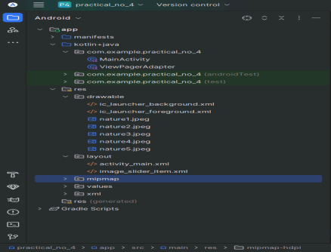
STEP 5:- Working with the MainActivity.kt file
Go to the MainActivity.kt file and paste the following code. Below is the code for the MainActivity.kt file. Delete all the lines except the first line of this file and paste the code. Comments are added inside the code to understand the code in more detail.
Code: -
package com.example.practical_no_4
import android.os.Bundle
import
androidx.appcompat.app.AppCompatActivity
import androidx.viewpager.widget.ViewPager
class MainActivity : AppCompatActivity() {
// on below line we are creating variable for view pager,
// viewpager adapter and the image list.
lateinit var viewPager: ViewPager
lateinit var viewPagerAdapter:
ViewPagerAdapter lateinit var imageList:
List<Int>
override fun onCreate(savedInstanceState: Bundle?) {
super.onCreate(savedInstanceState)
setContentView(R.layout.activity_main)
// initializing variables
// of below line with their id.
viewPager = findViewById(R.id.idViewPager)
// on below line we are initializing
// our image list and adding data to it. imageList
= ArrayList<Int>()
imageList = imageList + R.drawable.nature1 //your image
name imageList = imageList + R.drawable.nature2 //your
image name imageList = imageList + R.drawable.nature3
//your
image name
imageList = imageList +
R.drawable.nature4 //your image name imageList =
imageList + R.drawable.nature5 //your image name
// on below line we are initializing our view
// pager adapter and adding image list to it.
viewPagerAdapter = ViewPagerAdapter(this@MainActivity,
imageList)
// on below line we are setting
// adapter to our view pager.
viewPager.adapter = viewPagerAdapter
}
}
STEP 6: - Run the application.
Click the play button at the top or use the shortcut ‘SHIFT + F10’.
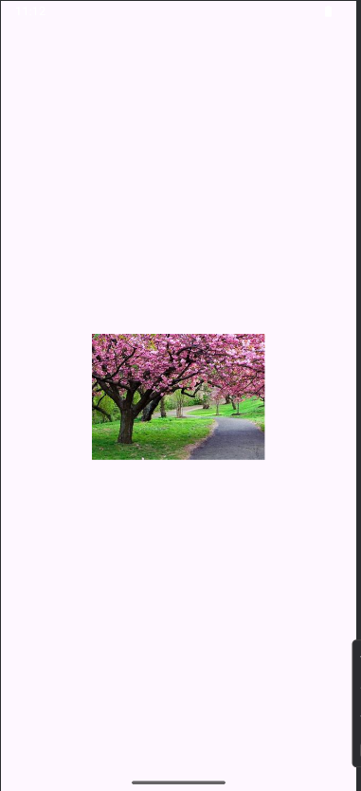
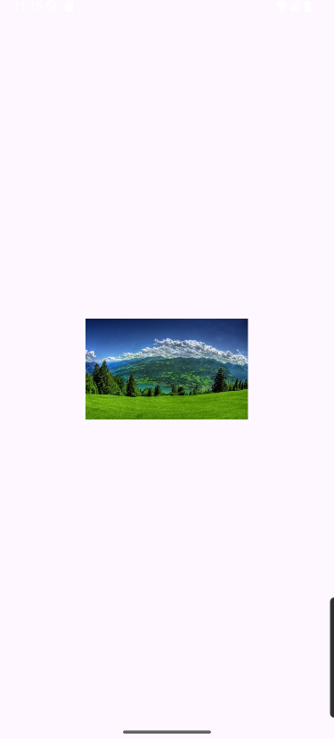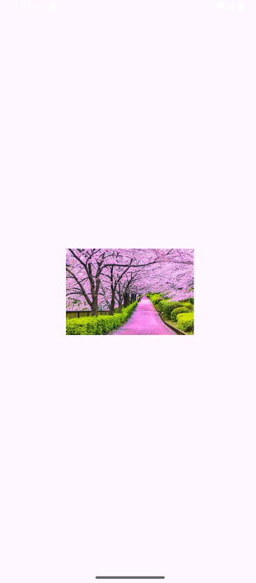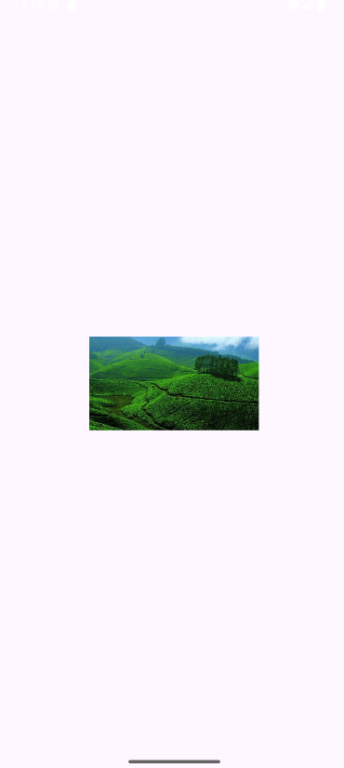
Just click on the screen and your image changes.
Practical 4
Create an Android application to demonstrate implicit and explicit intents
STEP 1: -In this step first, we will create a new Android project in Android
studio.
STEP2: -Working with the activity_main.xml file.
Now let us design the UI of the activity_main file. In this file, we need to first design two buttons each for explicit intent and implicit intent.
Navigate to app > res > layout > activity_main.xml and paste the following
code to activity_main.xml file.
Code: -
<?xml version="1.0" encoding="utf-8"?>
<LinearLayout xmlns:android="http://schemas.android.com/apk/res/android"
xmlns:app="http://schemas.android.com/apk/res-auto"
xmlns:tools="http://schemas.android.com/tools"
android:layout_width="match_parent"
android:layout_height="match_parent"
android:orientation="vertical"
tools:context=".MainActivity">
<Button
android:id="@+id/bt_explicit"
android:layout_width="wrap_content"
android:layout_height="wrap_content"
android:layout_marginTop="60dp"
android:layout_gravity="center_horizontal"
android:text="EXPLICIT INTENT"
android:onClick="callSecondActivity" />
<Button
android:id="@+id/bt_implicit"
android:layout_width="wrap_content"
android:layout_height="wrap_content"
android:layout_marginTop="10dp"
android:layout_gravity="center_horizontal"
android:text="IMPLICIT INTENT" />
</LinearLayout>
STEP 3: - Working with the MainActivity.kt file.
In the MainActivity.kt file paste the following code.
Code: -
package com.example.practical_5
import android.content.Intent
import android.os.Bundle
import android.view.View
import android.widget.Button
import android.widget.Toast
import androidx.appcompat.app.AppCompatActivity
import android.net.Uri
class MainActivity : AppCompatActivity() {
var bt_explicit: Button? = null
var bt_implicit: Button? = null
override fun onCreate(savedInstanceState: Bundle?) {
super.onCreate(savedInstanceState)
setContentView(R.layout.activity_main)
bt_explicit = findViewById<Button>(R.id.bt_explicit)
bt_implicit = findViewById<Button>(R.id.bt_implicit)
bt_implicit?.setOnClickListener(View.OnClickListener { val implicit_intent
= Intent(
Intent.ACTION_VIEW,
Uri.parse("geo:37.7749,-122.4194")
)
startActivity(implicit_intent)
Toast.makeText(
this@MainActivity,
"Clicked Implicit Intent Button",
Toast.LENGTH_SHORT ).show()
})
}
fun callSecondActivity(view: View?) {
val explicit_intent = Intent(
this@MainActivity,
Explicit_intent::class.java )
startActivity(explicit_intent)
Toast.makeText(this@MainActivity, "Clicked Explicit Intent Button",
Toast.LENGTH_SHORT).show()
}
}
STEP 4:- Design the UI of the second layout file.
Now design the UI of another activity where the user will navigate after they click on the bt_explicit button.
Navigate to app > res > layout > create a new activity and name it
activity_explicit_intent and paste the following code.
Code: -
<?xml version="1.0" encoding="utf-8"?>
<LinearLayout xmlns:android="http://schemas.android.com/apk/res/android"
xmlns:app="http://schemas.android.com/apk/res-auto"
xmlns:tools="http://schemas.android.com/tools"
android:layout_width="match_parent"
android:layout_height="match_parent"
android:orientation="vertical"
tools:context=".Explicit_intent">
<TextView
android:layout_width="wrap_content"
android:layout_height="wrap_content"
android:layout_gravity="center"
android:layout_marginTop="60dp"
android:text="Explicit Intent "
android:textSize="20sp"/>
<Button
android:id="@+id/bt_back"
android:layout_width="wrap_content"
android:layout_height="wrap_content"
android:text="Call First Activity"
android:onClick="callFirstActivity"
android:layout_gravity="center"
android:layout_marginTop="10dp"/>
</LinearLayout>
STEP 5: -Create a new kotlin class.
Navigate to the app > kotlin+java > your file name/your package name(here our file file name is practical_no_4> Right-click on it >New > Java/Kotlin class and name it as Explicit_intent . Delete all the lines in that file except the 1st line and paste the below code to it.
Code: -
package com.example.practical_5
import android.content.Intent
import android.os.Bundle
import android.view.View
import android.widget.Button
import android.widget.Toast
import androidx.appcompat.app.AppCompatActivity
class Explicit_intent : AppCompatActivity() {
var bt_back: Button? = null
override fun onCreate(savedInstanceState: Bundle?) {
super.onCreate(savedInstanceState)
setContentView(R.layout.activiy_explicit_intent)
bt_back = findViewById<Button>(R.id.bt_back)
}
fun callFirstActivity(view: View?) {
val i = Intent(this, MainActivity::class.java)
startActivity(i)
Toast.makeText(this, "We are moved to First Activity",
Toast.LENGTH_SHORT)
.show()
}
}
Output:
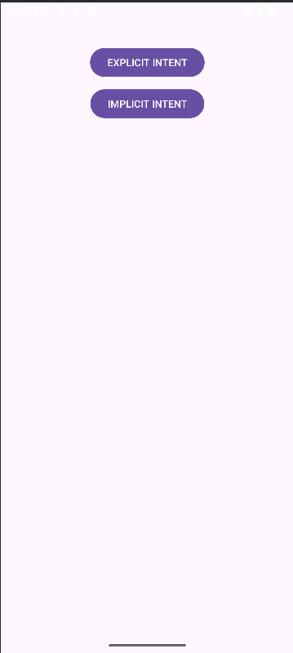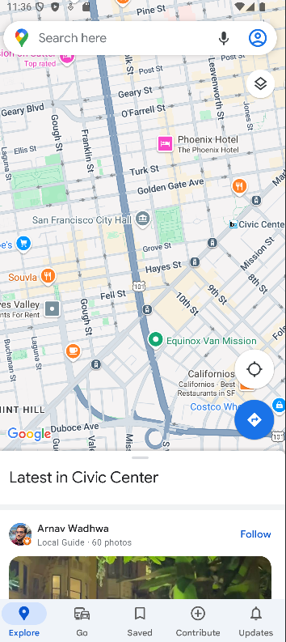
PRACTICAL 5
Create an application to demonstrate shared preferences
We are going to explore the implementation of SharedPreferences in Android. Our goal is to create an Android app that stores user-entered data from a textbox and retains it even after the app is removed from the background.
STEP 1: -In this step first, we will create a new Android project in Android
studio.
STEP 2: - Working with the MainActivity.kt file.
Delete all the existing code in MainActivity.kt, except for the first line:
package com.example.ProjectName
Note: This line should remain unchanged, reflecting your project's package
name. Now, copy and paste the following code directly below the package name
line.
Code: -
import android.os.Bundle
import android.widget.EditText
import androidx.appcompat.app.AppCompatActivity
class MainActivity : AppCompatActivity() {
private lateinit var name: EditText
private lateinit var age: EditText
override fun onCreate(savedInstanceState: Bundle?) {
super.onCreate(savedInstanceState)
setContentView(R.layout.activity_main)
name = findViewById(R.id.edit1)
age = findViewById(R.id.edit2)
}
// Fetch the stored data in onResume() Because this is what will be called
when the app opens again
override fun onResume() {
super.onResume()
// Fetching the stored data from the SharedPreference
val sh = getSharedPreferences("MySharedPref", MODE_PRIVATE)
val s1 = sh.getString("name", "")
val a = sh.getInt("age", 0)
// Setting the fetched data in the EditTexts
name.setText(s1)
age.setText(a.toString())
}
// Store the data in the SharedPreference in the onPause() method
// When the user closes the application onPause() will be called and data will
be stored
override fun onPause() {
super.onPause()
// Creating a shared pref object with a file name "MySharedPref" in
private mode
val sharedPreferences = getSharedPreferences("MySharedPref",
MODE_PRIVATE)
val myEdit = sharedPreferences.edit()
// write all the data entered by the user in SharedPreference and apply
myEdit.putString("name", name.text.toString())
myEdit.putInt("age", age.text.toString().toInt())
myEdit.apply()
}
}
Step 3: activity_main.xml
3.1: Opening activity_main.xml file to code
navigate to app > res > layout > activity_main.xml and open the file.
3.2: Writing Code in activity_main.xml
Select all the existing code (Shift + A) and delete it. Copy and paste the following code into the activity_main.xml file.
Code: -
<?xml version="1.0" encoding="utf-8"?>
<RelativeLayout
xmlns:android="http://schemas.android.com/apk/res/android"
xmlns:tools="http://schemas.android.com/tools"
android:layout_width="match_parent"
android:layout_height="match_parent"
tools:context=".MainActivity"
tools:ignore="HardcodedText">
<TextView
android:id="@+id/textview"
android:layout_width="wrap_content"
android:layout_height="wrap_content"
android:layout_centerHorizontal="true"
android:layout_marginTop="32dp"
android:text="Shared Preferences Demo"
android:textColor="@android:color/black"
android:textSize="24sp" />
<!--EditText to take the data from the user and save the data in
SharedPreferences-->
<EditText
android:id="@+id/edit1"
android:layout_width="match_parent"
android:layout_height="wrap_content"
android:layout_below="@+id/textview"
android:layout_marginStart="16dp"
android:layout_marginTop="8dp"
android:layout_marginEnd="16dp"
android:hint="Enter your Name"
android:padding="10dp" />
<!--EditText to take the data from the user and save the data in
SharedPreferences-->
<EditText
android:id="@+id/edit2"
android:layout_width="match_parent"
android:layout_height="wrap_content"
android:layout_below="@+id/edit1"
android:layout_marginStart="16dp"
android:layout_marginTop="8dp"
android:layout_marginEnd="16dp"
android:hint="Enter your Age"
android:inputType="number"
android:padding="10dp" />
</RelativeLayout>
Step 4: Running the Application
4.1: Save and Run
Save both files (.xml and .kt) using Ctrl + S, then run the application by clicking the Run icon or pressing Shift + F10.
Wait patiently.
Once completed, enter some text and age in the input fields (EditText), then close the application—even remove it from the background. When you reopen the app, you'll see that your last input has been saved.
Output:


PRACTICAL 6
Create an Android application to display canvas and allow the user to draw on it.

MainActivity.kt

package com.example.canva
import android.annotation.SuppressLint
import android.graphics.Bitmap
import android.graphics.Canvas
import android.graphics.Color import
android.graphics.Paint import
android.os.Build
import androidx.appcompat.app.AppCompatActivity import
android.os.Bundle
import android.view.MotionEvent
import android.view.View
import android.widget.ImageView
import androidx.annotation.RequiresApi
class MainActivity : AppCompatActivity(), View.OnTouchListener {
// Declaring ImageView, Bitmap, Canvas, Paint,
// Down Coordinates and Up Coordinates
private lateinit var mImageView: ImageView
private lateinit var bitmap: Bitmap
private lateinit var canvas: Canvas
private lateinit var paint: Paint private
var downX = 0f
private var downY = 0f
private var upX = 0f
private var upY = 0f
@RequiresApi(Build.VERSION_CODES.R)
@SuppressLint("ClickableViewAccessibility")
override fun onCreate(savedInstanceState: Bundle?) {
super.onCreate(savedInstanceState)
setContentView(R.layout.activity_main)
// Initializing the ImageView
mImageView = findViewById(R.id.image_view_1)
// Getting the current window dimensions
val currentDisplay = windowManager.currentWindowMetrics
val dw = currentDisplay.bounds.width()
val dh = currentDisplay.bounds.height()
// Creating a bitmap with fetched dimensions
bitmap = Bitmap.createBitmap(dw, dh, Bitmap.Config.ARGB_8888)
// Storing the canvas on the bitmap
canvas = Canvas(bitmap)
// Initializing Paint to determine
// stoke attributes like color and size
paint = Paint()
paint.color = Color.RED
paint.strokeWidth = 10F
// Setting the bitmap on ImageView
mImageView.setImageBitmap(bitmap)
// Setting onTouchListener on the ImageView
mImageView.setOnTouchListener(this)
}
// When Touch is detected on the ImageView,
// Initial and final coordinates are recorded
// and a line is drawn between them.
// ImagView is updated
@SuppressLint("ClickableViewAccessibility")
override fun onTouch(v: View?, event: MotionEvent?): Boolean {
when (event!!.action) {
MotionEvent.ACTION_DOWN ->
{ downX = event.x
downY = event.y
}
MotionEvent.ACTION_MOVE -> {
upX = event.x
upY = event.y
canvas.drawLine(downX, downY, upX, upY, paint)
downX = upX // Update start point for continuous drawing
downY = upY
mImageView.invalidate()
}
MotionEvent.ACTION_UP -> {
upX = event.x
upY = event.y
canvas.drawLine(downX, downY, upX, upY, paint)
mImageView.invalidate()
}
}
return true // Ensure event is consumed
}
}
activity_main.xml

<?xml version="1.0" encoding="utf-8"?>
<RelativeLayout
xmlns:android="http://schemas.android.com/apk/res/android"
xmlns:app="http://schemas.android.com/apk/res-auto"
xmlns:tools="http://schemas.android.com/tools"
android:layout_width="match_parent"
android:layout_height="match_parent"
tools:context=".MainActivity">
<ImageView
android:id="@+id/image_view_1"
android:layout_width="match_parent"
android:layout_height="match_parent"
android:background="@color/white"
tools:ignore="ContentDescription" />
</RelativeLayout>
Output: -
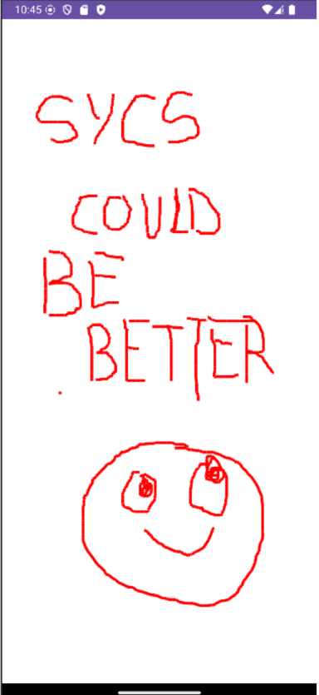

PRACTICAL 7
Create an Android application to use a camera and capture image/video and
display them on the screen.
activity_main.xml file
<?xml version="1.0" encoding="utf-8"?>
<RelativeLayout xmlns:android="http://schemas.android.com/apk/res/android"
xmlns:tools="http://schemas.android.com/tools"
android:layout_width="match_parent"
android:layout_height="match_parent"
tools:context=".MainActivity">
<!-- add Camera Button to open the Camera -->
<Button
android:id="@+id/camera_button"
android:layout_width="100dp"
android:layout_height="50dp"
android:layout_marginStart="150dp"
android:text="Camera" />
<!-- add ImageView to display the captured image -->
<ImageView
android:id="@+id/click_image"
android:layout_width="350dp"
android:layout_height="450dp"
android:layout_marginStart="30dp"
android:layout_marginTop="70dp"
android:layout_marginBottom="10dp" />
</RelativeLayout>
Mainactivity.kt file
package com.example.practical_7
import android.content.Intent
import android.graphics.Bitmap
import android.os.Bundle
import android.provider.MediaStore
import android.view.View
import android.widget.Button
import android.widget.ImageView
import androidx.appcompat.app.AppCompatActivity
class MainActivity : AppCompatActivity() {
// Define the button and imageview type variable
private lateinit var cameraOpenId: Button
lateinit var clickImageId: ImageView
override fun onCreate(savedInstanceState: Bundle?) {
super.onCreate(savedInstanceState)
setContentView(R.layout.activity_main)
// By ID we can get each component which id is assigned in XML file get
Buttons and imageview.
cameraOpenId = findViewById(R.id.camera_button)
clickImageId = findViewById(R.id.click_image)
// Camera_open button is for open the camera and add the
setOnClickListener in this button
cameraOpenId.setOnClickListener(View.OnClickListener { v: View? ->
// Create the camera_intent ACTION_IMAGE_CAPTURE it will open
the camera for capture the image
val cameraIntent = Intent(MediaStore.ACTION_IMAGE_CAPTURE)
// Start the activity with camera_intent, and request pic id
startActivityForResult(cameraIntent, pic_id)
})
}
// This method will help to retrieve the image
override fun onActivityResult(requestCode: Int, resultCode: Int, data: Intent?)
{
super.onActivityResult(requestCode, resultCode, data)
// Match the request 'pic id with requestCode
if (requestCode == pic_id) {
// BitMap is data structure of image file which store the image in memory
val photo = data!!.extras!!["data"] as Bitmap?
// Set the image in imageview for display
clickImageId.setImageBitmap(photo)
}
}
companion object {
// Define the pic id
private const val pic_id = 123
}
}
Output:
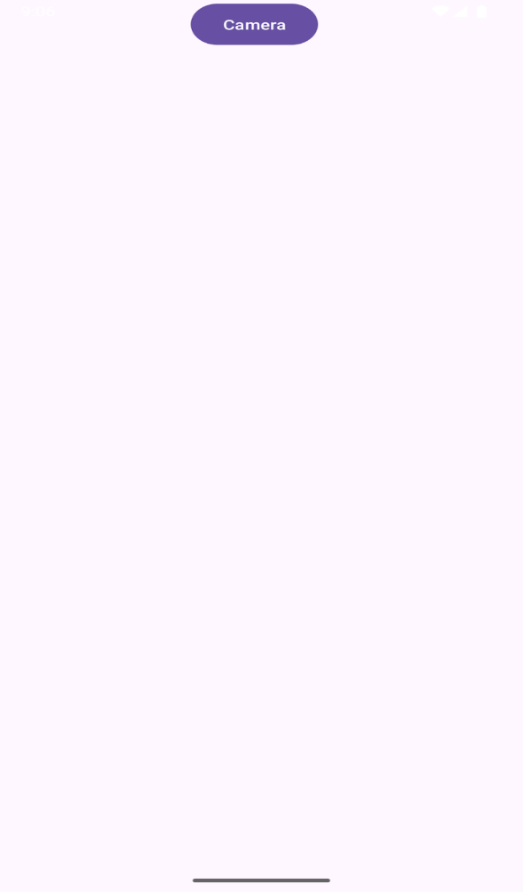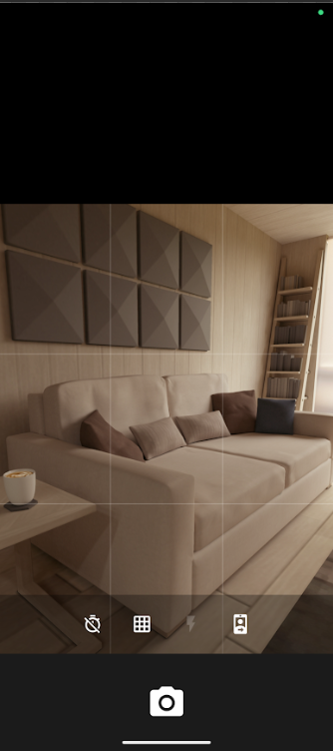

PRACTICAL 8
Create an Android application to demonstrate the different types of menus.
a. Pop-up Menu
b. Context Menu
c. Option Menu
Step 1: Create a new directory (Android Resource Directory) in the res directory.
Navigate to app > res > new > Android Resource Directory
Step 2: Change Resource type to menu and Directory name to menu
Step 3: Create 3 Menu Resource Files
1.menu.xml
2.popup_menu.xml
3.context_menu.xml
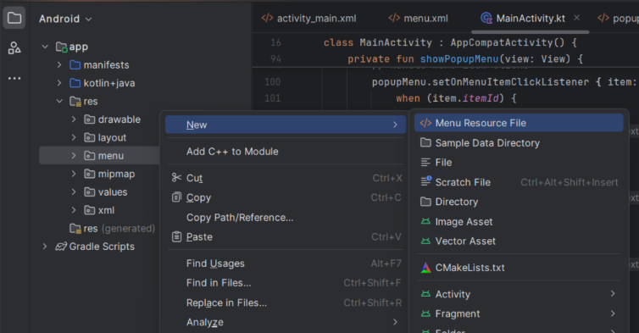
Step 4: Enter all the codes in the respective files.
MainActivity.kt
package com.example.menus
import android.annotation.SuppressLint
import androidx.appcompat.app.AppCompatActivity
import android.os.Bundle
import android.view.ContextMenu
import android.view.Menu
import android.view.MenuInflater
import android.view.MenuItem
import android.view.View
import android.widget.TextView
import android.widget.Toast
import androidx.appcompat.widget.PopupMenu
import androidx.appcompat.widget.Toolbar
class MainActivity : AppCompatActivity() {
@SuppressLint("MissingInflatedId")
override fun onCreate(savedInstanceState: Bundle?) {
super.onCreate(savedInstanceState) setContentView(R.layout.activity_main)
val toolbar = findViewById<Toolbar>(R.id.toolbar)
setSupportActionBar(toolbar) supportActionBar?.title =
"Options Menu"
// Find TextView and register it for the context menu val
textView: TextView = findViewById(R.id.textView)
registerForContextMenu(textView)
//Find TextView
val atextView: TextView = findViewById(R.id.textViews)
// Set click listener to show pop-up menu
atextView.setOnClickListener { view ->
showPopupMenu(view)
}
}
override fun onCreateOptionsMenu(menu: Menu): Boolean {
menuInffater.inflate(R.menu.menu, menu) return
true
}
override fun onOptionsItemSelected(item: MenuItem): Boolean { return when
(item.itemId) {
R.id.about -> {
Toast.makeText(this, "About Selected", Toast.LENGTH_SHORT).show()
true
}
R.id.settings -> {
Toast.makeText(this, "Settings Selected",
Toast.LENGTH_SHORT).show()
true
}
R.id.exit -> {
Toast.makeText(this, "Exit Selected", Toast.LENGTH_SHORT).show() true
}
else -> super.onOptionsItemSelected(item)
}
}
// Create the Context Menu
override fun onCreateContextMenu( menu:
ContextMenu?,
v: View?,
menuInfo: ContextMenu.ContextMenuInfo?
) {
super.onCreateContextMenu(menu, v, menuInfo)
menuInffater.inflate(R.menu.context_menu, menu)
}
// Handle the Context Menu Item Click
override fun onContextItemSelected(item: MenuItem): Boolean { return when
(item.itemId) {
R.id.option1 -> {
Toast.makeText(this, "Option 1 Selected",
Toast.LENGTH_SHORT).show()
true
}
R.id.option2 -> {
Toast.makeText(this, "Option 2 Selected",
Toast.LENGTH_SHORT).show()
true
}
R.id.option3 -> {
Toast.makeText(this, "Option 3 Selected",
Toast.LENGTH_SHORT).show()
true
}
else -> super.onContextItemSelected(item)
}
}
// Function to show Pop-up Menu
private fun showPopupMenu(view: View) {
val popupMenu = PopupMenu(this, view)
val inflater: MenuInflater = popupMenu.menuInffater
inflater.inflate(R.menu.popup_menu, popupMenu.menu)
// Handle menu item clicks
popupMenu.setOnMenuItemClickListener { item: MenuItem ->
when (item.itemId) { R.id.option1 ->
{
Toast.makeText(this, "Option 1 Selected",
Toast.LENGTH_SHORT).show()
true
}
R.id.option2 -> {
Toast.makeText(this, "Option 2 Selected",
Toast.LENGTH_SHORT).show()
true
}
R.id.option3 -> {
Toast.makeText(this, "Option 3 Selected",
Toast.LENGTH_SHORT).show()
true
}
else -> false
}
}
popupMenu.show()
}
}
activity_main.xml
<?xml version="1.0" encoding="utf-8"?>
<androidx.constraintlayout.widget.ConstraintLayout
xmlns:android="http://schemas.android.com/apk/res/android"
xmlns:app="http://schemas.android.com/apk/res-auto"
xmlns:tools="http://schemas.android.com/tools"
android:id="@+id/main"
android:layout_width="match_parent"
android:layout_height="match_parent"
tools:context=".MainActivity">
<androidx.appcompat.widget.Toolbar
android:id="@+id/toolbar"
android:layout_width="match_parent"
android:layout_height="?attr/actionBarSize"
android:background="@color/material_dynamic_primary70"
app:popupTheme="@style/ThemeOverlay.AppCompat.Light"
tools:ignore="MissingConstraints" />
<TextView
android:id="@+id/textView"
android:layout_width="wrap_content"
android:layout_height="wrap_content"
android:background="@android:color/holo_blue_light"
android:gravity="center"
android:padding="16dp"
android:text="Long Press Me for Context Menu"
android:textColor="@android:color/white"
android:textSize="18sp"
app:layout_constraintBottom_toBottomOf="parent"
app:layout_constraintEnd_toEndOf="parent"
app:layout_constraintHorizontal_bias="0.495"
app:layout_constraintStart_toStartOf="parent"
app:layout_constraintTop_toTopOf="parent"
app:layout_constraintVertical_bias="0.33" />
<TextView
android:id="@+id/textViews"
android:layout_width="wrap_content"
android:layout_height="wrap_content"
android:background="@android:color/holo_blue_light"
android:gravity="center"
android:padding="16dp" android:text="Tap
Me for Pop-up Menu"
android:textColor="@android:color/white"
android:textSize="18sp"
app:layout_constraintBottom_toBottomOf="parent"
app:layout_constraintEnd_toEndOf="parent"
app:layout_constraintStart_toStartOf="parent"
app:layout_constraintTop_toTopOf="parent"
app:layout_constraintVertical_bias="0.642" />
</androidx.constraintlayout.widget.ConstraintLayout>
context_menu.xml
<?xml version="1.0" encoding="utf-8"?>
<menu xmlns:android="http://schemas.android.com/apk/res/android">
<item
android:id="@+id/option1"
android:title="Option 1" />
<item
android:id="@+id/option2"
android:title="Option 2" />
<item
android:id="@+id/option3"
android:title="Option 3" />
</menu>
popup_menu.xml
<?xml version="1.0" encoding="utf-8"?>
<menu xmlns:android="http://schemas.android.com/apk/res/android">
<item
android:id="@+id/option1"
android:title="Option 1" />
<item
android:id="@+id/option2"
android:title="Option 2" />
<item
android:id="@+id/option3"
android:title="Option 3" />
</menu>
menu.xml
<?xml version="1.0" encoding="utf-8"?>
<menu xmlns:android="http://schemas.android.com/apk/res/android"
xmlns:app="http://schemas.android.com/apk/res-auto">
<item
android:id="@+id/overflowMenu"
android:icon="@drawable/ic_3_dots"
android:title="Options"
app:showAsAction="always">
<menu>
<item
android:id="@+id/settings"
android:icon="@drawable/ic_settings"
android:title="SETTINGS"
app:showAsAction="never" />
<item
android:id="@+id/about"
android:icon="@drawable/ic_about"
android:title="ABOUT"
app:showAsAction="never" />
<item
android:id="@+id/exit"
android:icon="@drawable/ic_exit"
android:title="EXIT"
app:showAsAction="never" />
</menu>
</item>
</menu>
Output: -
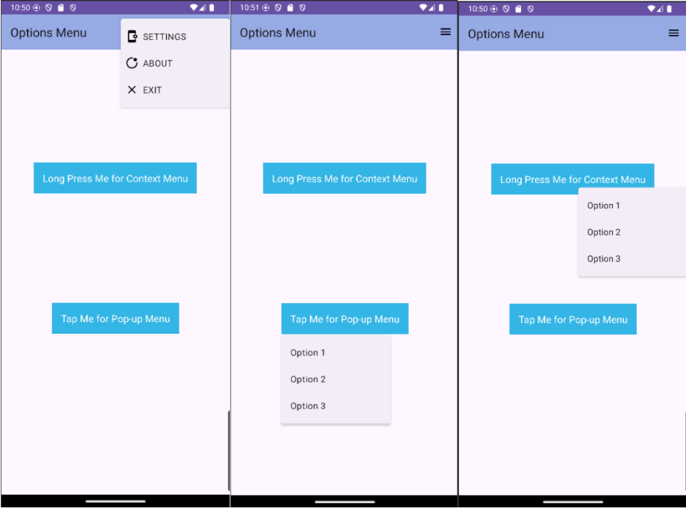
Note: The “@drawable/ic_3_dots”, “@drawable/ic_settings”,
“@drawable/ic_about”, “@drawable/ic_exit” are vectors used for Options menu.
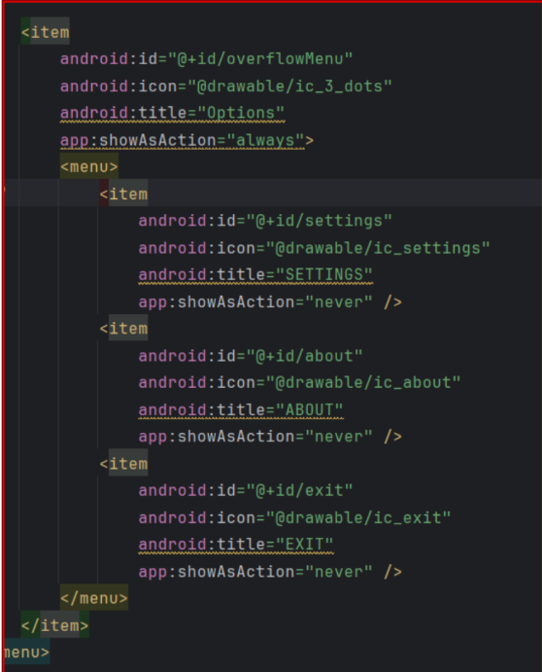

Follow the steps below to define vectors in your project:
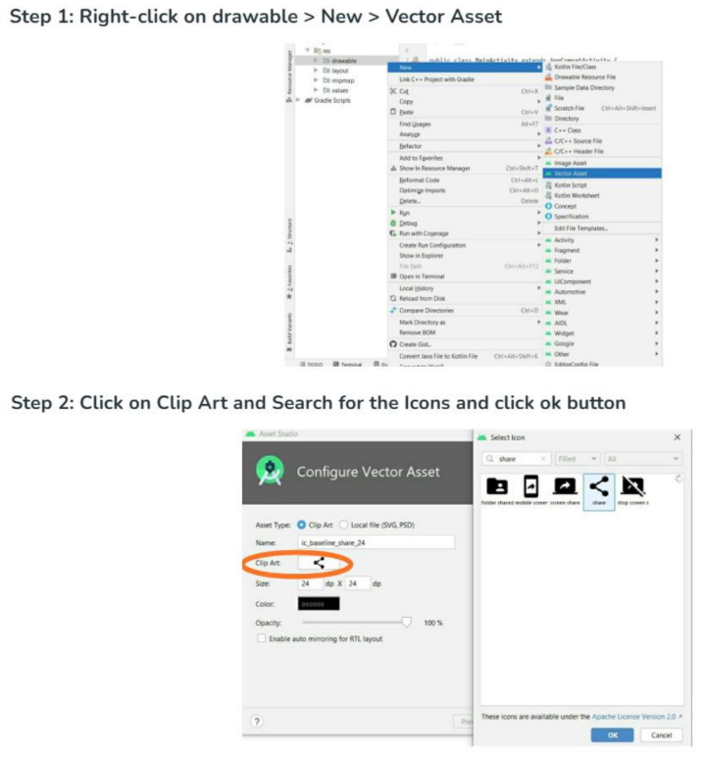
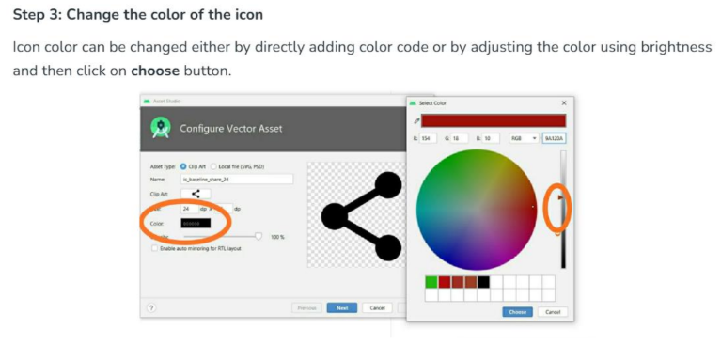

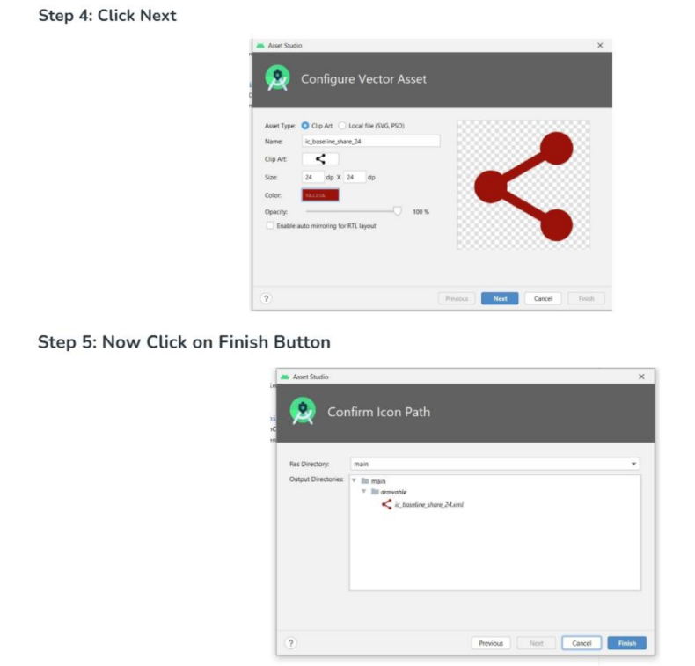
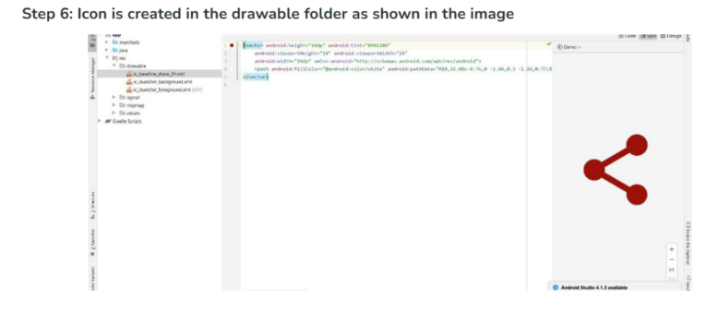


Oriental Education Society’s
SANPADA COLLEGE OF COMMERCE & TECHNOLOGY
SECTOR-2, PLOT-3/4/5, ADJACENT SANPADA RAILWAY STATION, SANPADA (W), NAVI MUMBAI -400 705.
DEPARTMENT OF COMPUTER SCIENCE
CERTIFICATE

This Is to Certify That Ms.__________________________________ of Class S.Y.B.Sc(CS) Bearing Roll No.______ of Semester IV Has Successfully Completed the Practical Work in The Subject Of “Android Application Development”. During The Academic Year 2024-25 Under the Guidance of Dr. P. Ramila Rajaleximi
being the Partial Requirement for The Fulfilment of The Curriculum of Degree of Bachelor of Science in Computer Science, University of Mumbai.
Place: Sanpada
Date: / /2025
Subject In-charge External Examiner HOD-CS Principal

Index
S.NO | Practical Name | Date | Signature
1 | A) Write a program using Kotlin to implement control structures and loops.  B) Write a program to implement object oriented concepts in Kotlin. | 05/12/2024 30/12/2024
2 | Write an android application demonstrating response to event/user interaction for  a. Checkbox  b. Radio button  c. Button  d. Spinner | 06/01/2025
3 | Create an application to create Image Flipper and Image Gallery. On click on the image display the information about the image. | 13/01/2025
4 | Create an Android application to demonstrate implicit and explicit intents. | 20/01/2025
5 | Create an application to demonstrate shared preferences. | 27/01/2025
6 | Create an Android application to display canvas and allow the user to draw on it. | 10/02/2025
7 | Create an Android application to use a camera and capture image/video and display them on the screen. | 24/02/2025
8 | Create an Android application to demonstrate the different types of menus.  a. Pop-up Menu  b. Context Menu  c. Option Menu | 04/03/2025

