The Evolution of Gaming: From Consoles to Cloud Gaming
Gaming has come a long way since its inception, transforming from pixelated adventures on dedicated machines to immersive, cloud-powered experiences accessible on virtually any device. Let's take a walk down memory lane and explore how gaming has evolved from traditional consoles to the cutting edge of cloud gaming.
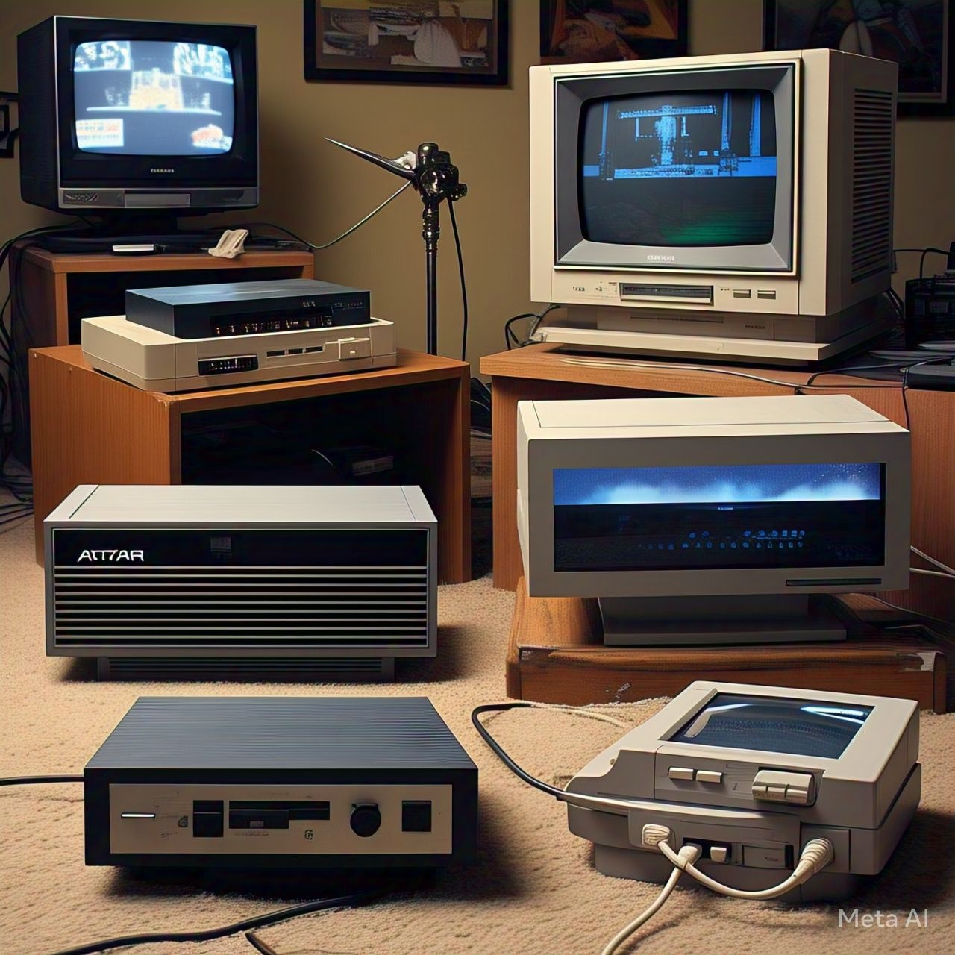
The Birth of Console Gaming
The journey began in the 1970s with the introduction of home gaming consoles. Atari's Pong and later the Atari 2600 brought video games into the living room for the first time. In the 1980s and 90s, Nintendo and Sega became household names, thanks to iconic titles like Super Mario Bros, The Legend of Zelda, and Sonic the Hedgehog.
Each new console generation brought improved graphics, better performance, and deeper storytelling. The PlayStation, Xbox, and Nintendo 64 ushered in 3D gaming, which fundamentally changed how games were designed and experienced.
The Rise of Disc-Based and Digital Gaming
As technology advanced, cartridges gave way to CDs, DVDs, and eventually Blu-ray discs. Consoles like the PlayStation 2, Xbox 360, and PlayStation 3 expanded gaming into the realm of high-definition visuals and online multiplayer. With faster internet speeds, digital downloads became more common. Gamers no longer had to rely on physical copies—they could simply buy, download, and play games directly from digital storefronts like Steam, PlayStation Store, and Xbox Live Marketplace.
The PC Gaming Boom
Meanwhile, PC gaming grew alongside consoles, offering customization, high-end graphics, and expansive genres like MMOs and real-time strategy. The modding community flourished, and platforms like Steam made game discovery and management easier than ever.
PCs gave birth to esports and livestreaming culture. Titles like League of Legends, Counter-Strike, and DOTA 2 turned competitive gaming into a billion-dollar industry.
Mobile Gaming Explosion
With the proliferation of smartphones, gaming transcended consoles and PCs to take root in mobile devices. Games like "Angry Birds" and "Candy Crush" captivated casual players and widened the gaming demographic. The app store model also created opportunities for independent developers to showcase their creativity.
Enter Cloud Gaming: The Future of Play
Cloud gaming is the latest frontier, allowing players to stream games on demand no console, no downloads, just a screen and an internet connection. Platforms like NVIDIA GeForce NOW, Xbox Cloud Gaming (xCloud), Amazon Luna, and PlayStation Now are revolutionizing how we access and enjoy games.
Cloud gaming has the potential to democratize gaming, offering players access to an extensive library without the need for physical consoles or high-end PCs. It represents a paradigm shift, where gaming is defined by software and connectivity rather than hardware.
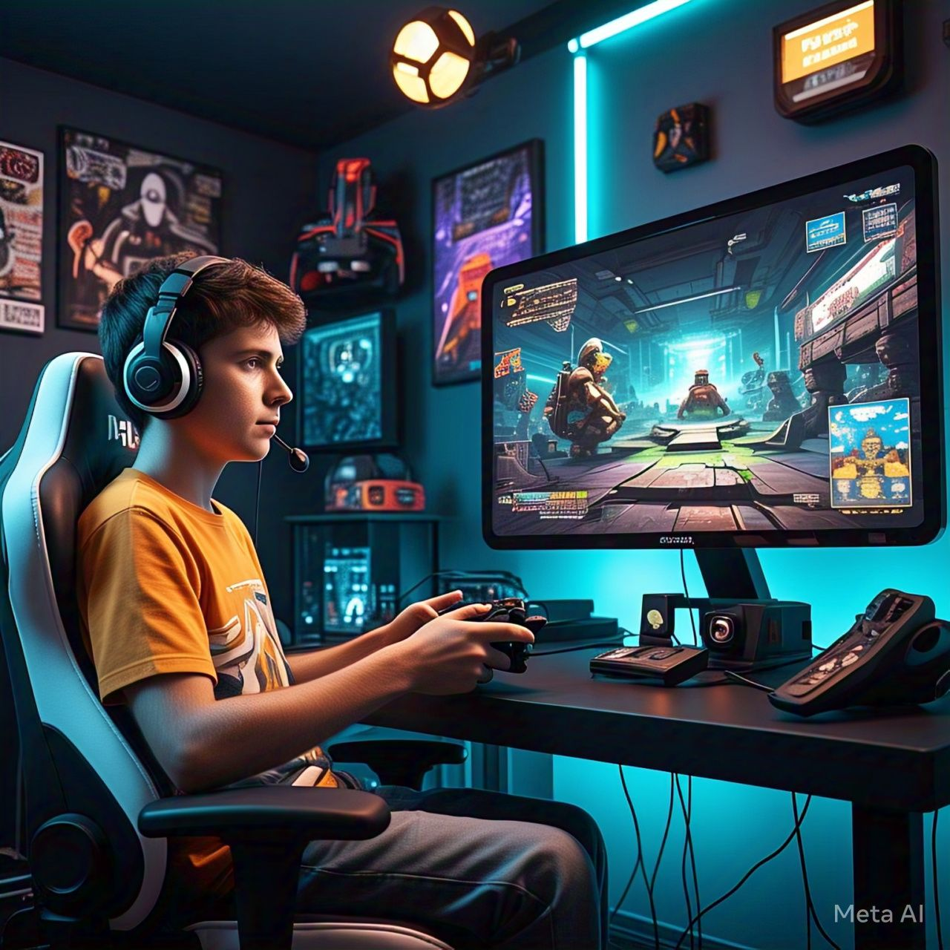
Conclusion
Gaming has grown from simple console-based fun to a multi-platform, cloud-connected ecosystem. As technologies like augmented reality (AR), virtual reality (VR), and artificial intelligence (AI) continue to evolve, the possibilities for gaming are endless. Whether you're a nostalgic fan of cartridge classics or an explorer in the cloud gaming frontier, one thing is clear: the future of gaming is incredibly exciting.
What are your thoughts on the direction gaming is headed? Do you see cloud gaming becoming the dominant force? Let’s continue the conversation!

