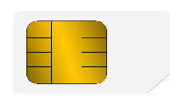

BANK NAME

11

3334 VALID

CARDHOLDER NAME THRU 12/23



[This Photo](https://www.pngall.com/visa-logo-png/download/18093) by Unknown Author is licensed under [CC BY-NC](https://creativecommons.org/licenses/by-nc/3.0/)