Name - Sakshi Shingole
Roll no - 150096724056
Jensen huang cohort

INSUREX — Digital Insurance Claim Management System

1. Problem Understanding

1.1 Introduction
Insurance claim processing often involves multiple steps such as submitting a claim, providing supporting documents, verifying evidence, communicating with insurance officers and tracking the claim status.
Traditional claim processes can involve paperwork, repeated communication and limited visibility into the current status of a claim.
InsureX is a cross-platform mobile insurance claim management application developed using Flutter. The application provides a centralized digital platform where customers can manage their policies, submit claims, upload supporting documents and evidence, track claim progress and communicate with assigned insurance officers.
The system also provides dedicated interfaces for insurance officers and administrators to manage and process claims efficiently.

1.2 Objective
The main objectives of InsureX are:
- Digitize the insurance claim submission process.
- Allow customers to submit claims from their mobile devices.
- Provide secure document and evidence upload.
- Allow customers to track claim status in real time.
- Enable officers to review and process assigned claims.
- Provide communication between customers and officers.
- Provide administrators with centralized management and analytics.
- Maintain an audit trail of important claim activities.

2. Application Design

2.1 Technology Stack

Frontend
Flutter / Dart
Flutter is used to develop the cross-platform mobile application.

Authentication
Firebase Authentication
Used for secure customer, officer and administrator authentication.

Database
Cloud Firestore
Used for storing structured application data such as:
- Users
- Policies
- Claims
- Documents metadata
- Evidence metadata
- Officers
- Notifications
- Messages
- Audit logs

Media Storage
Cloudinary
Cloudinary is used for storing uploaded:
- Images
- Videos
- Documents
The actual media is stored in Cloudinary while the corresponding URL and metadata are stored in Firestore.

Architecture
Flutter Application
│
├── Firebase Authentication
│
├── Cloud Firestore
│ ├── Users
│ ├── Policies
│ ├── Claims
│ ├── Documents
│ ├── Evidence
│ ├── Notifications
│ ├── Messages
│ └── Audit Logs
│
└── Cloudinary
├── Images
├── Videos
└── Documents

3. User Roles
InsureX uses three primary roles.

3.1 Customer
The customer can:
- Register/login
- View policies
- View policy details
- Create claims
- Upload documents
- Upload accident/evidence images and videos
- Review claim information
- Submit claims
- Track claim status
- View assigned officer
- Communicate with the officer
- Receive notifications
- View claim history
- Manage profile

3.2 Insurance Officer
The officer can:
- Login securely
- View assigned claims
- Search and filter claims
- Review claim information
- Verify submitted documents
- Review uploaded evidence
- Request additional information
- Add remarks
- Update claim status
- Approve or reject claims
- Communicate with customers
- View completed claims

3.3 Administrator
The administrator can:
- Monitor overall claim activity
- Manage customers
- Manage officers
- View claims
- Assign claims to officers
- Monitor claim status
- View analytics
- Monitor system activity
- View audit logs
- Manage notifications/settings

4. Application Navigation Flow

Customer Flow
Login / Register
↓
Customer Dashboard
↓
Policies
↓
Select Active Policy
↓
Create Claim
↓
Claim Information
↓
Upload Documents
↓
Upload Evidence
↓
Review Claim
↓
Submit Claim
↓
Claim Timeline
↓
Officer Review
↓
Status Updates
↓
Approval / Rejection / Completion

Officer Flow
Officer Login
↓
Officer Dashboard
↓
Assigned Claims
↓
Claim Details
↓
Document Verification
↓
Evidence Review
↓
Request Information / Add Remarks
↓
Update Claim Status
↓
Approve / Reject
↓
Customer Notification

Admin Flow
Admin Login
↓
Admin Dashboard
↓
Claims / Customers / Officers
↓
Assign Officer
↓
Monitor Claim
↓
Analytics
↓
Audit Logs

5. Main Application Features

5.1 Policy Management
Customers can view their insurance policies along with:
- Policy type
- Policy ID
- Coverage amount
- Monthly premium
- Policy status
Example policy categories:
- Home Insurance
- Auto Insurance
- Health Insurance
- Travel Insurance
- Personal Accident Insurance
Expired policies remain visible for history but cannot be used to create new claims.

5.2 Digital Claim Submission
Customers can create a claim by providing:
- Policy
- Claim type
- Incident date
- Incident location
- Description
- Estimated damage
- Claim amount
- Supporting documentation
The selected policy is automatically associated with the claim.

5.3 Document Upload
Customers can upload required insurance documents.
The application stores:
Document
↓
Cloudinary
↓
secure URL
↓
Firestore
Firestore stores the document metadata and Cloudinary URL rather than storing the binary file itself.

5.4 Evidence Upload
Customers can upload claim-related evidence such as:
- Accident photographs
- Property damage photographs
- Videos
- Supporting images
This provides officers with visual evidence during claim verification.

6. Claim Status Tracking
The customer can follow the progress of a claim through a timeline.
Example:
Claim Submitted
↓
Under Verification
↓
Under Review
↓
More Information Required
↓
Approved
↓
Completed
If additional information is required, the customer can see the request and provide the required information.

7. Officer Verification
Officers receive claims assigned to them.
They can:
- Review customer information
- Review policy details
- Check uploaded documents
- Examine evidence
- Add remarks
- Request additional information
- Update claim status
- Approve or reject claims
This creates a complete workflow between the customer and insurance organization.

8. Notifications
The application provides notifications for important claim events.
Examples:
- Claim submitted
- Claim assigned to officer
- Document verification completed
- Additional information requested
- Claim status changed
- Claim approved
- Claim rejected
- Claim completed

9. Communication
Customers and assigned officers can communicate regarding a claim.
This reduces the need for separate communication channels and keeps claim-related communication associated with the claim workflow.

10. Audit Trail
Important actions are recorded in the audit log.
Example:
Customer submitted claim
↓
Officer assigned
↓
Document verified
↓
Additional information requested
↓
Customer submitted information
↓
Officer approved claim
The audit trail provides transparency about what happened during claim processing.

11. Screenshots / Demonstration
For the final demonstration, show screenshots in this order:

Customer

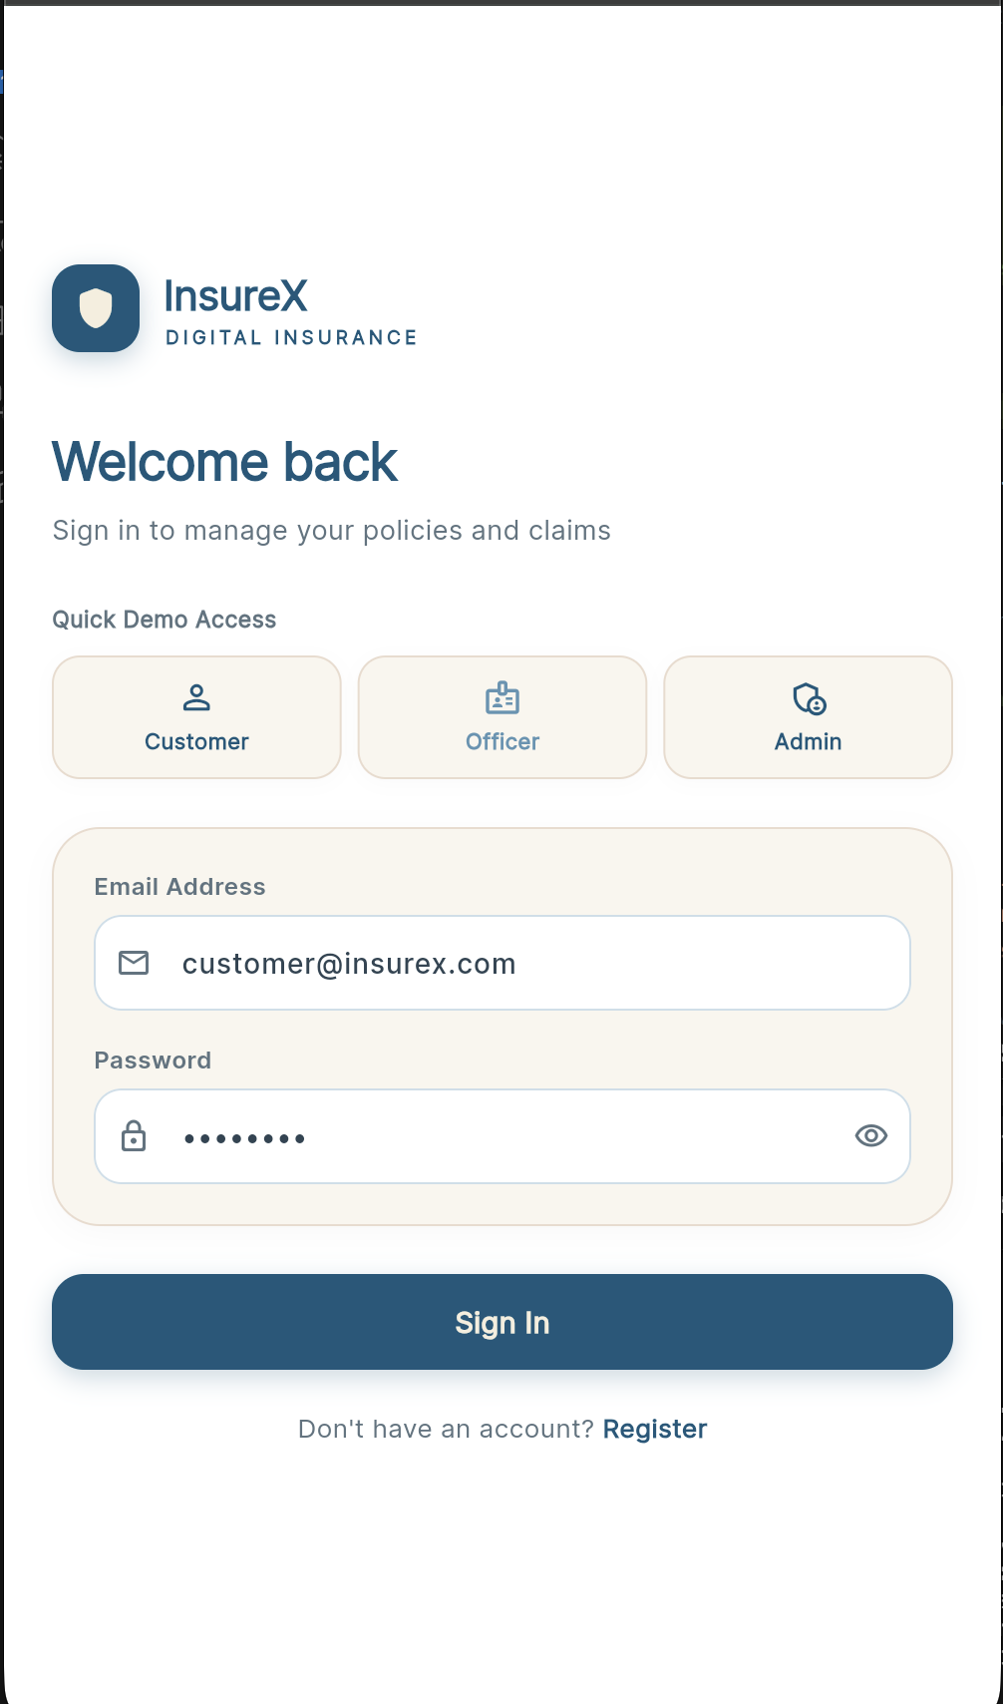 | 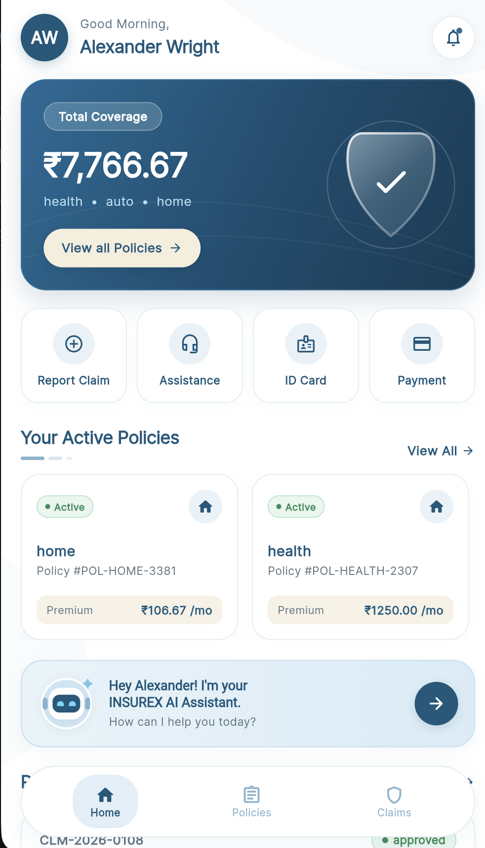
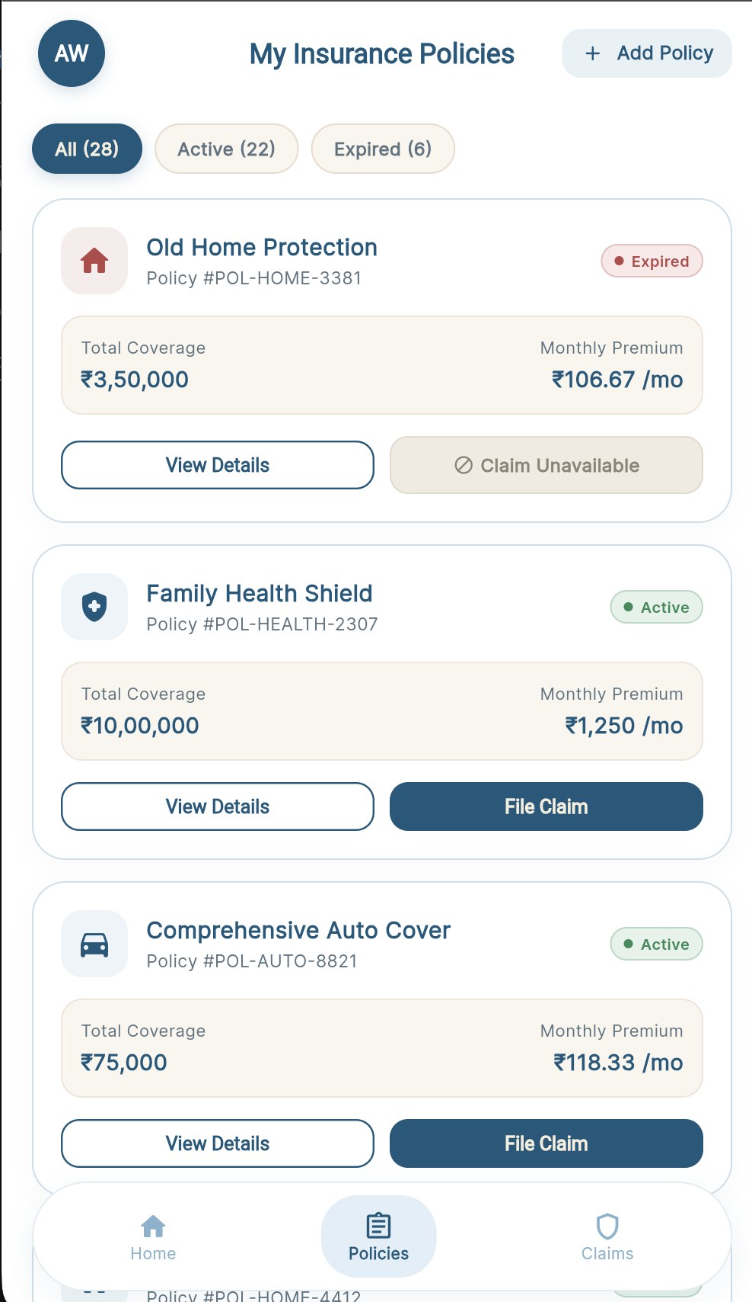 | 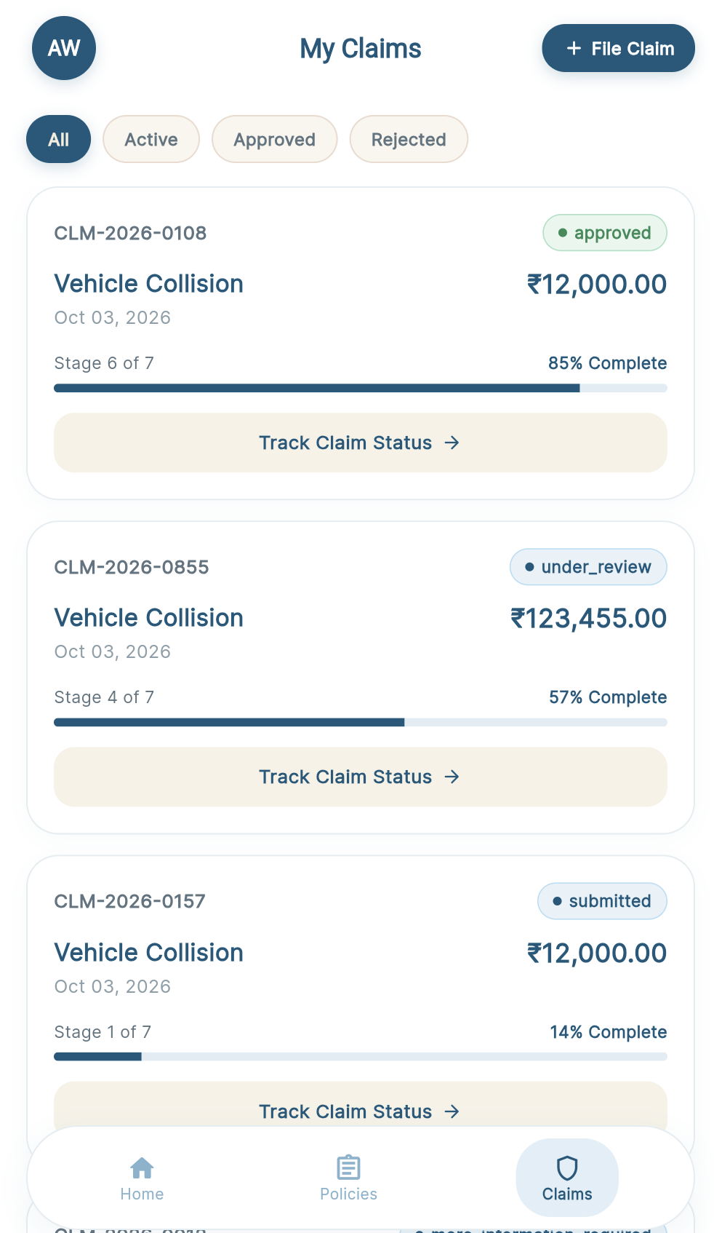
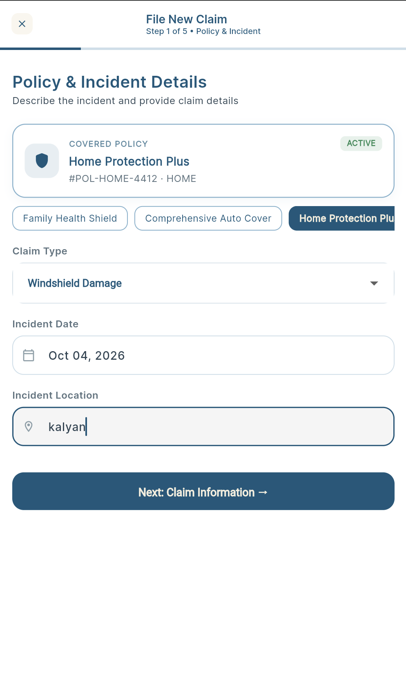 | 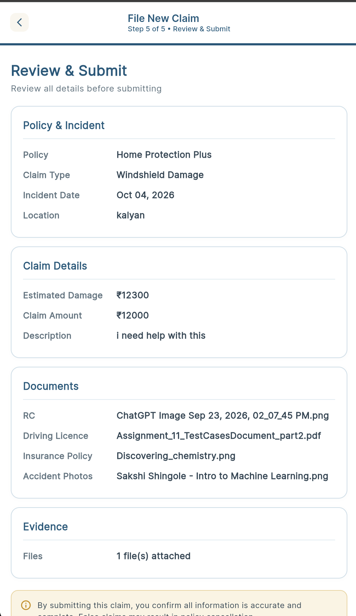
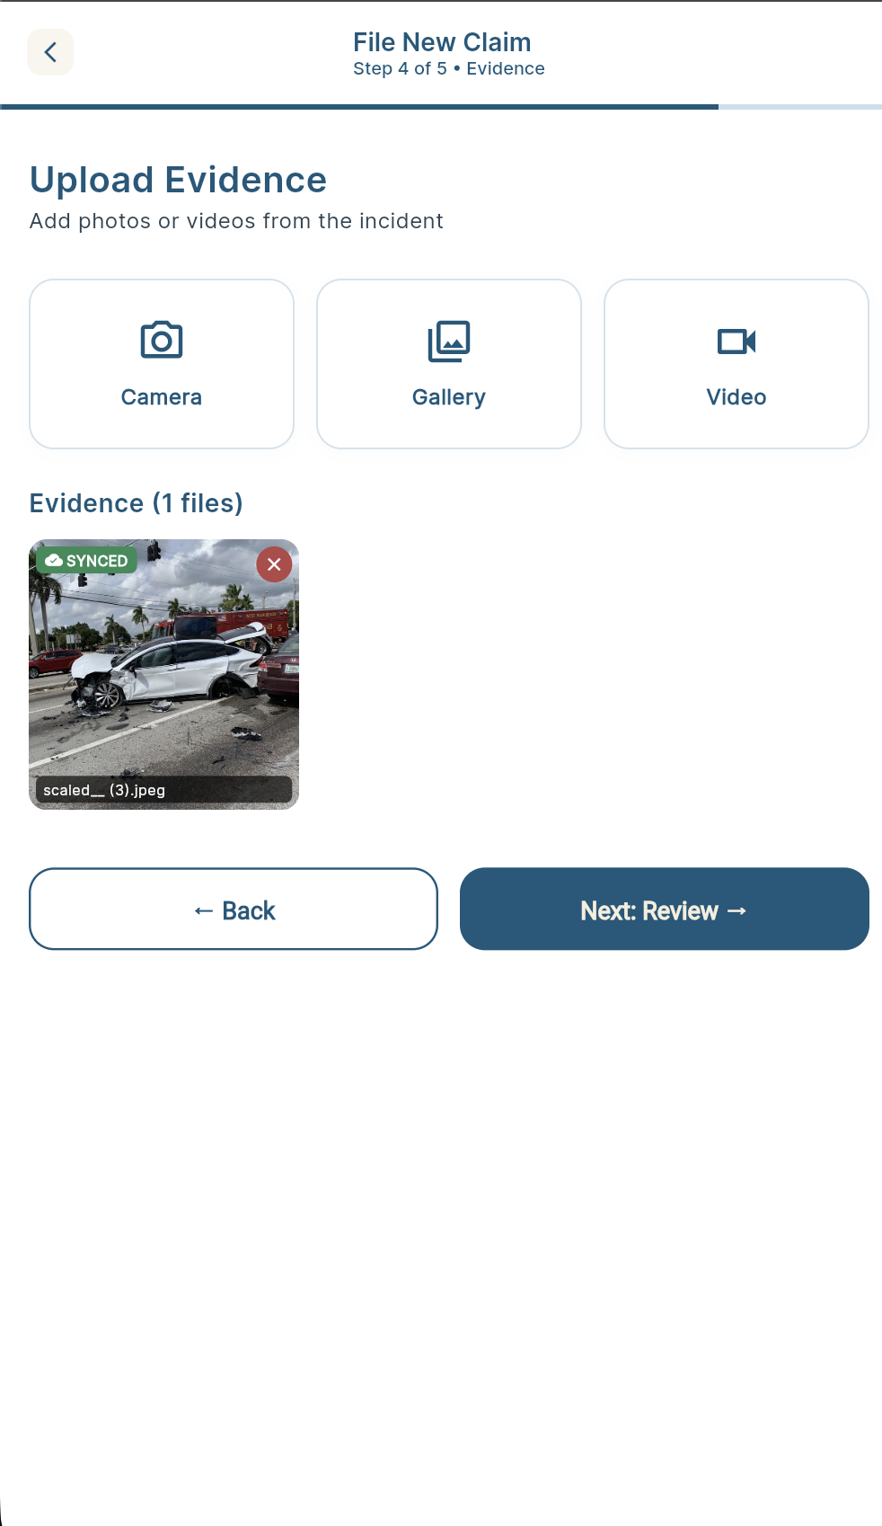 | 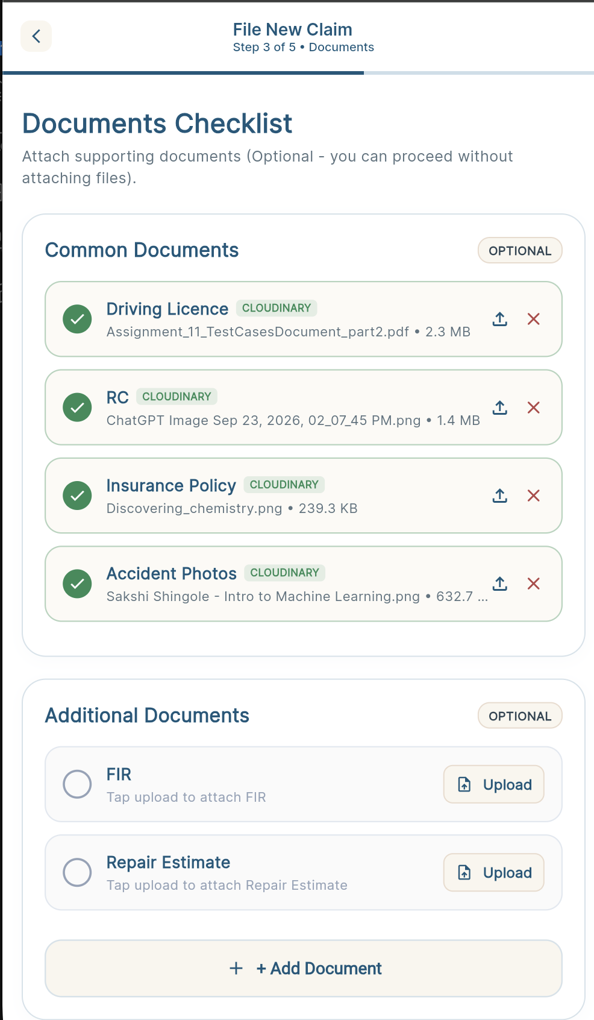
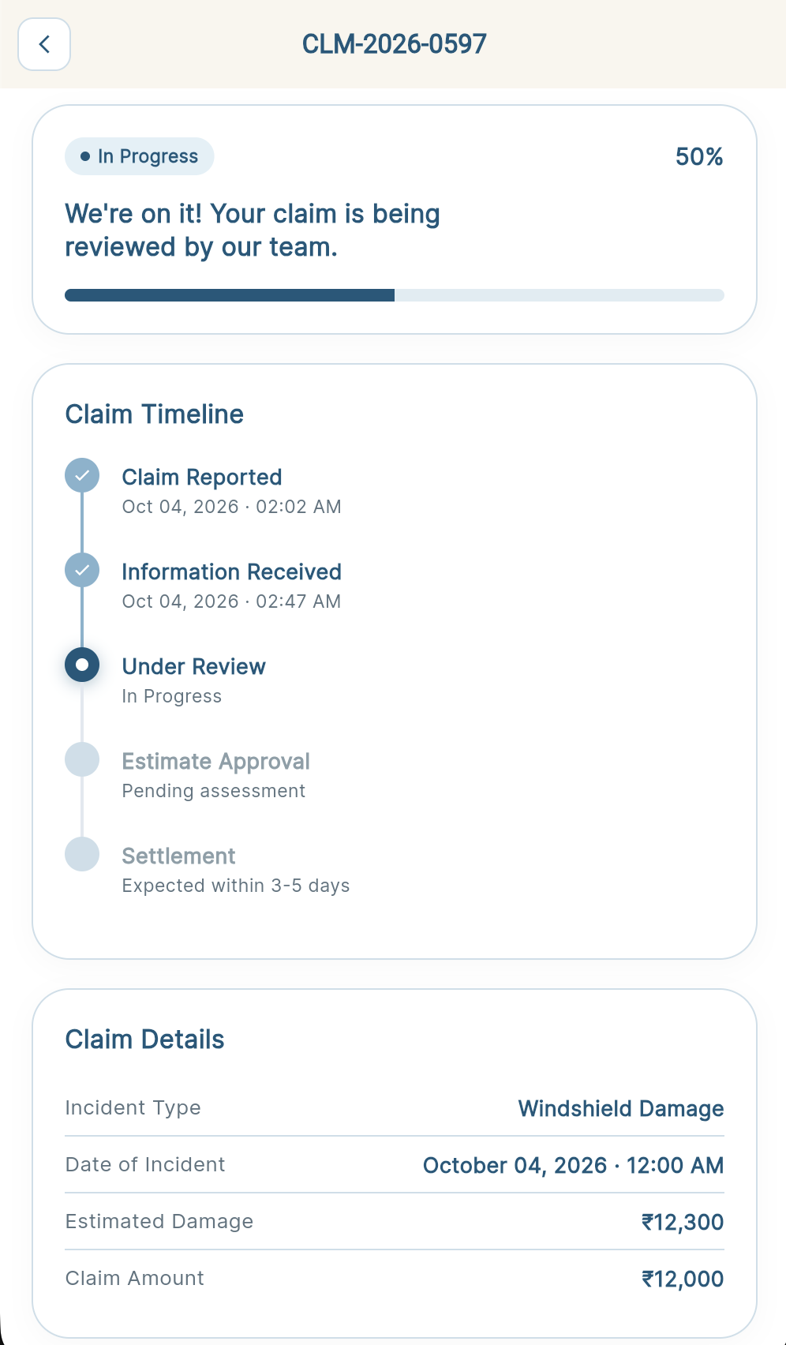

Officer

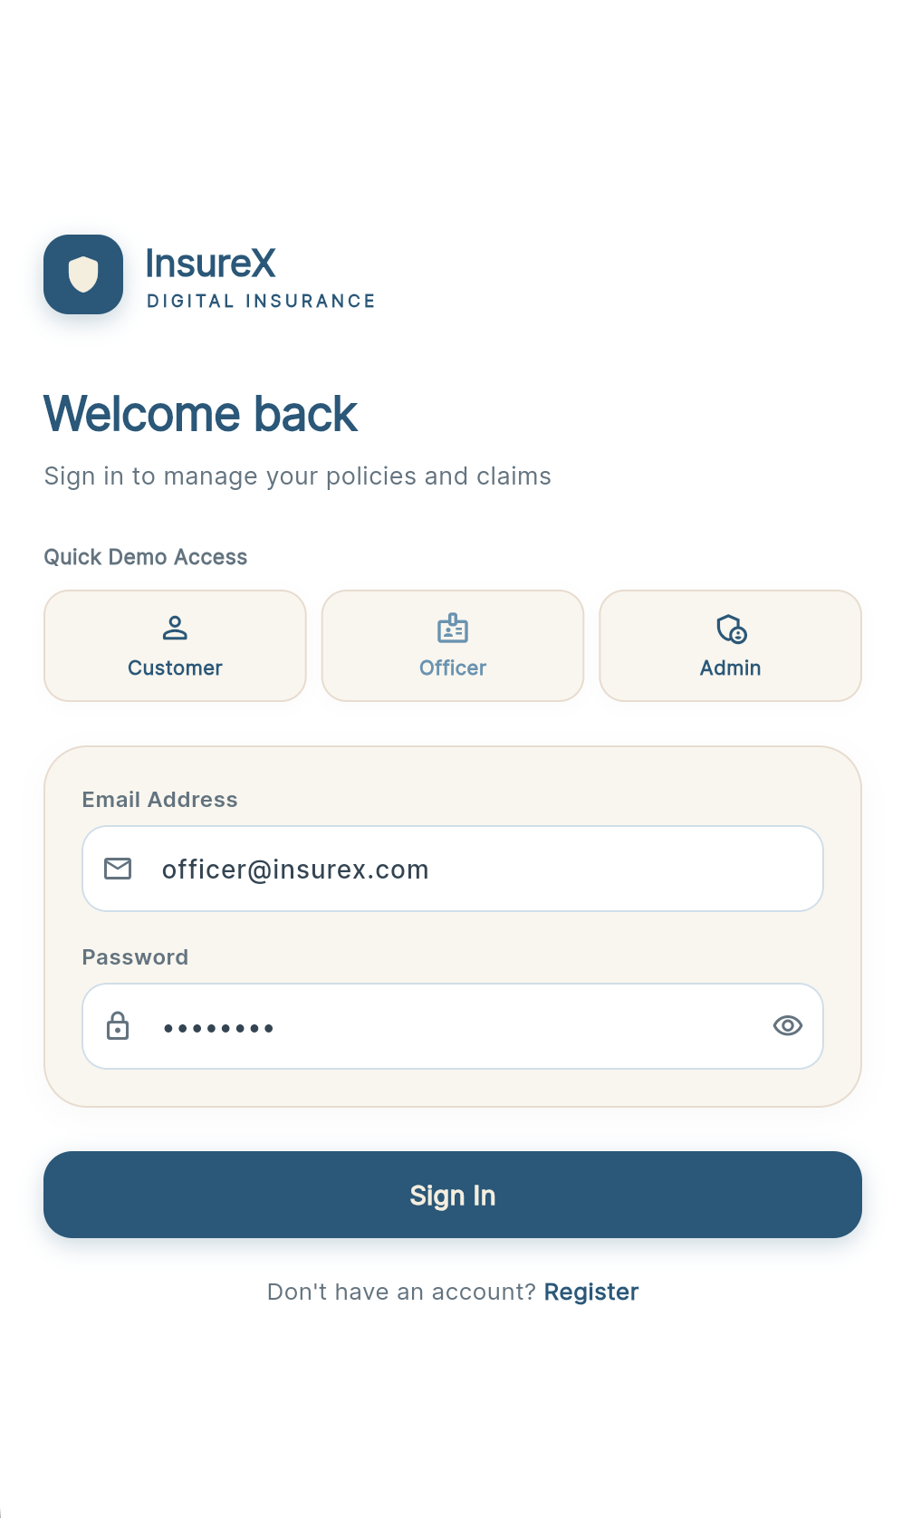 | 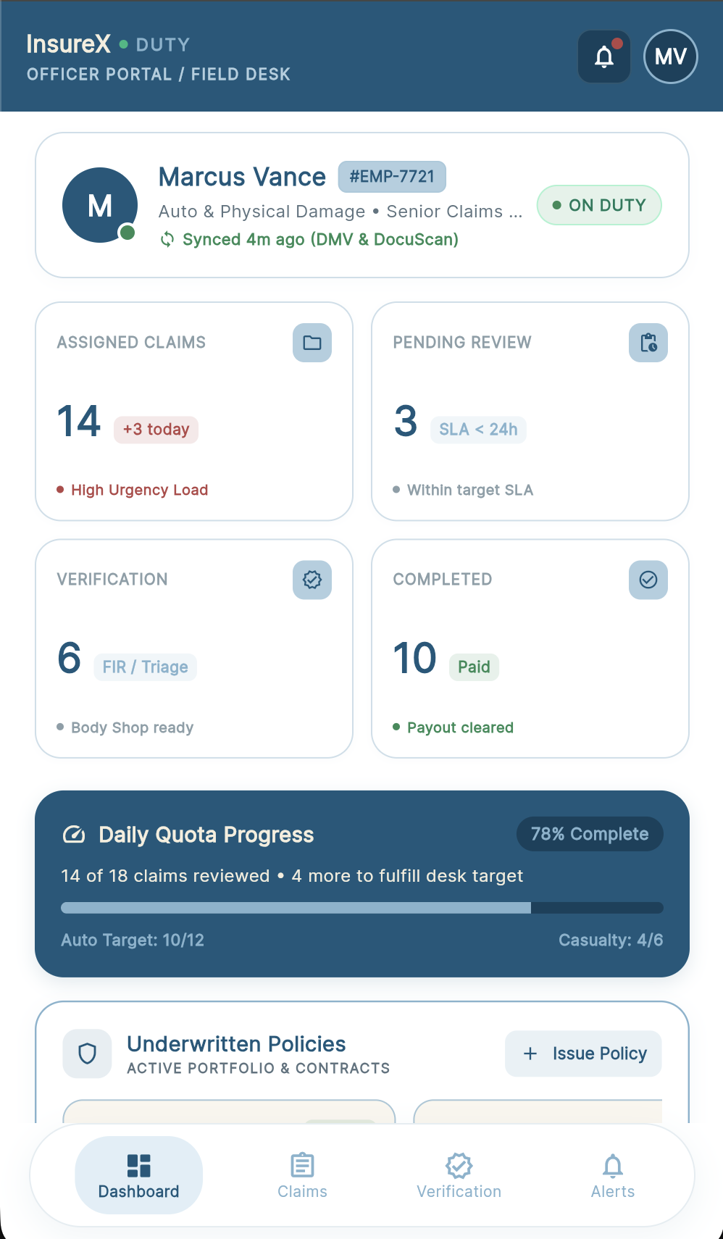
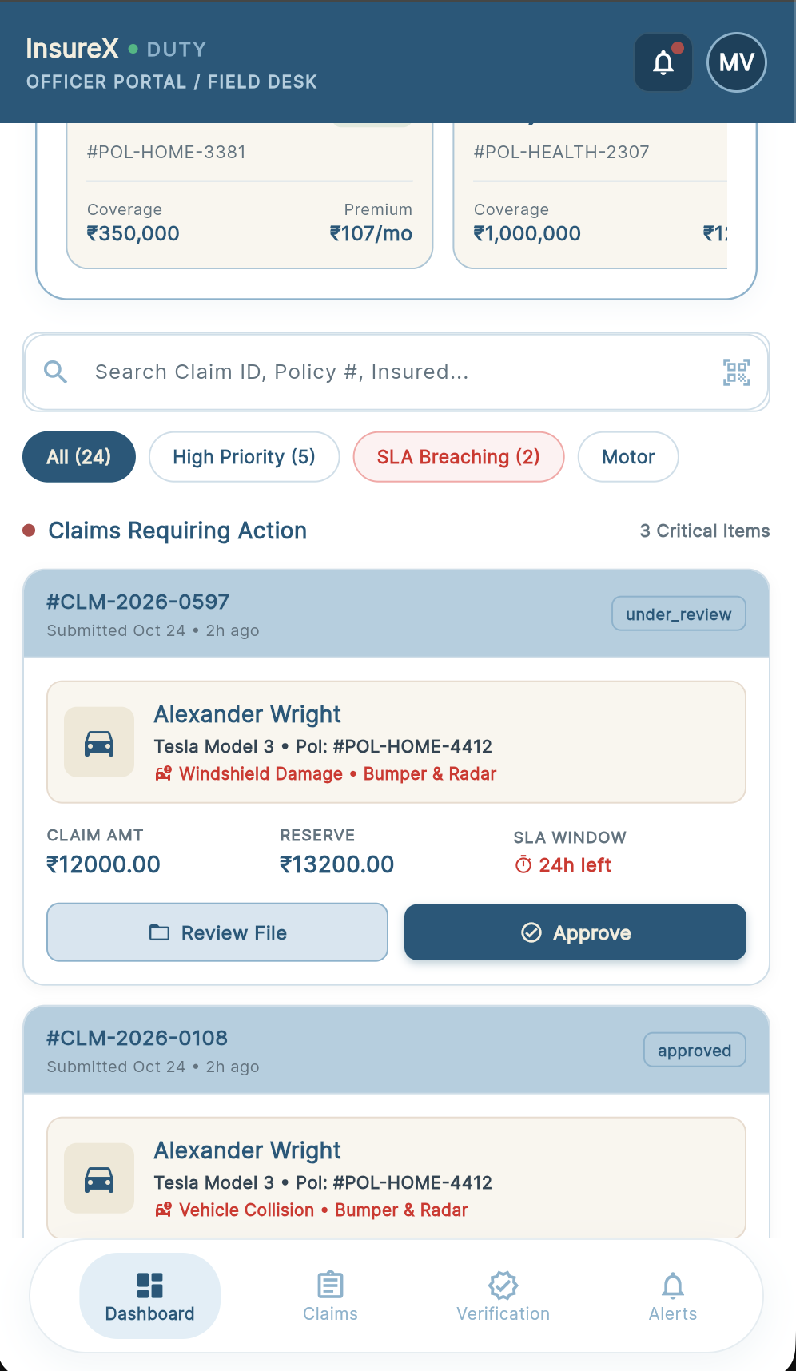 | 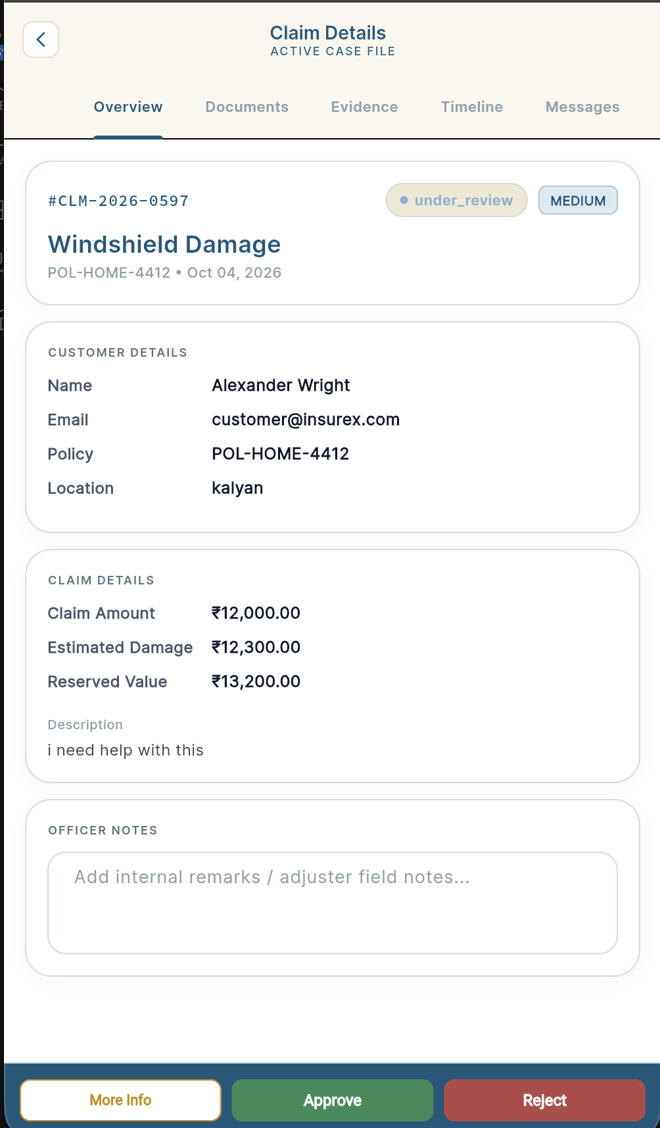
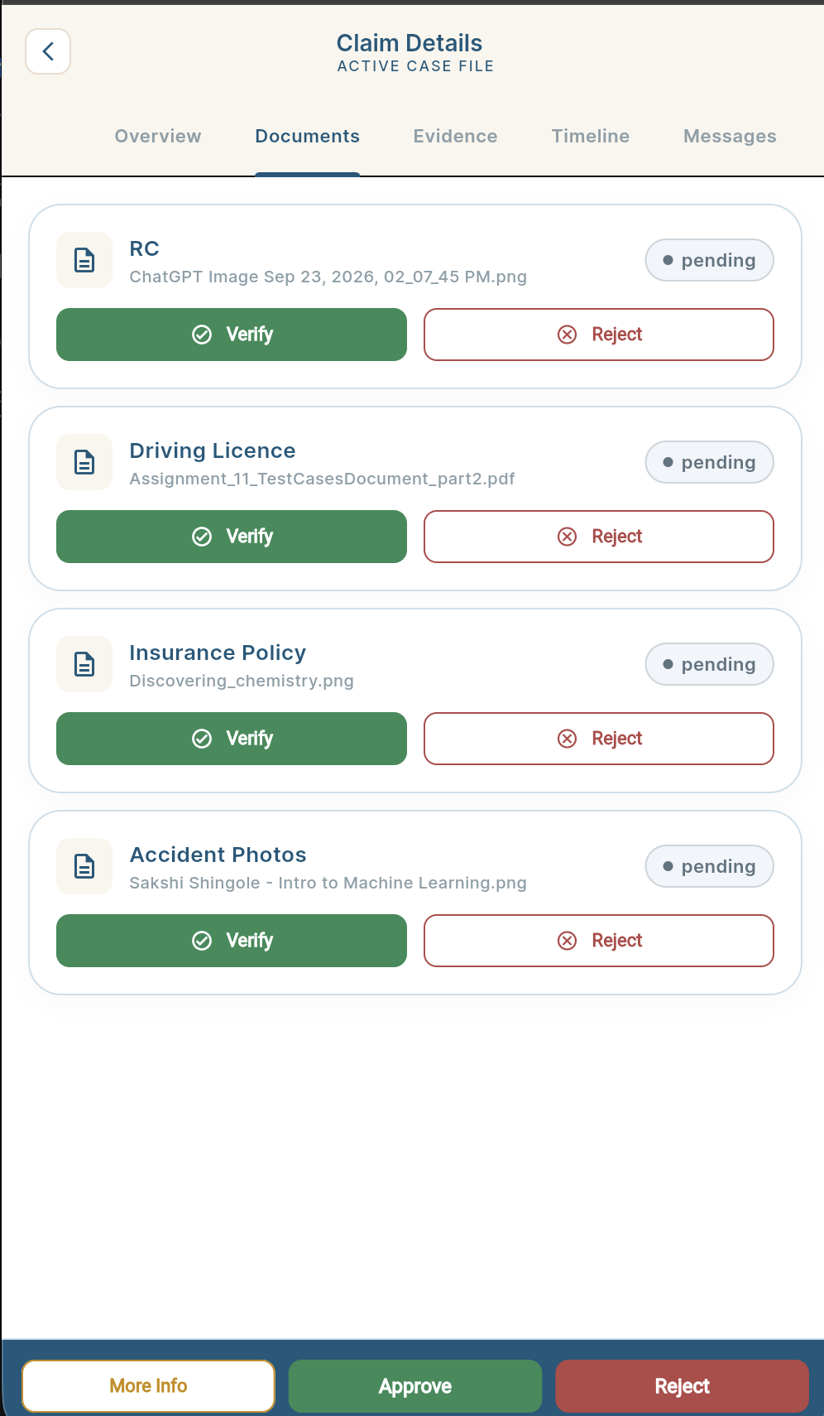 | 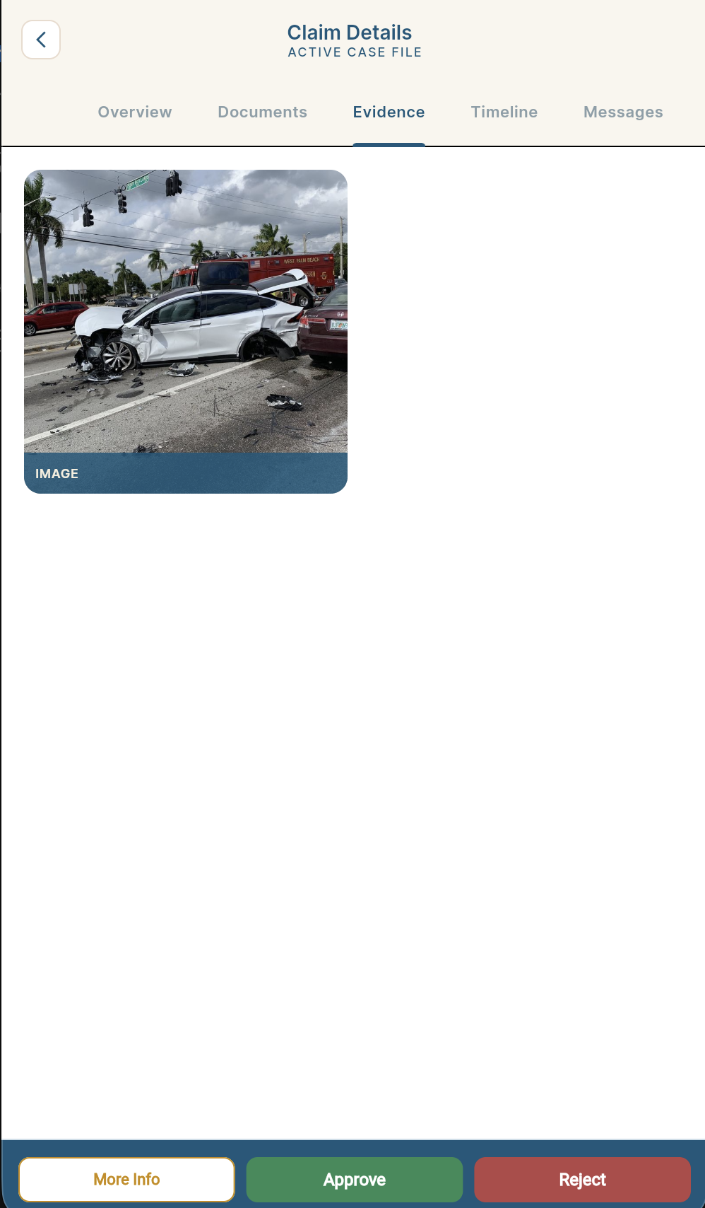
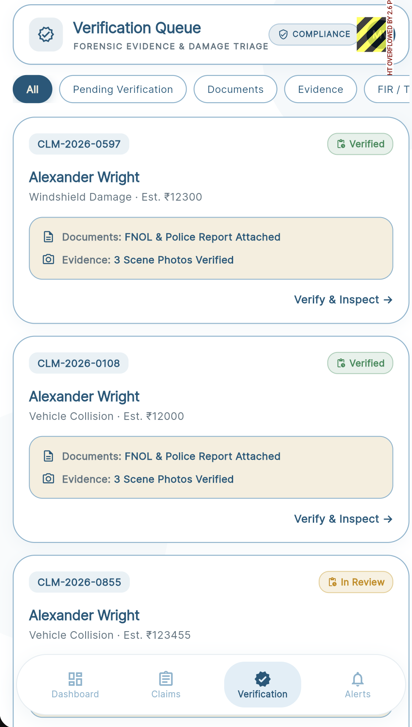 | 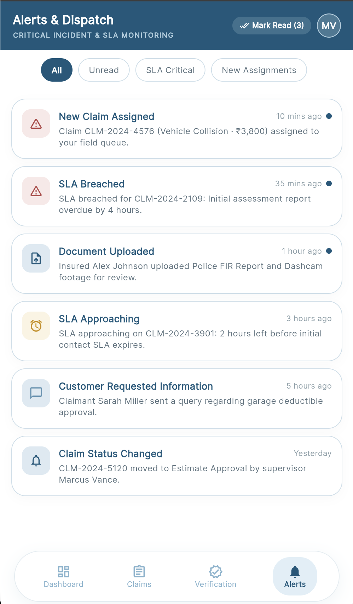

Admin

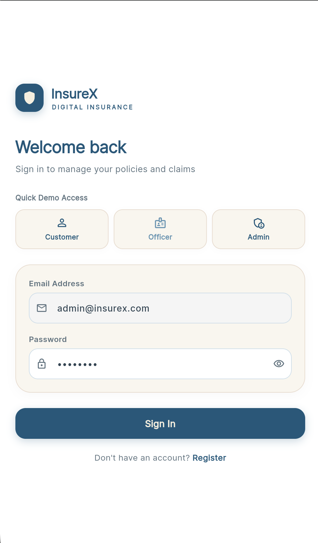 | 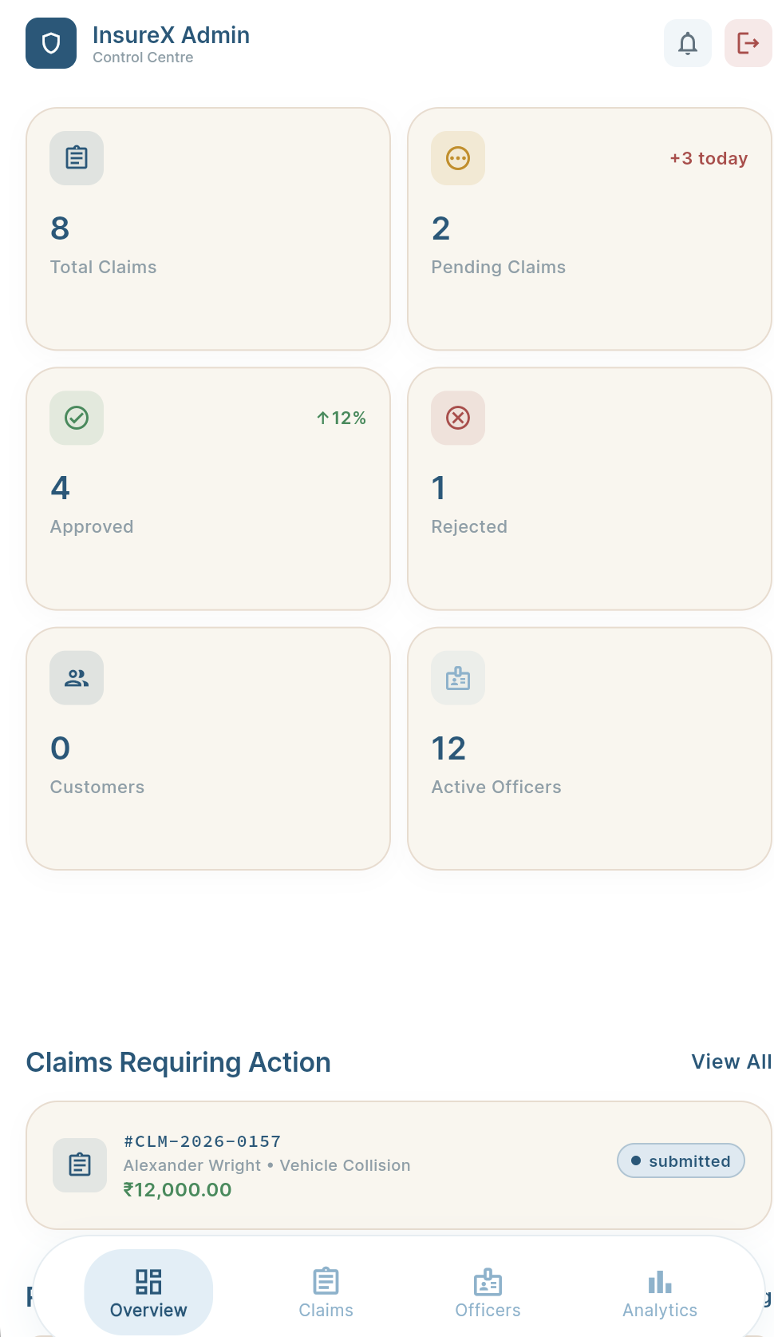
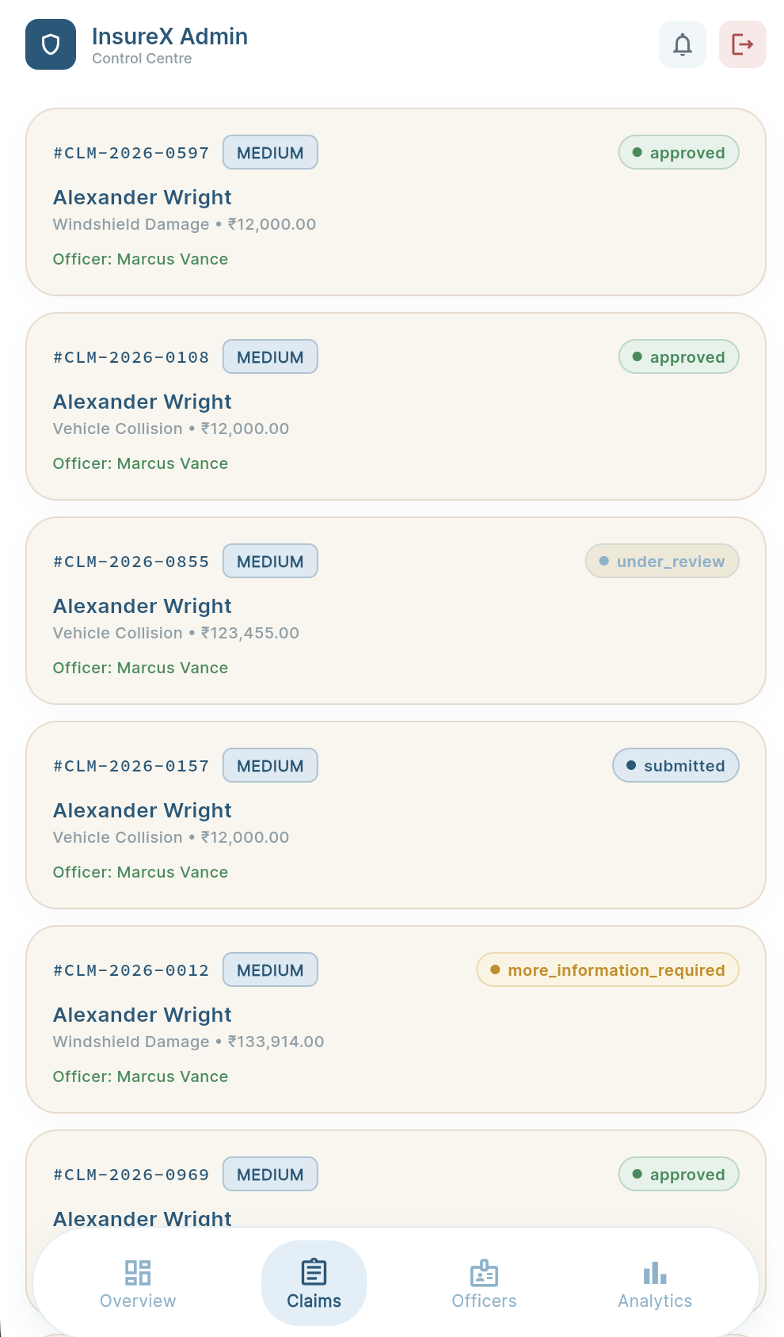 | 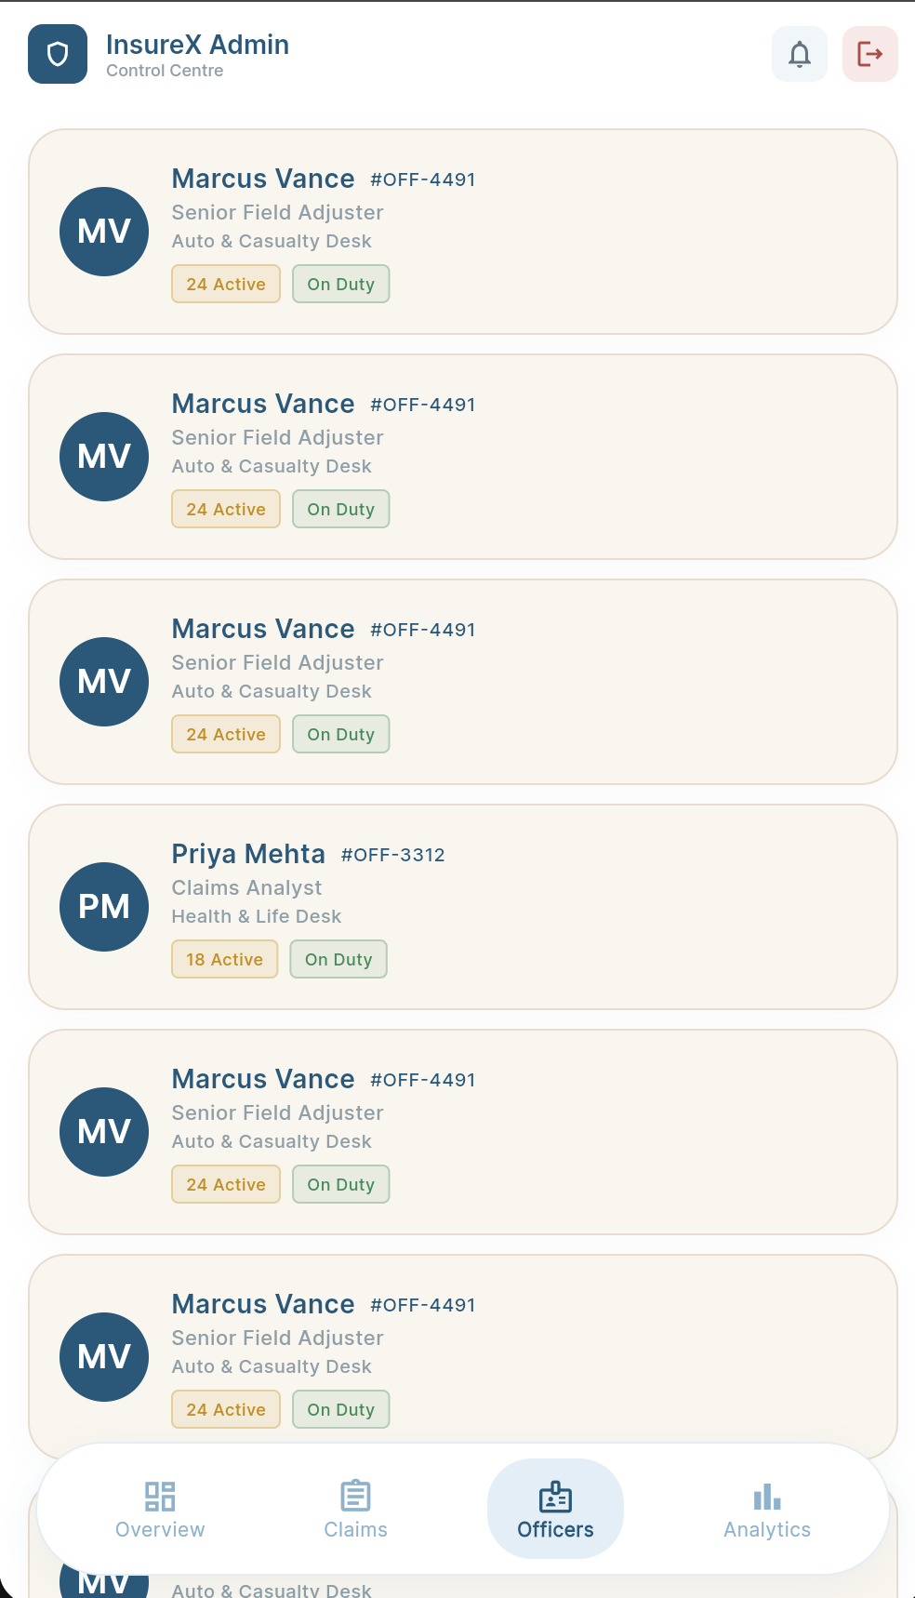
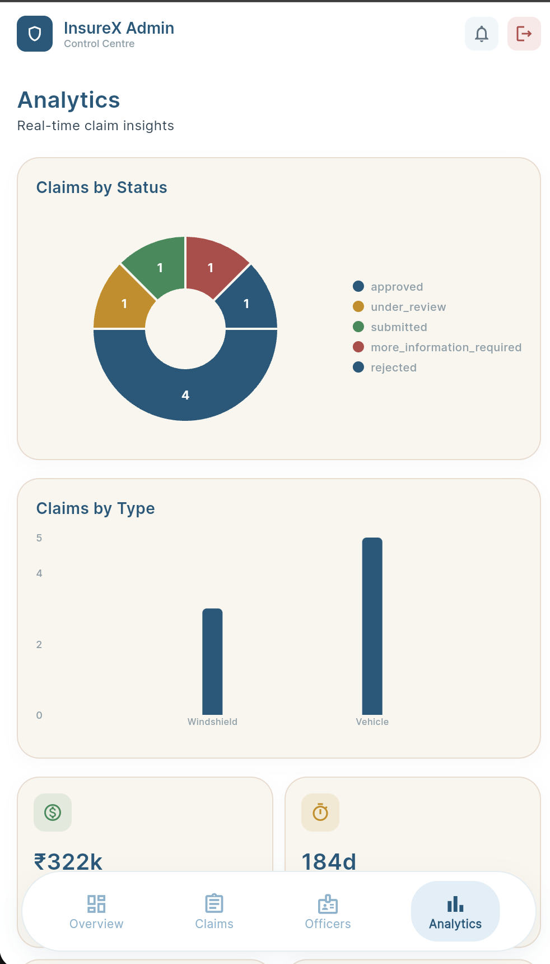

12. What Makes This Project Different?

1. End-to-End Claim Lifecycle
Your project doesn't stop at:
"Customer submits claim."
It covers:
Policy → Claim → Documents → Evidence → Verification → Officer Review → Communication → Decision → Completion
That makes it a complete claim-management workflow.

2. Customer + Officer + Admin in One System
Customer
↕
Officer
↕
Admin
Each role has different permissions and responsibilities.

3. Cloudinary-Based Evidence Management
Instead of simply storing a local file path, this application has a dedicated media workflow:
Flutter
↓
Cloudinary
↓
Secure URL
↓
Firestore Metadata
This allows the claim to retain its supporting evidence independently of the user's local device.

4. Policy-to-Claim Relationship
A claim isn't treated as an isolated form.
It is connected to:
Customer
↓
Policy
↓
Claim
↓
Documents
↓
Evidence
↓
Officer
This gives database a meaningful relational structure even though you're using Firestore.

5. Expired Policy Validation
Policies page now has realistic business logic.
For example:
Active Policy
File Claim → Available
Expired Policy
Claim Unavailable
This is a small feature, but it demonstrates that this application isn't simply displaying static UI.

6. Document Verification Workflow
The officer doesn't just see a claim.
They can specifically review the supporting documents and evidence and record verification status.
For example:
Uploaded
↓
Under Verification
↓
Verified / Requires Correction

7. "More Information Required" Workflow
This is particularly useful for demonstrating a real claim lifecycle.
Instead of immediately rejecting an incomplete claim:
Officer
↓
Requests Additional Information
↓
Customer receives notification
↓
Customer uploads missing document/evidence
↓
Officer continues verification
That creates an actual two-way workflow.

8. Claim-Centric Communication
Instead of having generic chat, communication can be associated with the specific claim.
For example:
Claim #CLM-1024
Officer requested vehicle repair estimate.
This keeps communication relevant to the claim.

9. Audit Trail
The system records important claim actions.
This gives you an additional accountability/transparency layer:
Who → Did What → On Which Claim → When
This is particularly useful to mention when explaining your Admin module.

