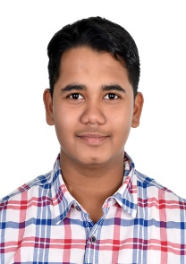 **Snehal Ray**

B.Tech – Mining Engineering- IIT(ISM), Dhanbad



**#** ​20JE0953 +91 7838833190 **@**20je0953@me.iitism.ac.in

# EDUCATION

* **IIT(ISM), Dhanbad —** B.Tech in Mining Engineering

December 2020 – May 2024(expected) **SGPA-9.45**

* **G.D Goenka Public School, Gurgaon**

**12th –** April 2019 – April 2020 – **96%**

**10th –** April 2017 – April 2018 – **95.6%**

# ACHIEVEMENTS

* **12K Rank** in JEE Advance, 2020 – Among 1.3 million candidates
* **97.56 Percentile** in JEE mains, 2020 – Among 1.3 million candidates
* **School Topper** in 10th and 12th
* **Selected** in final round for NSTSE

# SKILLS

* **Programming Language:** C
* **Scripting Languages:** HTML, CSS, JavaScript

# PROJECTS

**CYBERLABS GAMING WEBSITE**

* Sign in page with firebase Implementation
* Basic HTML and CSS in Main page
* Github Repo link: [GitHub - Snehal0102/Gamebase](https://github.com/Snehal0102/Gamebase)
* Website hosted at: <https://homebase-gamebase.000webhostapp.com/>

# POSITION OF REPONSIBILITY

* **Social Outreach secretary** of student council
* **House Captain** of student council

# EXTRACURRICULARS

* Participated in the **National round** of World school debating championship
* Qualified in **CBSE** national science exhibition -2019
* Participated in district level cricket championship in Haryana