Location

1. Ping Handler
Request
GET /location/ping
Content-Type: application/json
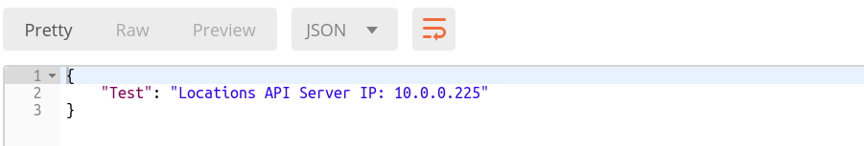

2. Get a Location by Zip code
Request
GET /location/zipcode/{zipcode}
Content-Type: application/json
Parameter | Type | Description
LocationName | string | Name of the location
LocationId | string | Unique ID assigned to every location
Zipcode | string | Zip code of the location
AddressLine1 | string | First line of address
AddressLine2 | string | Second line of address
City | string | City of the restaurant location
State | string | State of the restaurant location
Country | string | Country of the restaurant location
Phone | string | Phone of the restaurant
Email | string | email of the restaurant
Hours | string | The timings of the restaurant
AcceptedCards | string | The cards accepted at restaurant
Distance | string | Distance of the restaurant from current location

Response
Parameters for Success (Status code: 200)
Content-Type: application/json
Parameter | Type | Description
LocationName | string | Name of the location
LocationId | string | Unique ID assigned to every location
Zipcode | string | Zip code of the location
AddressLine1 | string | First line of address
AddressLine2 | string | Second line of address
City | string | City of the restaurant location
State | string | State of the restaurant location
Country | string | Country of the restaurant location
Phone | string | Phone of the restaurant
Email | string | email of the restaurant
Hours | string | The timings of the restaurant
AcceptedCards | string | The cards accepted at restaurant
Distance | string | Distance of the restaurant from current location

Parameters for Error (Status code: 404)
Parameter | Type | Description
message | string | Error message

