1.Develop a program to perform addition of two matrices.

#include<stdio.h>

int main()

{

int r,c,i,j,a[10][10],b[10][10],sum[10][10];

printf("Enter the number of rows: ");

scanf("%d",&r);

printf("Enter the number of columns: ");

scanf("%d",&c);

printf("\nEnter the elements of first matrix:\n");

for(i=0;i<r;i++)

for(j=0;j<c;j++)

scanf("%d",&a[i][j]);

printf("Enter the elements of second matrix:\n");

for(i=0;i<r;i++)

for(j=0;j<c;j++)

scanf("%d",&b[i][j]);

printf("Addition of matrices:\n");

for(i=0;i<r;i++)

{

for(j=0;j<c;j++)

{

sum[i][j]=a[i][j]+b[i][j];

printf("%4d",sum[i][j]);

}

printf("\n");

}

return 0;

}

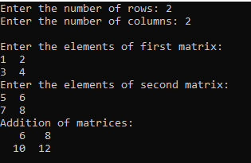

2. Program to read a 2D array of marks which stores marks of 4 students in 3 subjects

and display the highest marks in each subject.

#include<stdio.h>

void main()

{

int i,j,max_marks,marks[4][3];

for(i=0;i<4;i++)

{

printf("Enter the marks obtained by student %d",i+1);

for(j=0;j<3;j++)

{

printf("\nmarks[%d][%d]=",i,j);

scanf("%d",&marks[i][j]);

}

}

for(j=0;j<3;j++)

{

max_marks=marks[0][j];

for(i=1;i<4;i++)

{

if(marks[i][j]>max_marks)

max_marks=marks[i][j];

}

printf("\nThe highest marks obtained in the subject %d=%d\n",j+1,max_marks);

}

}

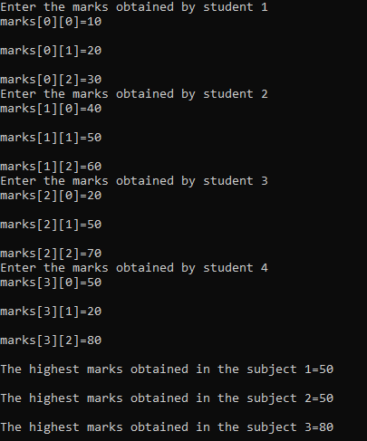

3.Develop a program to print the transpose of matrix.

#include<stdio.h>

void main()

{

int r,c,i,j,a[10][10],transpose[10][10];

printf("Enter the number of rows: ");

scanf("%d",&r);

printf("Enter the number of columns: ");

scanf("%d",&c);

printf("Enter the elements of matrix:\n");

for(i=0;i<r;i++)

for(j=0;j<c;j++)

scanf("%d",&a[i][j]);

for(i=0;i<r;i++)

for(j=0;j<c;j++)

transpose[j][i]=a[i][j];

printf("Transpose of the matrix:\n");

for(i=0;i<c;i++)

{

for(j=0;j<r;j++)

printf("%4d",transpose[i][j]);

printf("\n");

}

}