LAB-1::

TABLES(QUERY)

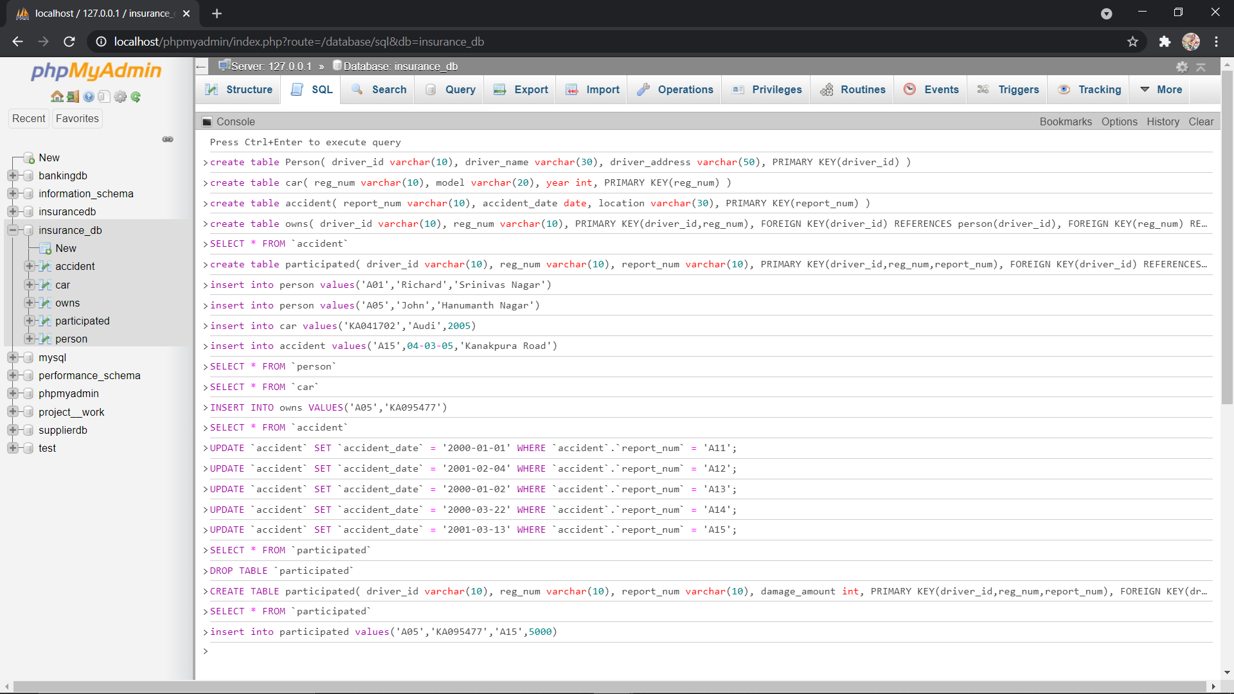

PERSON TABLE:-

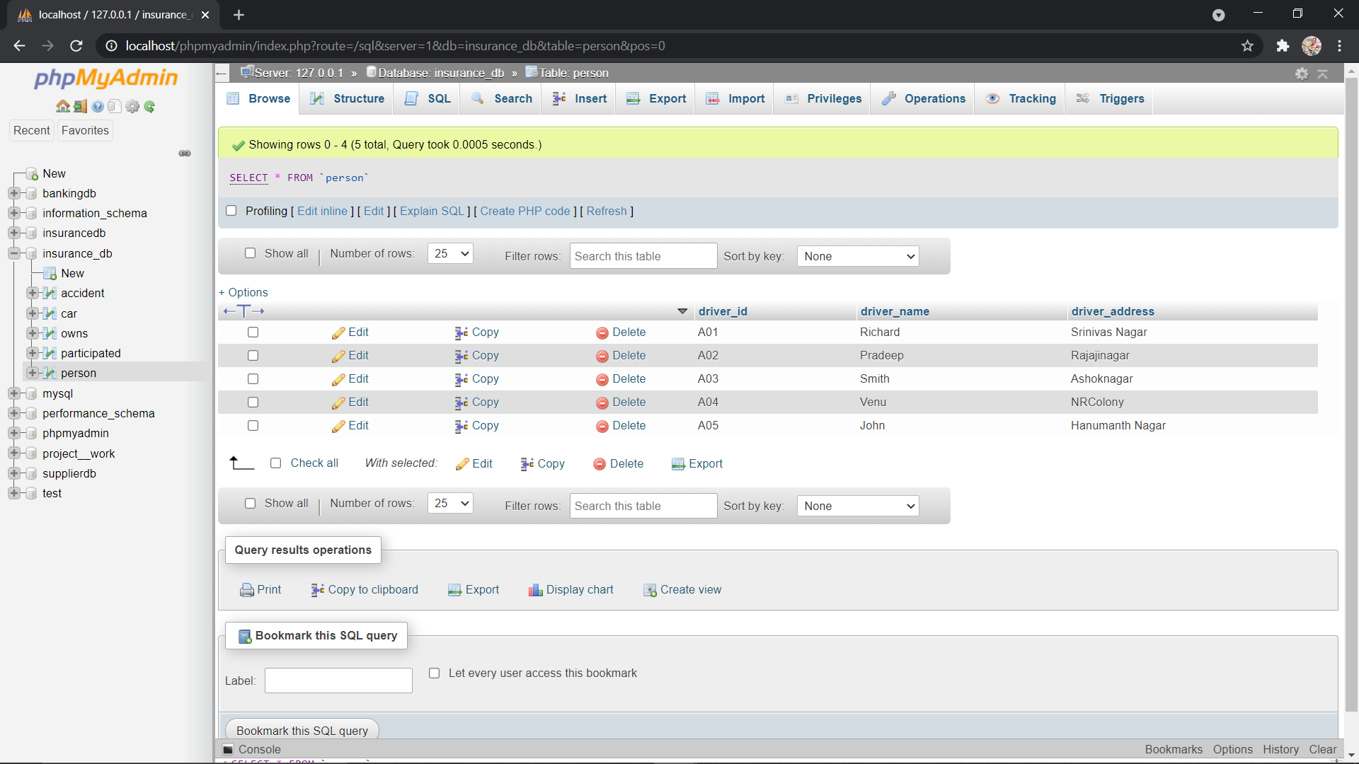

CAR TABLE:-

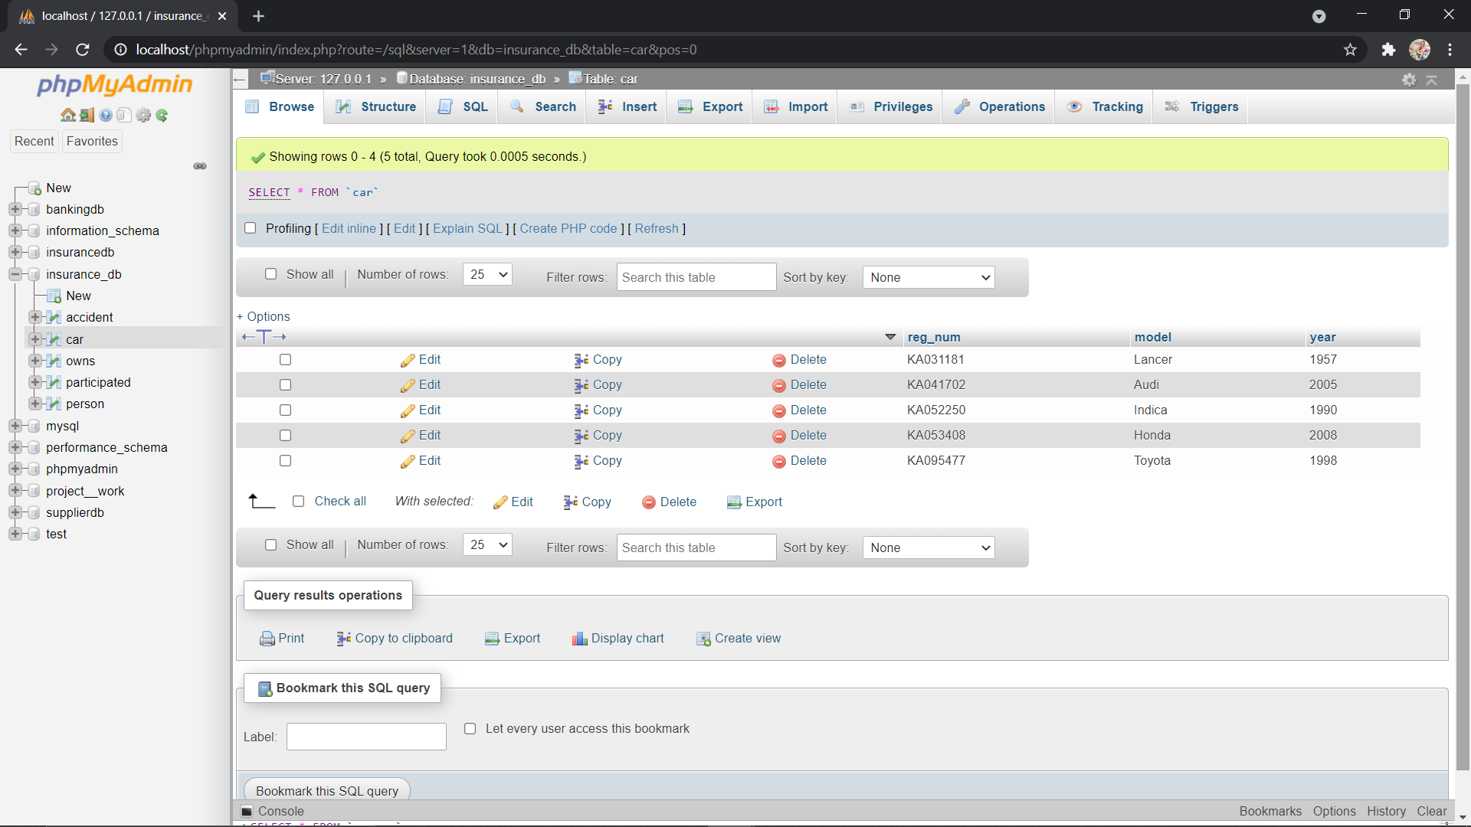

ACCIDENT TABLE:-

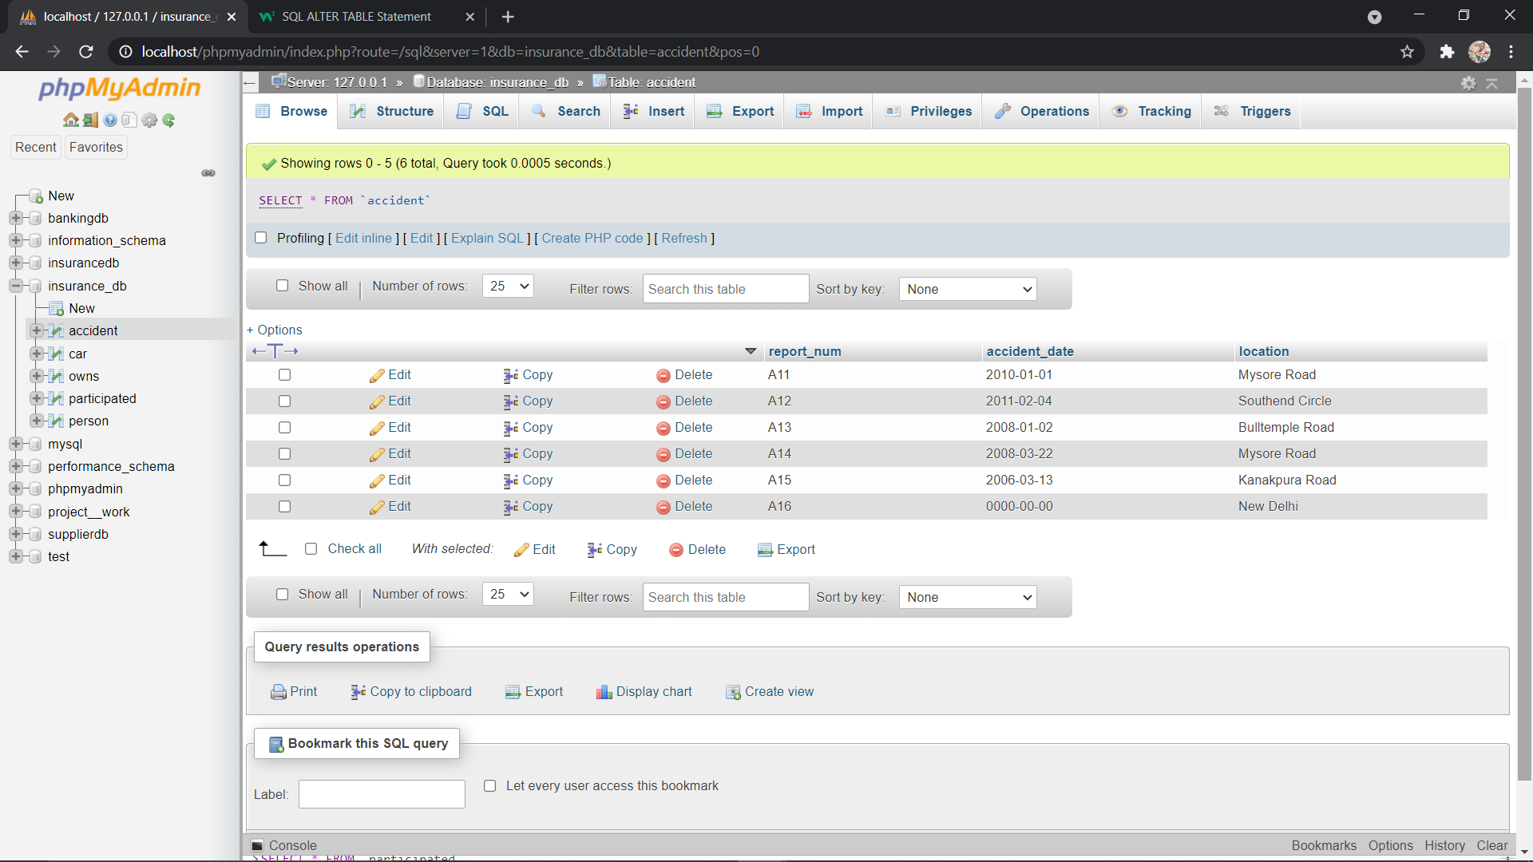

OWNS TABLE:-

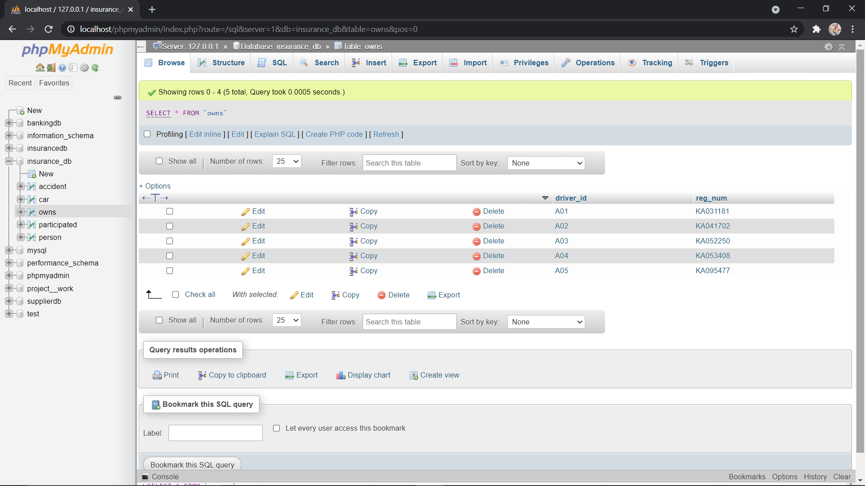

PARTICIPATED TABLE:-

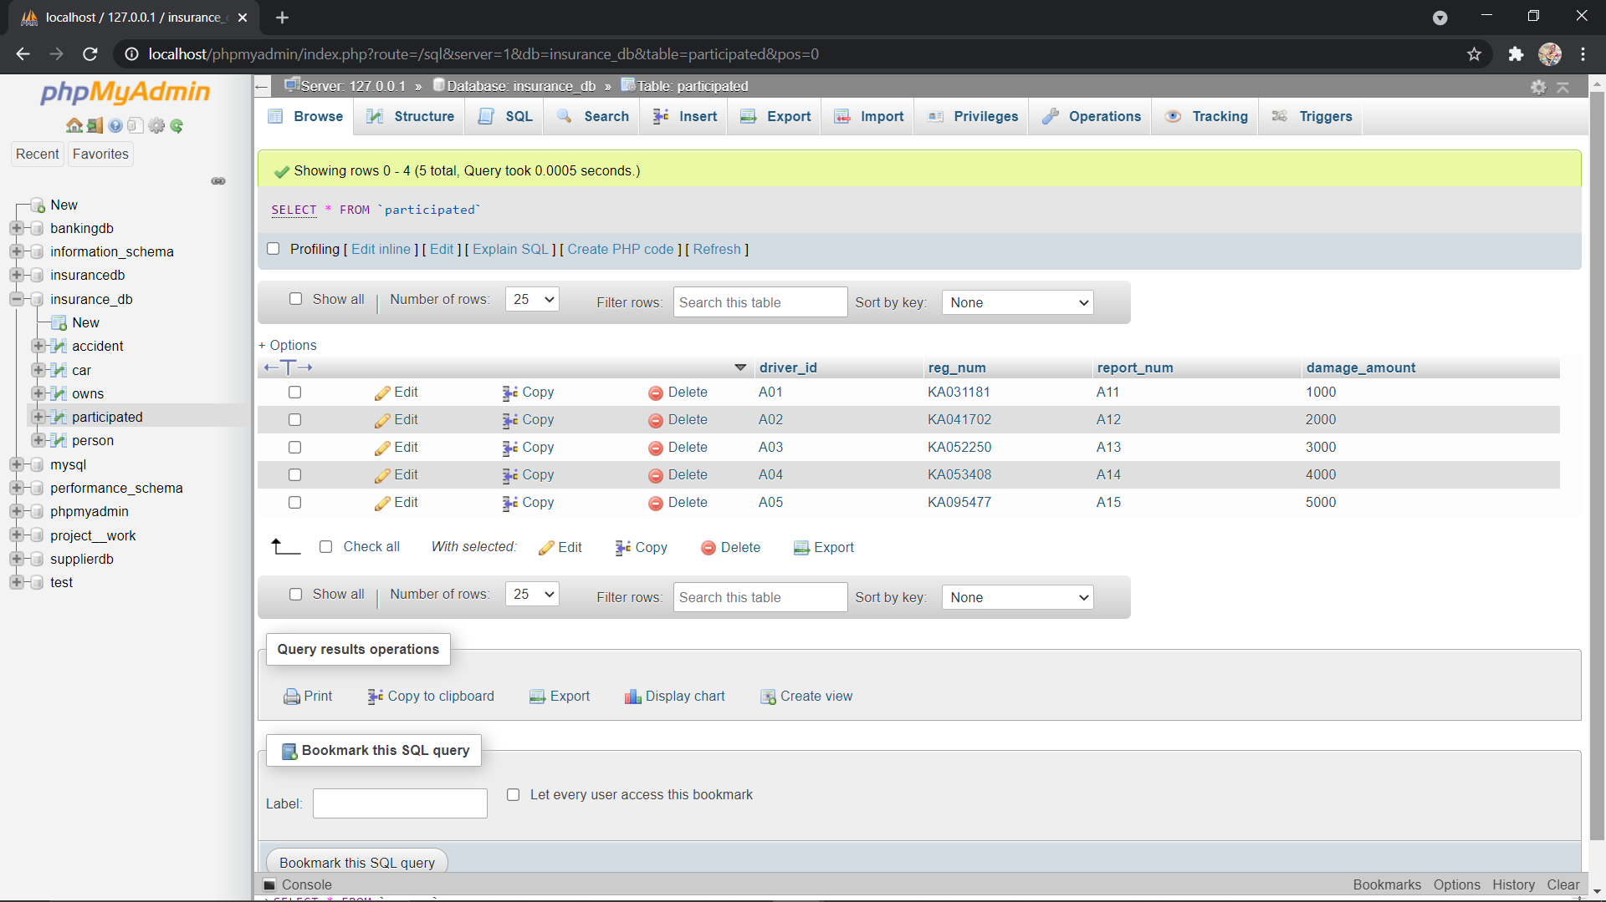

Demonstrate how you

a. Update the damage amount to 25000 for the car with a specific reg-num(example 'K A053408') for which the accident report number was 12.

b. Add a new accident to the database.

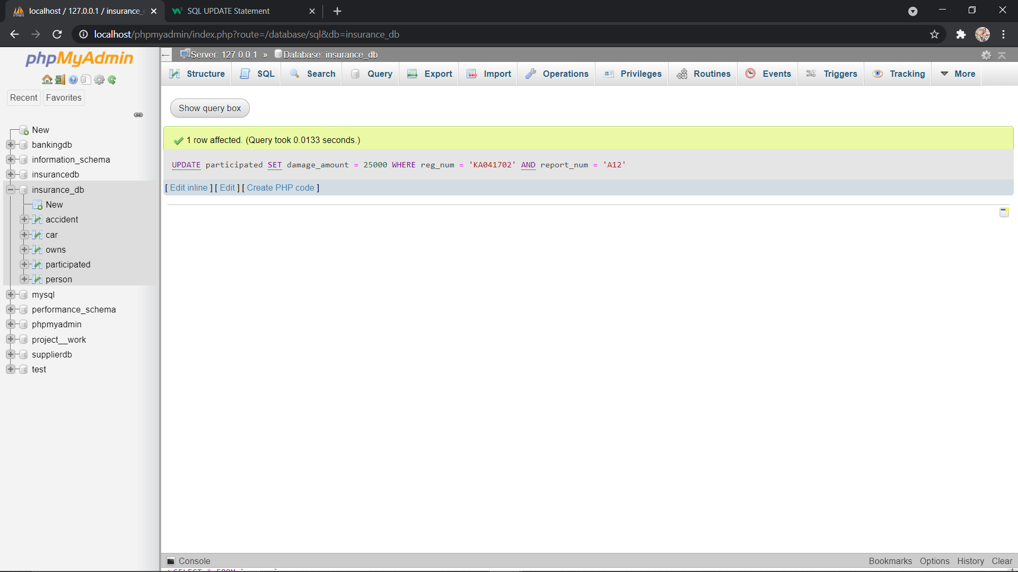

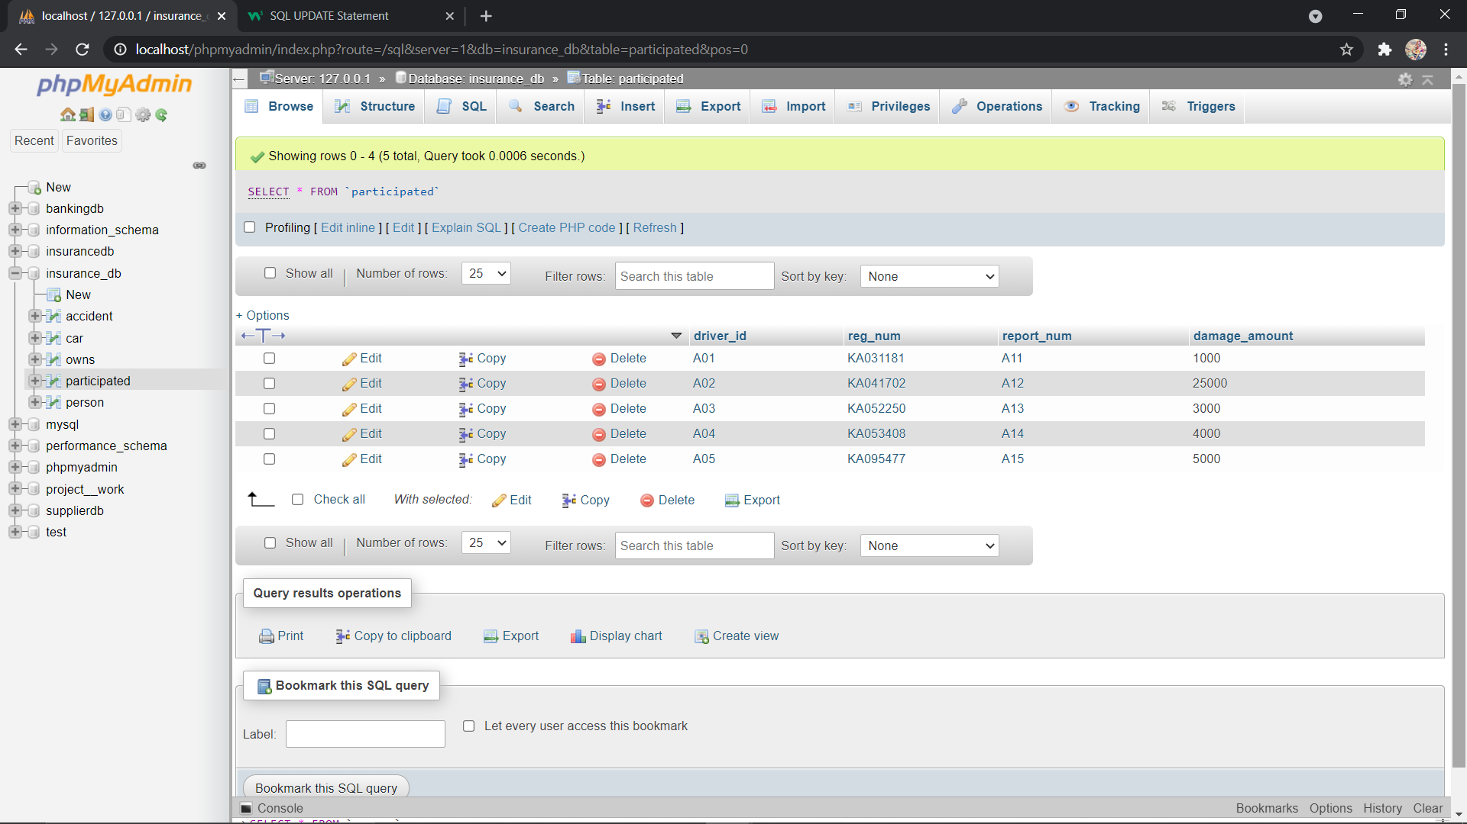

B.

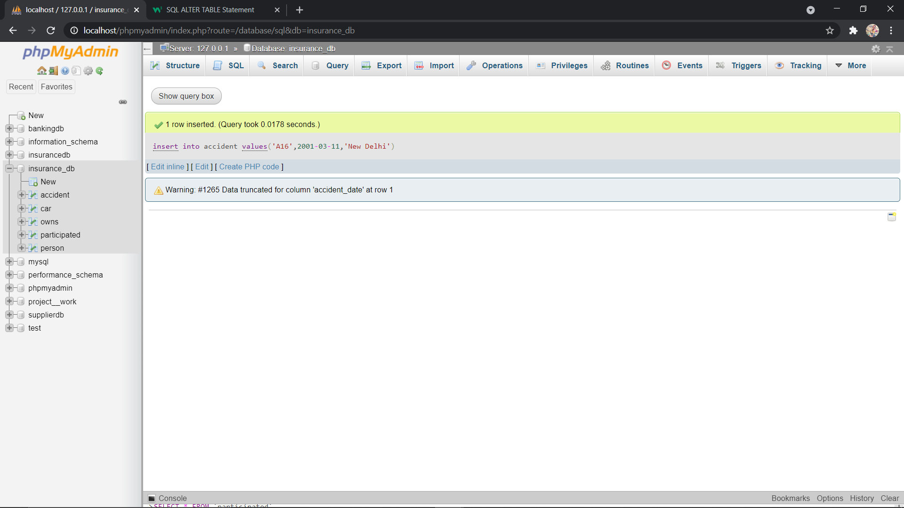

Find the total number of people who owned cars that involved in accidents in 2008.

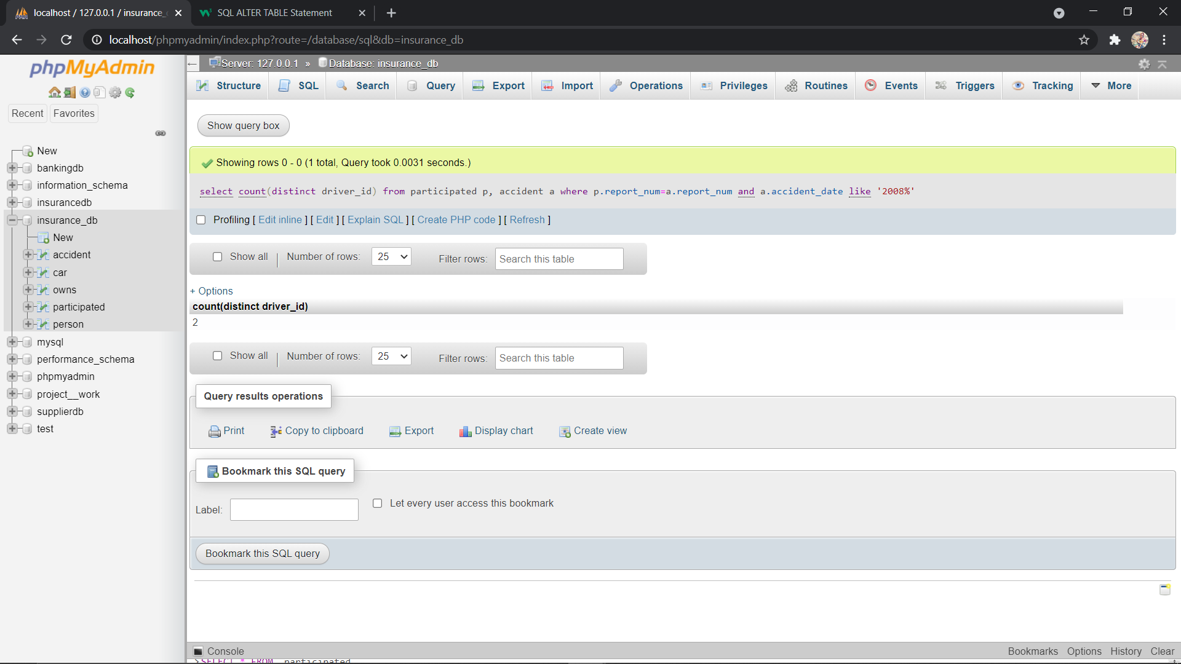

Find the number of accidents in which cars belonging to a specific model (example )were involved.

