LAB-2:-

BANKING DATABASE:-

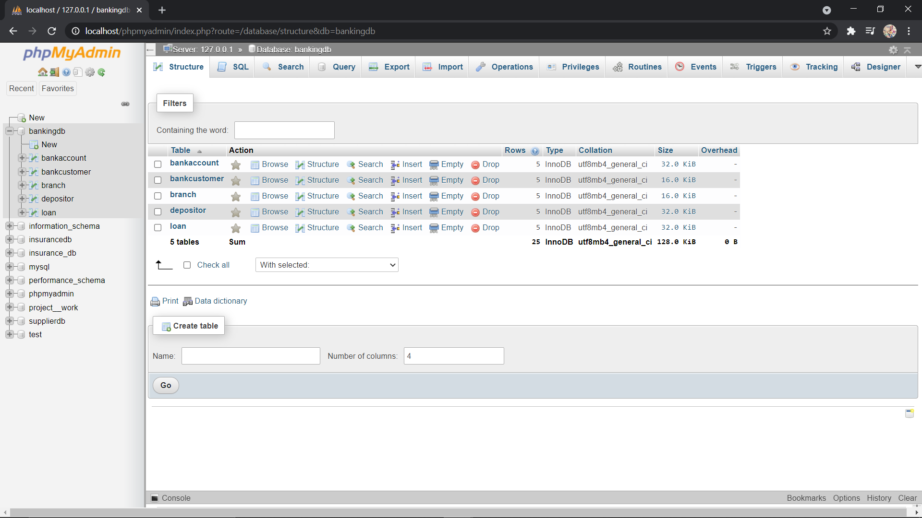

BRANCH TABLE:-

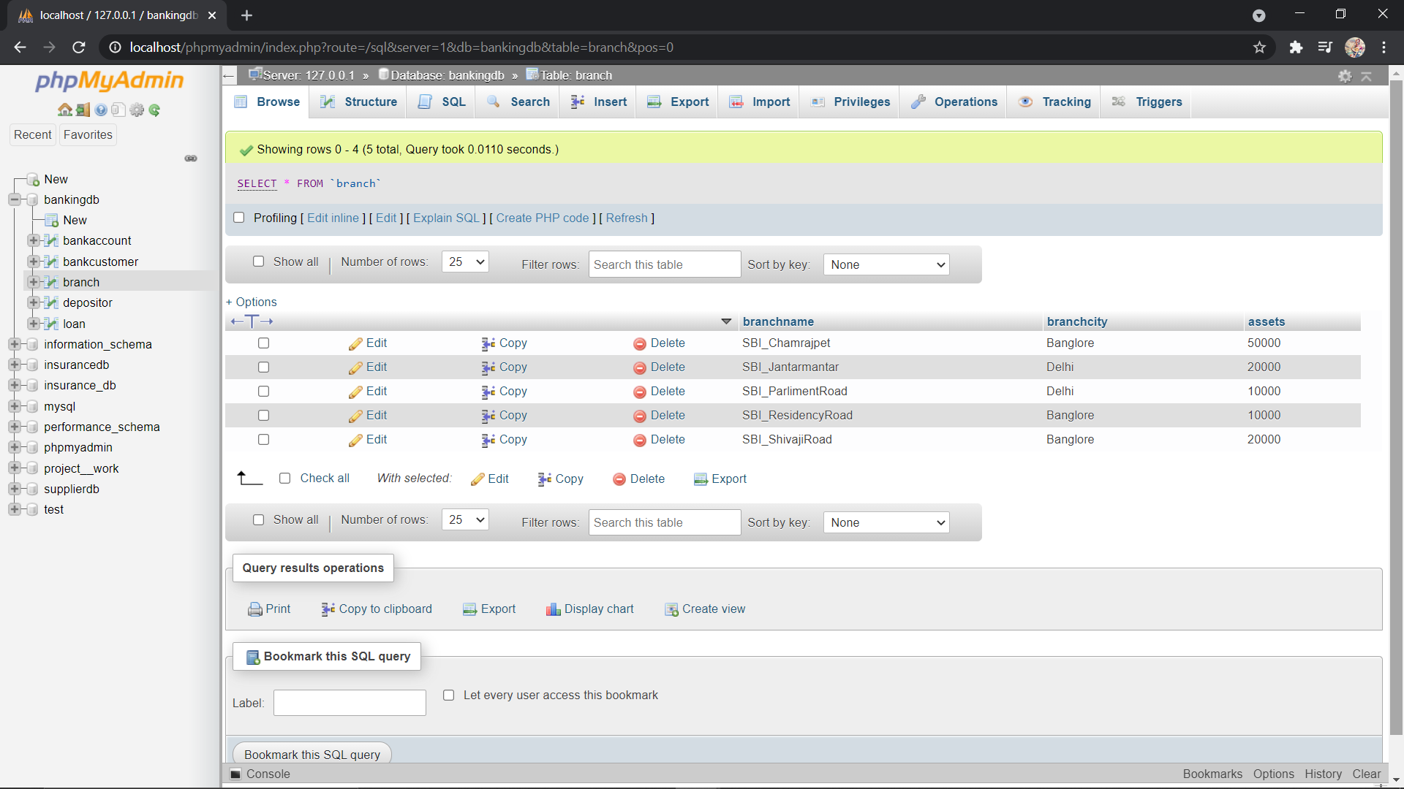

BANK ACCOUNT TABLE:-

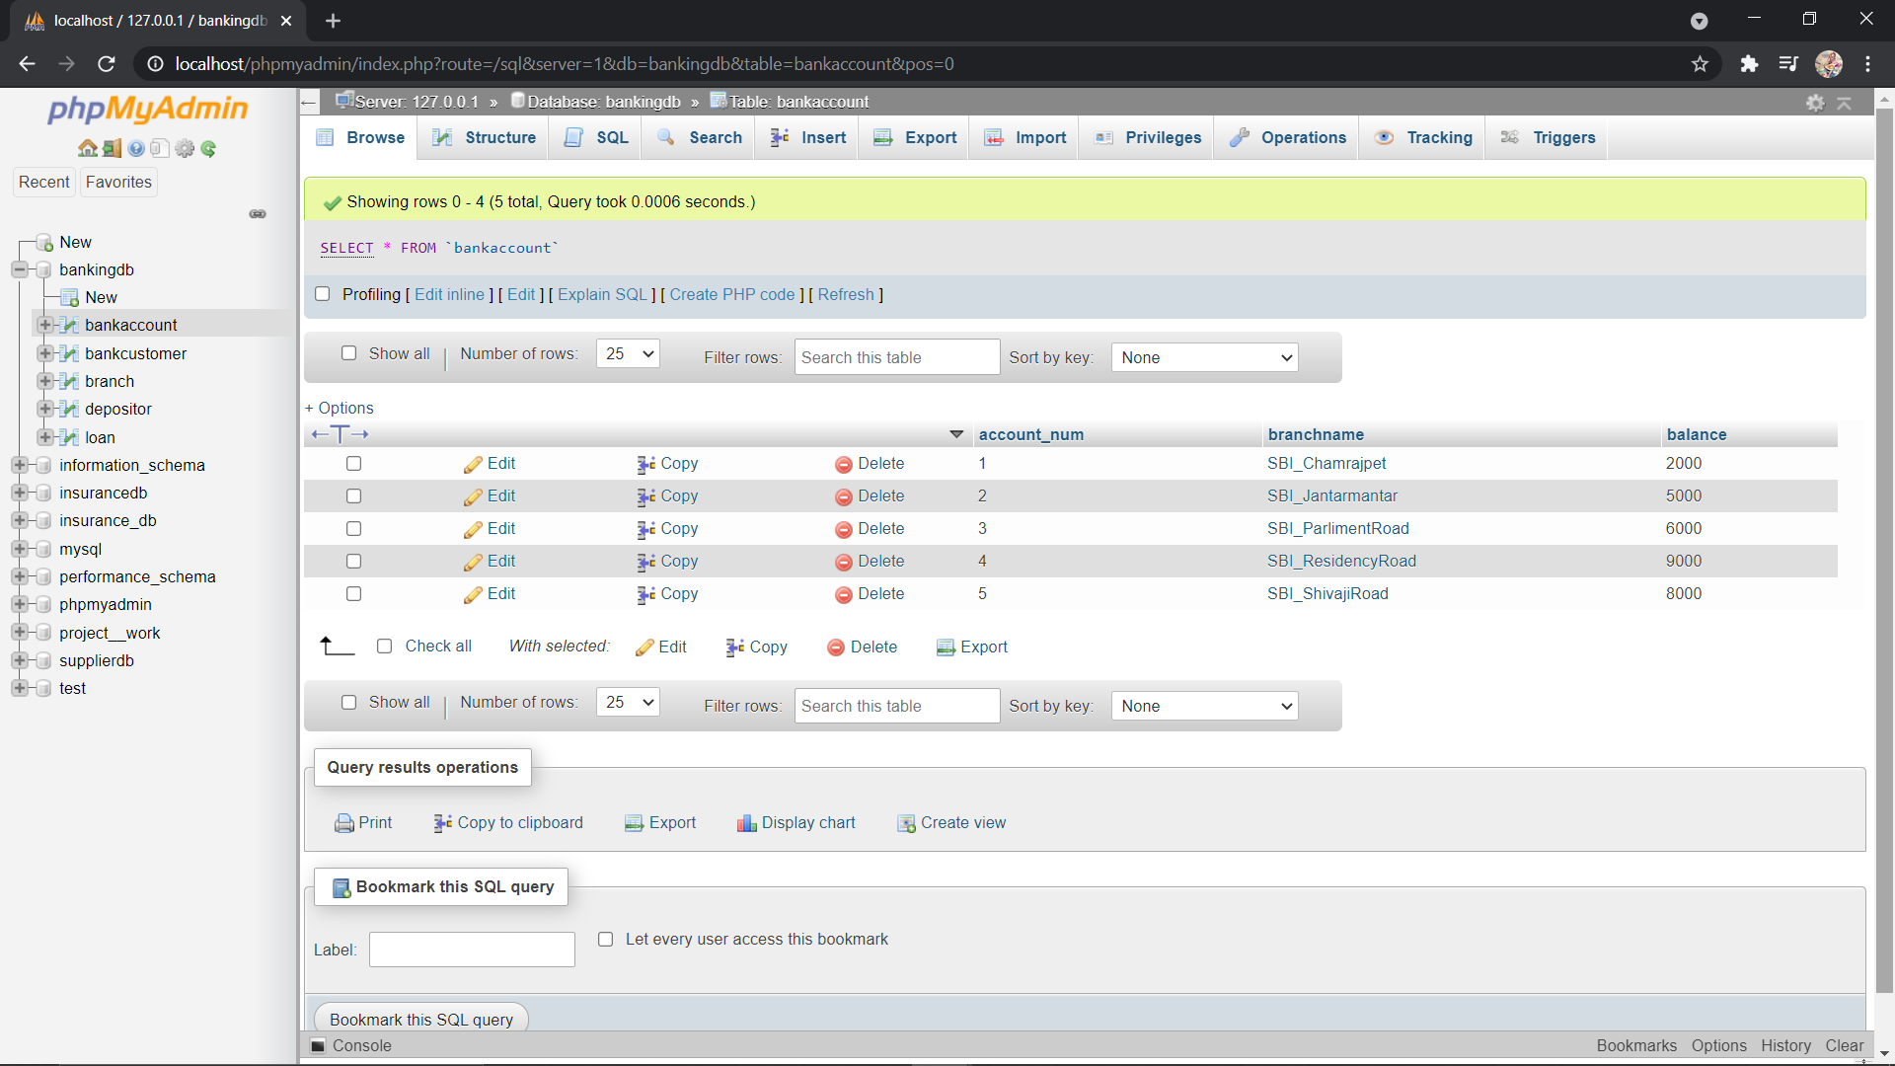

BANK CUSTOMER TABLE:-

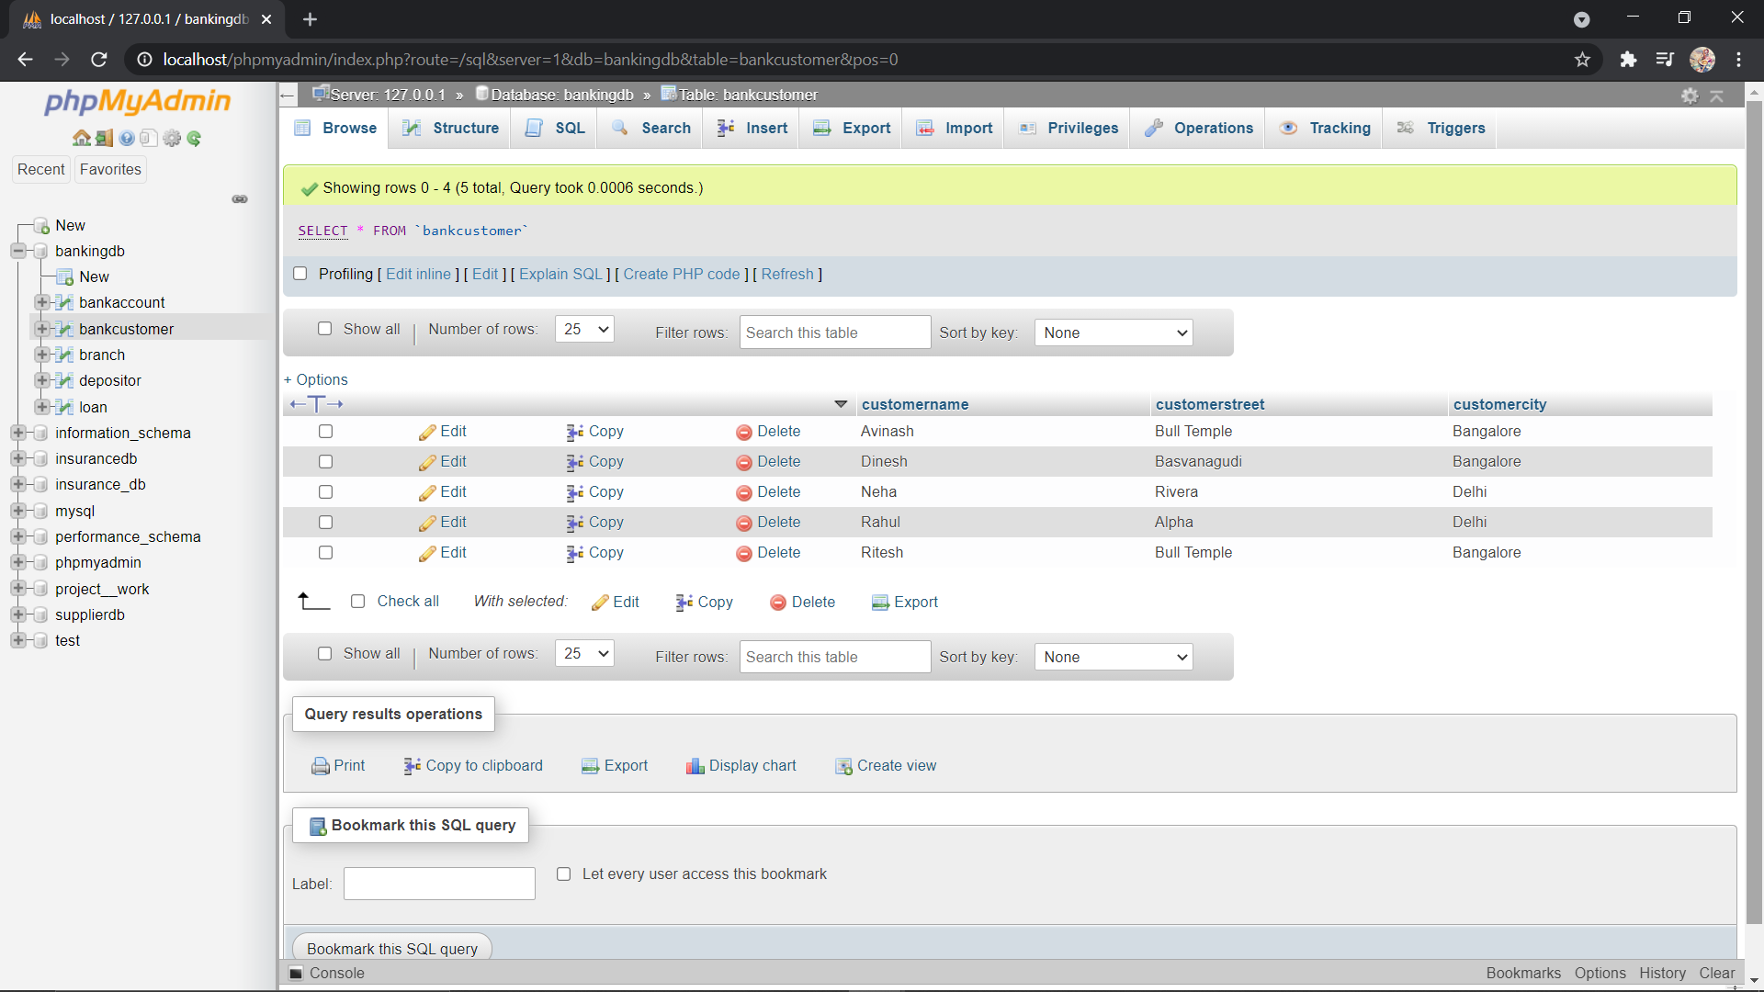

DEPOSITOR TABLE:-

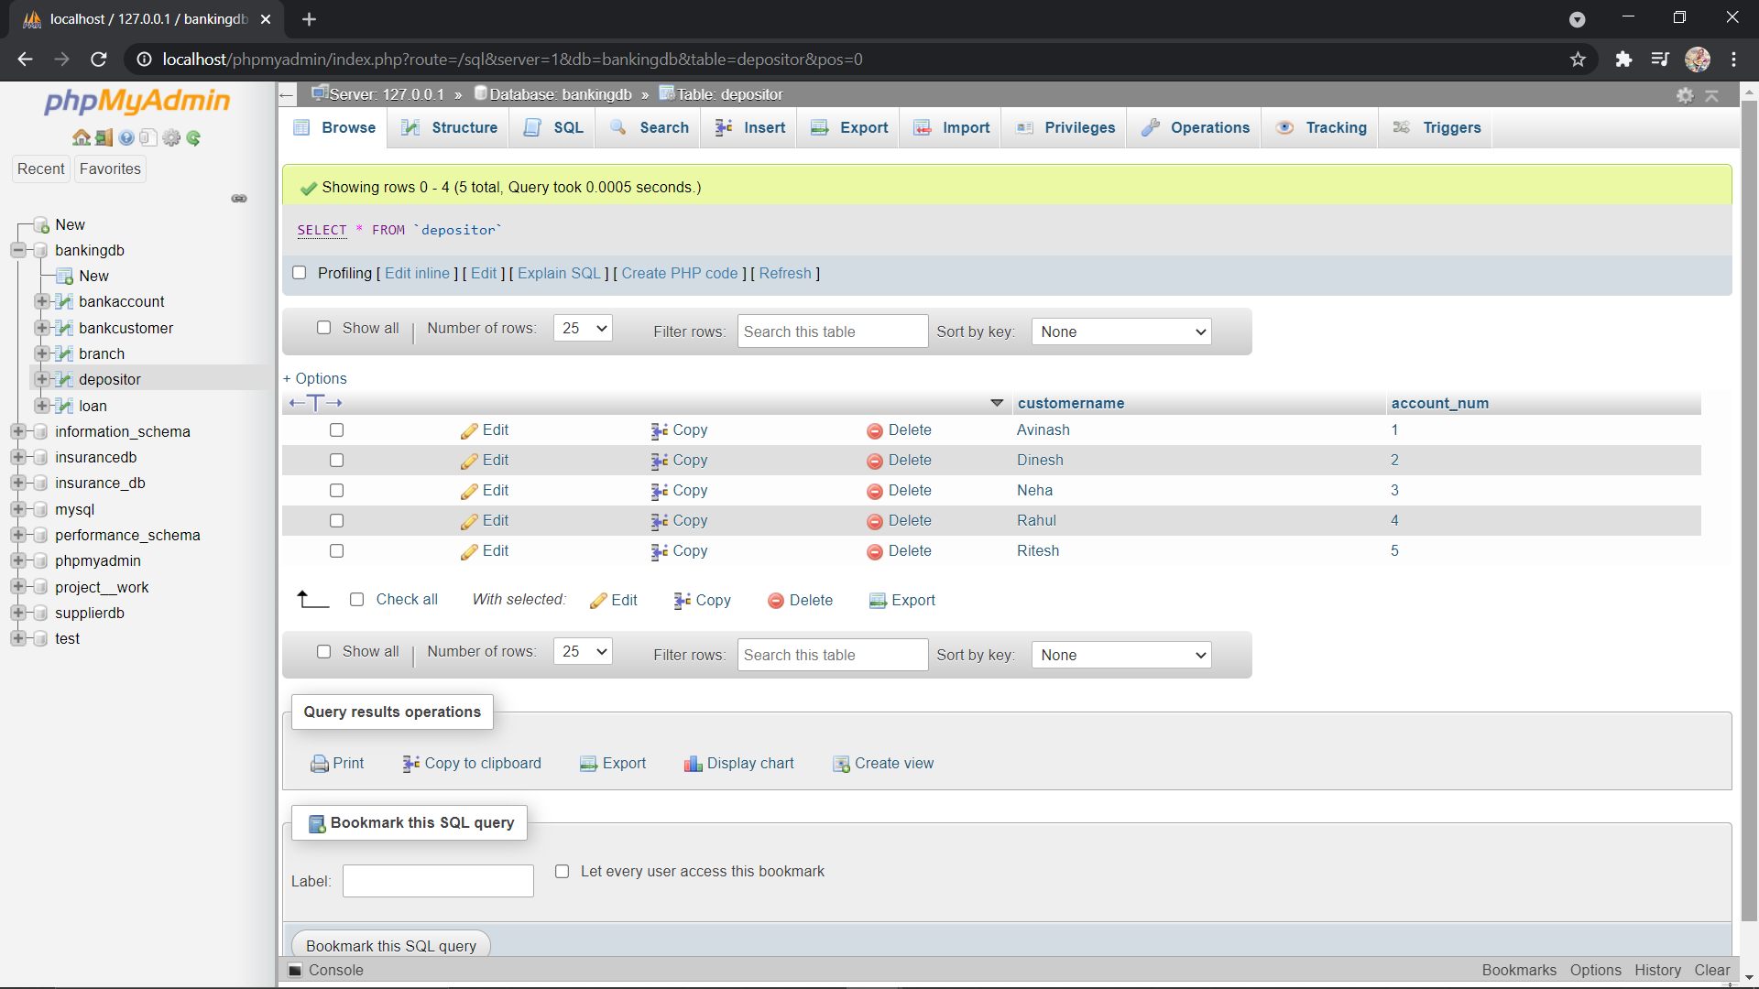

LOAN TABLE:-

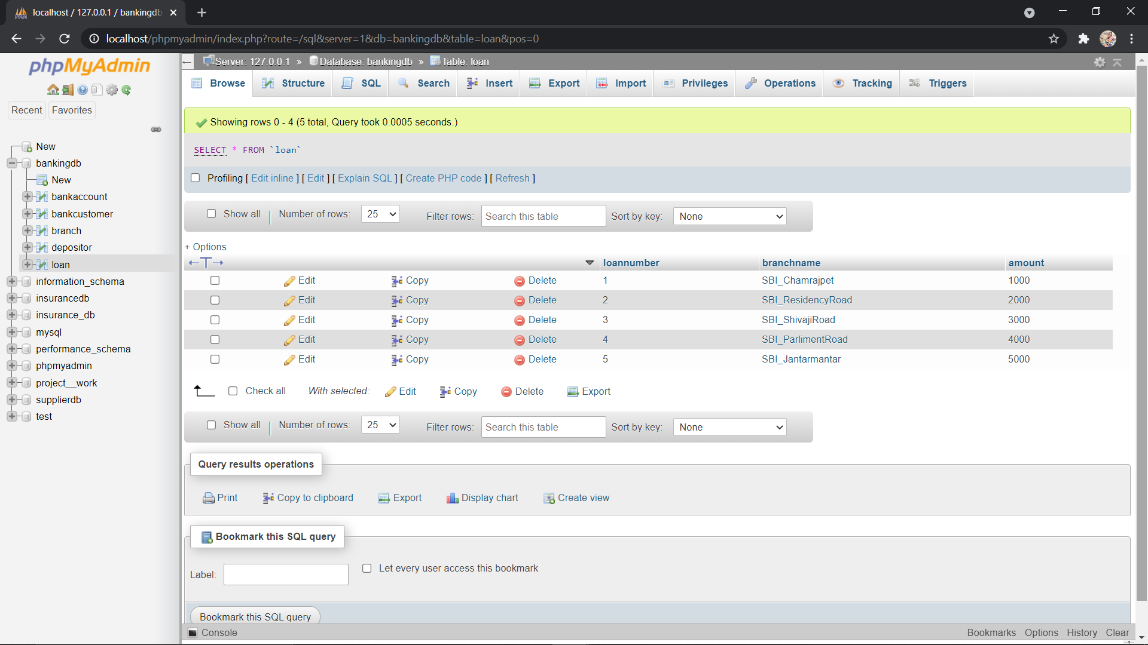

Find all the customers who have at least two accounts at the *Main* branch (ex. SBI_ResidencyRoad).

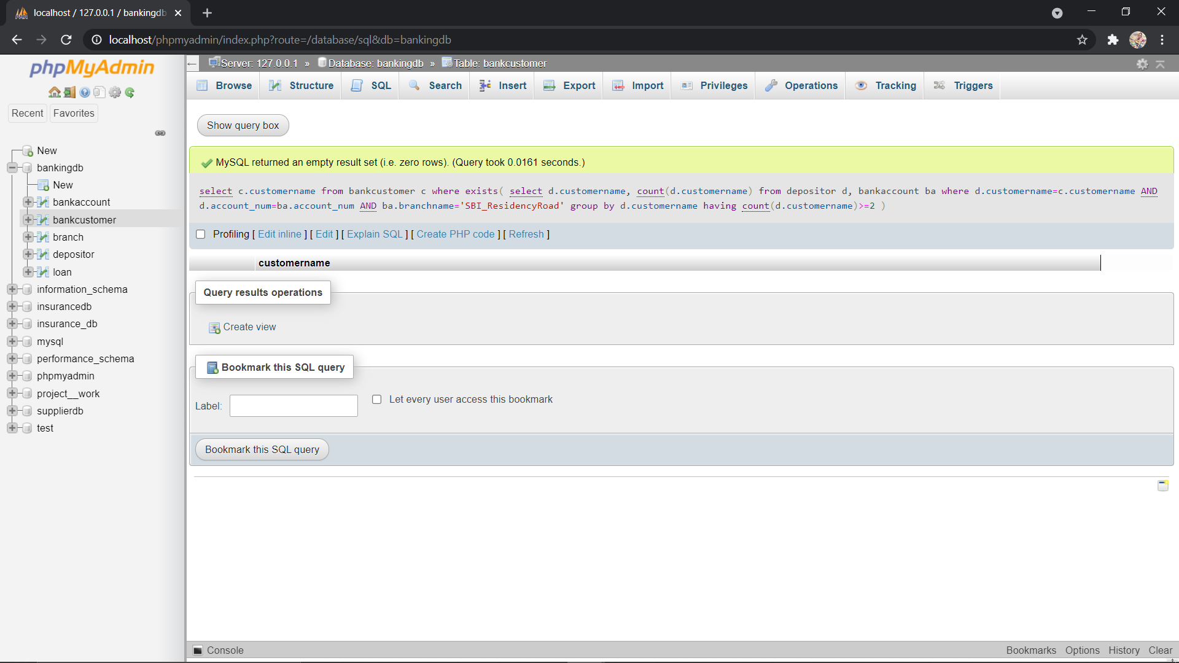

Find all the customers who have an account at *all* the branches located in a

specific city (Ex. Delhi).

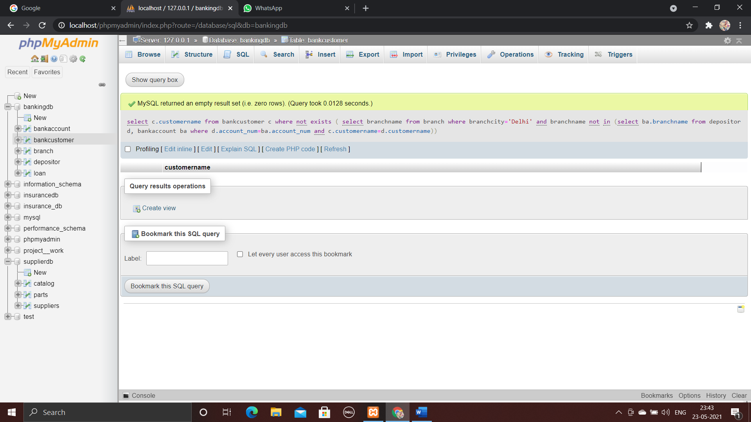

IF DEPOSITOR TABLE LOOKS LIKE:-

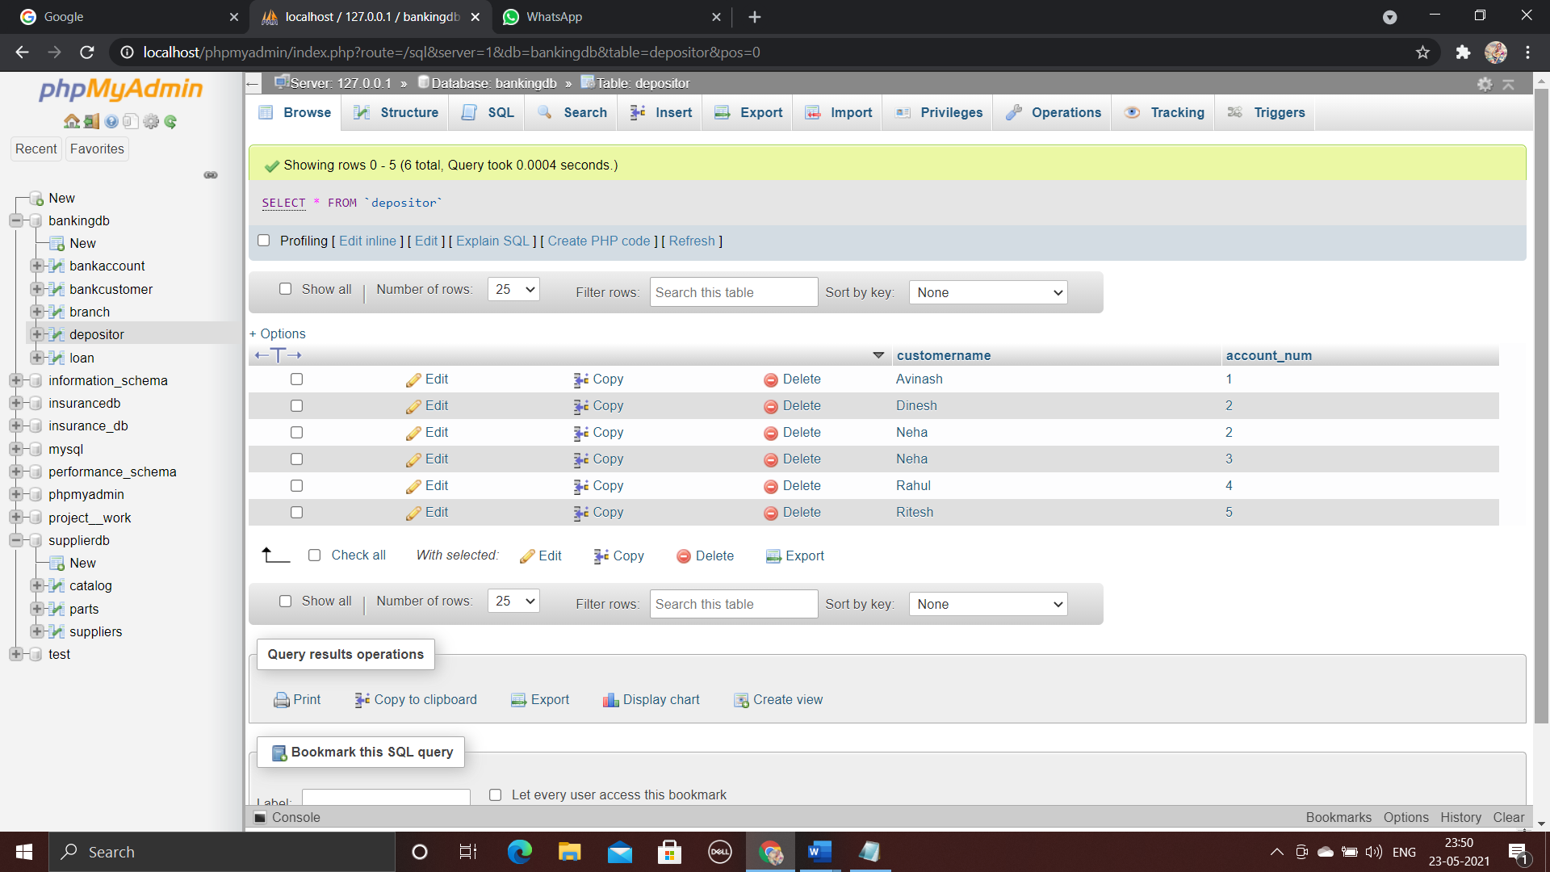

THEN OUTPUT IS:-

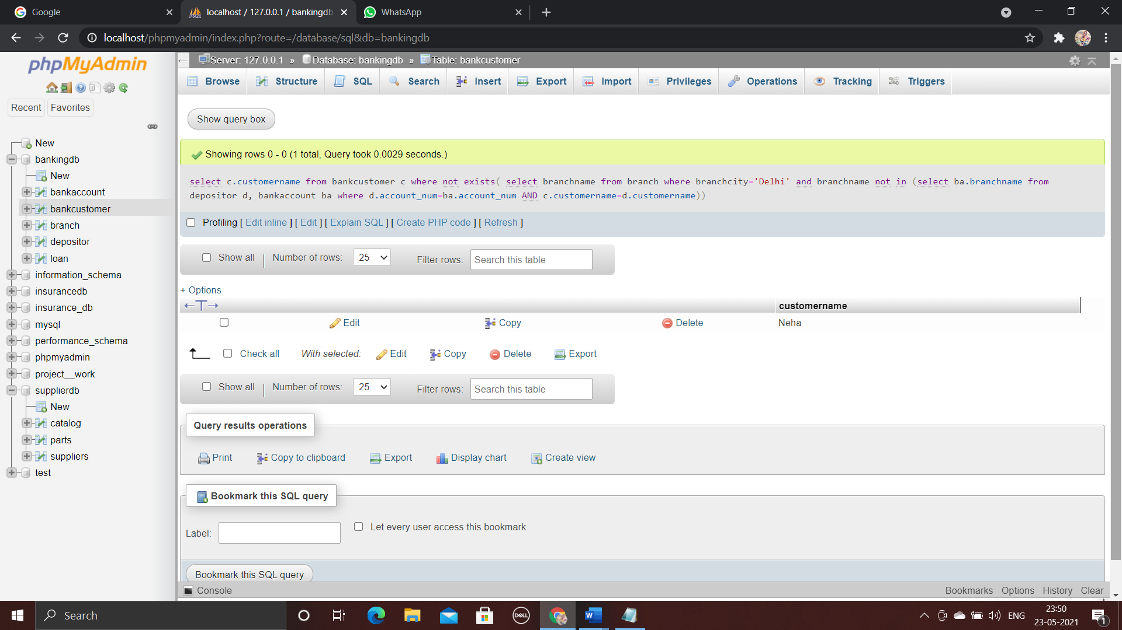

Demonstrate how you delete all account tuples at every branch located in

a specific city (Ex. Bombay).

