1. Name: The sum of two elements

Example 1: Input: nums = [2,7,11,15], target = 9

Output: [0,1]

Explanation: Because nums[0] + nums[1] == 9, we return [0, 1].

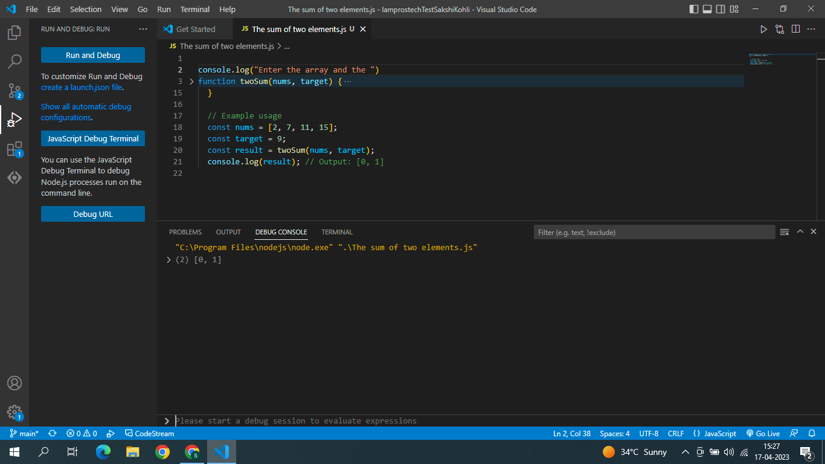

Example 2: Input: nums = [3,2,4],

target = 6

Output: [1,2]

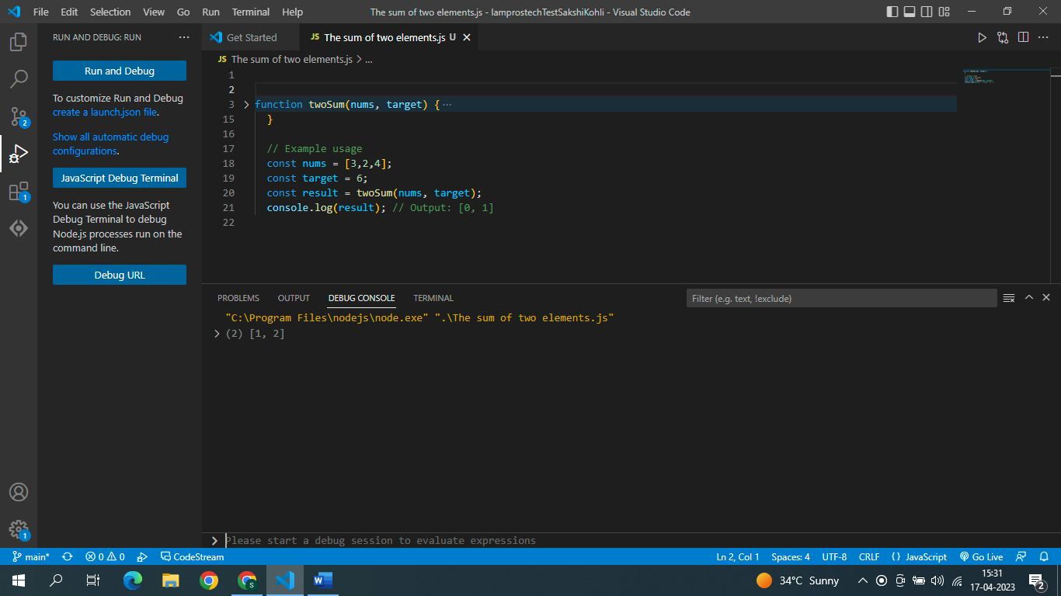

Example 3: Input: nums = [3,3],

target = 6

Output: [0,1]

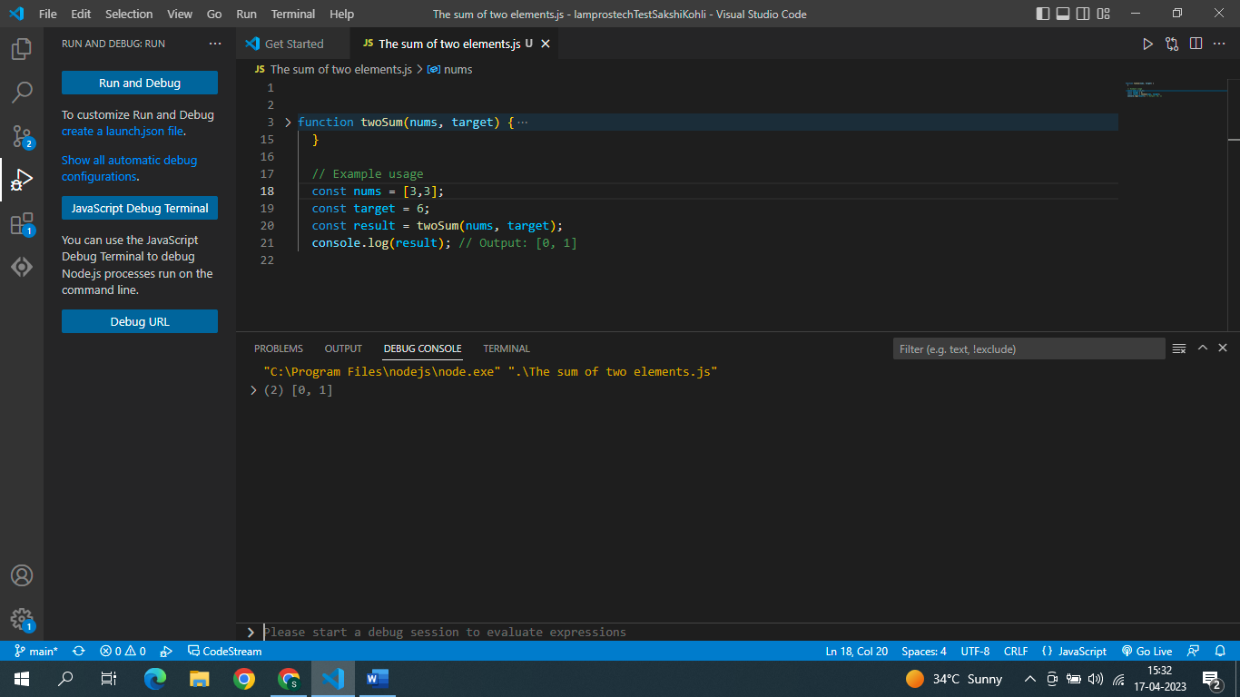

1. Single Integer

Example 1: Input: nums = [2,2,1] Output: 1

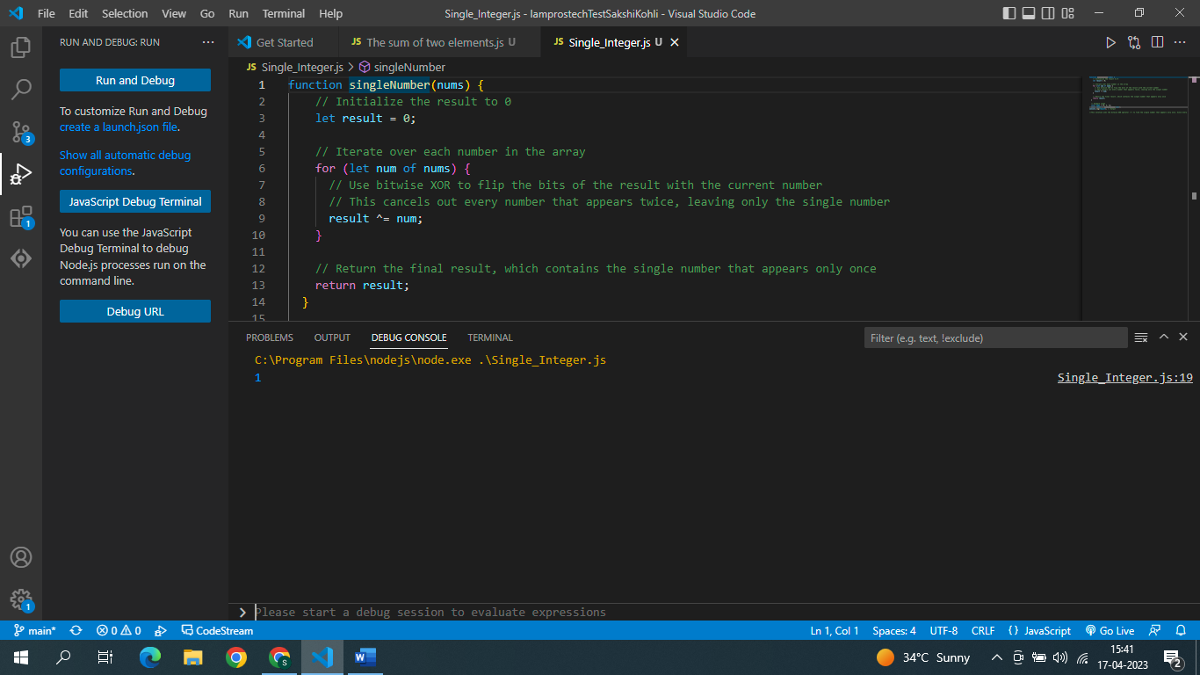

Example 2: Input: nums = [4,1,2,1,2] Output: 4

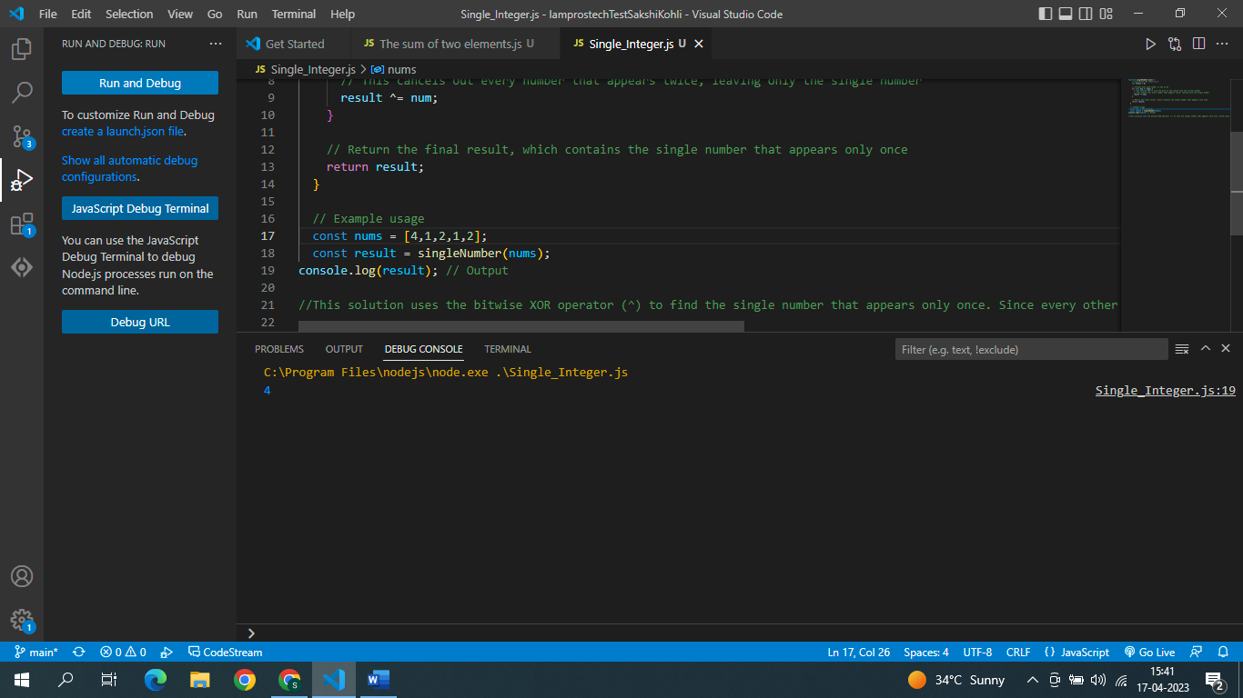

Example 3: Input: nums = [1] Output: 1

