Course Name: | Digital Design Laboratory | Semester: | III
Date of Performance: | 14 and 21 /07/2023 | Batch No: | A2
Faculty Name: | Dr. Kiran Ajetrao | Roll No: | 16010122034
Faculty Sign & Date: |  | Grade/Marks: | ___/25

Experiment No: 3
Title: 4:1 Multiplexer and 3: 8 Decoder

Aim and Objective of the Experiment:
To design and implement a 4:1 multiplexer and 3: 8 Decoder

COs to be achieved:
CO2: Use different minimization techniques and solve combinational circuits.

Tools used:
Trainer kits

Theory:
Multiplexer: Multiplexer is a special type of combinational circuit. It is a digital circuit that selects one of the n data inputs and routes it to the output. The selection of one of the n inputs is done by the select lines. To select n inputs we require m select lines, such that 2^{m}=n. Depending on the digital code applied at the select inputs, one out of the n data sources is selected and transmitted to a single output.

Decoder: A decoder is a multiple-input, multiple-output logic circuit that converts coded inputs into coded outputs, where the input and output codes are different. The input code generally has fewer bits than the output code, and there is a one-to-one mapping from input code words into output code words. The general structure of a decoder circuit is shown in the Figure below. The enable inputs, if present, must be asserted for the decoder to perform its normal mapping function. The most commonly used input code is an N-bit binary code, where an N-bit word represents one of 2^{N} different coded values. Normally, they range from 0 through 2^{N} − 1. The input code lines select which output is active. The remaining output lines are disabled.

Implementation Details:
4:1 Multiplexer Block Diagram

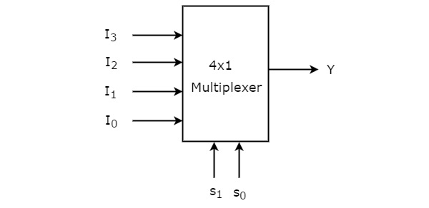

4:1 Multiplexer Circuit
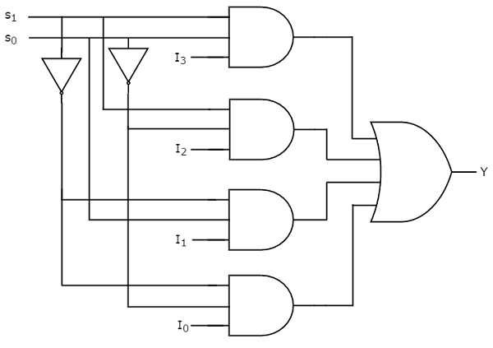

Pin Diagram IC74153
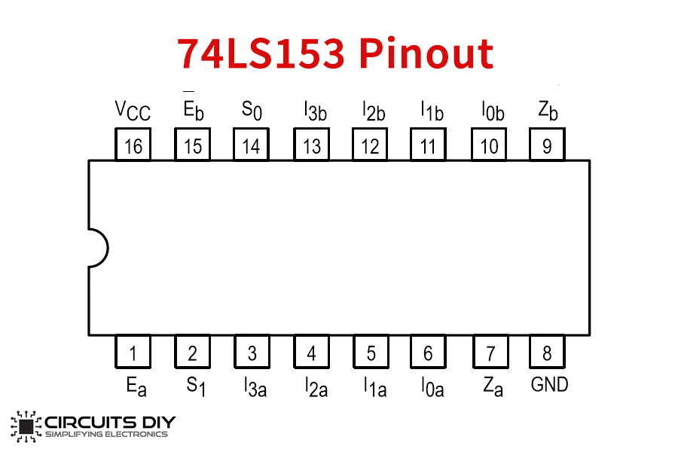

Implementation Details:
3:8 Decoder Block Diagram
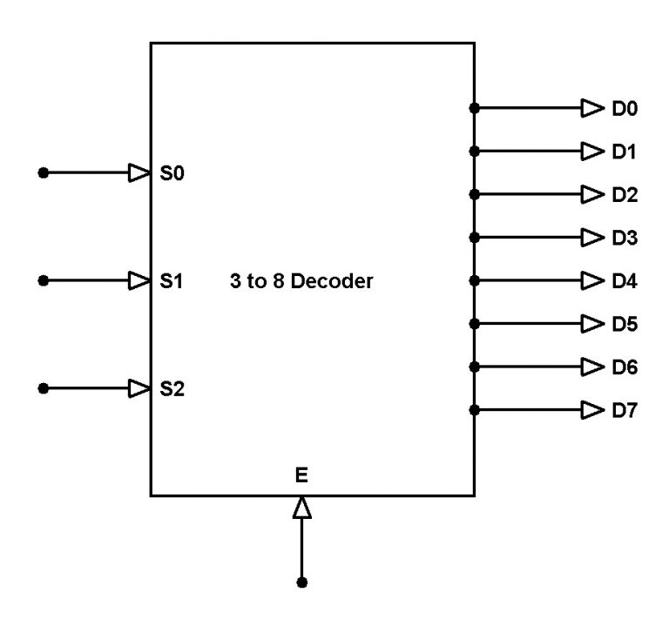

3:8 Decoder Circuit
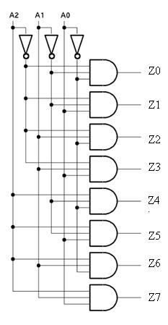
Pin Diagram IC74138

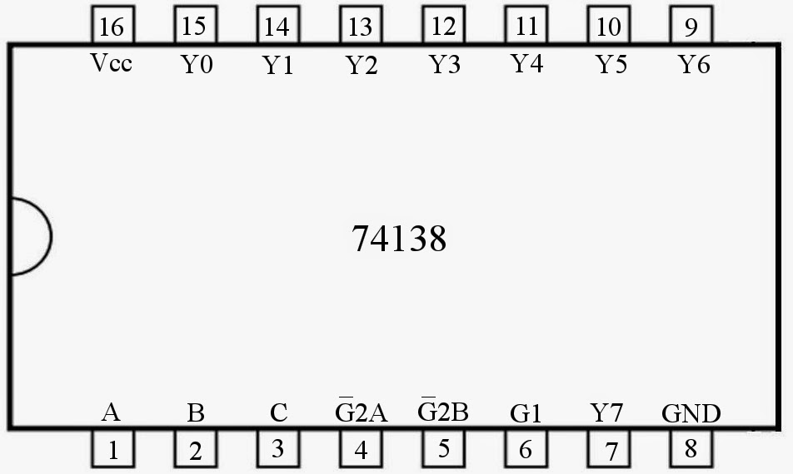

Implementation Details
Procedure:

- Locate the IC 74153 and place the IC on trainer kit.
- Connect VCC and ground to respective pins of IC trainer kit.
- Implement the circuit as shown in the circuit diagram.
- Connect the inputs to the input switches in the trainer kit.
- Connect the outputs to the O/P LEDs
- Apply various combinations of inputs according to the truth table and observe the condition of the LEDs.
- Note down the corresponding output readings for various combinations of inputs.
- Repeat the same for IC 74138

Post Lab Subjective/Objective type Questions:
- Design and verify a 2:1 multiplexer using logic gates.
Ans)
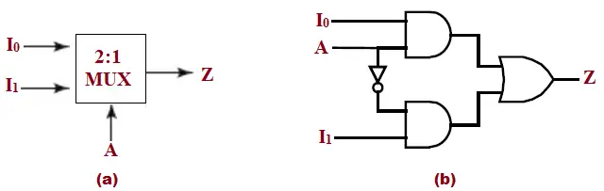


Truth Table for 2:1 multiplexer

Inputs |  | A | Z
I0 | I1
0 | 0 | 0 | 0
0 | 1 | 0 | 1
1 | 0 | 1 | 1
1 | 1 | 1 | 1

- Build an 8:1 multiplexer using only 2:1 multiplexers.
Ans)
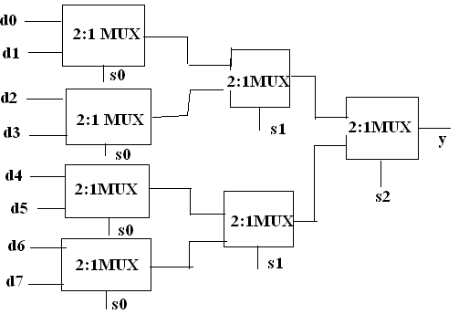
Truth Table for 8:1 Multiplexer

INPUTS |  |  | OUTPUT
S2 | S1 | S0 | Y
0 | 0 | 0 | d0
0 | 0 | 1 | d1
0 | 1 | 0 | d2
0 | 1 | 1 | d3
1 | 0 | 0 | d4
1 | 0 | 1 | d5
1 | 1 | 0 | d6
1 | 1 | 1 | d7

Conclusion:
In conclusion, the Digital Electronics Lab has been an illuminating journey into the world of combinational logic circuits, with a primary focus on designing and implementing a 4:1 multiplexer and a 3:8 decoder.

Our exploration began with the 4:1 multiplexer, a versatile device that allowed us to select one of four input data sources based on control signals. We learned how to construct the multiplexer using basic logic gates, and through experimentation, we witnessed its ability to efficiently route data in a flexible manner.

The 3:8 decoder was another crucial component we delved into. This decoder transformed a binary input into one of eight possible output lines, enabling us to address specific devices or functions within a digital system. By designing and implementing the decoder, we gained a deeper understanding of how to handle multiple outputs and the importance of accurate signal decoding.

Signature of faculty in-charge with Date:

