Course Name: | Digital Design Laboratory | Semester: | III
Date of Performance: | 31/07/2023 | Batch No: | B2
Faculty Name: | Bharati H. N. | Roll No: | 16010122158
Faculty Sign & Date: |  | Grade/Marks: | ___/25

Experiment No: 2
Title: Binary Adders and Subtractors

Aim and Objective of the Experiment:
To implement half and full adder–subtractor using gates and IC 7483

COs to be achieved:
CO2: Use different minimization technique and solve combinational circuits.

Tools used:
Trainer kits

Theory:
Adder: The addition of two binary digits is the most basic operation performed by the digital computer. There are two types of adder:

- Half adder
- Full adder

Half Adder: Half adder is a combinational logic circuit with two inputs and two outputs. It is the basic building block for the addition of two single-bit numbers.

Full adder: A half adder has a provision not to add a carry coming from the lower order bits when multi-bit addition is performed. For this purpose, a third input terminal is added and this circuit is to add A, B, and C where A and B are the nth order bits of the number A and B respectively and C is the carry generated from the addition of (n-1) order bits. This circuit is referred to as full adder.

Subtractor: Subtraction of two binary digits is one of the most basic operations performed by a digital computer. There are two types of subtractors:

- Half subtractor

- Full subtractor

Half subtractor: Logic circuit for the subtraction of B from A where A,B are 1 bit numbers is referred to as half subtract or the subtract or process has two inputs and difference and borrow are the two outputs.

Full subtractor: As in the case of the addition using logic gates, a full subtractor is made by combining two half-subtractors and an additional OR-gate. A full subtractor has the borrow in capability (denoted as BORIN) and so allows cascading which results in the possibility of multi-bit subtraction.

IC 7483

For subtraction of one binary number from another, we do so by adding 2’s complement of the former to the latter number using a full adder circuit.

IC 7483 is a 16 pin, 4-bit full adder. This IC has a provision to add the carry output to transfer and end around carry output using Co and C4 respectively.

2’s complement: 2’s complement of any binary no. can be obtained by adding 1 in 1’scomplement of that no.
e.g. 2’s complement of +(10)₁₀ =1010is
1C of 1010 |  |  | 0101
 |  | + | 1
-(10)₁₀ |  |  | 0110

In 2’s complement subtraction using IC 7483, we are representing negative number in 2’s complement form and then adding it with 1st number.

Implementation Details:

Half Adder Block Diagram
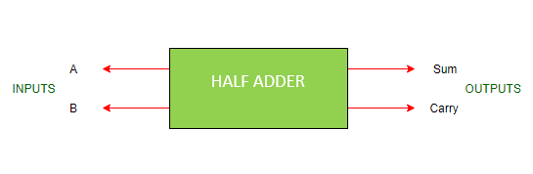

Half Adder Circuit
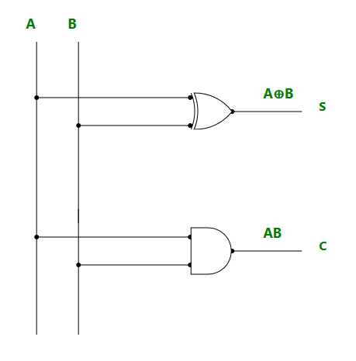

Truth Table for Half Adder
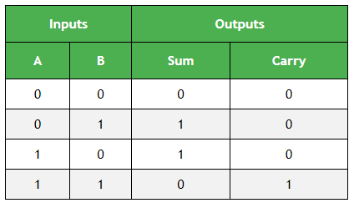
From the truth table (with steps):

A | B | A’ | B’ | A’B | AB’ | AB (CARRY) | A’B+AB’ (SUM)
0 | 0 | 1 | 1 | 0 | 0 | 0 | 0
0 | 1 | 1 | 0 | 1 | 0 | 0 | 1
1 | 0 | 0 | 1 | 0 | 1 | 0 | 1
1 | 1 | 0 | 0 | 0 | 0 | 1 | 0

Full Adder Block Diagram
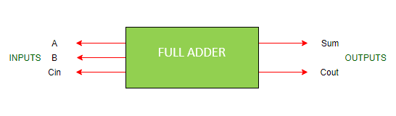
Full Adder Circuit
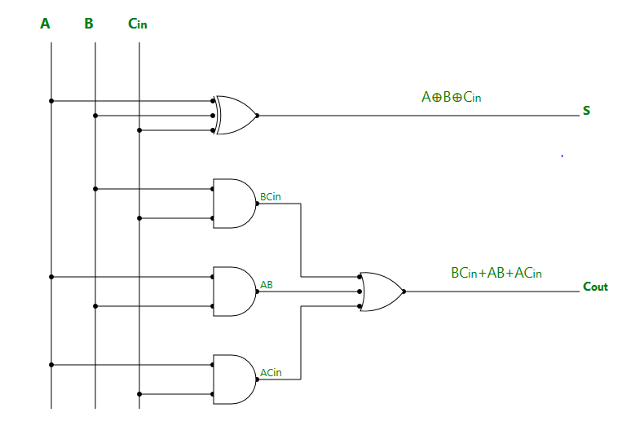

Truth Table for Full Adder
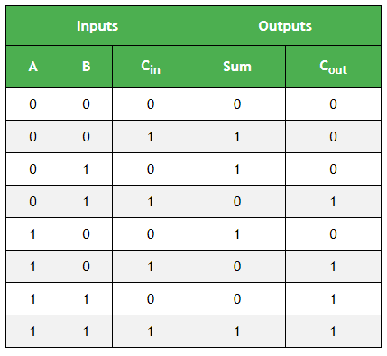
From the truth table (with steps):

A | B | Cin | A⊕B⊕Cin (SUM) |  | AB | ACin | BCin | AB+ACin+BCin(CARRY)
0 | 0 | 0 | 0 |  | 0 | 0 | 0 | 0
0 | 0 | 1 | 1 |  | 0 | 0 | 0 | 0
0 | 1 | 0 | 1 |  | 0 | 0 | 0 | 0
0 | 1 | 1 | 0 |  | 0 | 0 | 1 | 1
1 | 0 | 0 | 1 |  | 0 | 0 | 0 | 0
1 | 0 | 1 | 0 |  | 0 | 1 | 0 | 1
1 | 1 | 0 | 0 |  | 1 | 0 | 0 | 1
1 | 1 | 1 | 1 |  | 1 | 1 | 1 | 1

Half Subtractor Block Diagram
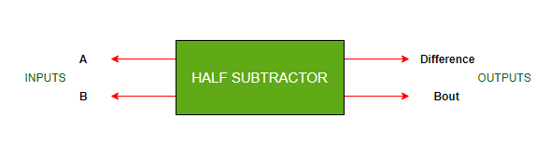
Half Subtractor Circuit
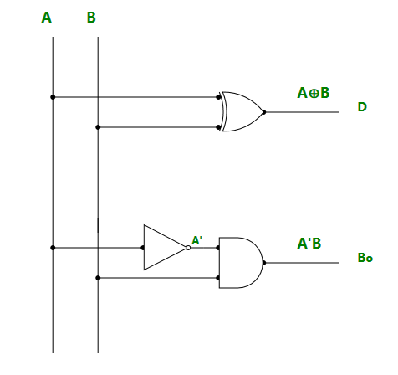

Truth Table for Half Subtractor
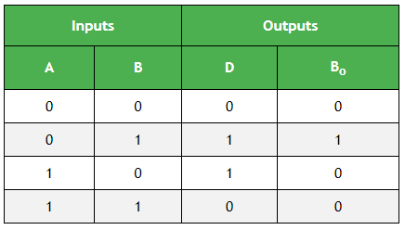
From the truth table (with steps) :

A | B | A’ | B’ | A’B  (BORROW) | AB’ | A’B+AB’ (DIFFERENCE)
0 | 0 | 1 | 1 | 0 | 0 | 0
0 | 1 | 1 | 0 | 1 | 0 | 1
1 | 0 | 0 | 1 | 0 | 1 | 1
1 | 1 | 0 | 0 | 0 | 0 | 0

Full Subtractor Block Diagram
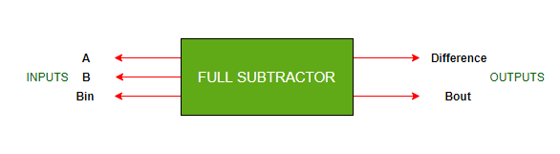
Full Subtractor Circuit
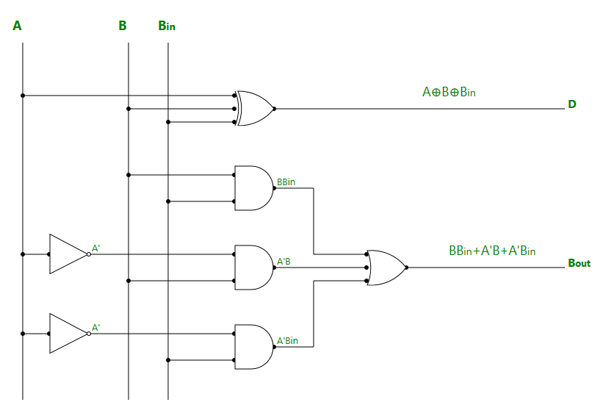

Truth Table for Full subtractor

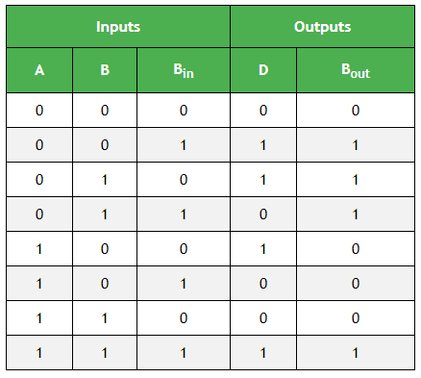

From the truth table (with steps):
A | B | Bin | A’ | BBin | A’B | A’Bin | A⊕B⊕Bin  (DIFFERENCE) | BBin+A’B+A’Bin (BORROW)
0 | 0 | 0 | 1 | 0 | 0 | 0 | 0 | 0
0 | 0 | 1 | 1 | 0 | 0 | 1 | 1 | 1
0 | 1 | 0 | 1 | 0 | 1 | 0 | 1 | 1
0 | 1 | 1 | 1 | 1 | 1 | 1 | 0 | 1
1 | 0 | 0 | 0 | 0 | 0 | 0 | 1 | 0
1 | 0 | 1 | 0 | 0 | 0 | 0 | 0 | 0
1 | 1 | 0 | 0 | 0 | 0 | 0 | 0 | 0
1 | 1 | 1 | 0 | 1 | 0 | 0 | 1 | 1

Example:

1) 710 -210 = 510
7 |  | 0111
2 |  | 0010
1’C of 2 |  | 1101
 |  | + 1
2’C of 2 |  | 1110

0111 + 1110 1 0101

Pin Diagram IC7483
Adder
Subtractor

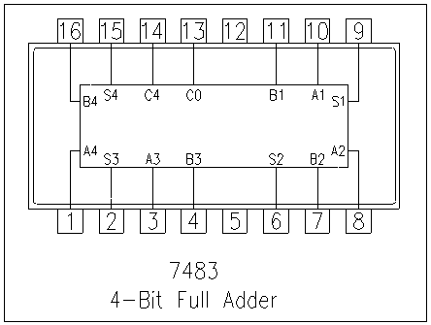

Implementation Details
Procedure:

- Locate the IC 7483 and 4-not gates block on trainer kit.

- Connect 1st input no. to A4-A1 input slot and 2nd (negative) no. to B4-B1 through 4-not gates (1C of 2nd no.)

- Connect high input to Co so that it will get added with 1C of 2nd no. to get 2C.

- Connect 4-bit output to the output indicators.

- Switch ON the power supply and monitor the output for various input combinations.

Post Lab Subjective/Objective type Questions:
- Design a full adder using two half adders.
Ans)
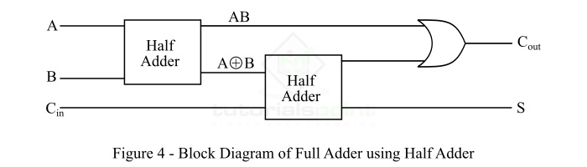
The output equation of the half adder are,
Sum, S = A⨁B
Carry ,C = A⋅B
The output equations of the full adder are,
Sum, S = A⨁B⨁Cin
Carry, Cout = AB+ACin+BCin

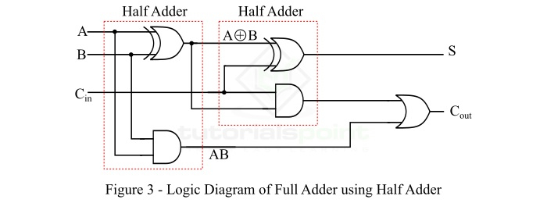

- Perform the following Binary subtraction with the help of appropriate ICs:
  - 6-4
  - 5-8
  - 7-9
Ans)
a.
6₁₀-4₁₀=2₁₀

6 0110
4 0100
2 0010

1’C of 4 1011
2’C of 4 1100

6 + 2’C of 4 = 0110 + 1100 = 10010
0010 = ₁₀

b.
5₁₀-8₁₀= -3₁₀

5 00101
8 01000

1’C of 8 10111
2’C of 8 11000

5 + 2’C of 8 = 00101 + 11000 = 11101

2’C of 11101 = 00011 = 3₁₀

c.
7₁₀-9₁₀= -2₁₀

7 00111
9 01001

1’C of 9 10110
2’C of 9 10111

7 + 2’C of 9 = 00111 + 10111 = 11110

2’C of 11110 = 00010

Conclusion:
In conclusion, this experiment has provided us with an insightful and practical journey into the world of half and full adder-subtractor circuits, utilizing both gates and the versatile Integrated Circuit (IC) 7483.

This integrated circuit not only simplified complex operations but also demonstrated the importance of practical components in digital design. The IC 7483 efficiently performed binary addition and subtraction, emphasizing the efficiency and speed that integrated circuits bring to digital circuits.

This hands-on experience has been instrumental in deepening our understanding of fundamental digital electronics principles and their real-world applications. As we conclude this lab, we have not only honed our theoretical knowledge but also refined our practical abilities.

Signature of faculty in-charge with Date:

