Course Name: | Digital Design Laboratory | Semester: | III
Date of Performance: | 25 / 09/ 2023 | Batch No: | B2
Faculty Name: | Bharath H. N. | Roll No: | 16010122158
Faculty Sign & Date: |  | Grade/Marks: | ___/25

Experiment No: 6
Title: Shift Register

Aim and Objective of the Experiment:
To implement the SISO, SIPO, PISO, PIPO shift register using Universal IC 74194

COs to be achieved:
CO3: Design synchronous and asynchronous sequential circuits.

Tools used:
Trainer kits

Theory:
A register is capable of shifting its binary information in one or both directions is known as shift register. The logical configuration of shift register consist of a D-Flip flop cascaded with output of one flip flop connected to input of next flip flop. All flip flops receive common clock pulses which causes the shift in the output of the flip flop.The simplest possible shift register is one that uses only flip flop. The output of a given flip flop is connected to the input of next flip flop of the register. Each clock pulse shifts the content of register one bit position to right.

The basic types of shift registers are
- Serial In - Serial Out
- Serial In - Parallel Out
- Parallel In - Serial Out
- Parallel In - Parallel Out
- Bidirectional shift registers.

Pin diagram of IC 74194 and Function table

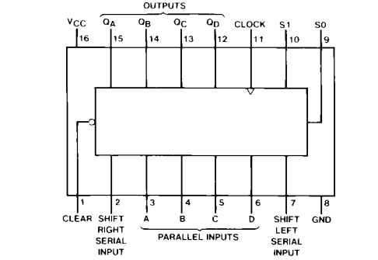
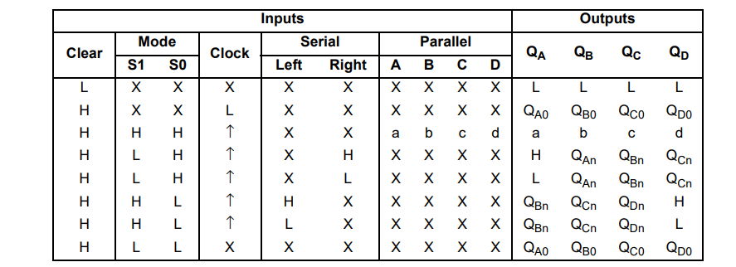

Circuit diagram: Serial left shift
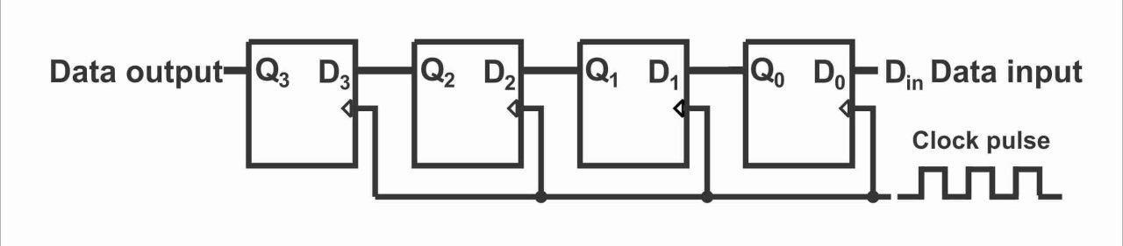
Truth Table
clk | A | B | C | D
1 | 0 | 0 | 0 | 0
1 | 1 | 0 | 0 | 0
1 | 1 | 1 | 0 | 0
1 | 1 | 1 | 1 | 0
1 | 1 | 1 | 1 | 1

Circuit diagram: Serial right shift
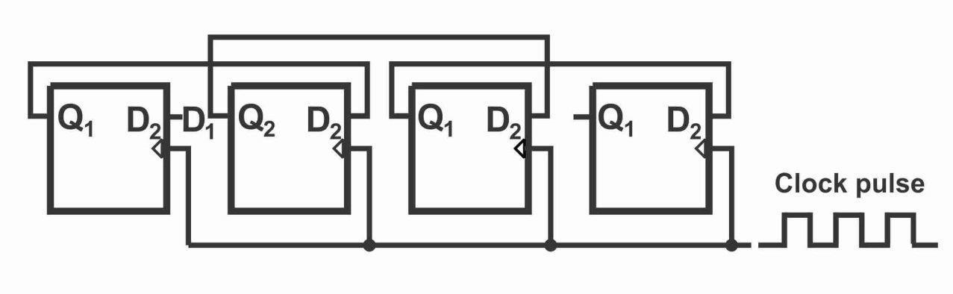
Truth Table
clk | A | B | C | D
1 | 0 | 0 | 0 | 0
1 | 0 | 0 | 0 | 1
1 | 0 | 0 | 1 | 0
1 | 0 | 0 | 1 | 1
1 | 0 | 1 | 0 | 0

Circuit diagram: Parallel in Parallel out
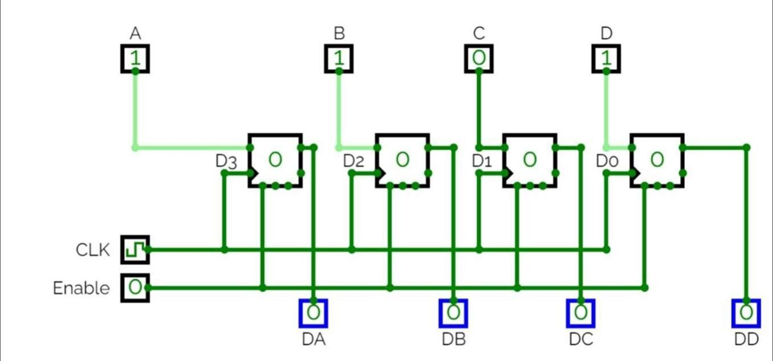
Truth Table
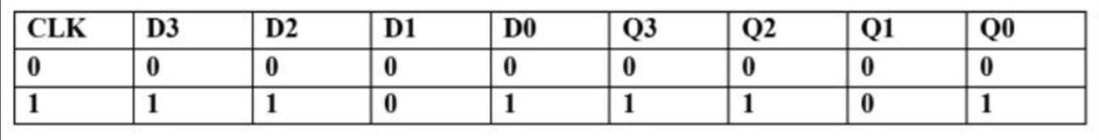

Implementation Details
Procedure
- Locate IC 74196 on Digital trainer kit
- Apply various inputs to appropriate pins as per the mode of operation with reference to the pin configuration of the IC.
- Connect a pulsar switch to the clock input.
- Verify the respective truth tables for different modes with reference to the truth table given in the data sheet of IC 74194.
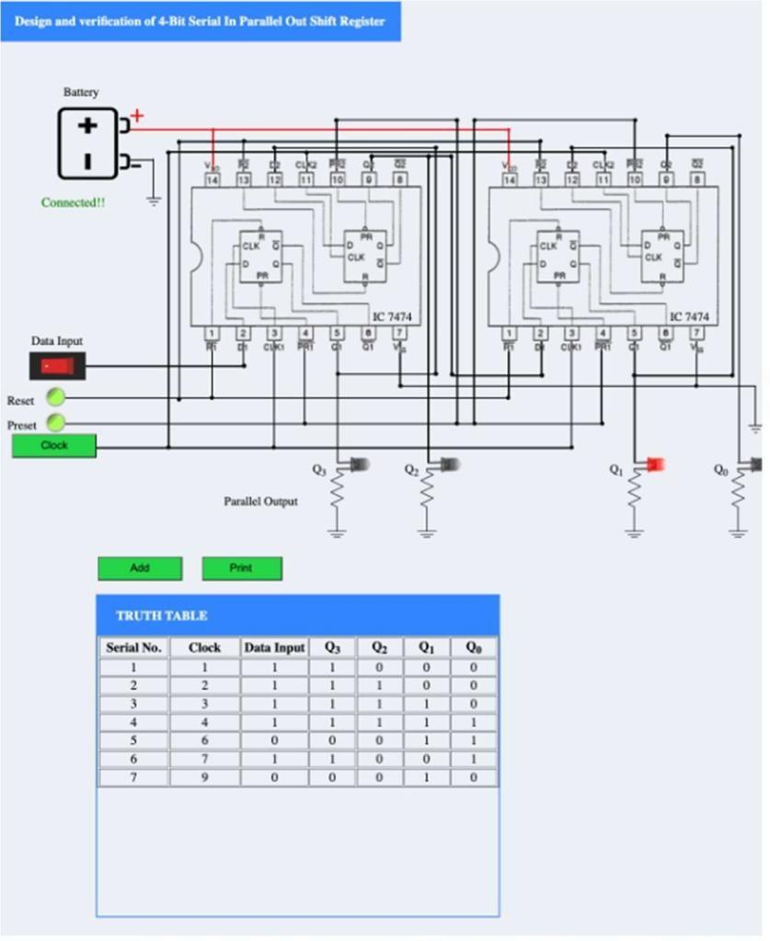

Post Lab Subjective/Objective type Questions:
- What is a universal shift register?
A universal shift register is a digital circuit that can perform both serial input and serial output

- Prepare a truth table for 3 bit SISO left shift with data(- - - ) along with clock pulse

CLK | D | Q2 | Q1 | Q0
0 | X | Q2 | Q1 | Q0
1 | 0 | Q1 | Q0 | 0
1 | 1 | Q1 | Q0 | D

- Can a shift register be used as a counter? Give any one application.
Yes, a shift register can be used as a counter. One application is in LED display multiplexing.

In this application, a shift register is used to sequentially activate different segments of a multi-digit LED display. By shifting a high bit through the shift register, it effectively counts through the segments, creating the appearance of a counter. This technique is used to display numbers, letters, or other characters on a multi-digit LED display using a limited number of output pins from a microcontroller or other control circuitry.

- How many clock pulses are required to enter a byte of data serially into an 8-bit shift register?
The number of individual data latches required to make up a single Shift Register device is usually determined by the number of bits to be stored with the most common being 8-bits (one byte) wide constructed from eight individual data latches. Shift Registers are used for data storage or for the movement of data and are therefore commonly used inside calculators or computers to store data such as two binary numbers before they are added together, or to convert the data from either a serial to parallel or parallel to serial format. The individual data latches that make up a single shift register are all driven by a common clock (CLK) signal making them synchronous devices.

Conclusion:
In conclusion, the experiment successfully implemented the SISO, SIPO, PISO, and PIPO shift registers using the Universal IC 74194. The shift registers demonstrated efficient data storage and sequential data manipulation capabilities, showcasing the versatility of the IC in digital circuit design. This experiment highlights the practicality of the 74194 IC for various applications requiring shift register functionality.

Signature of faculty in-charge with Date:

