Batch: B2 Roll. No.: 16010122158
Experiment: 9
Grade: AA / AB / BB / BC / CC / CD /DD

Title: Implementation of hashing concept

Objective: To understand various hashing methods

Expected Outcome of Experiment:

CO | Outcome
CO4 | Demonstrate sorting and searching methods.

Websites/books referred:
- https://www.geeksforgeeks.org/binary-tree-data-structure/
- https://www.thecrazyprogrammer.com/2015/03/c-program-for-binary-search-treeinsertion.html
- Data Structures A Pseudo Approach with C – Richard F. Gilberg & Behrouz A. Forouzan
_____________________________________________________________________
Abstract: -
(Define Hashing, hash function, list collision handling methods)
Hashing is a technique or process of mapping keys, and values into the hash table by using a hash function. It is done for faster access to elements. The efficiency of mapping depends on the efficiency of the hash function used.
A good hash function should have following properties:
1. Efficiently computable.
2. Should uniformly distribute the keys (Each table position equally likely for each).
3. Should minimize collisions.
4. Should have a low load factor(number of items in table divided by size of the table).
Collision Handling: Since a hash function gets us a small number for a big key, there is a possibility that two keys result in the same value. The situation where a newly inserted key maps to an already occupied slot in the hash table is called collision and must be handled using some collision handling technique. Following are the ways to handle collisions:
● Chaining:The idea is to make each cell of the hash table point to a linked list of records that have the same hash function value. Chaining is simple, but requires additional memory outside the table.
● Open Addressing: In open addressing, all elements are stored in the hash table itself. Each table entry contains either a record or NIL. When searching for an element, we examine the table slots one by one until the desired element is found or it is clear that the element is not in the table.
Code and output screenshots:
#include <stdio.h>
#include <stdlib.h>

struct HashNode
{
int key;
int value;
struct HashNode* next;
};

const int capacity = 20;
int size = 0;
struct HashNode** arr;

struct HashNode* createNode(int key, int value)
{
struct HashNode* newNode = (struct HashNode*)malloc(sizeof(struct HashNode));
newNode->key = key;
newNode->value = value;
newNode->next = NULL;
return newNode;
}

void insert(int key, int value)
{
int index = key % capacity;
struct HashNode* newNode = createNode(key, value);

if (arr[index] == NULL)
{
arr[index] = newNode;
}
else
{
struct HashNode* current = arr[index];
while (current->next != NULL)
{
current = current->next;
}
current->next = newNode;
}
size++;
}

int find(int key)
{
int index = key % capacity;
struct HashNode* current = arr[index];
while (current != NULL)
{
if (current->key == key)
{
return current->value;
}
current = current->next;
}
return -1;
}

int delete (int key)
{
int index = key % capacity;
struct HashNode* current = arr[index];
struct HashNode* prev = NULL;

while (current != NULL)
{
if (current->key == key)
{
if (prev == NULL)
{
arr[index] = current->next;
}
else
{
prev->next = current->next;
}
free(current);
size--;
return 1;
}
prev = current;
current = current->next;
}

return 0;
}

int main()
{
arr = (struct HashNode**)malloc(sizeof(struct HashNode*) * capacity);
for (int i = 0; i < capacity; i++)
arr[i] = NULL;

int choice, key, value;

while (1)
{
printf("1. Insert\n2. Delete\n3. Find\n4. Exit\n");
printf("Enter your choice: ");
scanf("%d", &choice);

switch (choice)
{
case 1:
printf("Enter key and value to insert: ");
scanf("%d %d", &key, &value);
insert(key, value);
break;
case 2:
printf("Enter key to delete: ");
scanf("%d", &key);
if (delete(key))
printf("Node value of key %d is deleted successfully\n", key);
else
printf("Key %d does not exist\n", key);
break;
case 3:
printf("Enter key to find: ");
scanf("%d", &key);
int result = find(key);
if (result != -1)
printf("Value of Key %d = %d\n", key, result);
else
printf("Key %d does not exist\n", key);
break;
case 4:
return 0;
default:
printf("Invalid choice. Please enter a valid option.\n");
}
}
}

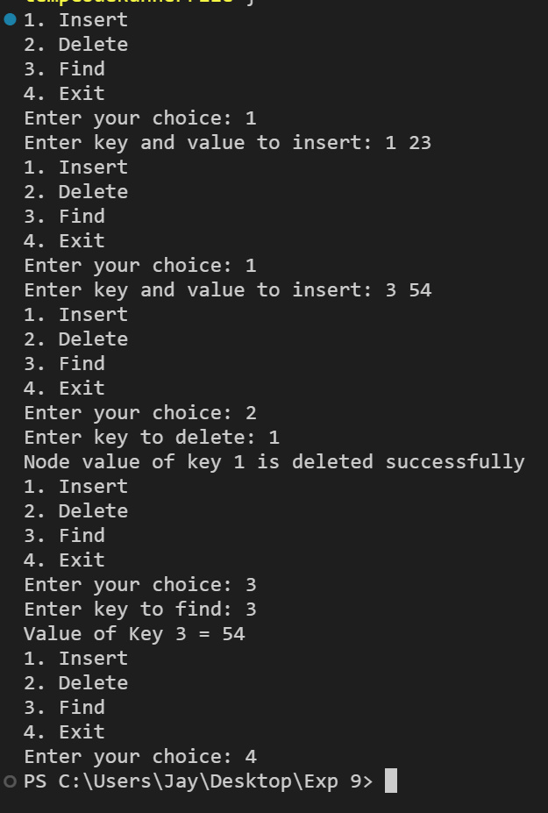

Conclusion: -
The given experiment was successfully completed and implemented. In this experiment we learnt about Hashing and algorithms related to hashing and also coded for the same in C language.
Post lab questions-
- Compare and contrast various collision handling methods.

Separate Chaining is a hashing technique in which there is a list to handle collisions. So there are many elements at the same position and they are in a list. The sequences are maintained in a linked list.

Linear Probing is a simple collision resolution technique for resolving collisions in hash tables, data structures for maintaining collection of values in a hash table. If there is a collision for the position of the key value then the linear probing technique assigns the next free space to the value.

Quadratic probing also is a collision resolution mechanism which takes in the initial hash which is generated by the hashing function and goes on adding a successive value of an arbitrary quadratic polynomial from a function generated until an open slot is found in which a value is placed.

Double hashing is also a collision resolution technique when two different values to be searched for produce the same hash key.It uses one hash value generated by the hash function as the starting point and then increments the position by an interval which is decided using a second, independent hash function. Thus here there are 2 different hash functions.

- Store the given numbers in bucket of size 16, resolve the collisions if any with
  - Linear probing
  - Quadratic hashing
  - Chaining
20, 33, 65, 23, 11, 32, 78, 64, 3, 87, 10, 7

Ans:-

- Linear Probing

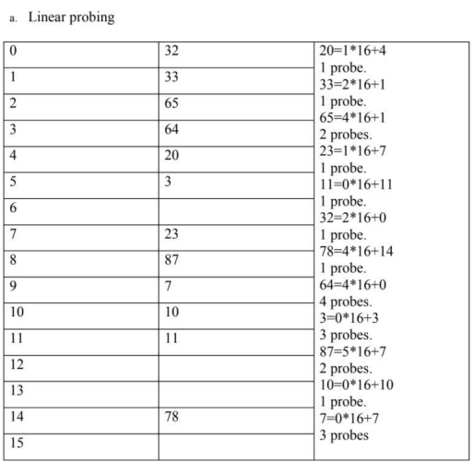

- Quadratic Hashing

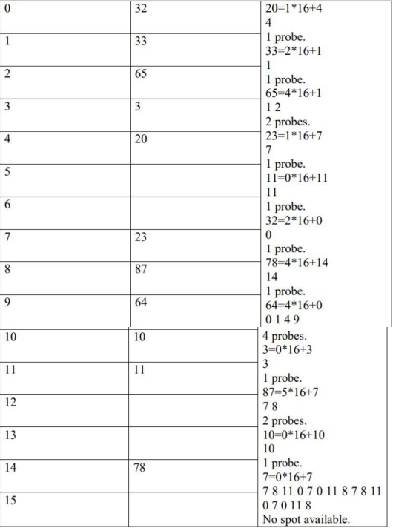

- Chaining

